INSTRUCTIONS : CYCLING MANAGER PROTOTYPE

Install

Double-click on install.exe and choose a directory to unzip the files.

To start the software

YOU NEED A 3D VIDEO CARD FOR THIS DEMO VERSION TO WORK (TNT and upper).

Before you can start the game,

To start the game

- Double-click on Game.exe (located in Data directory)

During the race

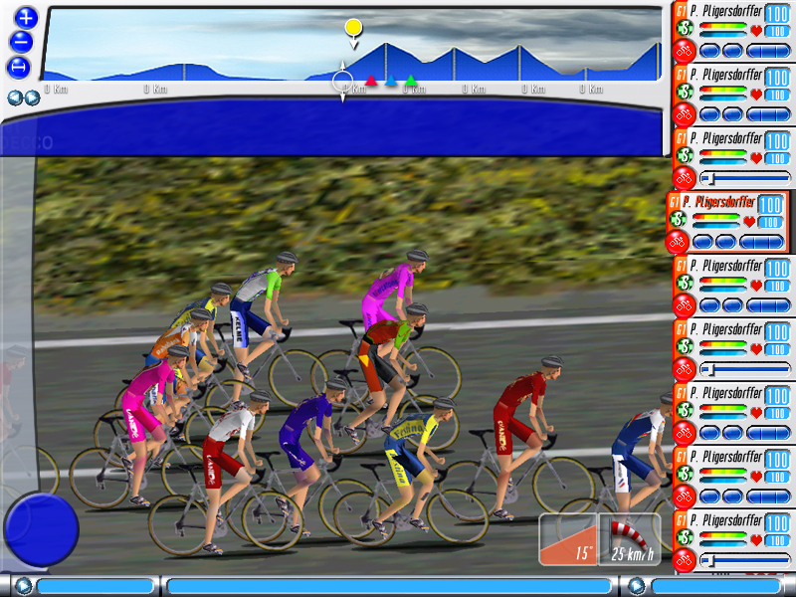

You can visualize the position of the different groups on the stage profile. Each time a new group is created, a new icon appears. A single click on this icon automatically move the camera to this group. You can zoom the profile by pressing the keys “+” and “-“.
To change the camera angle, use “F7”.

To cycle through racers, use the arrow keys or click on a racer in the video window.

The Groups Information area gives the time between groups (Group section) and information on the selected racer (name and team). The “Ranking” button is not functional yet but will give access to all the rankings before the stage.

Pressing F8 gives you access to the race events that have already taken place.

Team area

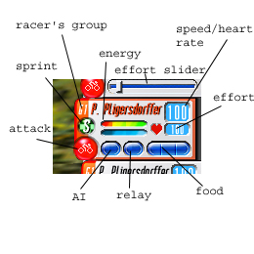
On the right side of the screen is your team area with all your racers action buttons.

To select a cyclist, click on his name. Once selected, the racer’s name switches to red.

The two energy bars are energy (upper) and punch (lower). Energy is lost during the race depending on the racer’s ratings and his speed. Punch is lost when the racer accelerates rapidly.

The group indicator displays the group where the cyclist is located.

To launch an attack, click on the « Attack » button. This button will light up while the racer attacks. When a racer is out of punch, he is not able to attack.

Effort ranges between 0 et 100%. You can modify this effort by clicking on the effort number and moving the slider that appears then.

You can switch the speed indicator to display the rider’s heart rate by clicking on the little red heart.

The relay button is used to determine if a racer takes relays and the strength of those. There are three states to this button: no relays (red), normal relay (green) and strong relay (blue). In a strong relay, the racer will try to stay ahead (if he goes fast enough) and will not attempt to pass the relay to someone else.

The sprint button is only active when approaching a sprint area. A single click on this icon (once activated) asks the racer to compete in the upcoming sprint (if he has enough punch). A second click invalidate this option.

The food icon allows to get back some energy (albeit slowly). Each racer has 3 food reserves that can be used at any time by clicking on them.

The AI button (light bulb) displays if the racer is under AI control or not. You can switch the control mode by clicking on this icon. Any action on the racer will automatically change the control mode to manual.

You can quit the game at any time by pressing « ESC ».

