E-mail management & automation
Emailrobot

By GFI FAX & VOICE Ltd.

This manual was produced by GFI FAX & VOICE Ltd.

GFI FAX & VOICE Ltd.
Communications House
St Julians, SGN 07, Malta
Tel +356-340760
Fax +356-340764
E-mail: info@gfifax.com

Information in this document is subject to change without notice. Companies, names, and data used in examples herein are fictitious unless otherwise noted. No part of this document may be reproduced or transmitted in any form or by any means, electronic or mechanical, for any purpose, without the express written permission of GFI FAX & VOICE Ltd.

Emailrobot was developed by GFI FAX & VOICE Ltd Malta, for GFI Communications Ltd. Emailrobot is copyright of GFI FAX & VOICE Ltd. © 1995-1997 GFI FAX & VOICE Ltd. All rights reserved.

Emailrobot is a registered trademark and GFI FAX & VOICE and the GFI FAX & VOICE logo are trademarks of GFI FAX & VOICE Ltd. in the Europe, the United States and other countries.

Contents
Chapter 1- Explaining Emailrobot 1
What is Emailrobot? 1
What can Emailrobot do? 1
Email Management 1
Email Automation 2
How does Emailrobot work? 2
The Emailrobot 3
The Emailrobot Task Manager 4
The Emailrobot Queue View 5
The Emailrobot Connector & Mailbox agent 5
The Email Communications Viewer 5
Chapter 2 Installation 7
Introduction 7
Installing Emailrobot for Exchange 7
Preparing for installation 7
Running the installation procedure 8
Installing Emailrobot for SMTP 10
Preparing for installation 10
Running the installation procedure 10
Chapter 3 Email Management 13
Introduction 13
Configuring ODBC 13
Configuring Email Management for Emailrobot for Exchange 15
Starting the services 18
Configuring Email Management for Emailrobot for SMTP 19
Starting the services 23
Email reporting & Email communications history 23
Using the Email Communications viewer 24
Searching for e-mail 24
Displaying the e-mail. 24
View Thread 25
Reports 25
Installing the Email Communications Viewer on client machines 25
Chapter 4 Email Automation 27
Introduction 27
Configuring ODBC 27
Set up of Email Automation (Inbound mail only) the 28
Configuring Automation the for Emailrobot for Exchange 28
Configuring Automation the for Emailrobot for SMTP 29
The Inbound Script Wizard 30
The Outbound Script Wizard 35
Examples 40
Example 1: Sending out a personalized e-mailing 40
Example 2: Archiving incoming mail 42
Example 3: Process e-mail generated by a Web form into a database 43
Creating the script 44
Example 4: Scheduled sales follow up 45
Chapter 5 Creating advanced scripts using VBscript 47
Introduction 47
VBscript documentation 47
VBscript Emailrobot commands 47
The app farm on Emailrobot site 48
Chapter 6 Troubleshooting 49
When you are having problems 49
Glossary of Terms 51
Appendix: Setting up a Web form on your server 53
Explaining Web forms 53
Setting up a Form processing program on your web site 53
Steps to install FormMail on your web server: 54
Creating a Web form on your website 54
Optional Form Fields 55
Index 57

Chapter 1- Explaining Emailrobot

What is Emailrobot?
Congratulations with your purchase of Emailrobot!
Emailrobot helps companies deal with the ever increasing e-mail overload, by managing corporate e-mail addresses, and automating standard e-mail processing tasks.

What can Emailrobot do?
Emailrobot can perform two main functions: Email Management and Email Automation.

Email Management
This function ‘manages’ corporate e-mail addresses, such as support@yourcompany.com, sales@yourcompany.com and info@yourcompany.com. With Email Management you will be able to:
- Distribute coporate e-mail among several mail agents.
- Send a personalized auto reply including tracking number.
- Automatically archive email into any ODBC database, so that you will have a centralized communications history for each customer or contact that communicates with you via e-mail.
- Track the status of each email – has it been answered and who has answered the email?
- Monitor corporate communications – how many support emails are you receiving, what is the average response time etc. Who is answering how many messages etc.
More information on how to set up Email Management can be found in Chapter 3.

Email Automation
This function allows you to perform automated e-mail tasks, such as:
- Process Web forms into a database
- Send out personalized mailings by querying a database
- Create your own automated e-mail process
Here are just a few examples of what you could do with Email automation: automatically send out invoice reminders at the end of the month, process Internet orders into a database & send auto replies with order numbers, and process sales leads from your website into your contact management package.
Emailrobot includes two scripting methods to automate your corporate e-mail. The more complicated and exceptional your company’s needs are, the more advanced the scripting method needs to be:
1. Standard – Emailrobot’s scripting Wizards (Chapter 4) provide customized processing, such as processing Web forms into a database, and sending out personalized mailings.
2. Advanced – For complete customization you can use the VBscript option (Chapter 5). In this way, you can program Emailrobot to automate any e-mail related task you can come up with! You can also choose to ask GFI or your reseller to perform this programming for you.

How does Emailrobot work?
Emailrobot is made up out of several components: The Emailrobot Task Manager, the Emailrobot itself, the Emailrobot Queue View, the Email Communications Viewer, the Emailrobot Connector, and the Mailbox Agent. The last two components, the Emailrobot connector and the mail box agent, are only installed with Emailrobot for Exchange.
Please find below an overview of the components for Emailrobot for Exchange and Emailrobot for SMTP.
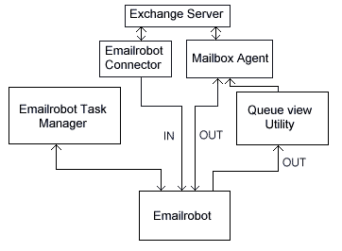
Overview of the components of Emailrobot and their interaction with Microsoft Exchange server
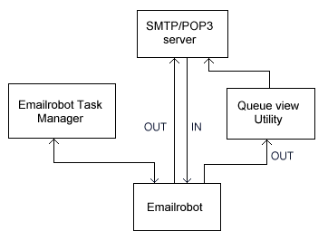
Overview of the components of Emailrobot and their interaction with an SMTP server

The Emailrobot
The Emailrobot is the component that sends, receives, routes and archives all e-mail and processes your scripts. It can run as a service (if you have Windows NT), or as an application in the taskbar (if you have Windows 95). You can view the status of Emailrobot’s script processing, by selecting ‘Emailrobot Status panel’ from the Emailrobot Task manager. Alternatively, you can start up the Emailrobot from the program group or double click the Emailrobot icon in the right hand corner of your screen. Beware though, that in Windows NT, the Emailrobot will already be running as a service in the background.
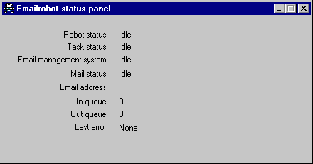
The Emailrobot
The Emailrobot will perform the following tasks:
- Download/scan e-mail
- Run scripts
- Send out e-mail
- Archive e-mail

The Emailrobot Task Manager
With the Emailrobot Task Manager you can create and configure the tasks that Emailrobot should run. These tasks are ‘jobs’ that Emailrobot will perform, and are defined by scripts.
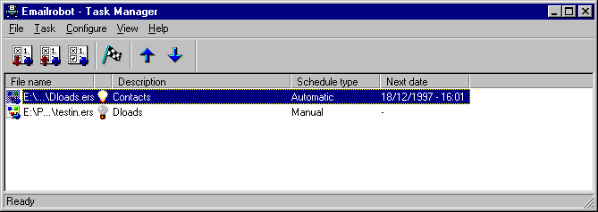
The Emailrobot Task Manager
With the Emailrobot Task Manager you will be able to:
- Configure the Email Management system
- Create scripts using the scripting Wizards or VBscript
- Edit or remove scripts
- Schedule scripts at a certain date or time
- Configure the Email Automation system.
- Specify what Emailrobot should do with e-mail that is not processed.

The Emailrobot Queue View
The Queue View utility allows you to view the outbound message queue. From here you can check whether the message text in the e-mails you wish to send is correct. If you are happy with the e-mail text, subject and recipient information, you can instruct Emailrobot to send out the e-mail.
Of course you can also instruct Emailrobot to send out the e-mail without you having to preview first.
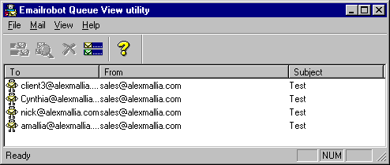
The Queue View utility

The Emailrobot Connector & Mailbox agent
The Emailrobot Connector & Mailbox agent are installed in Exchange server to interact with Exchange server in the most transparent manner. In this way, users (mail agents) will not notice the presence of Emailrobot. These components are not installed in the SMTP version of Emailrobot.

The Email Communications Viewer
The Email Communications Viewer allows you to view, search and track all the e-mails and their replies for a given customer, tracking number or profile. In addition, the Email Communications Viewer gives you vital statistics on the response rate of your mail agents.

Chapter 2 Installation

Introduction
Emailrobot is available in two versions – Emailrobot for Exchange and Emailrobot for SMTP.
Emailrobot for Exchange is specially designed for users who have Microsoft Exchange Server. Emailrobot for Exchange includes an Exchange Connector.
Emailrobot for SMTP is specifically designed for users who have an SMTP/POP3 server such as Software.com's Postoffice, Netscape Suitespot, Eudora Worldmail, VPOP3, N-Plex, Sendmail etc.
If you are installing Emailrobot for Exchange please follow the instructions in the next paragraph. If you are installing Emailrobot for SMTP, skip the next section and go to ‘Installing Emailrobot for SMTP’.

Installing Emailrobot for Exchange

Preparing for installation
To install Emailrobot for Exchange, you require the following:
 | Windows NT 4 Server
 | Microsoft Exchange Server 4, 5.0 or 5.5
 | An ODBC compatible database ( for example Microsoft Access) installed.
 | Internet Explorer 3.02 or 4.0
Before you install Emailrobot, please also check the following:
- Ensure that your Exchange server is running correctly. If you are not sure, check whether you can send e-mail messages from one client to another.
- Make sure that you are able to send and receive e-mail messages via the Internet.
- You will need to be able to create mailboxes for Email Management and for Email Automation.

Running the installation procedure
Please take note of the following:
Before starting the Emailrobot for Exchange setup, please make sure:
- The Exchange administrator is not running.
- If you are reinstalling Emailrobot, be sure that you have uninstalled the previous version first.
- Make sure you are logged on as an Administrator in Windows NT server and Exchange server.
Step 1: Insert the Emailrobot CD-ROM in your CD-ROM drive, and run 'setup.exe' from Windows Explorer. If you have downloaded Emailrobot, double-click on ‘erobotex.exe’.
Step 2: Set-up will now request you to close any open programs. When you have done so, click ‘Next’ to continue.
Step 3: Set-up will ask you to confirm the license agreement.
Step 4: Set-up will now prompt you for your company name, e-mail address and serial number. The serial number is indicated on the CD-ROM envelope. If you are evaluating the product, do not enter a serial number. You will be able to use Emailrobot as a free LITE version.
Step 5: Set-up will now ask you where you want Emailrobot to be installed. Emailrobot will need approximately 10 MB of free hard disk space. In addition to this you must reserve approximately 10 MB for temporary files. Click ‘Next’ to continue.
Step 6: Set-up will now query the name of the server computer. Please confirm it.
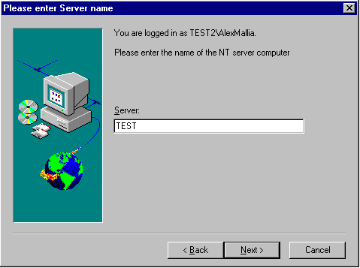
Setup prompts for machine name
Step 7: The set-up program will now query the organization and site name. In most situations, Emailrobot will return the correct Organization name and Site name, but sometimes the automatic querying will not succeed or return erroneous information.
Therefore please check that the format is as follows:
/o=ORGANIZATION/ou=SITE
Where Organization is the name, shown at the top of the Exchange administrator. For example, in the screen grab below, this is GFI FAX & VOICE. If your Organization name contains spaces or other special characters, you must enclose the site name in quotes, as follows; “GFI FAX & VOICE”.
The Site name is displayed in the Exchange administrator with a “World” icon next to it.

Exchange Organization name
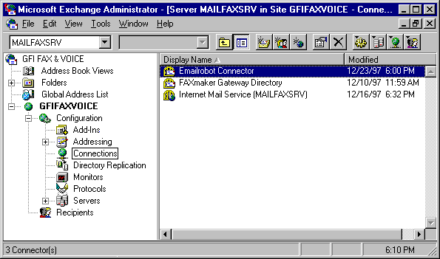
Exchange administrator with organization “GFI FAX & VOICE’ and site “GFIFAX”
Step 8: Set-up will now prompt you for an administrator account to run the Emailrobot services. You should enter the name and password of the administrator account with administrator rights.
If you change your password after installing Emailrobot, you must update the password for the Emailrobot Connector and Emailrobot service from the control panel as well. Otherwise the services will no longer start.
Step 9: Set-up will now finish the installation by creating an Emailrobot program group.

Installing Emailrobot for SMTP

Preparing for installation
To install Emailrobot, you require the following:

 | Windows NT 4 (workstation or server) or Windows 95
 | SMTP/POP3 server
 | Microsoft Access 97 or an ODBC compatible database installed.
 | Internet Explorer 3.02 or 4.0
Before you install Emailrobot, please also check the following:
- Ensure that your mail server is running correctly. If you are not sure, check whether you can send e-mail messages from one client to another.
- Make sure that you are able to send and receive e-mail messages via the Internet.
- Make note of your mail server name (in many cases your mail server name is the name of the computer running the mail server). The mail server name is the name you specify in the field ‘SMTP server name’ in, for example, the Eudora or Outlook client.

Running the installation procedure
Step 1: Insert the Emailrobot CD-ROM in your CD-ROM drive, and run 'setup.exe' from Windows Explorer. If you have downloaded Emailrobot, double-click on ‘erobot.exe’.
Step 2: Set-up will now request you to close any open programs. When you have done so, click ‘Next’ to continue.
Step 3: Set-up will ask you to confirm the license agreement.
Step 4: Set-up will now prompt you for your company name, e-mail address and serial number. The serial number is indicated on the CD-ROM envelope. If you are evaluating the product, do not enter a serial number. You will be able to use Emailrobot as a free LITE version.
Step 5: Set-up will now ask you where you want Emailrobot to be installed. Emailrobot will need approximately 10 MB of free hard disk space. In addition to this you must reserve approximately 10 MB for temporary files. Click ‘Next’ to continue.
Step 6: Set-up will ask you to enter your SMTP/POP3 server name located on your LAN. Here you must enter the mail server name which is on your LAN – not the mail server name of your ISP!
Step 7: Set-up will ask you whether your mail server supports APOP. Most mail servers do. If you are not sure, select ‘No’.
Step 8: If you have Windows 95, set-up will ask you whether you want Emailrobot to run automatically.
Step 9: The set-up program will now copy all program files to the selected destination, and finish the installation by creating an Emailrobot program group. You will now be asked whether you want to view the Getting Started file. Click ‘Finish’ to complete setup.

Chapter 3 Email Management

Introduction

With Emailrobot’s Email Management, you will be able to:
- Distribute incoming e-mail among different persons
- Send personalized auto replies
- Archive all incoming and outgoing e-mail
- Assign tracking numbers to e-mails
- Produce reports on corporate e-mail communication
- Produce communications histories per customer, tracking number or mail agent
In order to use Email Management, you must:
1. Configure your ODBC database
2. Configure the Email Management System
3. Install the Email Communications Viewer on client machines (optional)

Configuring ODBC
Emailrobot uses ODBC to allow you to use different kinds of databases, giving you maximum flexibility. To be able to use Email Management, you will have to setup the Access database, emanage.mdb, provided with Emailrobot in the Program Files\ERobot\database directory.
To do this:
Step 1: Go to the Control Panel (from the task bar or from the ‘My Computer’ icon)
Step 2: Double-click on the ODBC icon. This starts up ODBC Data Source Administrator dialog. ODBC requires that any database you wish to use is added as either a user DSN (if you want it to be available to you only) or a system DSN (If you want it to be available to all users on this machine). Depending on your preference, you must now select the User DSN Tab or the System DSN.
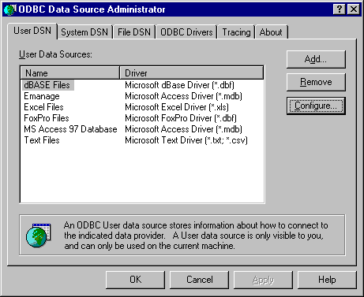
The ODBC Data Source Administrator
Step 3: Select 'Add'. This fires up the 'Create New Data Source' dialog. A data source is essentially a database.
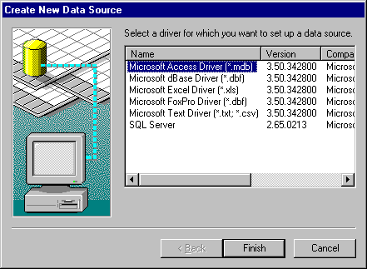
Create a new Data Source
Step 4: Select 'Microsoft Access Driver' (This requires that you have Microsoft Access installed). This will start up the dialog ODBC Microsoft Access 97 Setup dialog. Click 'Finish'.
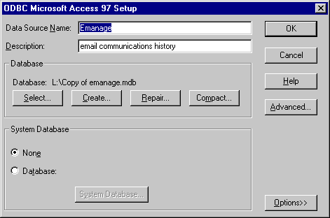
Database name, description and selection
Step 5: Give the database a name and description, then click 'Select' and select emanage.mdb file from the Program Files\ERobot\database directory. Click ‘OK’, and exit the ODBC Data Source Administrator.
Your data source is now setup! In step 3 of the next paragraph you will have to select this database source in the Configure Email Management dialog.

Configuring Email Management for Emailrobot for Exchange
For each corporate e-mail address that you wish Emailrobot to manage, you must now create a ‘Profile’: This Profile will contain a number of e-mail management options that you can set for each e-mail address.
Step 1: Before creating a Profile, you must create a mailbox for the corporate e-mail address you wish to manage, for instance sales@yourcompany.com.
Step 2: Start-up the Emailrobot Task Manager from the program group. From the ‘Configure’ menu, select ‘Email Management’.
Step 3: Enter the name of the profile in the profile name box (in our example ‘Sales’), and click on ‘Add’.
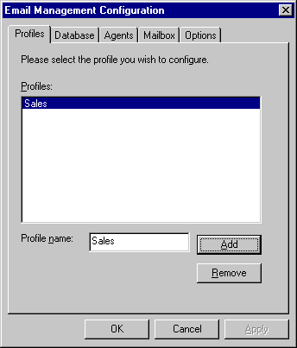
The Email management setup dialog
Step 4: You may now configure the management options for this corporate e-mail address in the other Tabs. The following Tabs are available:
Database - In this tab you must specify where you want Emailrobot to store all incoming e-mail:
Database source: You can store it in any database as long as you have configured it as an ODBC source first ( how to do this, see above). If you are not comfortable creating databases, we recommend using the included Access database emanage.mdb. If you do wish to use a different database, you will need to create a specified set of fields in the database. Please check the website for latest details on the format of the database.
Table: For each profile you must select a separate table to store the e-mails.
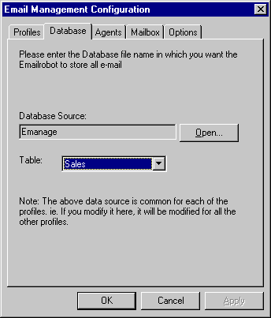
The Email management database tab
Agents - In this tab you must indicate which Exchange users will be answering this mail (i.e. they will be mail agents for this profile/corporate e-mail address). To make an Exchange user a mail agent for a particular profile, simply activate the relevant 'tickbox'.
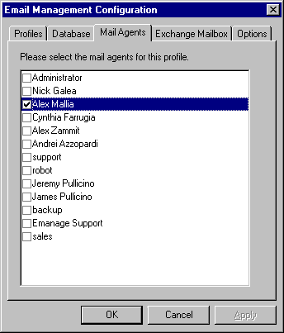
The mail agents tab
Exchange Mailbox – In this tab you must enter name of the Exchange mailbox in which you receive your corporate e-mail (our example: sales@yourcompany.com).
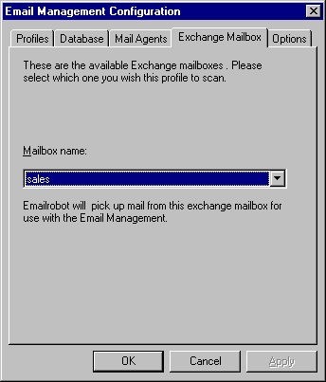
The Email management mailbox tab
Options – In this Tab you can set a number of different options:
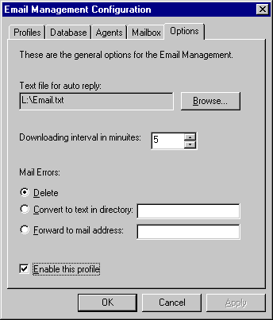
The Email management options tab
Text file for auto reply : Upon receiving an e-mail, Emailrobot can send a personalized custom reply. To personalize the auto reply, you can insert fields in your e-mail message, for example: [*Email.from*]. Emailrobot will then automatically replace the [*Email from*] field with the Email Alias.
For example:
Dear [*Email.from*],
Thank you for your interest in our products! Please rest assured that we are dealing with your request and that we will get back to you shortly.
Kind regards,
Undeliverable mail: This option allows you to specify what to do with e-mail that is returned. You can either delete the e-mail, save it in a text file, or forward the email to the postmaster/administrator.
Enable this profile: This option switches the Email Management system for this profile on or off. In this way you can periodically de-activate management of certain e-mail addresses.

Starting the services
Important: After configuring the mailboxes, you must ensure that the Emailrobot services are started. To do this, go to the Services applet in the Control panel and start the following services:
Emailrobot
Emailrobot Exchange connector
Emailrobot Mailbox Agent

Configuring Email Management for Emailrobot for SMTP
For each corporate e-mail address that you wish Emailrobot to manage, you must now create a ‘Profile’: This Profile will contain a number of e-mail management options that you can set for each e-mail address.
Step 1: Create two mailboxes for each e-mail address that you wish Emailrobot to manage, for example sales@yourcompany.com and sales-out@yourcompany.com. The first mailbox will be used by Emailrobot to pick up inbound corporate e-mail, and the second mailbox will be used by Emailrobot to pick up the replies of the Mail agents and send them out on the Internet. All replies from the Mail agents will automatically be forwarded to this Outgoing mailbox before being sent out to the actual recipient. Emailrobot will then store the reply messages and update the tracking numbers. This process is completely transparent to the user/mail agent.
Step 2: Start-up the Emailrobot Task Manager from the program group. From the ‘Configure’ menu, select ‘Email Management’.
Step 3: Enter the corporate e-mail address in the box (as it will be found in the To: field of the incoming e-mail, for example support), and click on ‘Add’.
The Email management setup dialog
Step 4: You may now configure the management options for this corporate e-mail address in the other Tabs. The following Tabs are available:
Database - In this tab you must specify where you want Emailrobot to store all incoming e-mail.
Database source: You can store it in any database as long as you have configured it as an ODBC source first ( how to do this, see above). We recommend using the included Access database emanage.mdb, if you are not comfortable creating databases. If you do wish to use a different database, you will need to create a specified set of fields in the database. Please check the website for latest details on the format of the database.
Table: For each profile you must select a separate table to store the e-mails.
The Email Management database tab
Agents - In this tab you must list the names and the e-mail addresses of the persons who will be dealing with the e-mail directed to this address. Type in the name and e-mail address and click on ‘Add’ for each person.
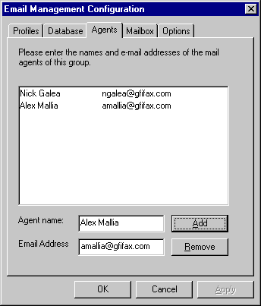
The Email management agents tab
Mailbox – In this tab you must enter the POP3 mailbox(es) which Emailrobot should use.
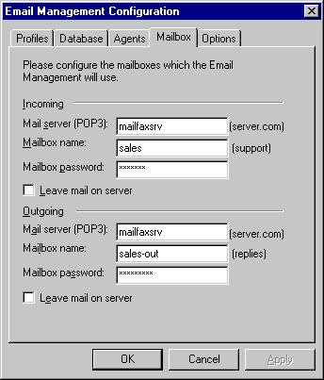
The Email management mailbox tab
Incoming: Here you must fill in the mailbox in which you receive the corporate e-mail. Emailrobot will pick up the e-mail from here every minute. In our example this is sales@company.com.
Outgoing: This mailbox will be used by Emailrobot to pick up the replies of the Mail agents and send them out on the Internet. In our example this mailbox is sales-out@company.com.
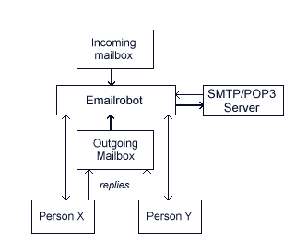
How the Email management system works
Options – In this Tab you can set a number of different options:
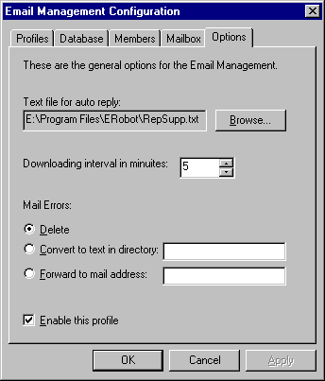
The Email Management options tab
Text file for auto reply: Upon receiving an e-mail, Emailrobot can send a personalized custom reply. To personalize the auto reply, you can insert fields in your e-mail message, for example: [*Email.from*]. Emailrobot will then automatically replace the [*Email from*] field with the Email Alias.
For example:
Dear [*Email.from*],
Thank you for your interest in our products! Please rest assured that we are dealing with your request and that we will get back to you shortly.
Kind regards,
Undeliverable mail: This option allows you to specify what to do with e-mail that is returned. You can either delete the e-mail, save them to a text file, or forward the email to a mail address.
Enable this profile: This option switches the e-mail management system for this profile on or off. In this way you can periodically de-activate management of certain e-mail addresses.

Starting the services
Important: After configuring the mailboxes, you must ensure that the Emailrobot services are started. To do this, go to the Services applet in the Control panel and start the following service:
Emailrobot

Email reporting & Email communications history
The Email Communications Viewer allows you to view all e-mail communications taking place between your organization and its correspondents. Using it, you can search for e-mail based on recipient, sender, tracking number and date. You can also view a message thread, i.e. see the incoming messages and answers for a particular tracking number.
In addition the Email Communications Viewer provides you with essential information, such as amount of received e-mail, average response time, and percentage of unanswered or outstanding mail. The reports will also allow you to compare the performance of different departments or employees and plot them against time.
With this information you will be able to determine:
- whether the amount of sales or support e-mail is satisfactory
- how much time is actually being spent on answering e-mail and how quickly it is done
- whether and when you need to expand or decrease staffing
- how effective your employees answer their e-mail
- whether your customer service is up to scratch
Besides monitoring your company’s response time, you can also monitor your customer’s e-mails. For example, you can measure which customers send how many e-mails, which could provide useful information for billing purposes.

Using the Email Communications viewer
To start up the Email Communications Viewer, select ‘Email Communications Viewer’ from the Emailrobot program group.
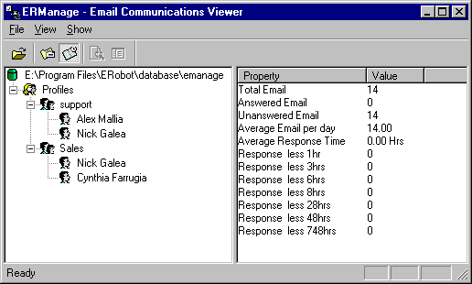
The Email Communications Viewer

Searching for e-mail
To search for a particular e-mail:
Step 1 : Select the profile in which you want to search for e-mail, for example support. Do this by right-clicking the profile name.
Step 2: Select 'Search Emails' from the search menu.
Step 3: Fill in the conditions to search for. You can search on: From (sender), Subject, Agent, Date and Time and Tracking number. Select ‘OK’ to start the search.
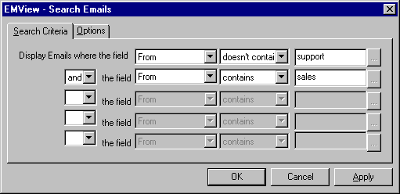
The search conditions of the Email Communications Viewer
The Email Communications Viewer will display all e-mails that match your conditions.

Displaying the e-mail.
To display the e-mail, simply double-click on the e-mail or press return.

View Thread
One of the most powerful features of the Email Communications Viewer is the ability to view a message thread, i.e. all the incoming and outgoing mail relating to a particular support issue/tracking number. To do this, highlight the e-mail and select ‘Thread’ from the ‘Show‘ drop down menu.

Reports
The Email Communications Viewer also allows you to view reports. The following data is available:
Total e-mail: displays the total amount of e-mail received.
Answered e-mail: displays the total amount of e-mail answered
Unanswered e-mail: displays the total amount of unanswered e-mail
Average e-mail per day: displays the average amount of e-mails received per day
Average response time: displays the average response time.
Remember that this does not take into account the fact that some e-mails do not require an answer, and that some e-mails come in at night or during the weekend. Because these e-mails 'skew' the response rate negatively, we have also created other statistics which might paint a more accurate picture, by showing how many e-mails are answered within a certain amount of time.
Responded to e-mail in less than 1 hour: displays the e-mail that is answered within 1 hour.
Responded to e-mail in less than 3 hours: displays the e-mail that is answered within 3 hours.
Responded to e-mail in 6-8 hours: These would generally be the e-mails which were received during the night/evening.
Responded to e-mail in24-48 hours: These e-mails can be e-mails which require no answer or were sent during the weekend. They have been put in this category so as not to distort the totals.
The above data is available per profile and per agent. This way you can monitor the performance of a department and a particular agent.

Installing the Email Communications Viewer on client machines
The Email Communications Viewer can easily be set-up on other machines on the network so that other users can access it as well. To install the E-mail Communications Viewer on a different machine, follow the next steps:
Step 1: Copy the ‘Emview.exe’ file to the client machine. The file can be found in: Program Files\ERobot\database.
Step 2: Set up the e-mail database (e.g. emanage.mdb) as an ODBC data source on the client machine ( see 'Configuring ODBC at the beginning of this chapter). To be able to do this, your e-mail database must be located in a shared folder.
Step 3: Start up ‘Emview.exe’. The first time it will ask you to identify the ODBC data source name. Select the data source name of the e-mail database and click ‘OK’. The next time the data source will be automatically loaded.

Chapter 4 Email Automation

Introduction
With Email Automation you can now further automate your company’s e-mail-related tasks, such as:
- Automatically processing results of Web forms into a database
- Sending out personalized mailings by querying a database
- Automate any other e-mail related process
To use Email Automation you must:
1. Configure your ODBC database
2. Configure the Emailrobot automation
3. Create Inbound and/or Outbound scripts with the Wizards (this Chapter) or VBscript (Chapter 5)

Configuring ODBC
Emailrobot uses ODBC to allow you to use different kinds of databases, allowing you maximum flexibility. For example, to send out a personalized e-mailing, you can retrieve your recipient data from any database that supports ODBC.
However, ODBC requires that any database you wish to use is added as either a user DSN (if you want it to be available to you only) or a system DSN (If you want it to be available to all users on this machine). This can be done from Control Panel on your machine. For instructions on how to do this, please refer to the Chapter on Email Management.

Set up of Email Automation

Configuring Automation for Emailrobot for Exchange
Step 1: Create a mailbox in which Emailrobot should receive all e-mail, for example robot@yourcompany.com (This mailbox must be dedicated to Emailrobot, i.e. you must not use it to receive your personal or other e-mail in, because Emailrobot will process all e-mail which is received in that mailbox.)
All e-mail that you wish to be processed must be forwarded to this mailbox. For example, if you have a Web form which sends mail to register@yourcompany.com and you have a Web form which sends mail to order@yourcompany.com, you should forward both these mails to the Emailrobot mailbox by using aliases on your Web or mail server.
Step 2: Start up the ‘Emailrobot Task Manager’ from the Emailrobot program group.
Step 3: Select ‘Configure’ and ’Email Automation’ from the Emailrobot Task Manager menu. This will fire up the ’Email Automation' dialog, which allows you to specify from where Emailrobot should download mail to process.
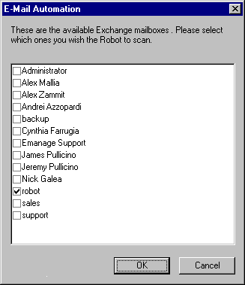
The Mail Retrieval for Email Automation dialog
Step 4: Now you must add the mailbox that Emailrobot should scan. Simply click on the checkbox next to the available mailboxes.
Note: If you create a mailbox in Exchange administrator, whilst the Emailrobot Task Manager is active, you must exit and restart the Emailrobot Task Manager for those mailboxes to become visible in this dialog.
Step 5: After you have specified the mailbox from which Emailrobot should download e-mail, click ‘OK ‘ to finish.

Configuring Automation for Emailrobot for SMTP
Step 1: Create a mailbox in which Emailrobot should receive all e-mail, for example robot@yourcompany.com (This mailbox must be dedicated to Emailrobot, i.e. you must not use it to receive your personal or other e-mail in, because Emailrobot will process all e-mail which is received in that mailbox.)
All e-mail that you wish to be processed must be forwarded to this mailbox. For example, if you have a Web form which sends mail to register@yourcompany.com and you have a Web form which sends mail to order@yourcompany.com, you should forward both these mails to the Emailrobot mailbox by using aliases on your Web or mail server.
Step 2: Start up the ‘Emailrobot Task Manager’ from the Emailrobot program group.
Step 3: Select ‘Configure’ and ’Email Automation’ from the Emailrobot Task Manager menu. This will fire up the ’Email Automation’ dialog, which allows you to specify from where Emailrobot should download mail to process.
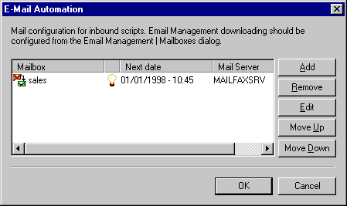
The Mail Retrieval Configuration dialog
Step 4: Now you must add the mailbox that Emailrobot should scan, by clicking on ‘Add’. This will start up the Mailbox properties dialog, where you must specify your mail server name, mailbox name, mailbox password and download interval.
General options: You can also specify whether Emailrobot should delete the e-mail after retrieving it, and you can also temporarily switch off downloading of e-mail.
Time scheduling: This allows you to specify when Emailrobot should scan the POP3 mailbox to retrieve e-mail.
Step 5: After you have specified the mailbox from which Emailrobot should download e-mail, click ‘OK ‘ to finish.

The Inbound Script Wizard
With the Inbound Script Wizard you will be able to:
- Archive e-mail
- Send auto replies
- Route e-mail
- Process Web forms into a database
The Inbound Wizard includes the following dialogs that you can configure:
Dialog 1. Email fields
Each e-mail contains a To, From, Subject, CC and Body Text field. You can specify which fields you wish Emailrobot to use. You can also add your own custom fields. For example, if you have a website with an enquiry form that allows the customer to specify a country or a telephone number, you can add the fields in the first dialog and use it for analysis later on in the script.
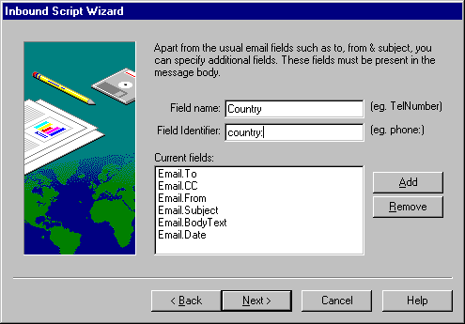
The Inbound Script Wizard – Email fields
To do this, you must have created a Web form that specifies the phone number and country name in the script, and precedes it with a ‘Field Identifier’, such as ‘phone:’ or ‘country:’ Using this Field Identifier, Emailrobot will find the number and country name, and will be able to use it as a field.
For more information on creating Web forms see the Appendix ‘Setting up a Web form on your server’.
Dialog 2. Conditions
Here you must specify which e-mails you wish Emailrobot to process.
For example, if you want to process e- mail sent to register@yourcompany.com, you must select ‘If’, ‘Email To:’, ‘is equal to’ and enter ‘register@yourcompany.com’.
You can add more conditions – each additional condition must be either AND (in this case the condition must be met also) or OR (Either of the conditions must be met).
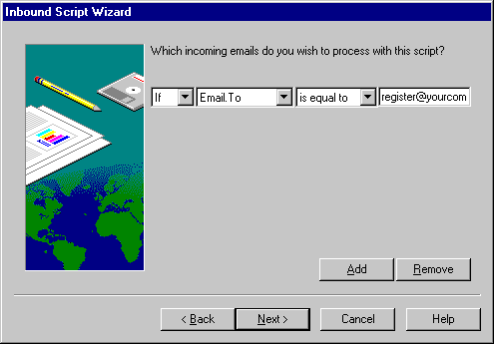
The Inbound Script Wizard - Conditions
Dialog 3. Archive e-mail
This dialog allows you to archive the e-mail into an ODBC data source. In the ‘Database Source’ you need to specify the database source, and in ‘Table’ the table in Access. If you do not wish to archive e-mail, uncheck the box and click ‘Next’. You will then go on to Dialog 5.
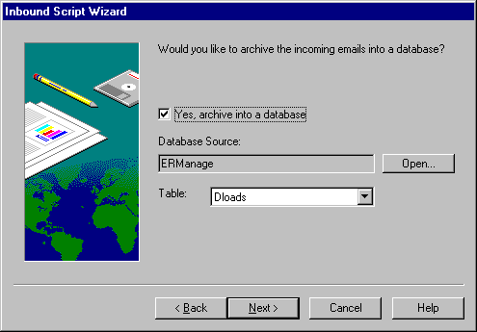
The Inbound Script Wizard – Archiving e-mail
Dialog 4. Specify fields
If you have specified to archive e-mail into a database, you will need to indicate which e-mail fields must be stored in which database fields. To do this, check the e-mail field and then select the appropriate field. Repeat this for all fields you wish to archive.
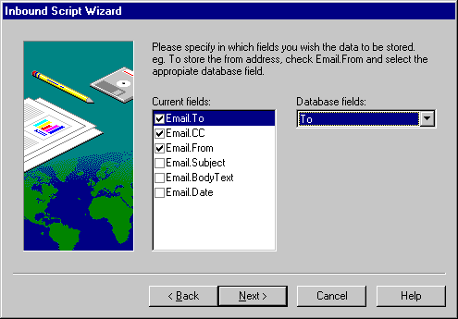
The Inbound Script Wizard – specifying the fields
Dialog 5. Send auto reply
You can choose whether to send the sender of the e-mail and automated reply. This automated reply can be personalized, simply by inserting a field name, for example the To: field in the reply of the message. For example, you could use the following auto reply message:
Dear [*Email.From*],
Thank you for your query regarding [*Product*]. Your request has been assigned a tracking no. and will be dealt with in the speediest manner possible.
If you do not want to send an auto reply, uncheck the box and click ‘Next’. You will then go to Dialog 7.
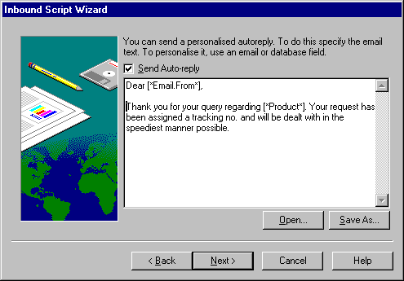
The Inbound Script Wizard – Send an auto reply
Dialog 6. Auto reply options
If you have specified to send an auto reply, you must type in the e-mail subject, which will appear in the subject line of the message, and the reply to address.
You can also delay sending the auto reply, by using the option 'Send after <number> hours'. In addition you can attach a file to the auto reply.
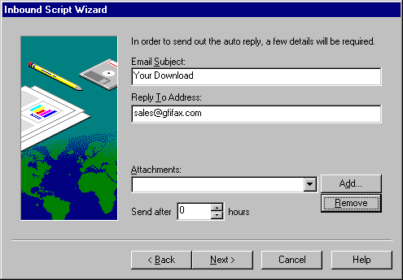
The Inbound Script Wizard – Auto reply options
Dialog 7. Route the e-mail
If after processing the e-mail, you want the mail to be forwarded to a particular mailbox or person, enter the e-mail address where the mail has to be redirected to. If you do not want to forward the mail, uncheck the box and click ‘Next’.
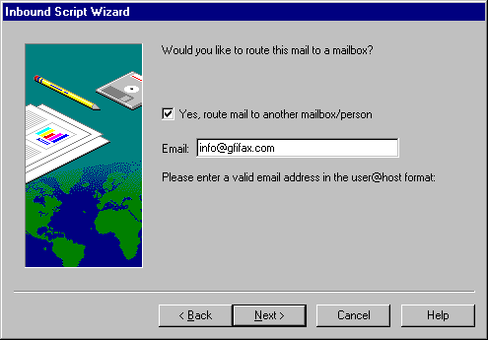
The Inbound Script Wizard – Routing e-mail
Dialog 8. Description
Here you must give the script a description and enter the file name in order to save the script in the Prgram Files\ERobot\scripts\files directory. You can also specify whether Emailrobot should ‘Add comments in the script file’ (this is only useful if you plan to edit the scripts at a later stage), or ‘Hold mail in queue for previewing’. This last option will allow you to preview e-mail before it is sent out. You can preview the e-mail in the ‘Emailrobot Queue view utility’. Remember that no e-mail will be sent out before you preview it and send it out!
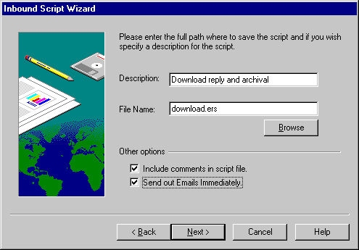
The Inbound Script Wizard – Specifying a script name
After creating the script, you will be able to view your settings an change them if necessary. After you click ‘Finish’, the ‘Task Properties’ dialog will automatically pop up. Here you can specify when the Emailrobot should run your script (=Task). You can specify to run it manually (from the menu ‘Task’, ‘Run now’), each time e-mail is downloaded, or at scheduled intervals.
After configuring this option, click ‘OK’. Your task will now be listed in the main window of the Emailrobot Task Manager.
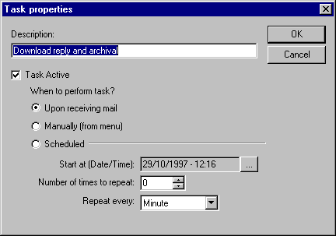
The Task properties dialog
If you later wish to edit the script, you can do so by selecting it in the ‘Emailrobot Task Manager’ and choosing ‘Edit script’ from the ‘Task’ menu. If you wish to remove it, choose ‘Remove script’.

The Outbound Script Wizard
The Outbound Script Wizard allows you to create scripts that create outgoing e-mail. With the Outbound Script Wizard you can:
- send follow up e-mail
- send payment reminders
- send regular newsletters or customer information
- send personalized mailings
The Outbound Script Wizard includes the following dialogs that you can configure:
Dialog 1. Specify database
Specify the database from which Emailrobot must retrieve the recipient details.
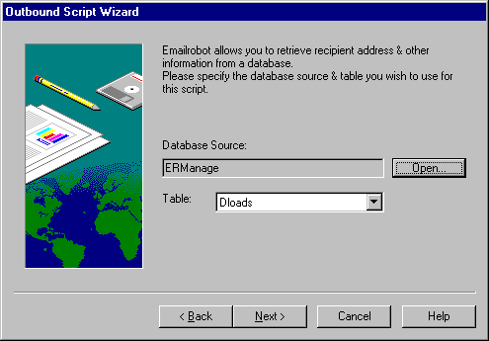
The Outbound Script Wizard –Specify Database
Dialog 2. Specify fields
Emailrobot will list all retrieved database fields under ‘Available fields’. You must now indicate which fields you will be using in your Outbound Script. In many cases you will be using fields such as: Email address, Name, Company, Product interest, Date last contacted, etc. To select fields, click on an available field and click on ‘→’. If you want to deselect a field, click on it and click ‘←’.
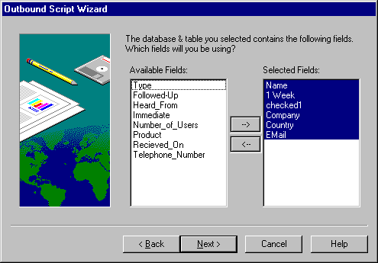
The Outbound Script Wizard – Specify fields to use
Dialog 3. Conditions
This dialog allows you to set conditions according to which Emailrobot will determine whether to send out an e-mail or not. (i.e. Emailrobot will query the database with these conditions)
For example, if you have a database with prospects, and you wish to send your Swedish resellers a special offer in Swedish, you will need to set the ‘Country’ equal to ‘Sweden’, and the ‘Customer Type’ equal to ‘Reseller’. If your offer is only meant for Swedish resellers interested in a particular product, you would have to set an additional condition for the product interest field.
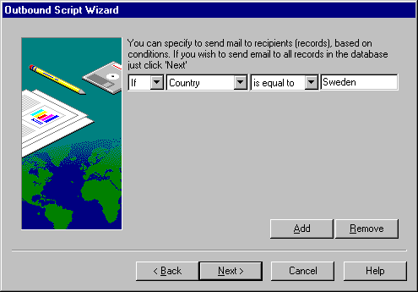
The Outbound Script Wizard - conditions
Dialog 4. Update database field (Flag).
This function is handy if you want to keep track of which customers you have already sent a follow up e-mail. To do this, you must add a separate field in your database, called a flag. For instance you could call this field ‘Mail Sent’. If Emailrobot comes across this flag when processing your mail, it will automatically update it to the name you entered in the dialog. For instance if you enter ‘TRUE’, Emailrobot will set the flag field to ‘TRUE’ for each customer who received an e-mail. You could thus eliminate a re-send of the follow-up mail next time you run the script.
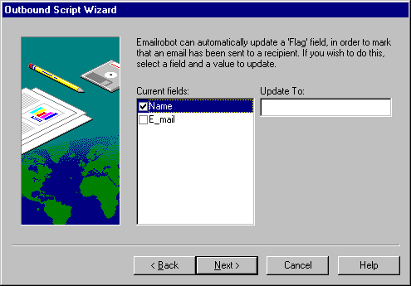
The Outbound Script Wizard – Update database field
Dialog 5. Specify e-mail text
This dialog allows you to specify what e-mail text you wish to send. You can personalize an e-mail by using fields in the text.
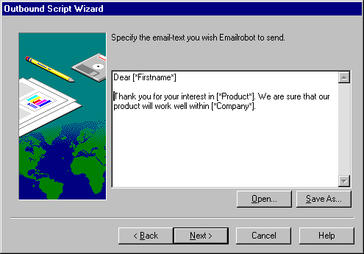
The Outbound Script Wizard – Email text to send
For example, you could write:
Dear [*Firstname*]
Thank you for your interest in [*Product*]. We are sure that our product will work well within [*Company*].
Note, that for this example to work, you would need to have the fields [Firstname], [Company] and [Product] in your database.
Dialog 6. Email options
This dialog allows you to specify the Subject line, and Reply To address. You must also indicate the database field where the e-mail addresses of the recipients are stored, e.g. ‘Email Address’.
You can also delay sending the e-mail, by using the option ‘Send after <number> hours’. In addition you can attach a file to the e-mail.
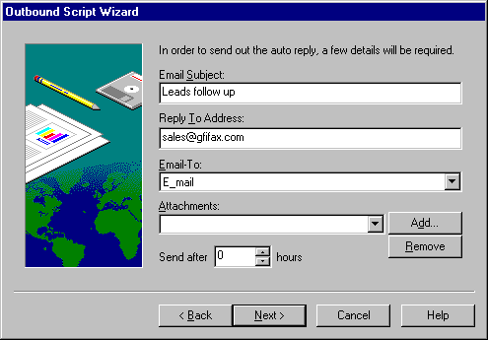
The Outbound Script Wizard – Email send options
Dialog 7. Description
Here you must give the script a description and enter the file name in order to save the script in the Program Files\ERobot\scripts\files directory. You can also specify whether Emailrobot should ‘Add comments in the script file’ (this is only useful if you plan to edit the scripts at a later stage), or ‘Hold mail in queue for previewing’. This last option will allow you to preview the email before it is sent out. You can preview the e-mail in the ‘Emailrobot Queue view utility’. Remember that no e-mail will be sent out before you preview it and send it out!

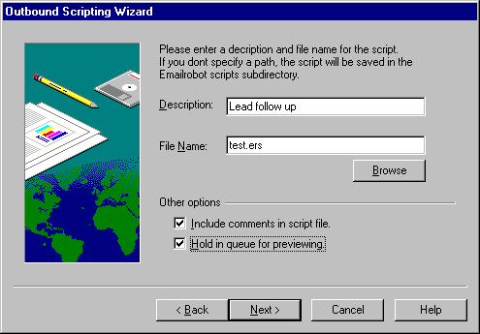
The Outbound Script Wizard – Script file name & options
After creating the script, you will be able to view your settings an change them if necessary. After you click ‘Finish’, the ‘Task Properties’ dialog will automatically pop up. Here you can specify when the Emailrobot should run your script (=Task). You can specify to run it manually (from the menu ‘Task’, ‘Run now’), each time e-mail is downloaded, or at scheduled intervals. After configuring when you wish Emailrobot to run the script, click ‘OK’. Your task will now be listed in the main window of the Emailrobot Task manager.
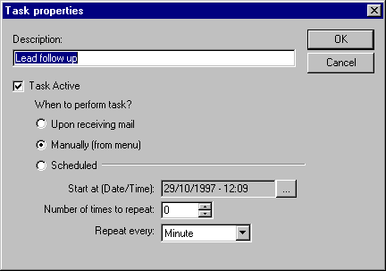
The Task properties Dialog
If you later wish to edit the script, you can do so by selecting it in the ‘Emailrobot Task Manager’ and choosing ‘Edit Script’ from the ‘Task’ menu. If you wish to remove it, choose ‘Remove Script’.

Examples
To illustrate the use of the Wizard, we will walk you through the creation of a few popular e-mail-processing applications.

Example 1: Sending out a personalized e-mailing
Before you start the Outbound Script Wizard, you will have to prepare:
- A database with recipient contact details. Since Emailrobot supports ODBC, which can connect to almost any database, it can be your current contact database. If you don’t have a contact database you will have to create one.
- A text for the e-mail. The text can include database fields in the following format:[*FIELD*]. For example, to address an e-mail personally, you would write:
Dear [*Name*],
We are just sending you this e-mail to let you know that we are running a special offer on [*Product*]. We are sure that [*Company*] would like to take advantage of this!
Step1: Start up the ‘Outbound Script Wizard’ by selecting ‘Add Inbound Script’ from the ‘Task’ menu in the ‘Emailrobot Task Manager’. Click 'Next' to continue on to the first page of the Wizard.
Step 2: Specify the database name and table, which contains the list of contacts/customers that you wish to send the e-mailing to. Click ‘Next’. Remember that your database must be set-up as an ODBC data source.
Step 3: Of the available fields, specify the fields you will be using. This includes the field which contains the e-mail addresses, but also any fields that you want to use in the text. For example, if you want to send the above text, you have to select the fields ‘Name’, ‘Product’ and ‘Company’.
Step 4: Now you must specify which contacts from the database should receive e-mail. To do this you can set conditions which have to be met. For example, if you want to send a mail to all prospects with interest in the product ‘FAXmaker’, you must have a field product interest, and set the condition:
“If - Product interest - is equal to – FAXmaker.”
Step 5: If you wish to keep track of whom you sent an e-mail mailing, you will have to specify a flag field in your database, which the Emailrobot can update to, for example ‘TRUE’, or ‘YES’.
Step 6: Enter the e-mail text you wish to send.
Step 7: Specify E-mail subject, Reply to address. In addition you must select which database field contains the e-mail address. You can also add an attachment and delay sending the message.
Step 8: Here you must give the script a name and enter the file name to save the script in the Program Files\ERobot\scripts\files directory. If you wish to preview the e-mails before sending them out, check ’Hold for previewing’.
After creating the script, the Outbound Script Wizard will automatically start up the Task properties dialog. The Task properties dialog allows you to specify when the Emailrobot should run your script (=Task). You can specify to run it manually (from the menu ‘Task’, ‘Run Now’), each time e-mail is downloaded, or at scheduled intervals. After configuring, when you wish Emailrobot to run the script, click OK. Your task will now be listed in the main window of the Emailrobot Task Manager.
Step 9: To run the Task now, select the Task in the Emailrobot Task manager, and select ‘Run Now’ from the Task menu.
Your e-mail will be prepared. If you have specified ‘on hold for previewing’, you will have to start up the Queue View utility, check whether the e-mail is correctly addressed and created, and if so, select Send!

Example 2: Archiving incoming mail
Emailrobot can archive all incoming e-mail. To do this, you must select the mailbox(es) in which you will receive your e-mail. This can be done in ‘Email Automation’ in the Emailrobot Task Manager.
Step1: Activate the ‘Emailrobot Task Manager’ from the Emailrobot program group.
Step 2: Select ‘Configure’, and ‘Email Automation’ from the Emailrobot Task Manager menu. This will start up the Email Automation dialog, which allows you to specify from where Emailrobot should download the mail to process.
SMTP version only:
If you have Emailrobot for SMTP, you must now add the mailbox that Emailrobot should scan. Click ‘Add’ and specify mail server name, mailbox name, mailbox password and download interval.
After you have specified the mailbox(es) that Emailrobot should scan, click ‘OK’.
Step 3: Select ‘Task’, and ‘Add Inbound Script’ from the menu. The Inbound Script Wizard will start up. Click 'Next' to continue on to the first page of the Wizard.
Step 4: Since you just want to archive the e-mail (i.e. not process particular fields in the message body into a database), you do not need to add any custom fields. Click ‘Next’
Step 5: If you wish to archive all incoming e-mail, you do not need to set any conditions. Select ‘Next’.
Step 6: Select the database you wish the data to be imported to. If you do not have a database and do not wish to create one, you can use the sample databases included with Emailrobot in the database subdirectory. Remember to set-up your database and an ODBC data source.
Step 7: Specify which e-mail fields you wish to import into which database fields. If you are using our sample database, select the ‘E-mail.To’ field from the current fields list box, and then select the ‘To’ field from the database fields list box. Then select the ‘E-mail.CC’ field and select the database field ‘CC’. Do this for all e-mail fields.
Step 8: If you wish to send an auto reply you can specify one here.
Step 9: After Emailrobot has archived the e-mail, it still needs to be forwarded to a member of your organization. You must enter the e-mail address here.
Step 10: Now you must give the script a name and enter the file name to save the script in the Emailrobot\Scripts\file directory.
After creating the script, the Inbound Script Wizard will automatically start up the Task properties dialog. The Task properties dialog allows you to specify when the Emailrobot should run your script (=Task). You can specify to run it manually (From the menu Task, run now), each time e-mail is downloaded, or at scheduled intervals. After configuring, when you wish Emailrobot to run the script, click OK. Your task will now be listed in the main window of the Emailrobot Task manager.

Example 3: Process e-mail generated by a Web form into a database
The use of Web forms to collect information on visitors has become very popular. Although you could set-up your Web server to process the information into a database directly, it is often more practical and certainly more economical to have the information collected sent to you as an e-mail. This is very easy to set-up on your web server, and Emailrobot is able to intercept those e-mails and process them into a database of your choice as they are received. To set-up this system, you will need to do the following:
Step 1: Install a form handling script on your Web server. For more information on this script and how to install it, check the EmailrobotError! Bookmark not defined. website FAQ.
Step 2: Create a form on your website that collects all the information you need from your web-visitor. For each part of information that you collect, you will need to make a separate field name. Make note of this field name. If you are not sure how to create a form, check the appendix of this manual on how to create a Web form using Frontpage Express or Frontpage. A sample form, ‘wwwform.htm’, is included in the Emailrobot\Samples directory.
Step 3: You need to set-up a mailbox or an e-mail address or a unique subject line by which Emailrobot can identify which Web form has generated the e-mail. In many cases you might have multiple Web forms, and for each Web form you probably have different information that needs to be stored in a separate way. If you are using a separate mailbox you will need to add it to the list of mailboxes that are checked periodically.
Step 4: Create a database with all the fields that you have used in the Web form, so that Emailrobot can insert the Web form fields into the database. As an example you can use wwwform.mdb, located in the samples directory.

Creating the script
Step 1: If you are using a separate mailbox, select 'E-mail automation' from the 'Configure' menu. Select the mailbox to which the form output will be e-mailed.
SMTP version only:
If you have Emailrobot for SMTP, you must now add the mailbox that Emailrobot should scan. Click ‘Add’ and specify mail server name, mailbox name, mailbox password and download interval.
After you have specified the mailboxes that Emailrobot should download, click ‘OK’ to proceed to create a task to process the e-mail.
Step 2: Start up the Inbound Script Wizard, by selecting ‘Add Inbound Script’ from the ‘Task’ menu in the ‘Emailrobot Task Manager.
Step 3: Add all the fields that you have used in the Web form. To do this correctly, you must know how your Web form is going to store each e-mail field. For example, the visitor’s name might be stored as name:. In this case, enter ‘name’ as the field name, and as the field identifier, enter 'name:'.
This will cause Emailrobot to look for a string 'name:'. When it finds this string, it will assume that the text after that ‘tag’ is actually the name of the visitor. Repeat this for each field that you have used in your Web form. When you are finished, select ‘Next’.
Step 4: If the mailbox you are using is used for other e-mail also, you will have to specify how Emailrobot will identify a particular e-mail from a Web-form. This can be done by having the Web form send the e-mail to a particular e-mail-address (if you use an alias you would not need to set-up a separate POP3/Exchange mailbox), or by using a unique subject line.
If you used a unique subject line, you must add the condition:
“If - Email.subject – is equal to – Your unique subject”
If you used a separate e-mail address, you must add the condition:
“If - E-mail.to – is equal to – Your unique email address/alias”
Step 5: Select the database you wish the data to be imported to. If you do not have a database and do not wish to create one, you can use the sample database included with Emailrobot in the database subdirectory. Select the database to which you wish to archive the form output. Remember to set it up as an ODBC data source first!
Step 6: Specify which e-mail fields you wish to import into which database fields. If you are using our sample database, select the ‘Email.To’ field, and then select the ‘To’ field from the database fields List box. Then select the ‘E-mail.CC’ field and select the database field ‘CC’. Do this for all e-mail fields.
Step 7: If you wish to send an auto reply you can specify one here.
Step 8: If you wish the Web form e-mail to be forwarded to another mailbox, you must enter the e-mail address here.
Step 9: Give the script a name and enter the file name to save the script in the Prgram Files\ERobot\scripts\files directory.
After creating the script, the Inbound Script Wizard will automatically start up the Task properties dialog. The Task properties dialog allows you to specify when the Emailrobot should run your script (=Task). You can specify to run it manually (From the menu Task, run now), each time e-mail is downloaded, or at scheduled intervals. After configuring, when you wish Emailrobot to run the script, click ‘OK’. Your task will now be listed in the main window of the ‘Emailrobot Task Manager’.

Example 4: Scheduled sales follow up
This script allows you to send out an automated e-mail to your (potential) customers, for instance customers who have inquired about your product. An example is a software company, which provides demos of their product for download. Before the customers can download the product, they have to fill in their contact details in a Web-form. The data of this form is sent to the Emailrobot which processes the data into the database. Exactly one week later, the customer receives a personalized e-mail inquiring how the evaluation is progressing!
To set-up a similar script, you will need to have the customer details in a database including the date when the customer inquired about your product.
Furthermore, you must have prepared an e-mail text, which includes the fields you wish to use in the following format [*FIELD*], where field is the field name you wish to insert in the text. For example, to address an e-mail personally, you would write:
Dear [*Name*],
We noticed that you downloaded [*Product*] from our website and were just wondering how you were getting on with the evaluation.
After you have decided and prepared on the above issues, you are ready to create a personalized follow up!
To do this, start up the Outbound Script Wizard, by selecting ‘Task’ and ‘Add Outbound Script’ in the Emailrobot Task Manager.
Step 1: Specify the database name and table which contains the list of contacts/customers that you wish to follow up.
Step 2: Of the available fields, specify which fields you will be using. This includes not only the field that contains the e-mail addresses, but also any fields that want to use in the e-mail text. For example, if you want to send the above message, you have to select the fields ‘Name’ and ‘Product’.
Step 3: Specify the contacts you wish to send e-mail, by setting the conditions that have to be met. For example, if you want to send an e-mail to all prospects with interest in the product ‘Emailrobot’, you must have a field product interest, and set the condition:
“If - Productinterest - is equal to – Emailrobot”
Step 4: Specify the time after which the e-mail must be sent
Step 5: If you wish to keep track of whom you sent a follow up e-mail, you will have to specify a flag field which the Emailrobot can set to ‘TRUE’, or ‘YES’.
Step 6: Enter the e-mail text. You can type in the message immediately, or specify a text file, which contains the e-mail message.
Step 7: Specify E-mail subject, reply to address. In addition, you must select which database field contains the e-mail address. If you wish to add a signature you can also add it in this dialog.
Step 8: Give the script a name and enter the file name to save the script in the ERobot\scripts\files directory.
After creating the script, the Inbound Script Wizard will automatically start up the Task properties dialog. The Task properties dialog allows you to specify when the Emailrobot should run your script (=Task). You can specify to run it manually (From the menu Task, run now), each time e-mail is downloaded, or at scheduled intervals. After configuring, when you wish Emailrobot to run the script, click ‘OK’. Your task will now be listed in the main window of the Emailrobot Task Manager.

Chapter 5 Creating advanced scripts using VBscript

Introduction
Emailrobot uses the Microsoft Visual Basic Scripting Engine to allow you to customize your Emailrobot scripts. Microsoft VBscript is the ‘World Wide Web edition’ of the popular Visual Basic language.
If you already know Visual Basic or Visual Basic for Applications, VBscript will be very familiar. Even if you are not yet familiar with Visual Basic, you will find VBscript easy to learn. We recommend that you consult a Step by Step book available from Microsoft Press.

VBscript documentation
Because VBscript is a very powerful & evolving scripting environment, we have not included the VBscript documentation in the manual. Rather, we have created an online link to the official Microsoft manual on our website.
To view the online manual of VBscript, go to the following URL:
http://www.emailrobot.com/docs/vbscript.htm
For more information on VBscript, visit the Microsoft website on:
http://www.microsoft.com/scripting

VBscript Emailrobot commands
GFI is continuously adding more commands and improving the documentation for each command. Therefore we have chosen to create an online explanation of the commands This ensures that you will always have the latest information.
For a complete listing of the latest Emailrobot VBscript commands please check the following document on our website:
http://www.emailrobot.com/docs/erfunctions.htm

The app farm on Emailrobot site
Emailrobot includes some example scripts, but you will find the largest collection on the Emailrobot Web site: http://www.emailrobot.com.
GFI have created a special section for Emailrobot scripts, called the Application farm. Here GFI, customers and third party developers can post and download Emailrobot scripts. To go to the Application Farm, go to the following URL:
http://www.emailrobot.com/pages/appfarm.htm

Chapter 6 Troubleshooting

When you are having problems
If you have any questions or encounter any problems, you can consult the ‘Emailrobot FAQ’ in the Emailrobot Program Group, which will automatically connect you to the latest FAQ version on the Emailrobot website at: http://www.emailrobot.com.
If you do not find your answer on the FAQ, please send an e-mail to support@gfifax.com or contact your dealer or distributor, or one of GFI’s offices.

Glossary of Terms

APOP
An authentication method which provides for both origin authentication and replay protection, but which does not involve sending a password in the clear over the network.
Domain Name
A Domain Name identifies an individual Internet computer, and can be a single word or abbreviation that makes up part of a computers unique name, such as “gfifax.com”.
Field
A field is a space in a database management program, which is reserved for a specified piece of information. Data fields might be: “Firstname, Lastname, Company, Address”.
FormMail
FormMail is a generic WWW form to e-mail gateway, which will parse the results of any form and send them by e-mail to the specified user.
Microsoft Access
A database management program for PC’s that features Wizards, automated assistants that help organize and locate data, and Access Basic, a powerful application programming language.
Open Database Connectivity (ODBC)
ODBC is a standard API for accessing information from different data storage formats and programming interfaces. It is an industry standard which nearly all software publishers support.
Post Office Protocol (POP3)
An Internet electronic mail standard that specifies how an Internet connected computer can function as a mail-handling agent.
Script
A script is a series of instructions, similar to a macro, that tells a program how to perform a specific procedure. Scripts can be made by programming, but also by making use of built-in script forms.
Simple Mail Transfer Protocol (SMTP)
An Internet protocol for transferring mail between Internet hosts. SMTP is often used to upload mail directly from the client to an Intermediate host, but can only be used to receive mail by computers constantly connected to the Internet..
Web form
A Web form is a set of document features (e.g. fill-in text areas, drop-down list boxes, check boxes) that enable you to interact with a web page. For example an order form, or a subscription form on the Internet.

Appendix: Setting up a Web form on your server

Explaining Web forms
In order to gather valuable information of your customers and website visitors you can include Web forms on your website. These forms are HTML pages that ask certain information, and then send the results as an e-mail to you.
Web forms can also be configured to store the data in a database directly, but this requires a much greater knowledge of Web site programming, and often adversely effects the performance and reliability of your web server. Therefore, we recommend using Web forms that submit the results as an e-mail to you. With Emailrobot, you will then be able to store this information in a database and you will be able to create some very powerful applications.
To set-up Web forms on your site, you must do two things:
- Set-up a form processing program on your website. GFI recommends using the popular FormMail CGI script. FormMail is a universal WWW form to Email gateway, and is easy to install and use. To obtain a copy of FormMail and for more information please visit the following website: http://www.worldwidemart.com/scripts/readme/formmail.shtml.
- After installing the form processing program, you can start creating Web forms. In the example we will show you how to create a form in Frontpage Express.

Setting up a Form processing program on your web site
Please note that to use FormMail, you will need to have access to the CGI-BIN directory on your web server. If you are not sure about this, ask your Internet Service Provider.

After obtaining Formmail.pl, you might need to change the following variables in the script:
$mailprog = '/usr/lib/sendmail';
This variable must define the location to your server's sendmail program. If this is incorrect, form results will not be mailed to you. However, in most cases you do not need to change this.
@referers = ('worldwidemart.com','206.31.72.203');
This array allows you to define the domains that you will allow forms to reside on and use your FormMail script. If a user tries to put a form on another server, that is not worldwidemart.com, they will receive an error message when someone tries to fill out their form. By placing worldwidemart.com in the @referers array, this also allows www.worldwidemart.com, ftp.worldwidemart.com, any other http address with worldwidemart.com in it and worldwidemart.com's IP address to access this script as well, so that no users will be turned away.

Steps to install FormMail on your web server:
1. To install the formmail.pl script, telnet or FTP to your Web Server, and copy the formmail.pl script (formmail.pl) into your cgi-bin directory:
% cp /usr/local/contrib/formmail.pl ~/www/cgi-bin
2. Make the script ‘accessible’ to visitors by issuing the following command (UNIX web servers only):
% chmod 775 ~/www/cgi-bin/formmail.pl
This is all you need to do. Forms processing capability has now been installed on your server!

Creating a Web form on your website
After you have installed FormMail on your server, you can now design a Web form page. Please find an example below, using ‘Frontpage Express’, which is part of the Internet Explorer 4 software. You can of course use any HTML editing package, including Frontpage, Netfusion and others.
Step 1: Start up Frontpage Express
Select ‘File’, ‘New page’. The New Page dialog appears. Select ‘Form Page Wizard’. When you select ‘OK’, the Form Page Wizard will start.
Step 2: Specify a HTML file name and title.
Step 3: Add the questions you wish to ask your visitor. This can be contact information, or even feedback on your products or website. For more information on the options available in Frontpage Express, please read the Frontpage help file.
Step 4: After you have specified the data in the form field, click ‘Next’ until you arrive at the OUTPUT options dialog.
Select ‘use custom CGI script’
Click ‘Finish’. The Form page will be created and displayed on your screen.
Step 5: Before you continue to finish the web page, you must configure the Form page to interact with FormMail. To do this follow the next steps:
1. Position the mouse cursor with the Square ‘Form area’. If you are not sure where this is, position the mouse close to the submit button at the bottom of the form.
2. Right-click the mouse and select ‘Form properties’. The form properties dialog will appear. At the top of the dialog, you will see a list box with ‘Custom ISAPI’, ‘NSAPI’, or ‘CGI script’. Next to it, there is a button ‘Settings’. Click on it. A dialog ‘Settings for custom handler’ will appear. Since FormMail is a custom form handler, you must enter the following settings:
In the Action edit field: /cgi-bin/formmail.pl
Where /cgi-bin is the relative path to your cgi-bin directory on your web server. In 99% of the cases this is the path on your web server as well. If in doubt, contact your ISP.
In the Method list box, select: ‘POST’.
Click ‘OK’.
Step 6: Add Form fields
Besides the form fields that you have specified, you must add a number of hidden or system fields for the web form to work. The most important one is the address where the output should be mailed to.
To specify the recipient form field:
From the Form properties dialog, select ‘Add’
In the Name edit field enter: recipient
In the Value edit field enter your e-mail address.
There are a great deal of optional form fields, all of which are specified below.

Optional Form Fields
Field: subject
The subject field will allow you to specify the subject that you wish to appear in the e-mail that is sent to you after this form has been filled out. If you do not have this option turned on, then the script will default to a message subject: WWW Form Submission
Syntax: If you wish to choose what the subject is:
<input type=hidden name="subject" value="Your Subject">
To allow the user to choose a subject:
<input type=text name="subject">
Field: e-mail
This form field will allow the user to specify their return e-mail address. If you want to be able to return e-mail to your user, we strongly suggest that you include this form field and allow them to fill it in. This will be put into the From: field of the message you receive. If you want to require an e-mail address with valid syntax, add this field name to the 'required' field.
Syntax: <input type=text name="email">
Field: realname
The realname form field will allow the user to input their real name. This field is useful for identification purposes and will also be put into the From: line of your message header.
Syntax: <input type=text name="realname">
Field: redirect
If you wish to redirect the user to a different URL, rather than having them see the default response to the fill-out form, you can use this hidden variable to send them to a pre-made HTML page.
Syntax: To choose the URL they will end up at:
<input type=hidden name="redirect" value="http://your.host.com/to/file.html">
To allow them to specify a URL they wish to travel to once the form is filled out:
<input type=text name="redirect">
Field: required
You can now require certain fields in your form to be filled in before the user can successfully submit the form. Simply place all field names that you want to be mandatory into this field. The user will then be notified if one or more of the required fields are not filled in. A link back to the form will also be provided so that the missing fields can be filled in.
To use a customized error page, see 'missing_fields_redirect'
Syntax: If you want to require that they fill in the e-mail and phone fields in your form, so that you can reach them once you have received the mail, use a syntax like:
<input type=hidden name="required" value="email, phone">

Index
A
Access 1, 7, 10, 13, 16, 20, 31, 53
administrator 9
Archive 1, 4, 13, 30, 42, 44
auto reply 18, 22, 32, 42
automated e-mail 45
C
communications history 1, 23
connector 5, 7, 10
E
Email Management 4–5, 8, 15, 19
Emailrobot Queue View 34
Emailrobot Task Manager 15, 19, 28
F
field 10, 18, 30, 55
Flag 37, 41, 46
I
Inbound Script Wizard 30, 42–44, 46
M
mail retrieval 28–29
mailbox 17, 28
mailbox agent 5
O
ODBC 1, 7, 10, 13, 16, 20, 26–27, 31, 40, 42, 44
Outbound Script Wizard 35, 40, 46
P
Password 9
personalized e-mailing 27, 40
S
Setup 11
SMTP server 10
T
the Emailrobot 8, 15, 19, 24, 10, 28–29, 10, 34, 39, 41–42, 48, 49
tracking 13, 19, 23–25, 32
V
VBscript 47
Visual Basic 47
W
Web forms 30, 43, 53
Windows NT 3, 7–8, 10
Wizard 30, 35, 40, 42–44, 46, 54

