Microsoft Word 2000
Product Overview

Published: October 1998
For the latest information, please see http://www.microsoft.com/office/

Introduction
Microsoft® Word 2000 was designed to be the easiest way to create common Web, e-mail and print documents around the world. To accomplish this, Word 2000 offers streamlined information sharing and enhanced workgroup collaboration, ease of use improvements and new levels of resiliency and personalization. The result is a word processor that enhances the way you communicate your ideas and information and streamlines the process of working with people and information in the office and on the Web.

This document discusses the design goals, end-user benefits and features of Word 2000. It begins with an overview of the design goals that drove the development of Word 2000 and then offers detailed descriptions of the new features in Word 2000 and the benefits they provide to customers.

Design Goals
The Word 2000 feature set is a direct result of customer feedback and the recognition that people are communicating information and ideas in an increasingly Web-centric and international work environment. Four broad goals resulted from the customer research and design phase for Word 2000:

- Enable Web-centered document creation
- Take ease of use to the next level
- Deliver resilient, personalized software that works the way users do
- Provide unparalleled support for international users

Enable Web-centered Document Creation
As people work in an increasingly interconnected environment, they are turning to intranets to publish, share, collaborate on and manage projects. Word 2000 helps customers maximize the productivity and effectiveness they can get from the intranet by making possible new levels of integration between document creation and the Web. At the same time, customers have told us that they do not want to learn an entirely new set of tools for this task. With Word 2000, users can use HTML as their default file format and can easily create and share rich Web-based documents with the same tools they use to create printed documents. Some examples of the new Web publishing features offered in Word 2000 include:

- Full-fidelity saving as HTML
- The ability to return HTML documents back into Word without losing any of the richness of Word editing tools
- Improved Web page creation tools such as themes, bullets and hyperlinks
- The ability to save documents to Web servers as easily as you save to your hard drive or file server today

Take Ease of Use to the Next Level
The legacy of Word is its ability to give customers the easiest to use and most powerful word processor available on the market. With Word 97 we delivered significant ease of use improvements by way of new intelligence which automated many routine tasks and simplified more complex ones. In Word 2000 we are delivering new levels of intelligence that make Word 2000 even easier to use when creating Web documents or more traditional print documents. The ease of use improvements in Word 2000 are concentrated in four areas:

- Make it easy to create complex documents
- Improve the way you use tables and graphical elements
- Tightly integrate Word and the Outlook™ messaging and collaboration client to make it easy to use Word as your e-mail editor and to send documents as e-mail messages
- Enhance your ability to find and save documents on your hard drive, file server or Web server

Deliver Resilient, Personalized Software that Works the Way You Do
Word 2000 also delivers new levels of resiliency and personalization so you can get up and running smoothly, stay working and work with software that intelligently adapts to the way you work. Word 2000 improves resiliency by being able to automatically detect and fix problems should they occur. Moreover, Word 2000 file formats are compatible with Word 97, so sharing and collaborating on documents between the two versions is easier. Word 2000 also delivers new levels of personalization, including toolbars that can be customized more easily and new intelligence that allows features to be installed on demand.

Provide Unparalleled Support for International Users
Deploying Word 2000 across the world is much easier than with previous versions because Word 2000 uses a single worldwide executable in every version except the Thai, Vietnamese and Indic language versions. This means that the same product can be rolled out everywhere and meet the needs of all users. It also means that users will have much improved multilingual support within documents when they are creating documents in multiple languages.

Benefits and Features
The following new and improved features in Word 2000 have been added to make Word 2000 the easiest way to create common Web, e-mail and print documents around the world.

Streamlining Information Sharing and Workgroup Productivity through Web-centered Document Creation
Word 2000 makes it possible for you to create rich documents for intranets or the Internet so you can communicate your ideas and information more easily. It makes publishing those documents to an intranet as easy as saving to your hard drive or file server. It also provides new collaboration tools that make it easier to work with others on documents that are housed on your intranet.

HTML Support
Word 2000 provides support for HTML as a first-class companion file format. Users have access to the full power of Word no matter whether they are working in the Word file format or in HTML. This means that Word 2000 lets users create documents in Word, save them as HTML, open them again in Word and still have all the rich editing features of Word available to use. The HTML output will be created in full fidelity so it looks just like the content created in Word and Word 2000 preserves all unknown HTML, so Word won’t damage HTML documents containing unknown tags.

Save to the Web
Word 2000, like each of the Office 2000 applications, makes publishing HTML and binary documents to a Web server as simple as saving a file to a hard drive. Opening, browsing and saving files on Web servers is done within the same file Open/Save dialog box used for regular files.

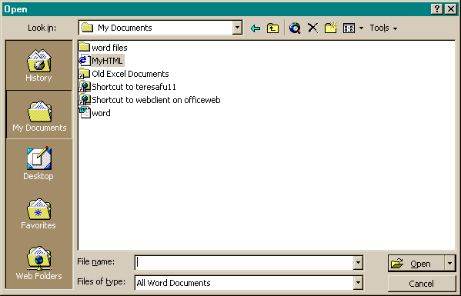

Figure 1. The new Office 2000 File Open and Save As dialog box makes it easy to save directly to a Web server.

Web Themes
To make it easy for users to create a consistent look for all of their Web pages, Word 2000 provides a set of Web page themes and templates. These themes provide consistent backgrounds, picture bullets, fonts, and other formatting features to documents. The themes can be applied at any point in the document creation process (the user needs to choose a theme before beginning a document). Finally, the themes in Word 2000 are shared with the Front Page® 2000 Web site creation and management tool, so Web pages created with either tool can easily share the same look.

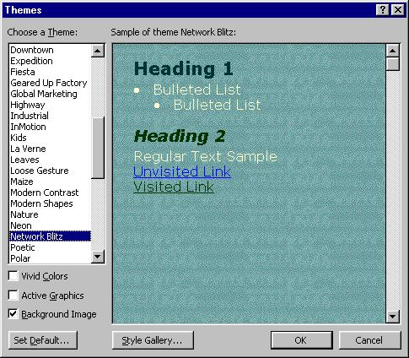
Figure 2. Office 2000 Themes Templates make it easy to create formatted Web pages.

Web Frames
Frames provide a simple way to make Web sites easier to navigate but can be quite difficult to create by hand. As a full HTML editor, Word 2000 provides powerful tools to create and view what you see is what you get (WYSIWYG) frames pages. Users can use the new Frames toolbar to add new frames. Users can easily resize a frame by dragging its border to a new location, delete a frame with a single click, and drag and drop content between frames. This WYSIWYG functionality allows users to see exactly how their pages will appear in a Web browser.

Web Page Preview
With Word 2000 it is now possible to preview published documents in the default Web browser from within Word. On the main command bar, the Print Preview button has been expanded to support Web Preview. The File menu also includes this command. Web Preview makes it easy to see the final result just the way others will see it.

Improved Hyperlink Dialog
Word 2000 offers an improved hyperlink interface to make it easier to manage hyperlinks in documents. Users can create different kinds of links, such as jumps or e-mail triggers, without having to know the HTML jargon. Users can easily specify the text displayed in hyperlinks and create links to new files as well as to multiple files from the same source. When users save documents, Word 2000 checks the links and repairs those that aren’t working because of moved files or other conditions.

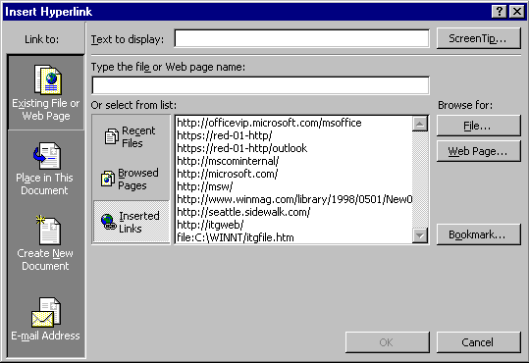
Figure 3. Office 2000 hyperlinking user interface makes it easy to manage hyperlinks in Office files.

Office E-mail Improvements
Word 2000 makes it easy to use Word as an e-mail editor and to use e-mail for collaboration on Word documents. Word 2000 includes a revised WordMail, now called Microsoft Office E-mail that uses HTML as the mail format, so any reader with an HTML-compliant e-mail reader will be able to view the mail with full fidelity. HTML-compliant e-mail readers include the Microsoft Outlook messaging and collaboration client and Microsoft Outlook Express, Eudora, several Lotus clients and several Netscape clients. Word 2000 has also improved the ability that users have to send Word 2000 documents as e-mail messages from within Word. It is now as simple as clicking a button and an e-mail header will come up in Word that lets you send the document you are working on as an e-mail message.
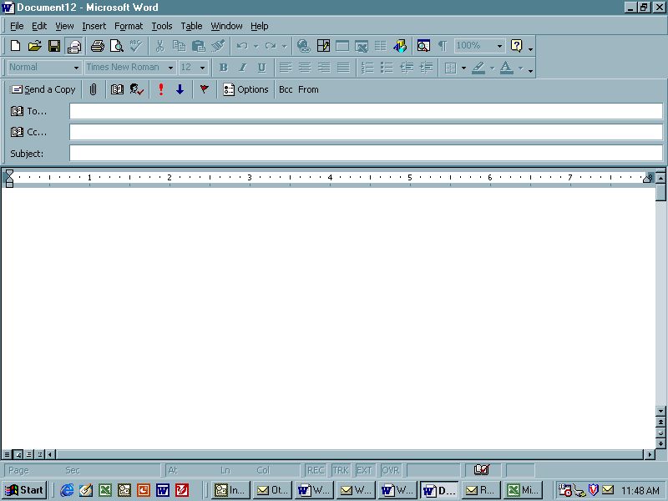

Web Discussions
With the Office Server Extensions installed on a Web server, users can have discussions in both native Word 2000 documents and HTML files. Discussions can be added either through Word or through the browser using a special toolbar supplied by Office Server Extensions. The discussions can be made in-line in the document or as general discussions about the document, which are stored in the discussion pane at the bottom of the page (see Figures 4 and 5). Using the Discussions toolbar, users can insert new comments; navigate through, edit and reply to existing comments; subscribe to a particular document; and view or hide the Discussions window. In Word 2000, the discussions will be placed at the end of a paragraph.

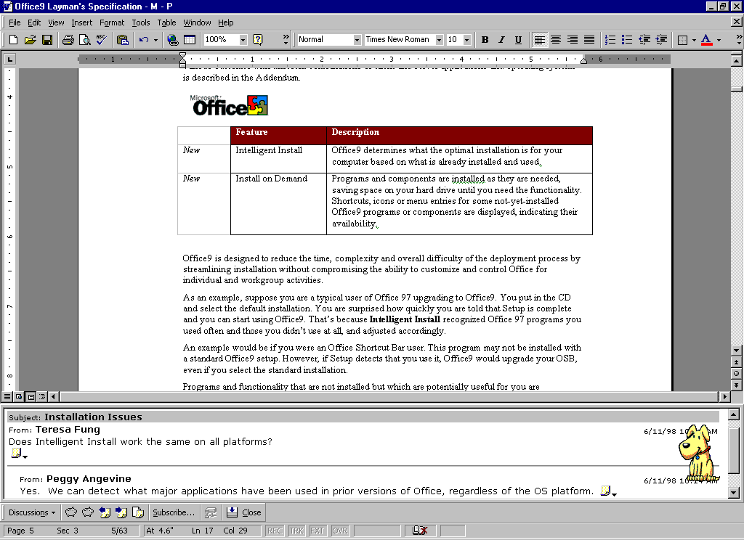
Figure 4. General discussion about the document appears in a pane at the bottom of the document.

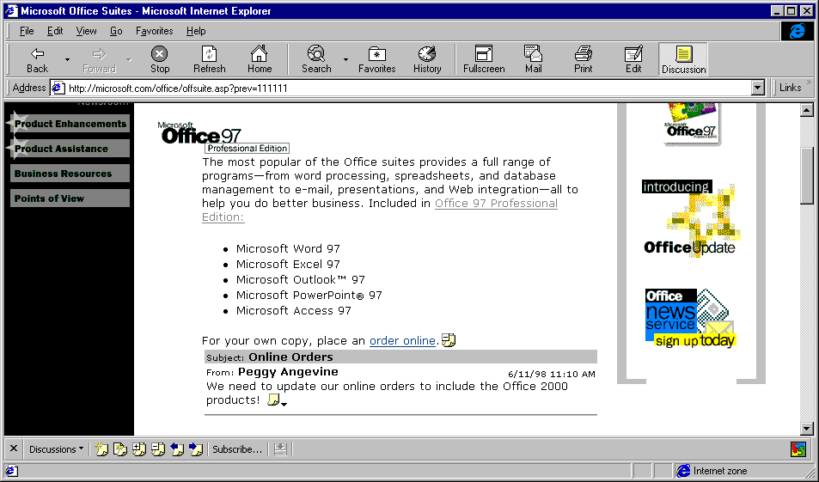
Figure 5. In-line discussions appear within the document and are anchored to paragraphs or other objects.

Web Subscriptions/Notifications
Again, with Office Server Extensions installed on a Web server Word 2000 gives users an opportunity to “subscribe” to particular documents on a Web server and to be automatically “notified” by e-mail when the status of selected documents changes. Users can choose to be notified when a document changes, or is created or deleted. They can be notified immediately, once per day, or even weekly to prevent undue amounts of e-mail when a document is changed several times in a short period. In addition to e-mail notification, users can also add a given document to a Microsoft Internet Explorer channel to receive updates through a browser.

Enhancing Productivity through New Ease of Use Features
Word 2000 extends its legacy as an easy-to-use word processor by adding new features and functionality that will help users create Web, e-mail and printed documents more easily than ever before. Examples of these new productivity-enhancing features include:

Click-n-Type
Click-n-Type allows users to insert text in a document by simply double-clicking where they want to type. Word shows users what formatting will be applied through simple cursor hinting and automatically applies the appropriate formatting, such as extra lines, tabs, alignment and text wrapping. This makes it easy to center-align titles, to create indented paragraphs, or to create a single line with text in different places (e.g., left aligned on the left, right aligned on the right).

What You See Is What You Get (WYSIWIG) Font Menu
Word 2000 introduces a WYSIWIG Font Menu, which allows users to see what the font looks like from the drop-down menu on the toolbar. In this way, users can spend less time finding the font type they want for their document.

Tables
Word 2000 tables are designed to be much more flexible than the tables in Word 97. It is now possible to build nested tables, tables with an integrated header row and tables with diagonal lines through cells. Tables can now be moved around the page, positioned side by side, or have text flow around them. These improvements make it easier for users to work with tables in Word 2000.

Picture Bullets
When users create Web pages, they frequently find graphics on the Web and use them in their own documents, often as graphical bullets. Word 2000 makes it very easy for users to do this. They can cut and paste graphical bullets from other Web pages and use them as graphical bullets in their own documents. Picture bullets behave just like regular Microsoft Word bullets, automatically repeating in bulleted lists. Word 2000 provides a wide number of picture bullets users can choose from. Finally, Word 2000 integrates picture bullets with Themes so that when users change the Themes, the picture bullets also change accordingly.

Intelligent AutoCorrect
AutoCorrect has been popular as a way to correct common spelling mistakes. The new AutoCorrect in Word 2000 is more intelligent than its predecessor, with the ability to identify and automatically correct many more misspelled words. This saves users the time it would take to look through a list of words to correct spelling mistakes.

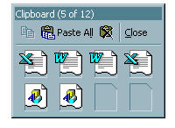
Collect and Paste
Gathering information from several sources has always been a common and arduous task. Collect and Paste in Word 2000 provides the means to more easily manage multiple pieces of information that users might want to add to their documents.

Using the standard Windows® clipboard, users typically copy information, switch windows, paste, switch windows, copy, switch windows, paste and so on. The Microsoft Office Clipboard allows Word 2000 users to easily copy multiple blocks of text or pictures from one or more documents, e-mail messages, Web pages, presentations or other files. Users can then paste these blocks into any Office application, either individually or all at once using the handy “Paste All” feature.

Quick File Switching
Quick file switching (like Single Document Interface) provides immediate access to any individual Word document, rather than the application itself. If a user has more than one Word document open, each document will have its own button on the Windows Taskbar. This is a response to customers wanting an easy way to switch between open documents, especially during cut-and-paste or drag-and-drop operations.

Delivering Software that is Resilient and Works the Way You Do
Word 2000 also introduces a number of new features designed to ensure that your software is easy to set up, keeps running smoothly and takes on the task of repairing itself when there are problems.

Self-repairing Applications
Word 2000 uses a new, more intelligent Microsoft Windows Installer technology to enable it to be self-repairing. This means that Word 2000 will determine at launch if essential files are missing and where they can be found. It then reinstalls the missing files with little or no user intervention. Office 2000 also automatically checks related registry entries for missing or corrupted information and repairs them as needed. The goal is to get users working as quickly as possible, often without their even knowing there was a problem.

Detect and Repair
In certain cases, Word 2000 will start as normal but there might be another problem, such as a corrupted font file or missing template. These kinds of problems are confusing and can take many hours to track down and fix. Fortunately, Word 2000 handles these as well, with the Detect and Repair tool on the Help menu. Detect and Repair scans non-critical Office files looking for discrepancies between the original installation state and the current state of a user’s machine and then fixes those problems wherever possible.

Personalized Menus
Personalized Menus are a unique solution to a long-term problem — how to focus on just the things a user needs and uses. When users first start Word 2000, the application menus will contain those commands that are used 95 percent of the time, while infrequently used commands do not immediately clutter the menu. At the bottom of each menu is a button that expands the menus to the full selection of choices so users can still easily find all menu commands. In addition, the menu will automatically expand based on IntelliSense® technology rules (e.g., timing, hovering, etc.) As users access menu commands, they are “promoted” and displayed higher on the list. Unused menu commands eventually are “demoted” and not displayed on Personalized Menus. When users want to explore new features, they can quickly expand the menus to find them. In the meantime, they are only shown what they use, which greatly simplifies the interface.

Enabling Effective Worldwide Usage
As the use of Microsoft Word has spread globally, the demand to simplify cross-language document sharing has increased dramatically. Multinational companies want to deploy Word easily in multiple languages and would like to be able to use a single version of the program, regardless of the native language of the user. Word 2000 responds to these needs with revolutionary new features.

Global Interface and Multilingual Editing
Office 2000 makes it easy to change the language of the user interface. Because the features of all supported languages are built into the single executable, changing the interface language doesn’t affect the operation of the applications. Users can also author documents in any supported language, including East Asian and Middle Eastern languages, independent of the interface. This means that if a corporation wants to roll out the standard English install of Office 2000 worldwide, users or administrators can easily adjust the Interface and Help language without incurring any management overhead.

Worldwide Executable
Word 2000 reduces complexities and makes sharing files easier for multinational companies and users. Word 2000 uses a single code base, meaning that there is only one worldwide executable. Users around the world can enter, display and edit text in all supported languages, including European languages, Japanese, Chinese, Korean, Hebrew and Arabic. Word 2000 has only one set of files to manage for any system, making deployment and administration much simpler. This means that all features for all supported languages are in any version of Office 2000. (The exceptions to the single executable feature are Thai, Vietnamese and Indic languages.) Features that are only used for specific languages are hidden from the user until Word knows that the user needs them. Word 2000 does rely on bidirectional operating system support (provided by Middle Eastern operating systems or Windows NT® 5.0) for the correct display of Hebrew and Arabic. East Asian typing is supported on non-Asian operating systems.

Language AutoDetect
To make it easier to use Word in a multilingual environment, Word 2000 automatically detects the language being used and changes the language settings accordingly. Hence, spelling, grammar, AutoCorrect and other proofing tools automatically reset. One of the greatest benefits from the automatic language detection is the ability to now use multiple multilingual AutoCorrect lists — Word 2000 automatically knows which AutoCorrect list to use for the appropriate language. Word 2000 also makes it easier to change the language property (something that took several mouse clicks in previous versions) by improving the interface based on customer research. Word 2000 further supports a number of changes to basic document creation tasks in multilingual settings, letting users create tables of contents, footnotes and other basic document elements using local language punctuation rules.

Conclusion
Microsoft Word 2000 was created to be the easiest way to create common Web, e-mail and print documents around the world. Word 2000 delivers significant improvements over previous versions—improvements that are designed to help users streamline information sharing, enhance workgroup productivity, and get their jobs done faster and more effectively. Word 2000 provides these benefits with easy Web publishing and collaboration, and software that is easier to use, more resilient and personalized. With Word 2000 you will be able to get the most out of the Web environment, in addition to gaining the ability to easily create professional-looking documents for the Web, e-mail and print.

For more information: http://www.microsoft.com/office/


This is a preliminary document and may be changed substantially prior to final commercial release. This document is provided for informational purposes only and Microsoft makes no warranties, either express or implied, in this document. Information in this document is subject to change without notice. The entire risk of the use or the results of the use of this document remains with the user. The example companies, organizations, products, people and events depicted herein are fictitious. No association with any real company, organization, product, person or event is intended or should be inferred. Complying with all applicable copyright laws is the responsibility of the user. Without limiting the rights under copyright, no part of this document may be reproduced, stored in or introduced into a retrieval system, or transmitted in any form or by any means (electronic, mechanical, photocopying, recording, or otherwise), or for any purpose, without the express written permission of Microsoft Corporation.
Microsoft may have patents, patent applications, trademarks, copyrights, or other intellectual property rights covering subject matter in this document. Except as expressly provided in any written license agreement from Microsoft, the furnishing of this document does not give you any license to these patents, trademarks, copyrights, or other intellectual property.
Unpublished work. © 1998 Microsoft Corporation. All rights reserved.
Microsoft, FrontPage, IntelliSense, the Office logo, Outlook, Windows and Windows NT are either registered trademarks or trademarks of Microsoft Corporation in the U.S.A. and/or other countries.
The names of actual companies and products mentioned herein may be the trademarks of their respective owners.

