Microsoft PhotoDraw 2000
Product Overview

Published: October 1998
For the latest information, please see http://www.microsoft.com/office/photodraw/

Introduction
Microsoft® PhotoDraw™ business graphics software uniquely provides photo editing and illustration in one easy-to-use program to help Microsoft Office and business users create custom looking graphics to use in PowerPoint®, Word, Publisher and on the Web.
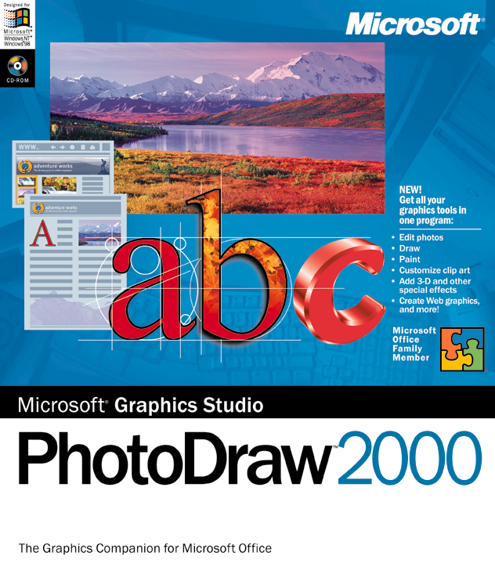

PhotoDraw allows users to focus on the task at hand, not on the tool or the terminology. Designed for business users, PhotoDraw reduces the number of steps required to complete any graphics task with professionally designed templates, pre-set defaults and automatic image correction features. Users can create customized graphics with ease - achieving high quality results without formal graphics training. Further, PhotoDraw incorporates a Microsoft Office look to speed new users on their way.
The Graphics Companion to Microsoft® Office!

With PhotoDraw, users can assemble and modify any of the following graphic elements in a seamless and easy manner and apply special effects to any and all of them:

- Clip art
- Shapes
- Photos, including scanned photos and those downloaded from a digital camera
- Text
- Images from other graphics programs
- User-drawn illustrations

Moreover, users can continue to make changes to individual elements at any stage in the creative process and even after the graphic is saved.

This document discusses the design goals and key end-user features of PhotoDraw 2000.

Design Goals
The PhotoDraw feature set is a direct result of customer feedback. Customers wanted software designed for them that is easy to learn and use and does not require understanding graphics terminology or underlying data types. Customers want to work with images, text and artwork seamlessly, in the same way, and easily assemble graphics for use in other programs. As a result, three core design goals emerged from research:

- Combine photo editing and vector illustration capabilities within a single program with a single user interface.
- Ensure ease-of-use for business users who don't have graphic design experience.
- Ensure compatibility with widely used desktop productivity programs including Microsoft Office.

Combine different graphic types
PhotoDraw is the first tool of its kind that is designed for business users; it provides illustration, photo editing, text and tools in one easy-to-use, integrated product. PhotoDraw has been built from the start to work with different object types in the same way - interactively, seamlessly - in one program. The PhotoDraw architecture was designed from scratch to optimize illustration, photo editing and text for both print and the Web.

Ensure the software is easy-to-use
With PhotoDraw, users can get started right away producing professional-looking graphics - assembling PhotoDraw content, graphics created in other applications, images, photos and text - to create eye-catching graphics to place in documents and Web pages. PhotoDraw is easy to use, with automatic tools, a visually revealing interface, lots of help and a seamless environment in which the same set of effects can be applied to different kinds of content without switching or conversion.

Ensure compatibility with Microsoft Office and other graphics programs
Microsoft Office users get added benefits with PhotoDraw. PhotoDraw has a similar look and feel to Microsoft Office as well as including Office clipart content and similar online help systems. PhotoDraw can prepare graphics for insertion in Microsoft Office and act as an OLE server. These features and others make PhotoDraw a great choice for Microsoft Office users. PhotoDraw also reads a wide range of graphics file formats, enabling users to reuse graphics that they have scanned or created using another program.

Benefits and Features
PhotoDraw business graphics software uniquely combines photo editing and illustration in a single program. Users can work seamlessly with different types of graphics including clipart, photos, shapes and text and can apply special effects, including 3D, to any and all of them. Users no longer need to use multiple graphics programs, or understand different file formats or image resolution. PhotoDraw works on behalf of the user to make creating custom graphics quick and easy. Highlights include:

All-in-One Photo editing and Illustration
PhotoDraw seamlessly combines clip art, drawing and painting with text and photo editing in a single, easy to use program. You can learn and use one program instead of three to create professional looking, custom graphics.

- Photo Editing, Painting, Drawing and 3D in one program. Through one familiar interface, the user can easily combine and edit photos, clipart, shapes, painting and line drawing with text and 3D effects to create custom looking business graphics.
- Customize ClipArt. Customize standard clipart with different special effects to create a unique customized look. For example, take a simple shape and make it look handpainted or hand drawn.
- Powerful Image Touchup. Automatically fix red eye, remove dust and scratches and correct brightness, contrast and color. The cloning tool allows you to remove unsightly objects from a photo.
- Painting, Drawing and Autoshapes. Paint using natural brush strokes, including unique photo strokes. Draw and edit vector graphics. Assemble graphics quickly using 198 Autoshapes.
- 3-D Effects. Apply 3-D effects to graphic elements with a single mouse click. Click to change the angle. You also control the lighting.
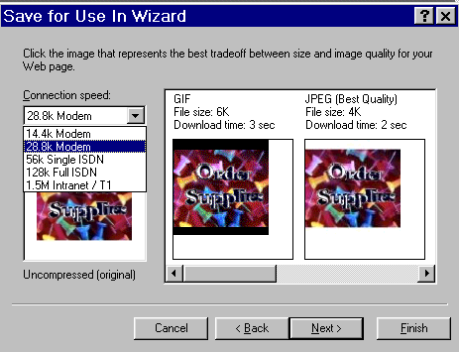
- Web Graphics. Create small, fast graphics for the Web. PhotoDraw automatically converts your image to a Web color palette and format. A wizard (shown here) lets you preview various image qualities with download times to help you make good decisions for your Web site. Templates for navigation buttons, Web banners and watermarks get you started.
- Special Effects. 200 built-in special effects can be applied to text, clip art, photos and other graphics. Each effect can be previewed before it is applied and adjusted to be more or less dramatic.
- Intelligent Print Capability. Intelligent printing automatically sizes and fits your graphic to a wide range of paper sizes, maintaining the correct aspect ratio and determining the highest print quality available from your printer.
- Advanced Support for Digital Cameras and Scanners. The process of capturing images and transferring them to your PC is simplified and automated. For example, automatically scan and correct your image with a single mouse click.

Ease of Use
PhotoDraw provides step by step instructions, professional design templates, design elements and smart tools to ensure that you'll get professional looking graphics every time--in print and the Web--even if you don't have graphic design experience.
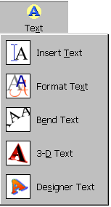
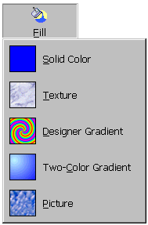
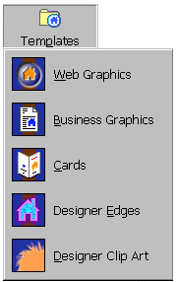
- Visual Menus. Visual menus (shown here) help the user navigate quickly through the program and discover features without having to memorize terminology.
- Visual Previews. Visual previews let users sample different special effects and apply them from a gallery of preset options.
- Smart Tools. Smart image correction tools save you steps by automating difficult photo editing tasks such as color correction and
- Multiple Level Undo. PhotoDraw supports multiple undo and redo.
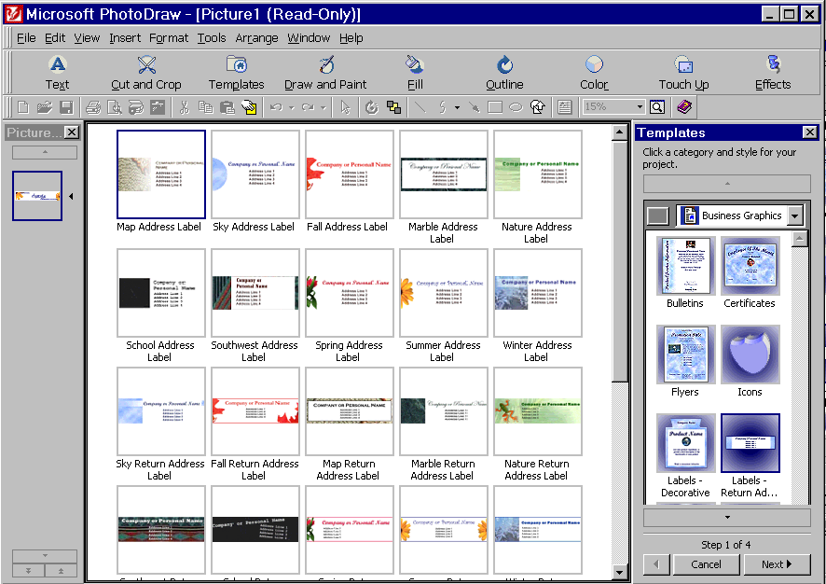
- Business Templates and Content. More than 300 professionally designed business templates (sample shown here) ensure that users can achieve great looking custom graphics every time. Additionally, 20,000 high quality photos, backgrounds and clipart are included to help you get started.
Selection of return address label templates
- Built in design expertise. Pre-set options help you create your best work and save you time.
- Interactive Tutorial. An interactive tutorial provides lessons and shortcuts to increase a user's productivity.

Compatibility
PhotoDraw looks and works like your favorite Office applications, so you can get started immediately, with a familiar interface and toolbar, and the same user assistance. Special help for CorelDRAW users ensures that none of your previous work and learning is lost.

- Office Compatible. If you use any Office product you'll recognize a familiar interface and tools, plus some familiar Office features such as the toolbar and Answer Wizard.
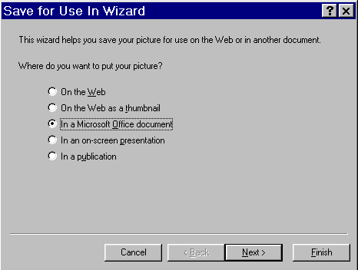
- Save for Use in Wizard. A wizard (shown here) asks you a few questions about how you plan to use your graphic then chooses the highest quality and smallest file size and format for your needs - whether you are exporting to a printed document, a presentation or a Web page.
- Drag and Drop graphics. Easily drag and drop graphics into any Office family program or other OLE compliant application.
- Create a Common Look for Your Business. Use color schemes consistent with those in other popular Office programs.
- File Format Support. Support for standard graphics file formats which allows users great flexibility in importing 22 different file formats (such as BMP, JPG, GIF, TIF, EPS, PSD, PCD and CDR) and exporting a choice of 14 different file formats.

System Requirements

To use Microsoft PhotoDraw 2000, the following components are required:

- Multimedia PC with Pentium 166 or higher is recommended
- Microsoft Windows® 95 or Windows NT® 4.0 or later
- 32 MB RAM recommended
- 190 MB available hard disk space
- CD-ROM drive
- SVGA monitor
- 1 MB VRAM
- Microsoft Mouse, Microsoft Intellimouse®, or compatible pointing device

Additional items or services required to use certain features:

- 9600 baud (or higher) modem required for online features (28,800 baud recommended)
- Microsoft® Internet Explorer (version 4.0 included on CD) or compatible Web browser required for Microsoft Clip Gallery Live and Web Site Preview
- Audio board with headphones or speakers

For more information: http://www.microsoft.com/office/photodraw/



This is a preliminary document and may be changed substantially prior to final commercial release. This document is provided for informational purposes only and Microsoft makes no warranties, either express or implied, in this document. Information in this document is subject to change without notice. The entire risk of the use or the results of the use of this document remains with the user. The example companies, organizations, products, people and events depicted herein are fictitious. No association with any real company, organization, product, person or event is intended or should be inferred. Complying with all applicable copyright laws is the responsibility of the user. Without limiting the rights under copyright, no part of this document may be reproduced, stored in or introduced into a retrieval system, or transmitted in any form or by any means (electronic, mechanical, photocopying, recording, or otherwise), or for any purpose, without the express written permission of Microsoft Corporation.
Microsoft may have patents, patent applications, trademarks, copyrights, or other intellectual property rights covering subject matter in this document. Except as expressly provided in any written license agreement from Microsoft, the furnishing of this document does not give you any license to these patents, trademarks, copyrights, or other intellectual property.
Unpublished work. © 1998 Microsoft Corporation. All rights reserved.
Microsoft, IntelliMouse, the Office logo, PhotoDraw, PowerPoint, Windows and Windows NT are either registered trademarks or trademarks of Microsoft Corporation in the U.S.A. and/or other countries.
The names of actual companies and products mentioned herein may be the trademarks of their respective owners.

