
Microsoft® Office 2000 Feature Highlights Guide

White Paper

Published: September 1998

Table of Contents
Introducing Microsoft Office 2000 1
Design Goals 1
Web-Enabled Collaboration and Information Sharing 2
Save in HTML Format for Universal Viewing 2
Web Page Preview 3
Round-Tripping HTML Documents 3
Save to the Web 3
Themes and Design Templates 3
Hyperlink Handling 4
Web Collaboration Features 5
AutoNavigation Pages 7
Creating Workgroup Webs with FrontPage 2000 8
Rich Analysis Tools for Better Decision Making 12
PivotTable and PivotChart Dynamic Views 12
Office Web Components 12
Data Access Pages 14
Software That is Easy to Use and Manage 15
Personal Productivity 15
Personalization and Resiliency 19
Conclusion 21

Microsoft Office 2000 Feature Highlights Guide
White Paper

Published: September 1998
For the latest information, please see http://www.microsoft.com/office/

Introducing Microsoft Office 2000
Welcome to the Microsoft® Office 2000 Feature Highlights Guide! This document is designed to give you a taste of what is new and exciting about Office 2000. It is organized around the primary design goals for the product and offers lots of product visuals and feature descriptions so you can get a good feel for Office 2000.

Better yet, if you have a copy of the Office 2000 beta or Office 2000 final release code you can use this guide to help streamline the way you evaluate Office 2000. For a more comprehensive description of all of the new features in Office 2000, or any of the individual applications in the Office suite, please visit the Office Web site at http://www.microsoft.com/office/.

We hope you enjoy learning about Office 2000!

Design Goals
Let's begin with an introduction to the Office 2000 product design goals.

When the Office team began planning and developing Office 2000, it recognized several important challenges our customers are facing.

First, customers are experiencing the Web revolution when it comes to accessing information on the Internet but are having trouble making the Web work for them in a practical day-to-day fashion. Customers see the potential for the Web to help them streamline information sharing and collaboration and want their familiar desktop tools to enable the Web to make them more productive.

Secondly, customers are increasingly looking to make their business information more of an asset. Instead of having important business data sitting around in a database only accessible to the highly technical few, they want the ability to have that data easily accessible through tools like Microsoft Office and their Web browser.

Finally, customers continue to want their software to be more intelligent and personalized so that it minimizes the time it takes to get their tasks done and keeps people from having to spend time worrying about how their software will work.

With this feedback in mind we developed Office 2000 to be a desktop suite that makes the Web work for you, streamlining the way you work with people and information so you can get better results. The following feature highlights will give you an idea of how we have delivered on that goal.

Web-Enabled Collaboration and Information Sharing
Today, the ability to easily access, utilize and share information is essential to getting great results. However, harnessing that information can be difficult since it is stored in places such as network servers, personal hard drives and e-mail threads.

The first design goal of Office 2000 was to enable users to take advantage of the Web as a central place to post documents, manage files and work together. The following great new features and functionality in Office 2000 will help you and your colleagues to increase workgroup productivity using Office 2000 and the Web:

Save in HTML Format for Universal Viewing
Office 2000 makes HTML a true peer file format to its own native file formats. Now, when you save an Office document in HTML you will get a full-fidelity rendering of your document and the comfort of knowing that anyone with a Web browser will be able to view content created in Office. Saving in HTML format is the same as saving a regular binary format document and the HTML-formatted documents have the same high fidelity that regularly formatted document have.

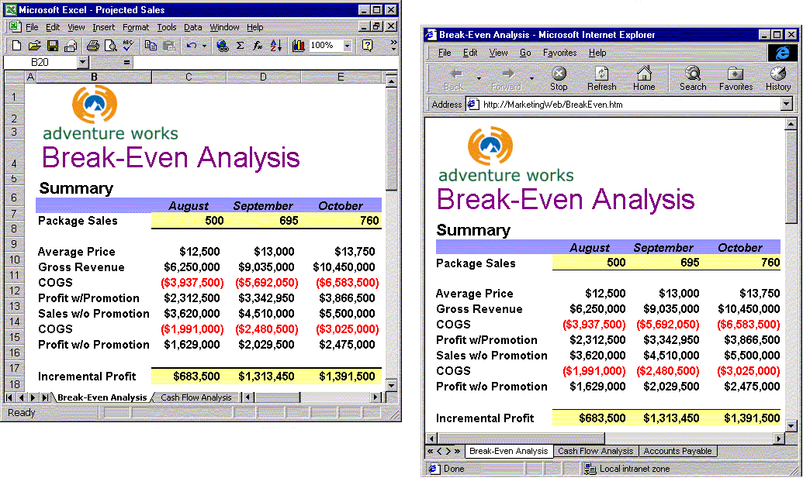

Figure 1 Office 2000 now lets you save Office documents in full fidelity in the HTML file format so that anyone with a Web browser will be able to view your documents.

Web Page Preview
From Office 2000 applications you can now preview HTML formatted documents and Web pages in your default browser so that you can see what others see when they view the document in their browser.

Round-Tripping HTML Documents
You can easily edit HTML files in Office 2000 by simply clicking the Edit button in your Microsoft Internet Explorer browser. This will "round-trip" the document back into its native Office file format and give you all the richness of the Office applications to edit your document.

Save to the Web
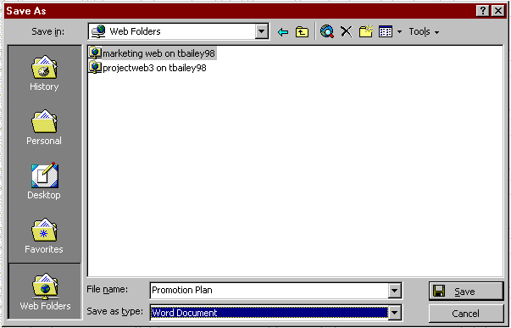Each of the Office 2000 applications makes publishing Office documents to a Web server as simple as saving a file to a hard drive. Opening, browsing and saving files on Web servers is done within the same file Open/Save dialog box used for regular files. Simply click the Web Folders icon in the new Places bar in the file Save dialog box and you can publish to your Web server.

Figure 2 The new Office 2000 File Open and Save As dialog box makes it easy to save directly to a Web server.

Themes and Design Templates
Office 2000 provides Themes and Design Templates to help you create compelling, graphically rich and consistent-looking Web pages and documents. The Themes include background images, bullets, hyperlinks and other graphical elements. The Themes are the same as those that ship in FrontPage® 2000 Web site creation and management tool so that if you customize a Theme in FrontPage using the FrontPage Themes Designer (see below), it will be available for you to use in Office. Each Theme also includes a dual color option, allowing users to select the default mix or a more vivid color scheme.

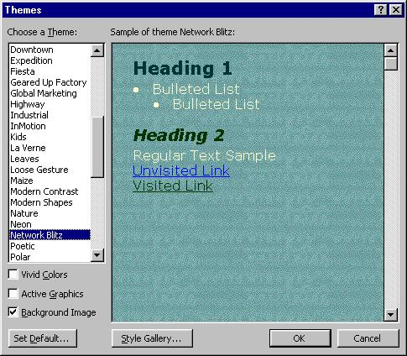

Figure 3 Office 2000 Themes and Design Templates make it easy to create formatted Web pages.

Hyperlink Handling
Office 2000 offers an improved hyperlink interface to make it easier to manage hyperlinks in Office documents. Users can create different kinds of links, such as jumps or e-mail triggers, without knowing HTML jargon. Users can easily specify the text displayed in hyperlinks and create links to new files as well as to multiple files from the same source. When users save documents, Office 2000 checks the links and repairs those that are not working because of moved files or other conditions.

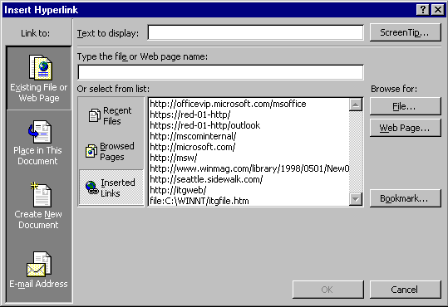

Figure 4 Office 2000 hyperlinking user interface makes it easy to manage hyperlinks in Office files.

Web Collaboration Features
With Office 2000, Web servers get new collaborative capabilities designed to enhance workgroup productivity. Some of these new Web collaboration features include:

- The ability to have threaded discussions on documents that live on a Web server.
- The ability to be notified though e-mail when changes are made to documents on a Web server.
- The ability to have automatic hyperlinks created to documents that you save to the Web server.

The Web collaboration capabilities are based on the Office Server Extensions, which ship with Office 2000. For more information on Office Server Extensions please see the Office Server Extensions White paper located on the Office Web site at http://www.microsoft.com/office/.

Web Discussions
With Office 2000, users can have discussions on Office 2000 documents -- binary and HTML format -- within the documents themselves or in their default Web browser. The discussions can be made "in-line" in the document or as "general" discussions about the document. Discussion content is stored in the Discussion pane at the bottom of the page (see Figures 4 and 5). Using the Discussions toolbar, users can:
- Insert new comments.
- Navigate through, edit and reply to existing comments.
- Subscribe to a particular document.
- View or hide the Discussions window.

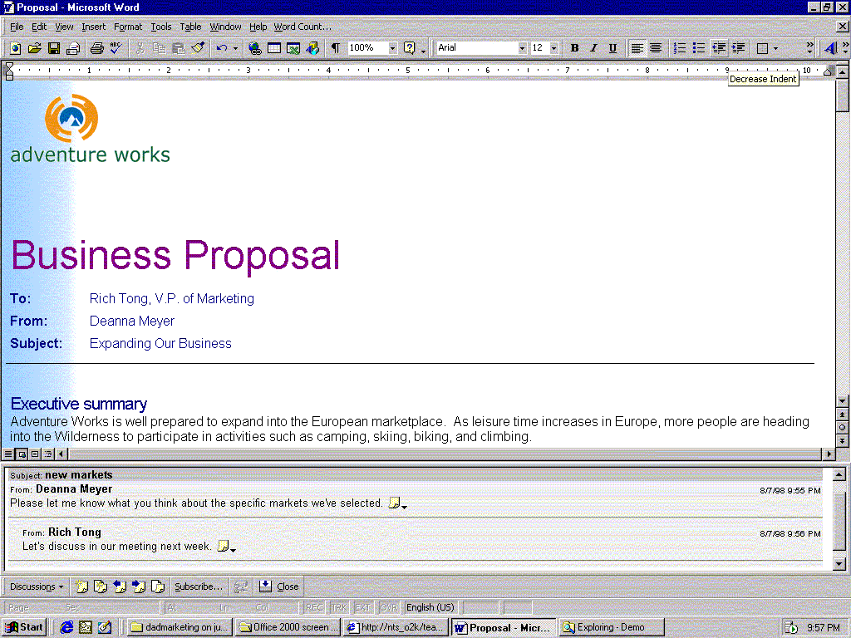

Figure 5 You can have “general” discussions about a document or a Web page that appear at the bottom of the document within the application or your Web browser.

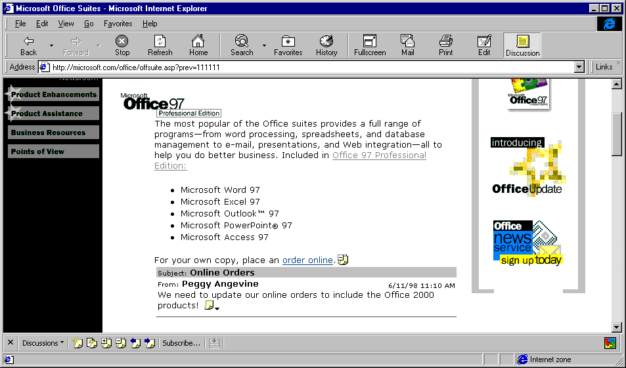

Figure 6 You can also have "in-line" discussions about a document or a Web page that appear within your Office documents or your Web browser.

Web Subscriptions and Web Notifications
Office 2000 gives users the ability to “subscribe” to documents on a Web server and be automatically “notified” by e-mail when the selected documents change. Users can also "subscribe" to folders of documents and be "notified" when any of the documents within a folder change. Users can choose to be notified immediately, once per day, or even weekly to prevent excess e-mail if a document is changed several times in a short period.

AutoNavigation Pages
Office 2000 ships with an AutoNavigation Page template that can be applied to any folder in a Web to make a Web page automatically recognize new documents published to it. Users simply click a hyperlink to open the documents in their Web browser or Office application.

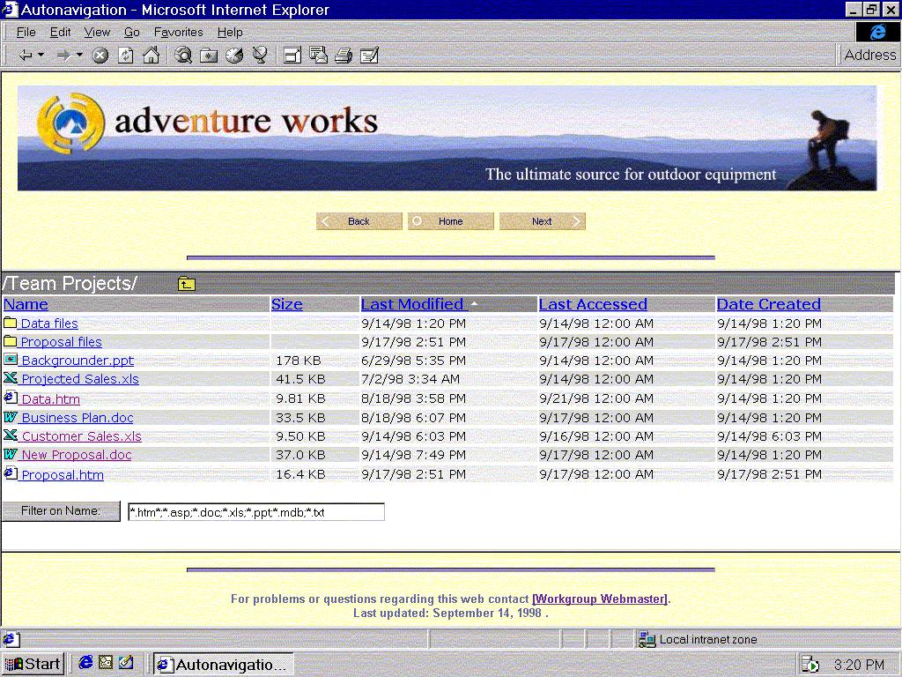

Figure 7 AutoNavigation pages make it easy to find your documents on your Web site.

Creating Workgroup Webs with FrontPage 2000
Intranets are fast becoming tools that workgroups and teams are using to improve productivity and FrontPage 2000 offers some exciting new functionality that will make creating workgroup Webs easier than ever before. To underscore the importance of intranets to Office 2000, a version of Office--Office 2000 Premium Edition--will ship with FrontPage 2000. The new Web functionality in FrontPage 2000 includes:

Workgroup Web Template
The new Workgroup Web template makes it easy to set up the basic structure of a workgroup Web. This template automatically creates Web pages, such as a Projects page, a Members page and a Search page, ties those pages together in a common navigation structure and applies one of the more than 60 new, professionally-designed FrontPage 2000 Themes. The Workgroup Web template is also completely customizable, allowing users to modify their Web to work for their team.

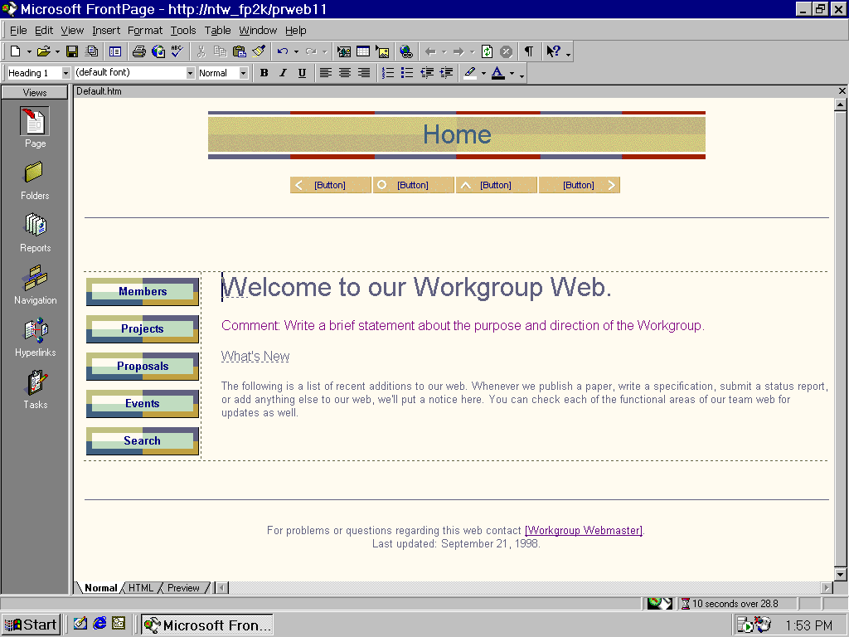

Figure 8 The Workgroup Web template is designed to help you create the foundation for your team Web in just a few minutes.

FrontPage/Office Integration
One of the primary design goals for FrontPage 2000 was to make it more tightly integrated with Office 2000 so that users can take advantage of familiar Office tools for Web creation. FrontPage 2000 shares with Office 2000 common themes, toolbars, menus, shortcuts, and tools like HTML Help, background spell checking, and the Format Painter. (See the Office toolbars in Figure 8 above.)

FrontPage Editor/Explorer Integration
FrontPage 2000 also makes Web creation easier by delivering complete integration between the FrontPage Explorer and the FrontPage Editor. Now users don't have to switch back and forth between Explorer and Editor to create Web sites. All they have to do is click the Page button in the FrontPage Views bar and they can begin creating and/or editing Web pages. (Figure 8 above shows a workgroup Web being edited in the same frame that is used by the FrontPage Explorer.)

FrontPage Themes
To give users the ability to create professional-looking Web sites easily, FrontPage 2000 ships with over 60 new, business-ready themes to provide a consistent look across a single page, multiple pages, or an entire Web site.

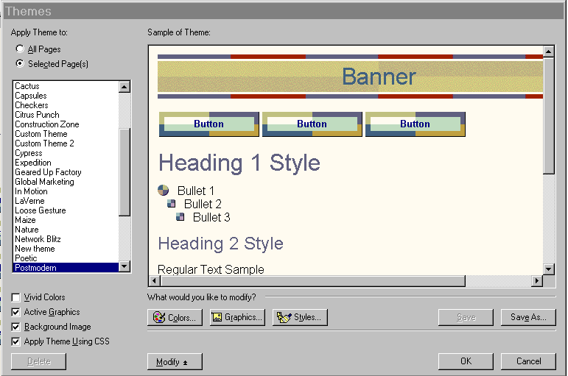

Figure 9 The Themes dialog box makes it easy to pick a theme, add it to a page or to an entire site, or customize the theme using the new Themes Designer.

FrontPage Themes Designer
FrontPage 2000 also ships with a brand new Themes Designer that lets users completely customize colors, logos, graphics, backgrounds and styles for their Web sites. As mentioned above, these custom themes are automatically shared with other Office applications so they can be used, for example, when creating Web pages in Word 2000. Simply click the Colors, Graphics and/or Styles icons identified in Figure 9 above and you will have everything you need to create a custom FrontPage theme.

Nested Subwebs
Often, users want the ability to allow other people to design pages, or Subwebs, in their Web site. With FrontPage 2000, users can create Nested Subwebs which give others permission to author Webs at the "sub-level" of their Web site.

Pixel Perfect Positioning
With FrontPage 2000, users can now place page elements like graphics and text anywhere on Web pages. This is accomplished through new absolute and relative positioning tools that provide more flexibility to get the exact look and feel that you want for your pages.

100% HTML Preservation
One of the most commonly requested features for FrontPage 2000 was to allow users to import HTML created in other tools into FrontPage without modifying the code. FrontPage 2000 delivers this functionality. Tag and comment order, capitalization, and even white space are preserved. For example, you can take this HTML from Notepad and import it into FrontPage and have 100% of the code format retained.

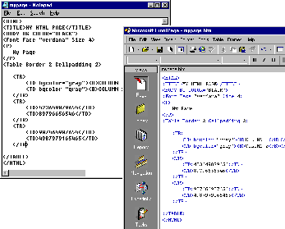

Figure 10 With 100% HTML Preservation you can bring into FrontPage HTML created in another HTML editor and retain its format.

Personalized HTML Formatting
FrontPage 2000 takes the commitment to preserve hand-coded HTML even further by allowing users to personalize how their HTML is formatted. Users tell FrontPage how they want code indented, choose the colors in which they want their tags to appear, and determine when to capitalize, and when to use optional tags. When pages are imported or new content is created, FrontPage automatically applies those preferences to the new code.

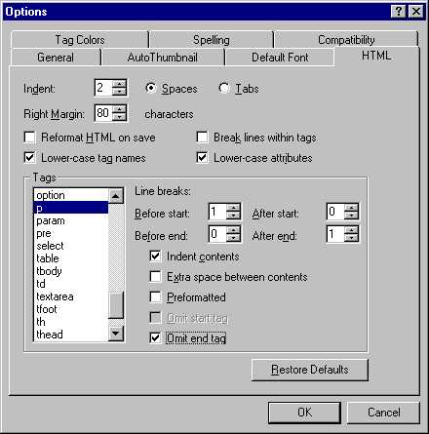
Figure 11 Personalization features give you complete control over how HTML looks in FrontPage 2000.

Design for Specific Browsers
FrontPage 2000 also now allows users to design Web pages for specific browsers. Users select the browser for which they want to design pages and FrontPage 2000 features that are not supported by that particular browser will not be available for that particular Web.

Rich Analysis Tools for Better Decision Making
The second design goal of Office 2000 was to make it easier to use an organization’s intranet to access, analyze, track and respond to business information. Office 2000 offers innovative new data analysis tools that enable users to access, analyze, track and respond to changing information. Examples of the new, innovative data analysis in Office 2000 are:

PivotTable and PivotChart Dynamic Views
PivotTable® dynamic views are a popular feature in Microsoft Excel, providing a powerful way to manipulate data. Excel 2000 improves PivotTable views in a number of ways. Now fields can be added to and removed from the worksheet directly. Clear “drop zones” provide cues to help position the fields, and a Tree view lets users expand and collapse specific data items.

Moreover, with Excel 2000 PivotTable views can now be charted. New PivotChart™ dynamic views are linked to PivotTable views and are automatically refreshed as fields in the PivotTable views are moved and managed. Together, PivotTable and PivotChart dynamic views provide a valuable way to view and evaluate important business data.

Office Web Components
Office 2000 includes three new Office Web Components — a Spreadsheet component, a Chart component and PivotTable component — that make corporate data available to users through their familiar Web browser.

The Spreadsheet component provides basic spreadsheet functionality in the browser, allowing users to enter text and numbers, create formulas, recalculate, sort, filter and perform basic formatting. It also supports frozen panes for keeping header rows and columns visible while scrolling through data, as well as in-cell editing and resizable rows and columns.

The Chart component is interactive, automatically updating as the underlying data changes.

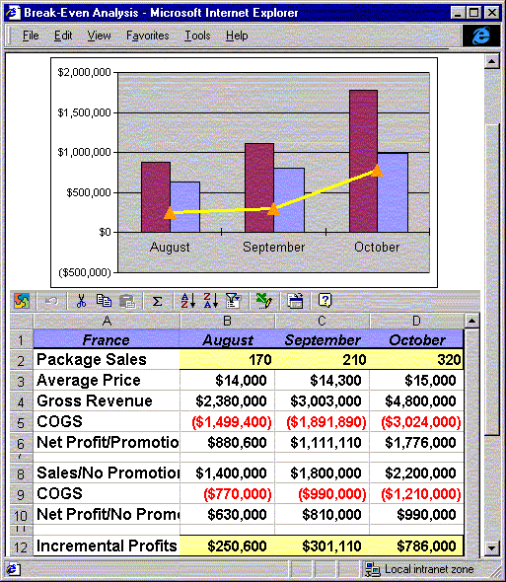

Figure 12 The Office Spreadsheet and Chart components allow users to interact with Excel data in a browser, view a graphical representation of their data and fully round-trip that data back into Excel 2000 for further analysis.

The PivotTable component is similar to PivotTable dynamic views in Excel and provides a dynamic way to view and analyze database information in the browser. This component lets users browse data, dynamically sort and filter it, group it by rows or columns, create totals and focus on the details behind the totals. Although the author of the PivotTable component determines the initial view, the user can access the Field List Chooser (see Data Access Page example below) to drag and drop the dynamically linked fields directly onto the page.

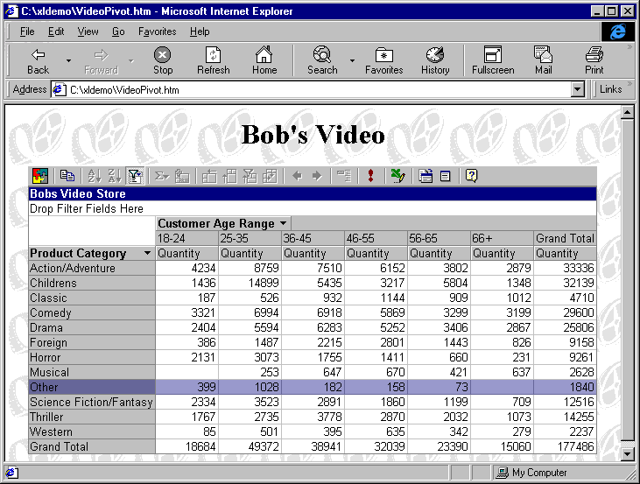

Figure 13 The Office PivotTable component lets users interact with Excel data in a browser.

Data Access Pages
Another exciting new way to use the Web to access and analyze data is through Data Access Pages. Data Access Pages are essentially HTML pages with the ability to maintain a live link to the data (the data is “bound”). This gives users the ability to view and report on data from within their Web browser.

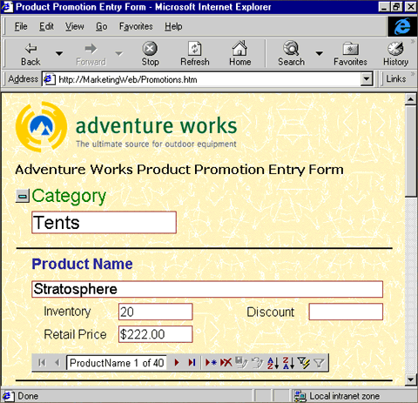

Figure 14 Data Access Pages give users the ability to access databases and contribute data to them through their Web browser.

Software That is Easy to Use and Manage
The third, and final, design goal for Office 2000 was to make Office easier to use and manage. Office 2000 delivers on that goal with innovative improvements in intelligence, personalization and installation. These improvements are designed to help you get up and running quickly, stay working and achieve great results easily.

Personal Productivity

File Open and Save
In Office 2000 we have modified the two most commonly used dialog boxes in Office -- File Open and File Save -- to help users find and share information more easily than ever before. As you can see in Figure 15 below, a command bar has been added for common file management tasks such as copying, moving and deleting files. The Places bar, similar to the one in the Outlook™ messaging and collaboration client, provides easy access to the History folder of recently used files, the My Documents folder, the Desktop, a Favorites folder and a Publishing folder. The Publishing folder points to Web servers for easy placement of files on an intranet or the Internet. The new dialog boxes also take a cue from the navigation method now familiar to millions of users through their Web browsers and include a Back button, which lets users easily return to recently visited folders, regardless of their location in the directory structure.

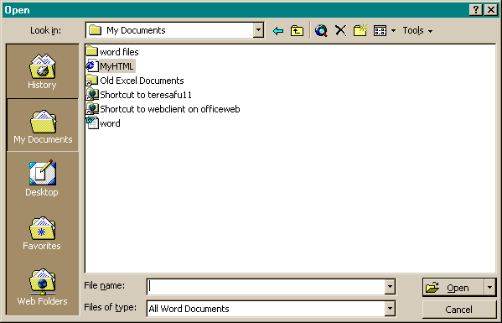

Figure 15 The new Office 2000 File Open and Save As dialog box makes it easy to save directly to a variety of locations including your hard-drive, your desktop and Web servers.

Collect and Paste
Gathering information from several sources has always been a common and often tedious task. The new Microsoft Office 2000 Clipboard allows users to easily copy to the clipboard up to 12 chunks of text or pictures from one or more documents, from e-mail messages, from Web pages, from presentations or from other files. These items can then be pasted into any Office application, either individually, or all at once using the handy Paste All feature.

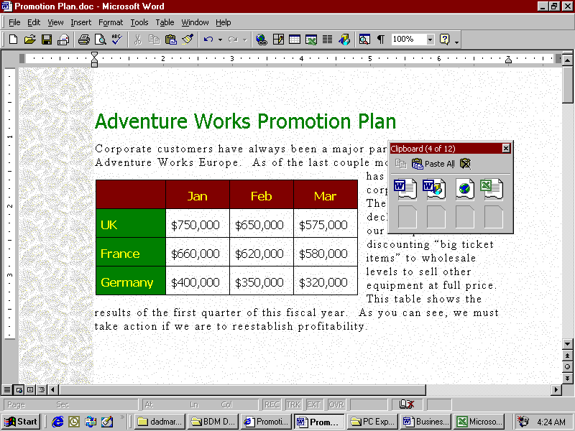

Figure 16 Collect and Paste saves users time copying information from multiple
information sources for use in other documents.

Word Floating Tables
As you can see from Figure 16, Word 2000 tables are much more flexible than before. Now users can wrap text around tables and position tables exactly as they want to on the page.

PowerPoint Tri-Pane View
PowerPoint® 2000 presentation graphics program now lets you combine Slide, Outline and Notes views into one. This makes it easy to perform many actions, including adding new slides, editing text, entering notes while creating a presentation, and navigating while editing.

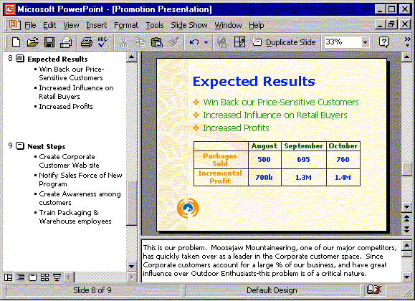

Figure 17 The PowerPoint Tri-Pane View integrates Slide, Notes and Outline views to make it easier for you to create presentations.

PowerPoint Tables
PowerPoint 2000 also includes support for tables without having to use Excel or Word. PowerPoint now gives you a Table Draw tool similar to the one in Word so that you can create precisely the table you want for your PowerPoint presentation. (See Figure 17 above.)

PowerPoint AutoFit Text
In PowerPoint 2000, text is automatically resized to fit into a placeholder so it doesn't "fall off" the slide. AutoFit changes the line spacing, then the font size--and then both--to make the text fit.

Outlook Bar Shortcuts
You can save time in finding information by easily creating shortcuts in the Outlook Bar to any file, folder, Web page or application executable.

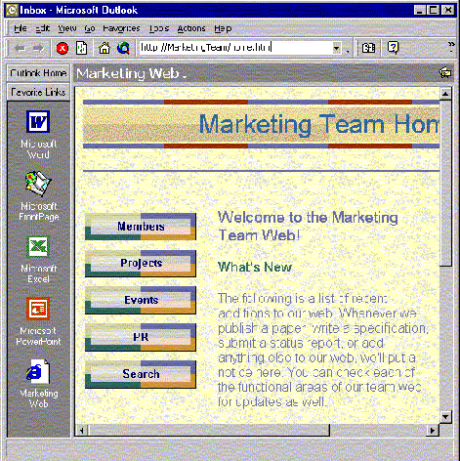

Figure 18 A more flexible Outlook Views Bar and Outlook Web Views save users time in finding information wherever it is stored and in getting started using other Office applications.

Outlook Web Views
Outlook 2000 can now host Web pages within the Outlook Right Pane view so you can quickly find information on the Web. Basic Web navigation is supported and the currently displayed page can be opened in the user's default Web browser.

Internet Group Scheduling
Outlook 2000 now lets users schedule group meetings with people inside their company and over the Internet at the same time. Users can publish and download free/busy information for scheduling meetings, and send/receive meeting requests and responses over the Internet.

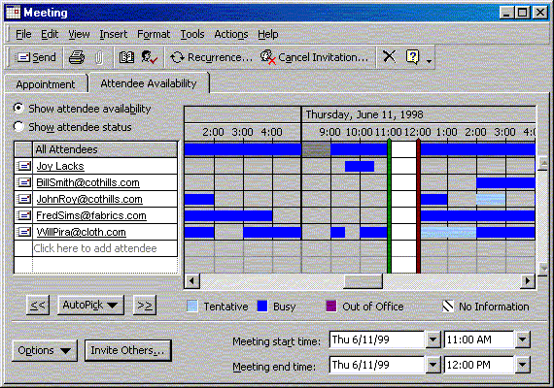

Figure 19 Outlook 2000 improves iCalendar support so that you can more easily use

Outlook to schedule meetings with people inside your company and over the Internet.

Contact Activity Tracking
Users can keep track of all e-mail, tasks, appointments and documents related (linked) to each contact.

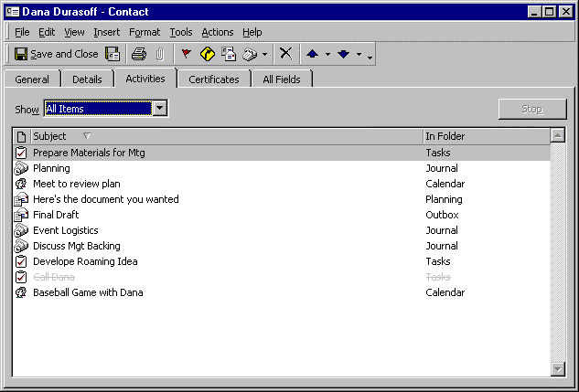

Figure 20 The new Contact Activity Tracking dialog box makes it easier to stay up to speed with all the communication users have with their Outlook contacts.

Personalization and Resiliency

Self-Repairing Applications
Office 2000 makes quantum leap improvements in personalization and resiliency that promise to help you spend more time working with your software than you do worrying about it. A prime example of this is Self-Repairing Applications. If you happen to delete a file that is essential to running one of the applications, Office 2000 is smart enough to automatically find the deleted file and reinstall it so that you can keep working instead of calling an internal helpdesk or Microsoft support engineer. Office 2000 also automatically checks related registry entries for missing or corrupted information and repairs them as needed. The goal is to get users working as quickly as possible, often without their even knowing there was a problem.

Install on Demand
Users told us that they don't want to have to install all of the Office tools from their CD when they first install Office. At the same time they want the piece of mind of knowing that if they need one of those tools it will be ready for them. To provide users with this type of personalization, Office 2000 comes with Install on Demand functionality. For example, if you want to use Office Clip Art but it wasn't installed on your computer during initial installation, Office 2000 will automatically install it when you try to use it.

Personalized Menus and Toolbars
Personalized Menus let users focus on just the things they need and use. When users first start Office, the application menus will contain those commands that are used 95 percent of the time. Infrequently used commands are not displayed, resulting in a simplified user interface. At the bottom of each menu is a button that expands the menus to the full selection of choices so users can still easily find all menu commands. As users access menu commands, those commands are “promoted” and displayed higher on the list. Unused menu commands are not displayed on Personalized Menus. The goal is that over time the user interface will be tailored to users' individual needs.

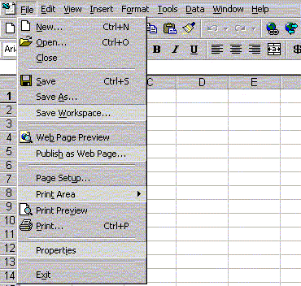

Figure 21 Personalized Menus adapt to usage patterns so that toolbars are optimized for each user.

Language AutoDetect and Multiple AutoCorrect
To make it easier to use Word in a multilingual environment, Word 2000 automatically detects the language being used and automatically applies the appropriate AutoCorrect list for each language.

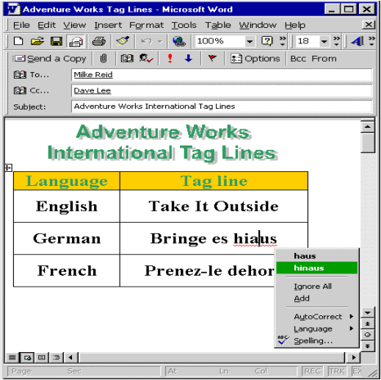
Figure 22 Language AutoDetect lets users use multiple languages in their documents while applying the appropriate spelling, grammar and other proofing tools
available.

Microsoft Office E-mail
In Office 2000, it is much easier for users to distribute documents through e-mail. Instead of having to create a new e-mail message and attach a document, users can click the Office Mail icon on an application, fill out the Mail Header that drops down (see Figure 22 above) and send the document in e-mail. Office Mail sends the document in the HTML format so it can be viewed by anyone with an e-mail program that supports HTML mail. Recipients using Office 2000 can also "round-trip" the HTML mail into their Office applications and edit the mail messages with the richness of their Office editing tools.

Conclusion
Thank you for taking the time to learn about some of the exciting new things that you can do with Office 2000. We hope that this document has helped you in your evaluation of Office 2000 and hope that you agree that Office 2000 offers valuable new ways to make the Web work for you. Its combination of Web-enabled information sharing and collaboration, rich data analysis tools and improvements in ease of use and management will help you and your workgroup or team to be more productive and get better results.

If you want more information about Office 2000, please visit our Web site at: http://www.microsoft.com/office/.


This is a preliminary document and may be changed substantially prior to final commercial release. This document is provided for informational purposes only and Microsoft makes no warranties, either express or implied, in this document. Information in this document is subject to change without notice. The entire risk of the use or the results of the use of this document remains with the user. The example companies, organizations, products, people and events depicted herein are fictitious. No association with any real company, organization, product, person or event is intended or should be inferred. Complying with all applicable copyright laws is the responsibility of the user. Without limiting the rights under copyright, no part of this document may be reproduced, stored in or introduced into a retrieval system, or transmitted in any form or by any means (electronic, mechanical, photocopying, recording, or otherwise), or for any purpose, without the express written permission of Microsoft Corporation.
Microsoft may have patents, patent applications, trademarks, copyrights, or other intellectual property rights covering subject matter in this document. Except as expressly provided in any written license agreement from Microsoft, the furnishing of this document does not give you any license to these patents, trademarks, copyrights, or other intellectual property.
Unpublished work. © 1998 Microsoft Corporation. All rights reserved.
Microsoft, FrontPage, the Office logo, Outlook, PivotChart, PivotTable, PowerPoint and Windows are either registered trademarks or trademarks of Microsoft Corporation in the U.S.A. and/or other countries.
The names of actual companies and products mentioned herein may be the trademarks of their respective owners.

