Complete Project Communication and Control

Effective project management is at the core of every successful business. Whether you’re overseeing simple, short-term projects or managing complex multiproject schedules, you can stay in complete control with Microsoft Project 98.
Microsoft Project 98 puts you
in control of even the most complex projects. It helps you share information easily with team members so everyone
stays involved. And with its compatibility with Microsoft Office, Microsoft Project 98
fits the way you work today.

Easily create great-looking Web sites.
With the flexible new scheduling engine in Microsoft Project 98, you can plan and track your projects more effectively and identify and respond to conflicts before they happen. Schedule and track project information by hour, day, week, or month. And use Microsoft Project 98 to model resource and cost information so you can adapt to scheduling changes as they occur.
Improve coordination with your team by consolidating multiple projects to view cross-project dependencies and multiproject reports.

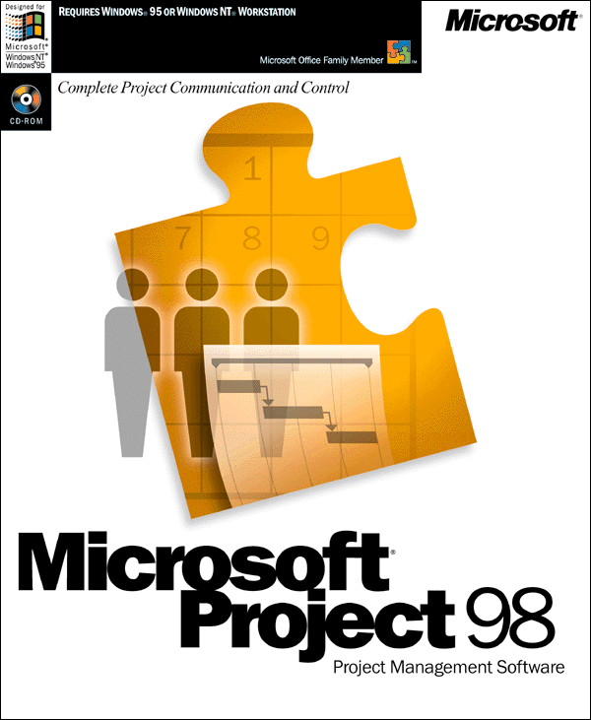Communicate your plans easily.
Intelligent project plans don’t mean a thing if you can’t communicate them to your team effectively. Microsoft Project 98 has rich presentation features, such as customizable Gantt charts that you can publish to your intranet or the Internet, to ensure that your plans are noticed and understood.
Plus, keep your entire team informed and involved with the powerful workgroup and intranet support in Microsoft Project 98. It enables you to share information, delegate tasks, and track project statuses over electronic mail, your company’s intranet—even over the Internet.

Works the way that you do.
Full compatibility with the Microsoft Office desktop applications, including sharing the common Office interface and Help system, makes learning and using Microsoft Project 98 faster and easier.
Plus, Microsoft Project 98 compatibility with ODBC-compliant databases means you can incorporate specific project information into your overall business solutions. And with Visual Basic® for Applications built right in, Microsoft Project 98 can be customized to suit your specific business needs.
With Microsoft Project 98, you get the tools you need to keep your plans on track and take complete control of every project.

Control your projects confidently. Communicate your plans effectively.

Product Highlights

Manage even the most complex projects.
- Increased consolidation limits: New upper limits let you consolidate more than 1,000 projects.
- Custom time-period tracking: Allocate your team’s time efficiently using custom time-period tracking to pinpoint how long team members spend on each task, each day.
- Multiple Critical Paths: Avoid scheduling pitfalls as Microsoft Project 98 helps you identify groups of tasks that could jeopardize your project’s completion date.
- Status date: Update a project’s status based on a date you define for accurate reporting.
- Cross-project linking: Track changes and links between separate projects with new placeholder tasks that represent dependencies in other project plans.
- Task Usage and Resource Usage views: Choose between views that show you tasks by resource assignment or resources by task assignment over time.
- Improved resource management: Accurately model real-world resource changes and their impacts on tasks and workloads.
- Resource contouring: Vary team members’ workloads by time period.

Keep your team informed and involved.
- Customizable Gantt charts: Tailor your charts to fit your needs.
- Workgroup features: Assign tasks and get status updates from team members using your e-mail system or Internet browsers.
- Out-of-the-box Web solution: Microsoft Project 98 ships with Microsoft Personal Web Server for Windows® 95, so you can instantly communicate and track project statuses on your intranet site.
- Web Publishing: Keep everyone informed by posting project information and Gantt charts to your intranet and the Internet, where they can be viewed easily in a Web browser by those involved with the project.
- Share information across Office applications: Simplify analysis and enrich reporting by sharing information across other Microsoft Office applications such as Microsoft Excel spreadsheets and the Microsoft PowerPoint® presentation graphics program.
- Microsoft Excel reporting: Easily create PivotTable® views, S-curves, cost charts, and more by exporting your data from Microsoft Project 98 into Microsoft Excel.

Take control quickly and easily.
- Office compatible: Get up to speed fast with the familiar Office interface, Tool Bars, and OfficeLinks.
- Works with other task management tools: Microsoft Project 98 shares task and resource information with the Microsoft OutlookTM desktop information manager and Microsoft Team Manager so you can build powerful workgroup solutions easily.
- Easily customizable user interface: Personalize menus and Tool Bars in Microsoft Project 98 to ensure that they meet your needs.
- Database file format: Use the new database file format in Microsoft Project 98 to store multiple project files in a central database.
- Full open database connectivity (ODBC) support: Directly save and retrieve Microsoft Project 98 data from ODBC-compliant databases, such as Microsoft SQL ServerTM and Oracle, to facilitate enterprise-level analysis, reporting, and data integration.
- Enhanced development support: Improved support for Microsoft Visual Basic for Applications version 5.0 and ActiveXTM technology makes it easy to build powerful custom solutions.

Easily manage the details. With flexible Task Usage and Resource Usage views, you can monitor work assignments closely and react quickly to changes
.
Involve your whole team. Communicate with your project team easily
over your intranet or e-mail system—or even over the Internet.

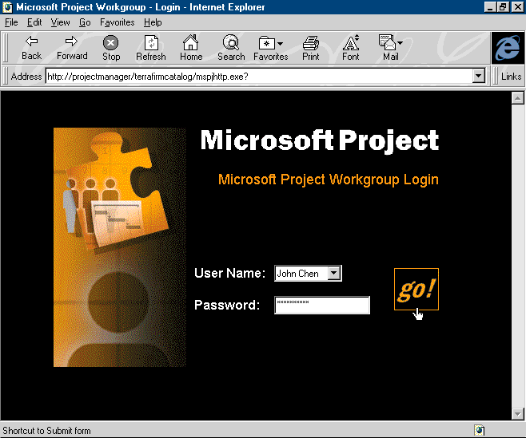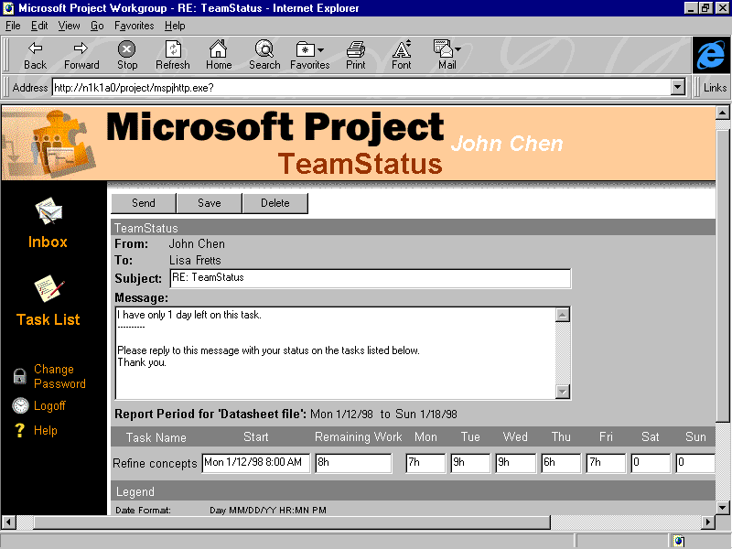
Rely on intranet/Internet communication. Enter the hours you work on a project
in the Web Task List and send it to the
project manager.
Stay on top of project plans. Take advantage of the View Bar to move quickly between project views—with just a click of your mouse.
Create personalized charts. Customize Gantt charts to suit your needs. Even change project schedules easily by clicking and dragging on points in your timelines.
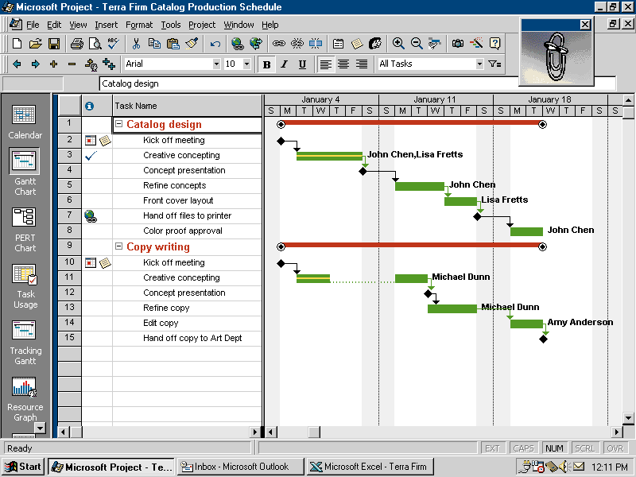
Keep projects on track. Adapt quickly to adjustments in your project plans—new on-screen Indicators automatically flag changes for you.
Realistically show project interruptions. Just click on the task in your Gantt chart that you want to split and drag it to the new time or resource.
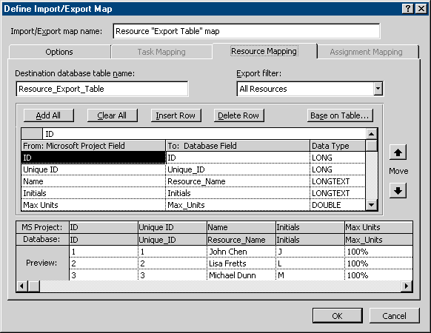
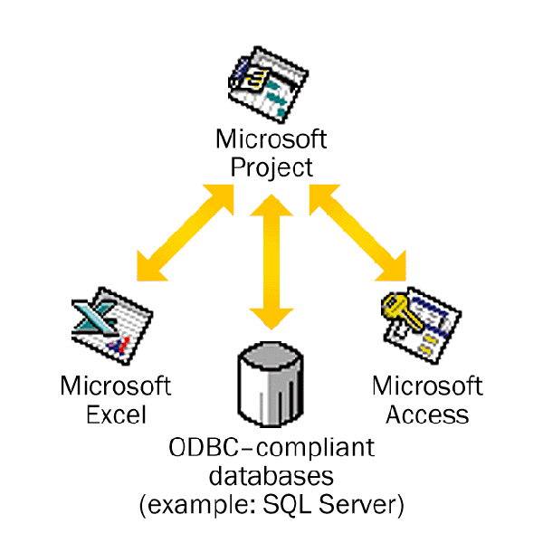
Import/export project data easily. With Microsoft Project 98, improved importing/exporting capabilities
make it easier than ever to export and analyze your information in Microsoft Excel, Microsoft Access,
Microsoft SQL Server, or any ODBC-compliant database.
Get the help you need. The comprehensive Help system and the interactive Office Assistant provide guidance while you work.

Inside Microsoft Project 98
Control your projects with confidence
Indicators | - Automatically flag changes to your project plans
Task Usage and Resource Usage Views | - Show you project plans organized by resources and by tasks
Custom time-period tracking | - Helps you identify how long team members spend on each task, each day
Cross-project linking | - Enables you to create links and dependencies between projects
Resource contouring | - Allows you to change each team member’s workload for each task
Multiple Critical Paths | - Helps you view groups of tasks that could affect your project completion date
Task Splitting | - Makes it easy for you to show project interruptions in your plans
Status date | - Lets you update a project’s status based on a date you define
Increased consolidation limits | - Enable you to consolidate more than 1,000 projects
Communicate your plans with ease
Customizable Gantt charts | - Help you tailor your charts to your needs
Workgroup features | - Enable you to use e-mail and the Internet to assign tasks and receive status updates
Web Publishing | - Lets you publish project information and Gantt charts to your intranet site or the Internet
Personal Web Server for Windows 95 | - Allows you to communicate and track project statuses over your intranet site
Gain control quickly with advanced compatibility
Office Assistant | - Provides interactive Help while you work
View Bar | - Helps you switch between project views with just a click of your mouse
Office compatibility | - Supports the familiar Office interface, Tool Bars, and OfficeLinks—as well as OLE integration
Compatibility with other task management tools | - Allows you to export task and resource information to Microsoft Outlook and Team Manager
Easily customizable user interface | - Enables you to personalize menus and Tool Bars
Database file format | - Lets you store multiple project files in a central database for easier management and reporting
Full ODBC support | - Allows you to save project information to and retrieve it directly from ODBC-compliant databases

To use Microsoft Project 98, you need:
- Personal or multimedia computer with a 486 or higher processor

Specifications
- Microsoft Windows 95 operating system or later, Microsoft Windows NT® Workstation operating system version 3.51 Service Pack 5 or later, or Microsoft Windows NT Workstation 4.0 Service Pack 2 or later (will not run on earlier versions)
- 12 MB of memory for use on Windows 95; 16 MB for Windows NT Workstation
- 20–40 MB of available hard-disk space required; 30 MB required for typical installation, depending upon configuration
- CD-ROM drive
- VGA or higher-resolution video adapter (Super VGA, 256-color recommended)
- Microsoft Mouse, Microsoft IntelliMouseTM, or compatible pointing device
- Leading Windows-compatible network and MAPI-compliant mail systems, or a Web server and Web browser, are required for workgroup functionality

Optional:
- Windows-compatible printer or plotter
- 9600 or higher-baud modem (14,400 baud recommended)
- Multimedia computer required to access sounds and other multimedia effects
- Some Internet functionality may require Internet access and payment of a separate fee to a service provider
Microsoft Personal Web Server for Windows 95 is included on the CD-ROM and may require additional memory.

Money-back guarantee and no-charge support notice:
As with all programs in the Microsoft Office family, you get a 30-day, money-back guarantee. You also receive, at no charge, easy access to the latest technical support information on the World Wide Web at http://www.microsoft.com
/support/ and unlimited usability support (toll and connection charges apply).*

Visit the Microsoft Office World Wide Web site at http://www.microsoft.com
/office/ or, for more information, visit the Microsoft Project 98 Web site at
http://www.microsoft.com/project/

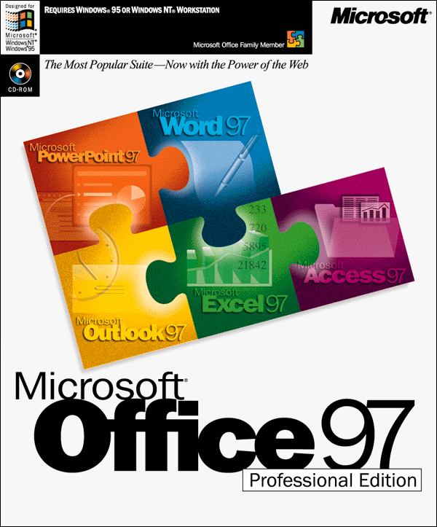
To accomplish even more, get Microsoft Office 97
Professional Edition. And for more products that look
and work like Microsoft Office, look for the Office logo.


*Support services vary outside the United States and Canada. For information on support in other locations, contact your local Microsoft subsidiary. Microsoft’s support services are subject to Microsoft’s then-current prices, terms, and conditions, which are subject to change without notice.
© 1997 Microsoft Corporation. All rights reserved.
This data sheet is for informational purposes only. MICROSOFT MAKES NO WARRANTIES, EXPRESS OR IMPLIED, IN THIS SUMMARY. Companies, names, and/or data used in screens and sample output are fictitious, unless otherwise noted.
Microsoft, ActiveX, BackOffice, the BackOffice logo, IntelliMouse, the Microsoft Internet Expolorer logo, the Office logo, Outlook, PivotTable, PowerPoint, Visual Basic, the Visual Basic logo, Windows, the Windows logo, Windows NT, and the Windows Start logo are either registered trademarks or trademarks of Microsoft Corporation in the United States and/or other countries. Other product and company names mentioned herein may be the trademarks of their respective owners.
Microsoft Corporation • One Microsoft Way • Redmond, WA 98052-6399 • USA
Microsoft Canada Inc. • 320 Matheson Blvd. West • Mississauga, ON L5R 3R1 • Canada
0897 Part No. 098-69409 (electronic data sheet)
Part No. 098-64887 (printed data sheet)

