Microsoft Office 2000 IT Features Tour
What Productivity Means Today

Let's face it. As an IT professional, your needs in an office suite are different from the average user's. What matters most to you is deployment flexibility, simple administration, and cost-effective support. You're focused on increasing efficiency and extending desktop productivity to the Web. And you want the most productive technology at the lowest cost. That's why Microsoft developed Office 2000—the most IT-focused office suite yet.
Reliable Solutions Developed with IT in Mind  With Office 2000, you can lower costs through flexible deployments and simplified administration. Leverage your existing infrastructure to work more efficiently. Connect users with a collaborative Web work space. And boost user productivity with powerful Web solutions. Office 2000 gives you the flexibility and control you need to make a positive impact on your company's bottom line. |  | 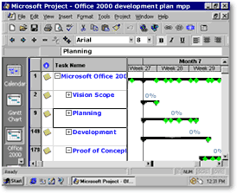
Learn more about Office 2000 for the IT professional:

- Reduce the Costs of Deployment, Administration, and Maintenance
- Connect Users to the Information They Need
- Connect Users to Each Other for Enhanced Collaboration
- Learn More About Office 2000

Lower Your Cost of Ownership

Reduce your implementation, maintenance, and support costs with Microsoft Office 2000. Designed specifically with IT professionals in mind, Office 2000 simplifies deployment and administration so you can lower your cost of ownership.
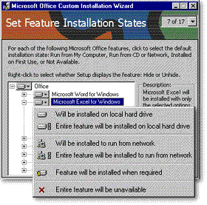 |  | Quickly Customize Your Installations  Save time and money using the new Microsoft Windows® Installer technology and the Custom Installation Wizard. They give you the flexibility to decide where your Office files reside and step you through the process of setting feature installation states—so you can easily control even large-scale Office installations.  Choose to install features to the desktop or to run them from a CD or the network. And decide whether to install them initially, on first use, or to make them unavailable to users. Then deploy your customization choices to a workgroup, department, division—even the entire enterprise.
Deliver a Single Worldwide Application  Reduce the time and complexity of international product deployment and support. Office 2000 gives you standardized applications that you can deploy worldwide. Then use the Multi–language Pack to switch to any supported language interface without reinstalling the applications. |  | 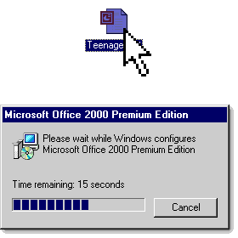

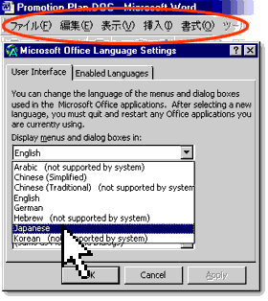 |  | Reduce Maintenance and Support Time  Give your help desk a break with the resilient, self-repairing applications in Office 2000. Whether a dynamic link library (DLL) has been deleted or a file has been corrupted, Office 2000 automatically goes back to a defined set of installation sources and repairs any file needed to launch and run its applications.
Set Up Powerful Organizational Support  Take advantage of the Natural Language Help engine in Office 2000 to link users directly to company-specific information and training resources. That way, users get the personalized organizational information they need—without having to contact your help desk.  Add Automatic User Support  Point users to answers on your company's intranet to reduce support calls. With Office 2000, customizable Office alerts provide direct links to user information on your help desk site. |  | 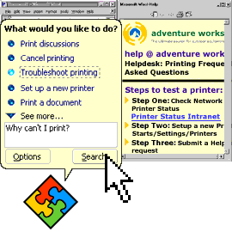

Reduce Installation and Maintenance Costs
- Install on Demand reduces your installation time by enabling users to install just the features they need, then add more later as they need them.

- Compatible file formats in Office 97 and Office 2000 make it easy for users to share information seamlessly—without converting files. (For more information, see the white paper titled Office 2000 and File Sharing in a Heterogeneous Office Environment.)

- New antivirus support enables you to specify accepted digital signatures—so you have more control over code running on the desktop.

- Additional information can be found in the following white papers:
Office 2000 Deployment and Maintenance
Reducing Cost of Ownership with Office 2000
Office 2000 in a Multinational Organization

Connect Users to the Right Information

Provide powerful tools and technologies that enable users to publish, edit, analyze, and share business information more effectively and efficiently. Microsoft Office 2000 delivers advanced Web-based content management capabilities so users can interact with corporate data right in their browsers.
Empower Users to Share Information with Anyone  Enable users to publish documents as HTML files on your company's intranet just as easily as they save standard Office files to their hard drives. Because HTML is a peer file format in Office 2000, anyone with access to your network—regardless of what software they're running—can then view the files in their browsers.  Make It Easy for Users to Edit HTML Files  Office 2000 users can change HTML files easily using the full functionality of the Office programs the files were initially created in. Then, when they resave as HTML, the files retain their formatting and functionality. |  | 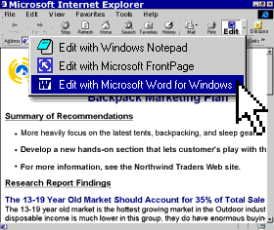
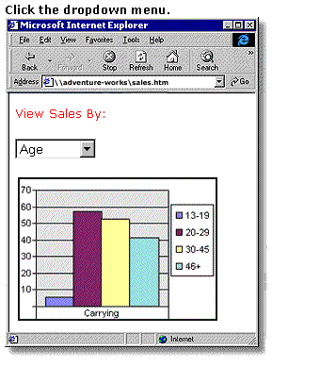 |  | Extend Corporate Reporting to the Web  Create powerful Web-based corporate solutions using Office Web Components. These solutions enable users to analyze their data in Excel spreadsheets, charts, and PivotTable® views, then easily publish it so that others can interact with the data right in their browser—they can sort, filter, calculate, and manipulate the data without leaving the Web. And because Web Components are linked directly to your database, users only work with current information.

Enable Easy Sharing of Enterprise Information
- Nested subwebs, with detailed authoring rights, help you organize and manage your growing Web.

- Data Access Pages make it easy to publish an Access form to the Web.

- Office E-mail gives users an easy way to send Data Access Pages—containing live database links—to coworkers.

- Additional Information can be found on the following white papers:
Office Server Extensions
Office 2000 Web Components

Connect Users to Each Other

Give users everything they need to collaborate like never before. Microsoft Office 2000 provides powerful tools that help you build a new collaborative Web platform, as well as technologies that streamline communication between users.
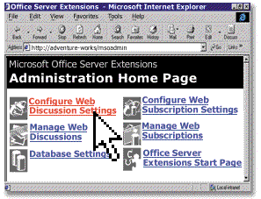 |  | Turn Your Web into a Collaborative Platform  Build a Web-based, collaborative platform easily by adding Office Server Extensions to your existing Windows NT® File Server infrastructure. This platform gives users a place to publish work, collaborate on joint projects, and manage shared documents—saving you time and alleviating the problem of large attachments clogging up your messaging system.
Manage Shared Web Content Easily  With Office Server Extensions, users can conduct secure Web Discussions inside Office documents and HTML files, subscribe to content they're interested in, and receive automatic notification of changes to that content. Using the Office Server Extensions Administration Home Page, you can administer all of this collaborative activity quickly and easily. |  | 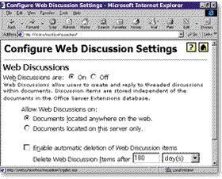
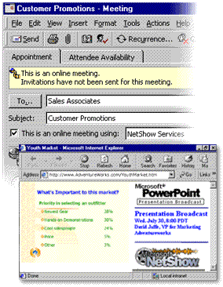 |  | Help Users Connect on the Spot  In Office 2000, users can schedule online presentations and meetings from within the applications, so they don't need to leave their desks or jump between programs to work together effectively. That makes it faster and more cost-effective for everyone—including remote users—to communicate with one another.

Learn More About Office 2000

For more in-depth information about Microsoft Office 2000 features and functionality, read these white papers:

- Introducing Office 2000
- Reducing Cost of Ownership with Microsoft Office 2000
- Microsoft Office 2000 in a Multinational Organization
- Microsoft Office 2000 Deployment and Maintenance
- Microsoft Office 2000 and File Sharing in a Heterogeneous Office Environment
- Microsoft Office 2000 and HTML
- Microsoft Office Server Extensions (OSE)
- Microsoft Office 2000 Web Components

Visit the Microsoft Office Enterprise site to get evaluation resources and information.

Select the Right Office Tools for Your Business
Choose between Microsoft Office 2000 Standard, Small Business, Professional, or Premium to deliver the right productivity tools—at the right cost.

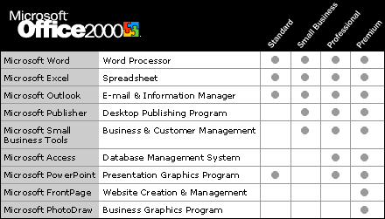

For information on Microsoft Office Developer, visit the Microsoft Developer Network Web site.

System Requirements
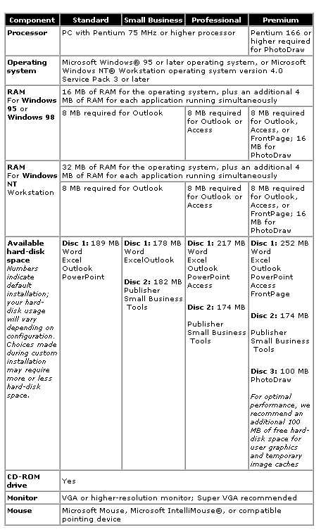

Additional Items Or Services Required To Use Certain Features:
- 9600 baud modem; 14,400 or higher-baud modem recommended
- Multimedia computer required to access sound and other multimedia effects
- Microsoft Exchange client or Microsoft Outlook required to run Office E-mail
- 8 MB of additional memory required to run Office E-mail
- Some Internet functionality may require Internet access and payment of a separate fee to a service provider
- Must own an Office 2000 license in order to browse a Web page interactively using Office Web Components

© 1999 Microsoft Corporation. All rights reserved. This data sheet is for informational purposes only. MICROSOFT MAKES NO WARRANTIES, EXPRESS OR IMPLIED, IN THIS SUMMARY. The example companies, organizations, products, people, and events depicted herein are fictitious. No association with any real company, organization, product, person, or event is intended or should be inferred.

Microsoft, FrontPage, IntelliMouse, the Microsoft Internet Explorer logo, the Office logo, Outlook, PhotoDraw, PivotChart, PivotTable, PowerPoint, Windows, the Windows logo, and Windows NT and the Windows Start logo are either registered trademarks or trademarks of Microsoft Corporation in the United States and/or other countries. Other product and company names mentioned herein may be the trademarks of their respective owners.

Microsoft Corporation o One Microsoft Way o Redmond, WA 98052-6399 o USA

Microsoft Canada Inc. o 320 Matheson Blvd. West o Mississauga, ON L5R 3R1 o Canada

0399 Part No. 098-82663IT

