ChessPad V2.1 Users Manual

Chess games recording program for the Palm Computing® platform.

Solutions In Hand  P.O. Box 4117  Foster City, CA 94404  www.solutions.hand.org  solutions@hand.org | 

This SOFTWARE PRODUCT is provided "as is" without warranty of any kind.
The author shall not be liable for any damages whatsoever arising out of the use of or inability to use this SOFTWARE PRODUCT.
Any unauthorized modification of this SOFTWARE PRODUCT is prohibited by law.
Unregistered copies of this SOFTWARE PRODUCT can be freely copied, redistributed. and used for a limited evaluation time (30 days, starting from the first time of use). After registration you can use this SOFTWARE PRODUCT, but not modify it. You can not redistribute the registered copy or use the given registration code for any other person or business registration.

Introduction
Palm ChessPad is a utility program to record chess games, openings, etudes, etc. with analysis and comments. Palm ChessPad can not play chess. It is oriented on advanced and professional chess players.
Installation
The package consists of:
- License.txt - License agreement.
- chesspad.prc - ChessPad, Palm program.
- cpconv.prc - PGN converter, Palm program.
- cpConv.exe - PGN converter, PC program.
- inst32.exe - ChessPad installation program.
- Setup.inf - Installation information.
- ChessPad.doc - This manual.
- Instaide.dll - Installation extension.
- PalmCmn.dll - Installation extension.

PC installation.
Installation on PC has to be done with ChessPad installation program. Unzip all the package files into one folder and run Inst32.exe for every Pilot user that will work with ChessPad. PalmPilot Desktop software is required to be present on your PC for the installation of Palm components.
To uninstall ChessPad run “Inst32.exe /u” parameter using DOS box or Windows “Run” command.
Non-PC installation.
All components have to be installed manually.
Handling Games
When you start the program, it opens the game that you were working with before, or creates a new one with default name if it can not find it. The ‘Game’ drop-down menu lets you create a new game, open another game or make a copy of the opened game. To access the drop-down menus you must press the Menu Icon in the bottom left of the Palm's graffiti area.
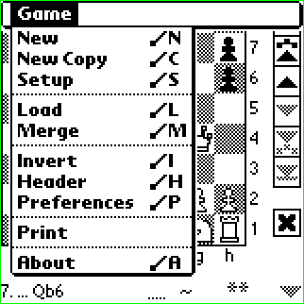 | Every game is stored in Pilot memory as a separate database. All your games are backed up as PDB files when you hotsync your Pilot and can be located in your PC’s <Pilot>\<User_Name>\Backup\ folder. They can be re-installed with the PalmPilot Install Tool.  ‘New’- creates a new game. The old one is stored in Pilot memory and can be opened again anytime.  ‘New Copy’- creates a new game and copies all data from the current one.  ‘Setup’- creates a new game in Setup mode (see below).
‘Load' (/L) - shows you other available games within the specified category and allows you select or delete them.
‘Merge' (/M) - same form as for ‘Load’. The selected DB will be merged with the current one. Note that merging could be rather long, Wait icon indicates the processing.
'Invert' (/I) - inverts the board.
'Header' (/H) - pops up PGN header Info form and allows to change the current game name, category and game description.
'Preferences (/P) - pops up the form where you can change notation and some other options.
'Print' - prints the game (without variations and comments) as a tournament score sheet. This feature works only if you have PalmPrint from Stevens Creek Software.
'About' (/A) - pops up the ChessPad information and registration form.

Palm ChessPad supports up to 15 different categories. Number of different games is limited by your Pilot memory only. All games have to have unique names.
Main Screen Details
To make a move either drag a piece or tap on it and tap on the target square. Branching occurs automatically when you scroll position back and make a move that is different from the next one.
Here is an example. After 1. e4 e5 2. Nf3 Nc6, you scroll back to the position after 1.. e5. Move 2. f4 and scroll one move back. Now you see that the Branch Choice button becomes enabled and you can choose between f4 and Nf3. Note: this behavior is different from V1.
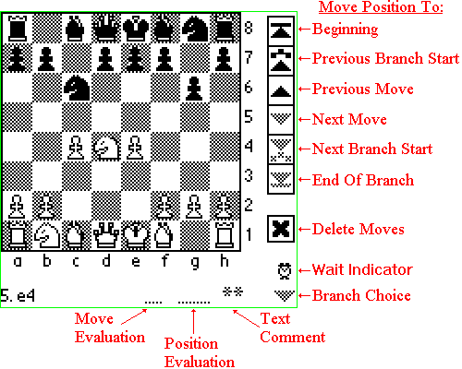
Every move can be commented. There are three types of comments: Move Evaluation Comment, Position Evaluation Comment and generic Text Comment. To enter a comment just tap on it. For predefined comments (stored as glyphs in PGN format) you’ll see a popup listbox. For Text Comment a special popup form will allow you to enter your text. If Text Comment is present, you’ll see “**” indicator.
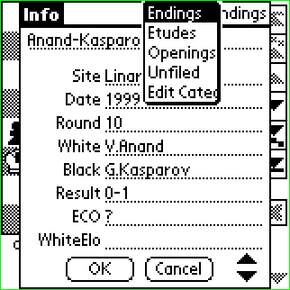 | At the beginning of the game tap on Text Comment will pop up the Info form.  Here you can enter the game (DB) name, its category, edit categories and enter PGN header information. Scroll buttons allow to see and update 11 header items. If you decide to abandon the changes you made, click on “Cancel” button.

Position Setup
When you click “Setup” command, you create a new game in Setup mode. The starting position is copied from your last game. If you decide to abandon the current position and restore the starting one, click on “Reset” button. When you are done with setup click on “Setup” menu command. ChessPad will exit Setup mode and will record your moves as usual.
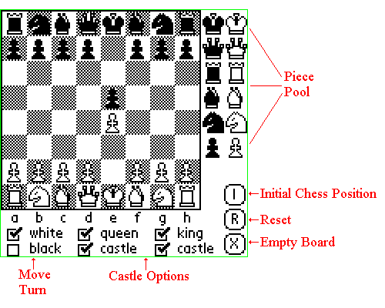
If you leave your game in Setup mode by opening another game, you can later re-open it and continue your setup.
Preferences
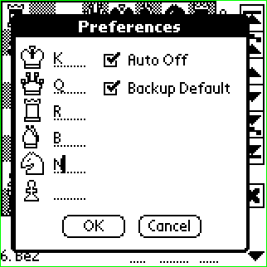 | On this screen you can define pieces notation. This feature is useful for non-English users. The set will be used in Pilot PGN converter (see below) also.  You can also control Pilot “Auto Off” mode while in ChessPad.  “Backup Default” when unchecked disables hotsyncing DBs with default names (makes sense for registered version only).
PC PGN converter
This utility allows you to move your games between ChessPad and any chess base program that understands PGN format. The converter allows you to have different sets of piece notation for different languages. Note that FEN notation is defined for English only, so if you start recording a game from non-initial chess position, your notation preferences for position are ignored. “Direction” button changes the conversion direction. Only one input file can be specified, no wildcard characters.
Converting PGN files to ChessPad:
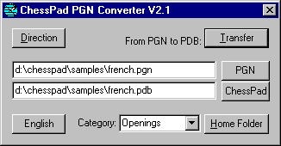 | Select input and output files, choose piece set, category and click “Transfer”. If your output file is located in your Home Folder, just hotsync your Pilot to complete transfer. Otherwise you have to use Pilot Install tool. Note. In order to use Categories defined in ChessPad, you have to hotsync Pilot prior to using converter.
Input PGN file may consist of several games. In this case every game will be converted to a separate ChessPad DB. Maximum PGN file length is 65535 byte. Note. In order the categories to become available you have to hotsync Pilot after you make changes to Categories within ChessPad.
To change the notation set click on “English” button (in fact, the label always shows the label of the current set).
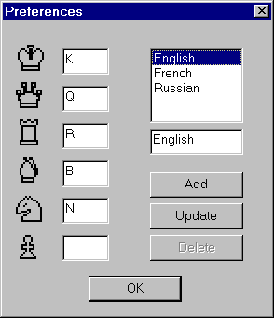 | To change any field in the selected set, just type your changes and click on “Update” button. To add a new set, type the new information and click on “Add”. “Delete” button is just a placeholder and is not functional.  Your selection becomes active for further transfers.  Note. The “factory default” is English only. You can add as many sets as you wish.

Converting ChessPad databases to PGN files:
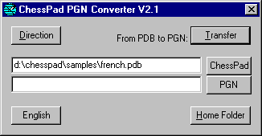 | Hotsync your Pilot, select input and output files, choose piece set and click “Transfer”. Your output file will be written using the set you chose.  “ChessPad” button pops up a special FileOpen dialog that allows you to select a ChessPad category for input in “Files of type” field.

Palm PGN converter
PGN converter for Palm Pilot is the “last resort” feature for non-PC users. It transfers games between ChessPad and Memo. All PC users are encouraged to use cpConv.exe utility (see above) that has more flexible interface. The major limitations of the Palm converter are the memo size (4K), Memo categories binding and not too convenient process of transferring games.
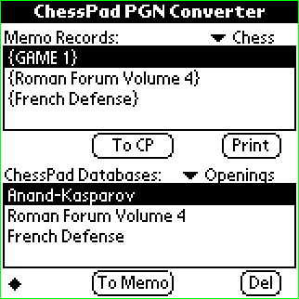 | The screen is divided in two parts. The top one shows Memo records in the specified category. The “To CP” button converts selected memo into ChessPad DB.  The bottom one shows ChessPad databases in the specified category. “To Memo” button converts selected DB into Memo. “Del” button deletes the selected DB.  Note that conversion sometimes takes rather long time, so wait while you see the clock indicator on the screen.  ‘Print’ button prints from Memo, works only with PalmPrint program.  Databases converted with this converter do not hotsync until opened in ChessPad.

Unregistered copy restrictions
Unregistered ChessPad does not allow you to save your games in Memo or PGN files.
Comments, Suggestions.
As we are working constantly on making our software more useful and friendly, we welcome all your comments. Please send them via email to solutions@hand.org.

