Table of Contents
Table of Contents 1
Introduction 1
Documentation 2
1. Registration 2
2. Date Window 2
1. Purge 3
2. Preferences 3
3. Modification Window 3
1. Choose A Lift 4
2. Create A Set 5
3. Sort/Delete A Lift or Set 5
4. Create a SuperSet 6
5. Add A Note 7
6. Save A Workout 7
7. Replace a Workout 8
4. History Window 8
1. Rename/Change Date on Workouts 9
2. Copy Workouts 9
3. Delete Workouts 10
4. Beam A Workout 10
5. Export/Import Workouts 11
6. Sort History Records 12
5. Workout Window 12
1. Pause Workout 12
2. Save Workout 13
3. Change Sound 13
6. Edit Lifts Window 14
7. Graph Progress 15
8. Decimal Weight 16

Introduction

Dear User,

I am so glad you have chosen Weights to review or to purchase. I have been weight lifting for 20 years and like many of you, I have had to carry a notepad or journal to record my lifts and sets. Finally, I gave up and decided to write Weights. Weights v5.0 has been designed for rapid workout creation. Lifts, sets, and supersets can be created with little effort using 78 pre-defined lifts or from user-defined lifts. Different periods of rest time between sets and lifts can be defined for each lift. Maintain notes before and after each workout. Export workouts to send to friends or clients. Weights replaces your workout journal for an electronic one.

Registration:

You do not have to re-download Weights. The shareware version that you have now can become the full-blown version just by entering in the registration code. See Documentation below on how to register once you have obtain a registration code from one of the following sites:

To order call 1-877-438-4843 or use the Internet at www.palmtrainer.com, www.palmgear.com, or www.handango.com.

www.palmtrainer.com is a new web site for Weights and Body Fat Calculator (BFC). From this site, you can purchase services such as advice from a trainer or buy workouts.

Sincerely,

Jeff Ayers
jeff.ayers@palmtrainer.com

Documentation

1. Registration

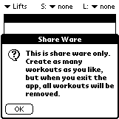
When you first load Weights onto your Palm or Visor, you will get an annoying nag shareware message. It clearly states that you can create as many workouts as you like as long as you do not leave Weights. This will allow you to try all features. Of course, once you purchase Weights, you will receive a registration code, which will allow you to create unlimited number of workouts.

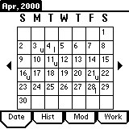
To register your Weights program, first obtain a registration code from any of the vendors listed in the introduction above. Click on the annoying nag message pictured above. If you are not already there, you must select the Date tab at the bottom of the screen. Then select menu option, Register, to display the registration screen. Then enter your registration code. This code is 12 characters long and is case sensitive.
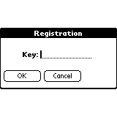
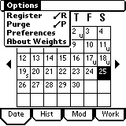

2. Date Window

The first screen of the three above is the Date window. It contains the calendar of the current month. On each day you workout, the first character of each workout’s name will appear in the lower right hand corner. It is important that you choose the first character of your workout name carefully. I prefer ‘u’ for upper body and ‘l’ for lower body. As a result, in one glance, you can determine how long you have waited between workouts and which type of workout is next.

Select one of the days that has a letter in it, and Weights will display that workout in the Modification window.
At the bottom of the Date window, there are four tabs: Date, Hist, Mod, and Work. Each tab takes you to another Weights window. Date, of course, takes you to the Date window.

1. Purge

Once you have been using Weights for awhile, you may want to purge old workouts 3 to 12 months and older. Select the Purge menu option from the Date Window.

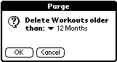
12,9,6, or 3 months. All Workouts older than the time period you have chosen will be purged.

2. Preferences

Preferences window allows the user to turn on two features: Decimal weight and/or Intensity. Decimal weight is for anyone who uses kilograms. The Intensity of a workout is used to help determine effort and whether or not to increase weight. For example, if your last lift was at 95% intensity, then increase weight or reps to reach 100% intensity.

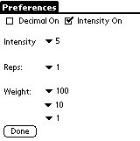
Check the Decimal check box if you want to use decimal weight. Go to the Decimal section of this document for a more detail discussion.

The Intensity, Reps, and Weight popup lists are used to decide the increments on each field. For example, intensity of 5 means that the up-down arrows in Modification screen and Workout screen increments the intensity by 5 up or down. You can change this to 10, 5, or 1.

Notice that Weight has three increments: large, medium, and small. The large weight increment, by default, will increment by 100 pounds or kilograms. It can be changed to 100, 50, or 25. The medium weight increment, by default, will increment by 10 pounds or kilograms. It can be changed to 25, 10, or 5 pounds or kilograms. And finally, the small weight increment, by default, will increment by 1 pound or kilograms. It can be changed to 10, 5, or 1 pounds or kilograms.

I threw in an increment for reps only for consistency. I doubt very seriously that anyone will change it from 1 to 10 or 5. But, you can if you want to.

Note: In the examples throughout this document, I assume that the Intensity feature is on.

3. Modification Window

Tap the Mod tab with your stylist. This will take you to the Modification window where you will create and modify your workouts.

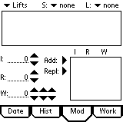
This screen was designed for rapid workout entry. At the top, there are three popup lists. The first, Lifts, contains a list of lift types. The two popup lists on the upper right specify the amount of rest time between sets and between lifts for each lift. The bottom portion of the window is used for set creation. As we create a workout, each feature of the window will be explained in detail.

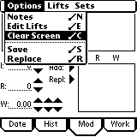
Tap the Palm menu button to display the Modification menu bar. There are four menus with the first, Option menu, leading you to the Edit Lifts section of this document. There you can create, delete, and modify your own lifts. The Clear Screen does just that.

Use the Save menu option to save your workouts and use the Replace menu option to replace an existing workout.

1. Choose A Lift

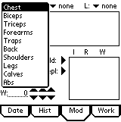
Select the Lift Types popup. Weights comes with a default list of Lift Types. Later in this document you will find out how to edit this list. Select the Lift Type Chest before proceeding to the next section.

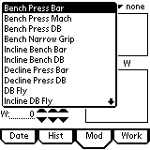
The Lift Type you selected above defines what you see in the Lifts list. In this case, Chest lift type was selected which leads to the Lifts shown to the left. Again, later in this document you will find out how to edit this list. Select ‘Bench Press Bar’ lift and move to the next section.

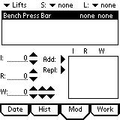
When you select one of the lifts, the name of the lift is placed into the largest scroll list box. In the picture left, Bench Press Bar was added along with the set and lift time. Later, we will change these two times to alternate rest periods for each lift. You can add up to 25 lifts to any workout.

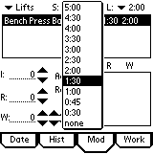
As I mentioned above, the two popup lists in the upper right define the amount of rest between sets and between lifts for each lift.

Defining these two times has implications on the workout defined in the Workout section of this document. The reason for defining these rest periods is to keep the workout moving along at a good pace. With the rest times I specify, my workouts stay under an hour.

In the example to the left, I have defined one minute and thirty seconds rest between ‘Bench Press Bar’ sets, and two minutes rest between ‘Bench Press Bar’ lift and the next lift.

2. Create A Set

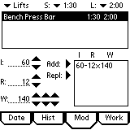
At the bottom of the Modification window, there are three fields Intensity, Reps, and Weight each having a set of repeating arrows. The first field, Intensity, allows a user to determine the level of effort to complete the set. The middle field is the Reps field and the last field is for Weight. You will notice that the Weight field has three sets of arrows. The first is for large increment, the second for medium increment, and the last for small increment. The user can define these in the Preferences screen. The defaults are 100, 10, and 1.

Tap the ‘Add’ arrow button to define and display a set in the small right scroll list. In the example, above, the user should put 60% intensity into the workout, with 12 reps, 140 pounds or kilograms. Once you have defined a set, you can modify it by tapping it from the small right scroll list, changing the intensity, reps, or weight, and then tap the 'Repl’ arrow button to replace the set.

Note: You can turn off/on the Intensity feature from the Preferences screen.

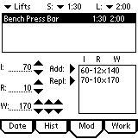
Each time you hit the Add arrow, a new set is created. You can add up to 15 sets per lift.

For those of you who want to use decimal weight, go to the Decimal section of this document.

3. Sort/Delete A Lift or Set

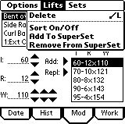
Tap the Palm menu button and then select the Lifts menu. From this menu, you can delete a selected lift or sort that lift or add/remove that lift to/from a superset. Select the Sort On/Off option from the Lifts menu or tap a lift or set twice.

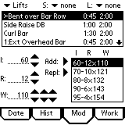
Notice the greater than sign ‘>’ next to the ‘Bent over Bar Row’ lift. This indicates that you can now sort this lift by pressing the hardware scroll button located at the very bottom of your Palm or Visor.

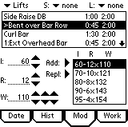
Push the hardware scroll button down once, and the ‘Bent over Bar Row’ has moved down one position.

To turn this off, tap the record with the ‘>’ or tap the Palm menu button and select Sort On/Off menu option from the Lifts menu. Now tap the Palm menu button and select the Set menu.

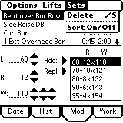
Select a set from the set list before tapping an option on the Set menu. From this menu, you can delete a set or sort a set in the list. Sorting a set works the same way as sorting a lift. Tap a set twice or tap the Sort On/Off menu option, and then press the hardware scroll button at the bottom of your Palm device.

4. Create a SuperSet

First, make sure you select a lift from the lift list. Tap the Palm menu button and then select the Lifts menu. There are two options involved in the addition or subtraction of a lift to a superset.

Select the Add to SuperSet menu option.

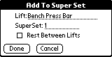
Enter a superset number and remember, each member of the superset must have the same number of sets; otherwise, Weights will not allow you to add this lift to that superset. The Rest Between Lifts check box allows a user to rest between lifts in a superset. Tap the Done button to finish.

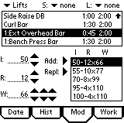
In the example to the right, I have created a superset of two lifts: ‘Ext Overhead Bar’ and ‘Bench Press Bar’. Without rest between lifts, the user will move from ‘Ext Overhead Bar’ to ‘Bench Press Bar’ without rest.

5. Add A Note

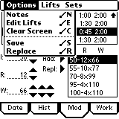
Tap the Palm menu button and then select the Notes menu option. The Notes window will appear below.

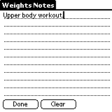
At this point, you can write yourself a long note up to 4096 characters long. Later, you can add/change/delete the note after running this workout.

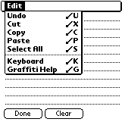
In addition to creating notes, you can also import notes from Memo pad or other Palm apps that support Undo, Cut, Copy, Paste, and Select All features.

6. Save A Workout

To save a workout, tap the Palm menu button and then tap the Save menu option.

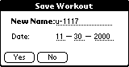
Enter a meaningful workout name like ‘u-OneLift’. Remember that the first character of your workout name will appear on the Date window. I use ‘u’ for upper body and ‘l’ for lower body. Tap the Yes button to save your first workout.

In addition to the name, there is also a date field that you can modify. With this feature, you can assign a workout to some future date allowing you to plan workouts well in advance.

Please note that anytime you make a change to an existing workout, the above Save Workout window will appear and ask you to save your changes.

7. Replace a Workout

To Replace a workout, tap the Palm menu button and then tap the Replace menu option.

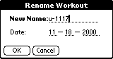
The Rename Workout window will appear and give you the opportunity to change the name of the workout as well as the date.

4. History Window

After saving above, Weights automatically sends you to the History window. You will probably find that you will live in this window.

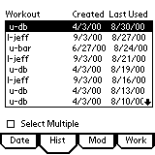
The history window is your list of workouts displayed in descending date order. From this window, you can Copy, Delete, Rename, Beam, or Export one or multiple workouts.

If you wish to modify a workout, select from the list and then tap the Mod tab at the bottom of the window.

If you wish to run one of the workouts, select from the list and then tap the Work tab at the bottom of the window.

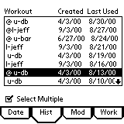
To perform any task on multiple workouts, first you must tap the Select Multiple checkbox, and then tap as many workouts from the workout list as needed. You will notice, left, that the workouts I selected have an ‘@’ sign in front of each.

Of course, you are not required to use the Select Multiple if you wish to perform a task on one workout. Just tap on a workout from the list to select it before choosing an operation like delete.

1. Rename/Change Date on Workouts

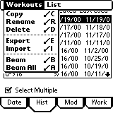
The Rename menu option has two functions. It allows a user to rename one or more workouts, and it allows a user to change the date on one or more workouts. You are not required to change the name if you wish to change the date. Tap the Rename menu option to rename the selected workout(s).

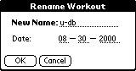
Either change the name or change the date and then press the OK button. If you selected multiple workouts, then each time you tap the OK button, the next workout to rename will appear.

2. Copy Workouts

Use this feature to copy one or more workouts. If used in conjunction with rename, you can plan your workouts weeks or months in advance. In the example below, I have chosen to show you how to copy multiple workouts. However, you can copy one workout by simply selecting it from the History list and then tapping the Copy menu option.
To copy multiple workouts, tap the Select Multiple checkbox, and then tap as many workouts from the History list box, as you want to export. Each time you select a workout, the ‘@’ is placed in front of the workout name. If you tap the checkbox again, all ‘@’ will be removed.

Once you have selected each workout, tap the Palm menu button to display the History menu.

Tap the Copy menu option to copy all selected workouts.

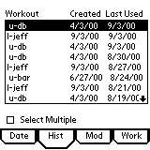
You will notice that each copied workout is given today’s date. In the example, u-db, l-jeff, and another u-db have all been given the date 9/3/00, which was the current date.

3. Delete Workouts

Use this feature to delete one or more workouts. In the example below, I have chosen to show you how to delete multiple workouts. However, you can delete one workout by simply selecting it from the History list and then tapping the Delete menu option.
To delete multiple workouts, tap the Select Multiple checkbox, and then tap as many workouts from the History list box, as you want to export. Each time you select a workout, the ‘@’ is placed in front of the workout name. If you tap the checkbox again, all ‘@’ will be removed.

Once you have selected each workout, tap the Palm menu button to display the History menu.

Tap the Delete menu option to copy all selected workouts.

4. Beam A Workout

If one of your friends has the Weights program, then you can use the Palm’s infrared device to beam a workout or all of your workouts to him or her. Trainers may like this feature for their clients that own a palm device.

5. Export/Import Workouts

The Export Workouts menu option is used to create a file called ‘weights_export.pdb’. The Import Workouts menu option is used to import that same file.

First, tap the Select Multiple checkbox, and then tap as many workouts from the History list box, as you want to export. Each time you select a workout, the ‘@’ is placed in front of the workout name. If you tap the checkbox again, all ‘@’ will be removed.

Once you have selected each workout, tap the Palm menu button to display the History menu.

Tap the Export Workouts menu option to export selected workouts. Tap the Import Workouts menu option to import workouts. You could use this feature to do mass copies on your own Palm.

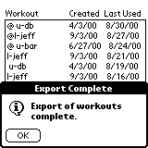
When the export is complete, the Export Complete alert will display left. You have now created your file.

Perform a hot sync with your Palm device to backup the exported workouts. On your PC, go to your backup directory located in your ‘c:\Palm’ directory and find ‘weights_export.pdb’. You can send this file via email to friends or clients with Weights 4.0.

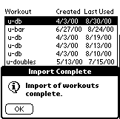
When you import workouts, the Import Complete alert window displays shown here.

6. Sort History Records

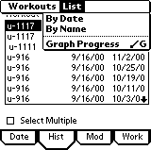
What good is a list if you can’t sort it? There are two ways to sort workouts. The default is to sort by date. The other is to sort by workout name and then by date.

5. Workout Window

The Workout window was designed to display your lifts in the order defined when you created the workout.

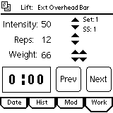
The top part of the Workout window displays the first lift in your workout. Just below the line, there is a ‘Set’ counter. This is useful if several of your sets have the same reps and weight combinations. The ‘SS:1’ only appears if you have defined a superset number.

The Notes animated icon is just to the left of the lift. You can tap the icon to display/change notes. The icon will move to indicate that you should read the notes before working out.

The middle displays the first set. You can change the intensity, reps, or weight before or after you lift. If you forget to change the reps or weight, and hit the ‘Next’ button by mistake, don’t worry. Tap the Prev button, change the reps or weight, and tap the Next button to move forward again.

At the very bottom, there is a count down box that contains the amount of rest time between sets and lifts. Each time you press the Next button to move to the next set or lift, the count down begins.

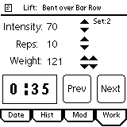
In this example, I have tapped the Next button to move to the next lift. You notice that the count down is 35 seconds away from starting your next lift. You do not have to watch the Palm screen as it counts down. When the count down is within 10 seconds, a beep will occur for each second and an alarm will occur when the time reads zero.

1. Pause Workout

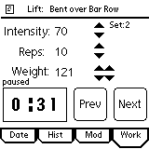
While working out, you may get interrupted and wish to stop the countdown until the interruption leaves. Just tap the countdown box to stop the countdown. This will stop the workout and display the word ‘paused’ just above the countdown box. Tap the countdown box to continue the countdown.

2. Save Workout

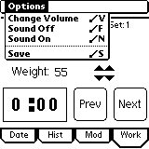
Once the workout is complete, tap the Palm menu button and select the Save menu option.

The Save window pops will appear. Change the name or date and then tap the Yes button.

3. Change Sound

On occasion, while working out, you may need to adjust the sound volume or the auto-off timer. Tap the Palm menu button and then tap the Change Sound menu item. This will take you to the General Preferences screen. Change the sound or timer and then tap the Done button to return to the Workout window.

Tap the Sound Off menu option to turn the sound completely off, or tap the Sound On menu option to turn it back on.

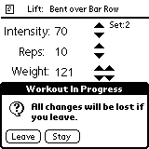
Sometimes during a workout, you may accidentally hit one of the tabs at the bottom of the screen. If you do, then an alert will appear warning you that you will loose all changes if you leave the workout screen.

This screen will not appear if you hit one of the palm buttons. Weights remembers where you left off and will display the same screen when you return to Weights.

6. Edit Lifts Window

In the Modification window described above, I said that you could change the Lift Types and lifts. To accomplish this feat, go back to the Modification window and tap the Palm menu button.

Tap the Edit Lifts menu item to display the Edit Lifts window.

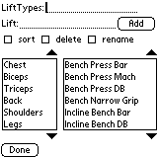
This window allows the user to add new Lift Types and lifts. Delete the old Lift Types or lifts, sort them, or rename them.

The delete checkbox only works for one delete at a time. Once you delete an item, the checkbox will uncheck itself. This prevents any delete accidents.

The sort checkbox works the same way as the sort checkbox in the Modification window. Tap the ‘sort’ checkbox, select a Lift Type or Lift, then tap the up or down scroll arrows.

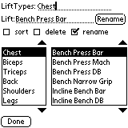
Select either the Lift Type Chest or the Lift Bench Press Bar. Then tap the rename checkbox. What you will notice is the Add button was changed to Rename. Change either the Lift Type name or Lift name and tap the Rename button.

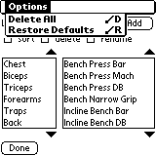
If you want to start from scratch, then tap the Palm menu button and then select Delete All menu item.

If you want to restore the defaults, then tap the Palm menu button and then select Restore Defaults menu item.

7. Graph Progress

On occasion, you may want view your progress in graph form. This is accomplished by going to the History window and then tap the Palm menu button. Select the Graph Progress menu item.

The Graph Progress screen will display. The top portion of the window is used to specify the lift and rep you want to graph. There are two ways to enter the number of reps. You can select from the drop down list or use Palm Graffiti to enter a number.

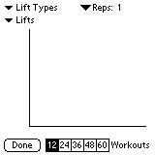
The middle portion, of course, is for the graph itself.

At the bottom, the different push buttons represent the number of workouts to display.

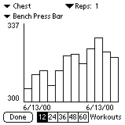
In this example, I selected ‘Bench Press Bar’ and left the reps at one. The graph displays the last 12 workouts for weight over a period of time. You will notice that the first date is the same as the second date. I had to add several workouts in order to illustrate this feature.

The weight number at the top of the graph is the maximum weight you achieved during the time period. And the weight number at the bottom is the minimum weight you achieved during the time period.

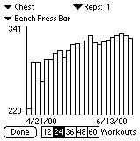
Here, in this example, I selected the last 24 Workouts push button. Notice the change in appearance from the previous graph. I threw in a small number to illustrate the graph’s capability in handling a large range of numbers.

8. Decimal Weight

For metric users, I have added the ability to use decimal weight.

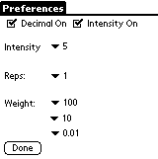
Go to the Date window and tap the Palm menu bar. Select the Preferences menu option to display the Preferences window. Tap the Decimal check box and then tap the Done button.

Notice that the last small increment for Weight has changed. You can select from 0.25, 0.10, 0.05, or 0.01 increments.

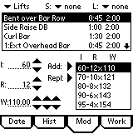
Go to the Modification screen. Instead of 110, it displays as 110.00. The third set of arrows to the right of the weight will increment the decimal portion of the number.

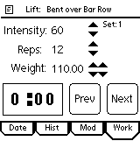
Go to the Workout screen. Notice that the Weight field has changed here as well. Instead of 110, it displays as 110.00. The second set of arrows to the right of the weight will increment the decimal portion of the number.

