Introduction

Dear User,

I am so glad you have chosen Body Fat Calculator (BFC) to review or to purchase. The BFC is a tool to help a person determine their body fat percentage in complete privacy - anywhere - anytime. Body fat percentage is the actual amount of body fat a person carries, as opposed to lean mass (including bone, muscle, organ tissue, blood and everything else). This method of determining fat levels is considered more accurate than simply weighing yourself on the scale, which can give a faulty measure of fitness. Knowing your level of body fat can help you to determine if your current fitness routine is working to decrease you body fat while maintaining and increasing lean mass. Always keep in mind that when you are trying to lose "weight", what you really want is to lose "fat".

To use the BFC you will need a set of body fat calipers (available at www.palm-trainer.com).

Registration:

You do not have to re-download BFC. The shareware version that you have now can become the full-blown version just by entering in the registration code. See Documentation below on how to register once you have obtain a registration code from one of the following sites:

To order call 1-877-438-4843 or use the Internet at www.palm-trainer.com.

Sincerely,

Jeff Ayers
jeff@palm-trainer.com

Documentation

1. Registration

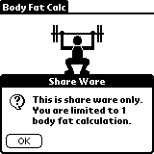
When you first load BFC onto your Palm or Visor, you will get an annoying nag shareware message. It clearly states that you are only able to create one body fat calculation. Of course, once you purchase BFC, you will receive a registration code, which will allow you to create unlimited number of calculations.

To register your BFC program, first obtain a registration code from www.palm-trainer.com. Tap on the annoying nag message pictured above. Then select menu option, Register, to display the registration screen. Then enter your registration code. This code is 12 characters long and is case sensitive.

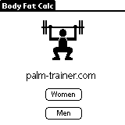
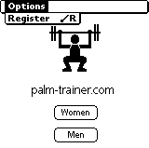
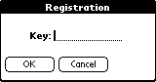

2. Body Fat Calculation for Women

To begin calculating body fat for women, first tap the Women’s button on the main window. The calculations for women are different from men and must be kept separate.

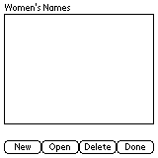
This is an empty list that will contain a list of calculations for each woman. Tap the New button to display the BFC for Women screen.

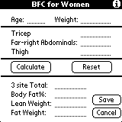
The BFC for Women screen requires you to enter your age and weight at the top of the screen. Then use your calipers and measure three areas: triceps, far right abdominal, and your thigh. The process for using the calipers is described in section four of this document. You can also access tips by tapping the “i” in the upper right corner, or via the Menu option.

Enter each measurement into BFC for Women and tap the Calculate button.

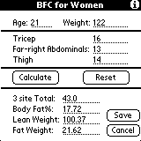
In this example, I entered the numbers for a 21-year-old woman weighing around 122 pounds. I entered some fake measurements and tap the calculate button.

The results show the total of the three measurements: 16 + 13 + 14 = 43, and it shows the body fat percentage. Using the body fat percentage, BFC then calculates the lean weight and fat weight.

Tap the save button.

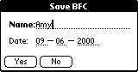
Enter your name and tap the Yes button to save the results of your calculations.

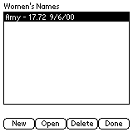
The list displays the name of the woman and her body fat percentage along with the date the calculations were taken.

3. Body Fat Calculation for Men

To begin calculating body fat for men, first tap the Men’s button on the main window. The calculations for men are different from women and must be kept separate.

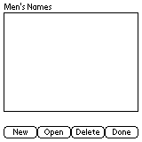
This is an empty list that will contain a list of calculations for each man. Tap the New button to display the BFC for Men screen.

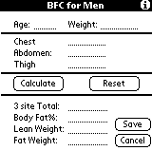
The BFC for Men screen requires you to enter your age and weight at the top of the screen. Then use your calipers and measure three areas: chest, abdomen, and your thigh. The process for using the calipers is described in section four of this document. You can also access tips by tapping the “i” in the upper right corner, or via the Menu option.

Enter each measurement into BFC for Men and tap the Calculate button.

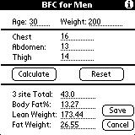
In this example, I entered the numbers for a 30-year-old man weighing around 200 pounds. I entered some fake measurements and tap the calculate button.

The results show the total of the three measurements: 16 + 13 + 14 = 43, and it shows the body fat percentage. Using the body fat percentage, BFC then calculates the lean weight and fat weight.

Tap the save button.

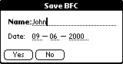
Enter your name and tap the Yes button to save the results of your calculations.

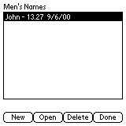
The list displays the name of the man and his body fat percentage along with the date the calculations were taken.

4. How to use Calipers

All measurements should be taken from the right side. It is best if you have a friend do the measurements for the most accurate results.
To measure the skinfold, you must get a parallel fold of flesh between your fingertips and lift it off the muscles. When you use the Accu-Measure calipers (available at Palmtrainer.net), the calipers should be held with the thumb in one groove with the index and middle finger in the opposite grooves. Begin with the slider to the far right. Press with the thumb where indicated on the Accu-Measure Personal Body Fat Tester until you feel a slight click. The slider will automatically stop at the correct measurement.
Wait 2 seconds and take your reading. After reading your measurement, return the slide member to the far right starting position. Each reading should be taken three times. You should release the skinfold between measurements to avoid pushing water out of the skinfold and getting progressively lower measurements.

1. Males:

Chest, a diagonal fold taken 1/2 between the nipple and the upper portion of the pec.

Abdomen, a vertical skinfold taken 1" to the right of the belly button.

Thigh, a vertical skinfold taken 1/2 the distance between the kneecap and the inguinal crease (the fold you get between thigh and groin when you lift your leg).

2. Females:

Triceps, a horizontal skinfold taken 1/2 the distance between the acromion process (pointy bone in shoulder) and the elbow on the backside of the arm.

Far right Abdominal, a diagonal fold taken above the superior anterior iliac crest (hipbone).

Thigh, a vertical skinfold taken 1/2 the distance between the kneecap and the inguinal crease (the fold you get between thigh and pelvic area when you lift your leg).

5. General Body Fat Percentage Categories

Classification | Women (% fat) | Men (% fat)
Essential Fat | 10-12% | 2-4%
Athletes | 14-20% | 6-13%
Fitness | 21-24% | 14-17%
Acceptable | 25-31% | 18-25%
Obese | 32% plus | 25% plus
*American Council on Exercise

