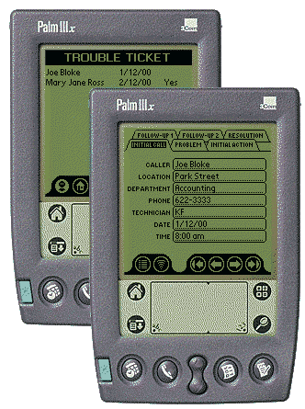

Trouble Ticket

For Palm OS Handheld Devices

Contents
Introduction 1
Issue Management 1
Application Design 1
Installation 4
Trouble Ticket Application 4
Option: Sample Database File 5
Running Trouble Ticket 6
Requirements & Limitations 7
System Requirements 7
Limitations 7
Application Usage 8
Adding A New Record 8
Viewing Existing Problems 10
Escalation of Issues – Follow-Up Action & Resolution 12
Record Deletion 13
Beaming Records to Other Trouble Ticket Users 13
GoType! Keyboard Support 15
List View Screens 15
Individual Record Screens 15
Known Issues 16
Licence Agreement 17
LICENCE TERMS AND CONDITIONS 17
WARRANTIES, WARNING, DISCLAIMER 17

Introduction
Trouble Ticket for Palm OS Handhelds is an application designed to capture Help Desk reports and to follow those reports to resolution, whether successful or unsuccessful.
The application is designed to be open enough to not restrict it to use in I.T. environments. A building superintendent, for example, could use Trouble Ticket to keep track of problems that occur in his buildings. The scope of usage is almost boundless.

Issue Management
The application design is based on the following ideas with respect to issue management:
- All information with respect to an issue should be recorded in as much detail as possible. Proper recording of the initial problem allows the Help Desk attendant, or the engineer receiving the problem report to make a proper assessment at first reading. Proper recording at every level allows for proper action at subsequent levels of escalation.
- Any problems should be resolved after at most two degrees of escalation. If a problem is not resolved after two degrees of follow-up, it is an indicator of a misdiagnosis of the original problem, or of improper action at escalation. In either case, a problem needs to be reviewed and reopened as a new problem.
- Resolutions of all problems are to be properly recorded on closure. This will assist in the diagnosis and treatment of similar problems that may occur later.

Application Design
The application serves as a data capture, structured to meet the requirements of issue management outlined above. There are two types of views – List views and individual record views. Details of these are outlined below.

List Views
The application provides the facility for viewing the list of reports by issue reporter, location of the issue, and summary of the problem. Each list also includes the date on which the problem was reported, and a status indicator (Yes/No or Blank) to show whether the problem has been resolved.
Reporter, | Location, and | Problem Summary.
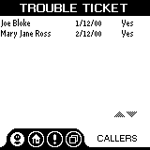 | 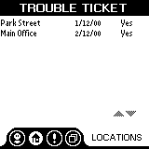 | 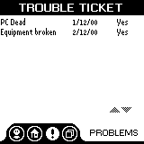

Individual Record View
Individual issues are presented in a tabbed layout, with grouping of relevant data items. Initial report data, first action, and follow-up and resolution information are all captured and viewed on their own tabs in a single screen.
Initial Call, | Problem, | Initial Action,
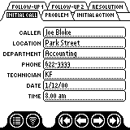 | 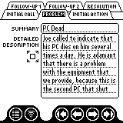 | 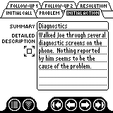
Follow-up Action Data, and |  | Resolution
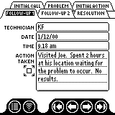 | 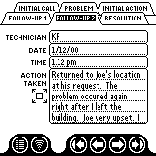 | 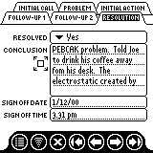

Installation
The package contains the following files:
- TTICKET.PRC – The Trouble Ticket Application
- MANUAL.DOC – This document.
- READMEPALM.TXT – README file and Quick Start Instructions.
- TROUBLEDB.PDB – Sample Trouble Ticket database file.

Trouble Ticket Application
- Open the downloaded self-extracting Zip file and extract all the files to the specified directory, or to one of your own choice.
- Use the Palm Install Tool to load the Trouble Ticket application onto your Palm device. The Palm Install Tool can usually be found under Palm Desktop on the Start menu. Click the Add button and locate the directory where you copied the Trouble Ticket files. Select the file TTICKET.PRC and click the Done button.
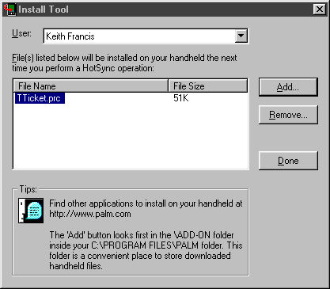
- Place you Palm device in its cradle and perform a HotSync. The Trouble Ticket application is now installed on your handheld and ready for use.

Option: Sample Database File
The download also contains a sample database file, TROUBLEDB.PDB, with two example problems. This may be installed in the same manner as the application above.

Running Trouble Ticket
Tap the Trouble Ticket icon to start the application.
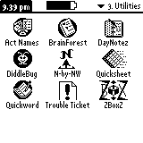
Trouble Ticket will open in the Caller List screen.
If you have installed the sample database, you will have two callers listed in the Caller List View screen. These two records can be viewed and edited at your leisure.

Requirements & Limitations

System Requirements
Palm OS 2.0 or greater.

Limitations
Limitations of applications generated with PDAToolbox v2.1beta apply.

Application Usage

Adding A New Record
From any of the List views, tap the New button.
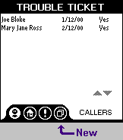
A new issue view screen will open.
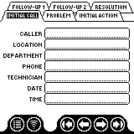
Tap on the fields indicated in the table below to activate them in turn, and enter data as specified in the table below.
Field | Data
Caller | Name of person calling in the problem or issue.
Location | General location of the problem occurrence, e.g. Main Street Branch
Department | Specific location of problem occurrence, e.g. Accounting Dept, Floor 3
Phone | Contact detail for caller. This can be a full phone number, extension number or even an e-mail address.
Technician | Identifier of the person taking the report. This can be a full name, initials, or an employee code.
Date | Date on which the problem was reported.
Time | Time at which the problem was reported.

Tap on the Problem tab, and enter a problem description on the tab.
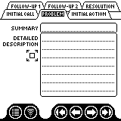
If the ‘Detailed Description’ field proves to be too small to record a full description, tap on the Expand button to its left.
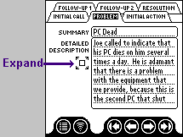
This opens a full screen for entry of the description.
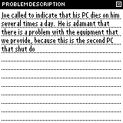
Tap on the ‘X’ in its top right corner to return to the Problem tab.
In most cases, initial action can be advised over the phone with the caller. In this case, the initial action will be recorded on the Initial Action tab. Tap on this tab to go to it for the current record.
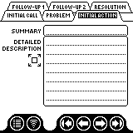
Enter a summary of the action, and a full description of the action taken in the Summary and Detailed Description fields. If the ‘Detailed Description’ field proves to be too small to record a full description, tap on the Expand button to its left. This opens a full screen for entry of the description, similar to that provided for the Problem Description. Tap on the ‘X’ in the top right of this screen to return to the Initial Action Tab.
Tap on the List View button to return to the List View.
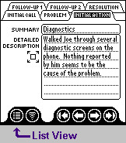
You should see your new problem listed on each of the three List View Screens.

Viewing Existing Problems
From any of the List View Screens, tap on the line containing the problem that you want to view.
For example, tapping on the line with “Park Street” from the Locations tab will open this problem’s record on the Initial Call tab.
Tap on the tabs at the top of the screen to view the contents of each tab.
Tapping on the four arrow buttons at the bottom of the screen will take you to the first, previous, next or last record in the database.
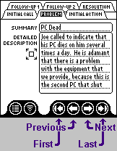
If any of the memo type fields contain more information than can be viewed on the tab, tapping on the Expand button – the square with the four arrows – next to these fields will all more of the text to be viewed.
Tap on the List View button to return to the Caller list view.

Escalation of Issues – Follow-Up Action & Resolution

Follow-up Action
To enter follow-up action information on a problem, select the problem on a List View screen, or navigate to the problem on the record screens.
Tap on the appropriate follow-up tab. If no action of this degree has been completed, the fields on the tab should be blank.
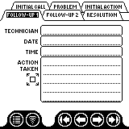
Tap on the Technician field to activate it and enter the name or identifier of the technician who is performing the follow-up action.
Enter the date and time of the follow-up action.
Enter the action taken at this degree of escalation. If this will not fit in the space on the tab, tap on the Expand button to use a larger editing area. Tapping on the ‘X’ in the top right corner of the expanded screen will take you back to the follow-up screen.

Resolution
The resolution report screen needs to be filled out in either of the following scenarios:
- The problem is solved after initial action or some degree of follow-up, or
- The problem is not resolved after two degrees of follow-up.
Select the problem to be updated.
Tap on the popup indicator in the Resolved field and select ‘Yes’ or ‘No’, indicating whether the problem has been resolved or not.
Tap on the Conclusion field and enter the conclusion report. Tap on the Expand button if you require more room to enter the conclusion.
Enter the date and time that this particular issue was closed.

Record Deletion
To delete a problem record, select that record on a List View screen, or navigate to the record on the record screens.
Tap on the screen’s Resolution tab to go to that tab.
Tap once on the Delete button.
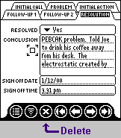
The record is now deleted.
NOTE: You will not be asked to confirm deletion of the record.

Beaming Records to Other Trouble Ticket Users
Trouble Ticket users can beam individual tickets to another user.
On a list view screen, select the record to be beamed. Alternatively, navigate to the record to be beamed on the individual record screens.
Tap the Beam button on any of the record’s tabs to commence the beaming operation.
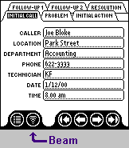
The receiving user will be asked if they want to receive the record. They should indicate ‘Yes’.
The application will open and attempt to display the record. The receiver of the beamed record should close Trouble Ticket by returning to the Applications screen, and then reopen Trouble Ticket.
The beamed record will now appear in their List Views, and can be edited and viewed in the Individual Record View.

GoType! Keyboard Support
The application now features limited shortcut command keys for the GoType! Keyboard.

List View Screens
Keystroke | Action
Command-Alt-C | Go to Caller List View
Command-Alt-L | Go to Location List View
Command-Alt-P | Go to Problem List View
Command-Alt-N | Create new record

Individual Record Screens
Keystroke | Action
Command-Alt-1 | Go to Initial Call tab
Command-Alt-2 | Go to Problem tab
Command-Alt-3 | Go to Initial Action tab
Command-Alt-4 | Go to Follow-up 1 tab
Command-Alt-5 | Go to Follow-up 2 tab
Command-Alt-6 | Go to Resolution tab
Command-Alt-M | Go to first record
Command-Alt-, (Comma) | Go to previous record
Command-Alt-. (Period) | Go to next record
Command-Alt-/ (Slash) | Go to last record
Command-Alt-N | Go to Caller List View
Command-Alt-D | Delete record (Resolution Tab only)

Known Issues
- No Confirmation is requested when deleting a record.
- When a beamed record is received, the receiver must close and open his Trouble Ticket application to view and edit his database.
- There are no scrollbars on memo-type fields.
- The application does not respond to the global Find on the Palm OS device.
The above limitations are inherited from the development environment. These will be addressed in minor version updates as they are addressed in the development environment.
- Use of DaggerWare’s MenuHack prevents access to the tabs in the individual record screen. When you tap on the tabs, the menu will pop up instead. Deactivate MenuHack before attempting to use Trouble Ticket. It is unknown how Trouble Ticket will behave in OS3.5, as tapping on an application’s title bar to drop the menu is a feature in OS3.5.x.

Licence Agreement
This Agreement sets forth your licensed rights to use TROUBLE TICKET and is granted to you upon condition that you accept the terms of this license. Your electronic indication of agreement, or your use of the program constitute acceptance of all of the terms of this license.
The program copy and documentation are furnished to make TROUBLE TICKET available for your use and remain the property of the author.
IF YOU DO NOT AGREE WITH ANY PART OF THIS LICENSE, DO NOT USE THIS SOFTWARE. Delete TROUBLE TICKET and all associated files from all media on which it has been copied.

LICENCE TERMS AND CONDITIONS

THE LICENSED PRODUCT
TROUBLE TICKET comprises copyrighted computer programs for the capture of help desk information. The Licensed Product is in its entirety protected by copyright. YOU MAY NOT DISTRIBUTE THE LICENSED SOFTWARE.

YOUR USE OF THE LICENSED PRODUCT
General Use. You have the right to use for the specified purpose of the licensed product.

LIMITATIONS ON USE
General Use Limitations. You have no right to reproduce, transfer, publish or otherwise distribute either the TROUBLE TICKET software, or any components or documentation provided.
THE AUTHOR RESERVES ALL RIGHTS NOT SPECIFICALLY GRANTED BY THIS LICENSE.

WARRANTIES, WARNING, DISCLAIMER
Warning and Disclaimer of All Warranties. THE PROGRAM IS FURNISHED "AS IS" WITHOUT WARRANTY OF ANY KIND, EXPRESS OR IMPLIED, IN ALL JURISDICTIONS WHERE ALL WARRANTIES MAY BE DISCLAIMED IN THE LICENSING OF INTELLECTUAL PROPERTY.
IN NO EVENT SHALL THE AUTHOR BE LIABLE TO LICENSEE FOR ANY SPECIAL, INDIRECT, INCIDENTAL OR CONSEQUENTIAL DAMAGES, INCLUDING, BUT NOT LIMITED TO, LOSS OF REVENUES OR PROFITS, EVEN IF LICENSOR HAS BEEN ADVISED OF THE POSSIBILITY OF SUCH DAMAGES.

