Chapter 2: Creating a Contents and Index

Preparation

Table of Contents
You must ensure that standard Heading styles have been applied to all the headings you want to include in the table of contents.
Add other hints and tips...

Index
You must ensure that index terms are specified in XE fields, normally in the heading of the section to which they relate.
Even more hints...

Inserting a Table of Contents or Index
To insert a table of contents or index, click where you want it, then either:
From the Insert menu, choose Index and Tables.
Press Alt + I, then D.
The Index and Tables dialog is displayed:
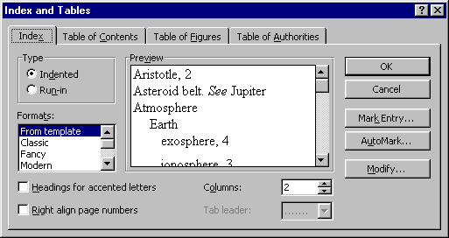

Using the Index and Tables Dialog
Click on the Index tab to create an index. For details, see Using the Index Tab 2.
Click on the Table of Contents tab to create a table of contents.
The tab has the following appearance:
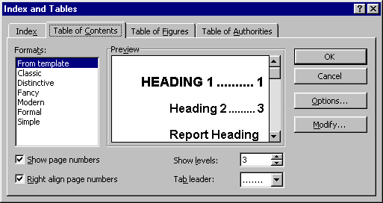
For details, see Using the Table of Contents Tab 2.

Using the Table of Contents Tab
Use this tab to create a Table of Contents for the document.

Formats
Select the From template format.

Show page numbers
Ensure that a cross appears in this check box so that page numbers are included in the table of contents. Otherwise, the converted HTML file will not contain hyperlinks in its table of contents.

Right align page numbers
Put a cross in this check box if you want the page numbers in the table of contents to be aligned to the right margin.

Show levels
Enter or select the number of heading levels you want to appear in the contents. For example, select 3 to including Heading levels 1, 2, and 3.

OK button
Click this button to create the contents as specified.

Using the Index Tab
Use this tab to create an index.
To be continued...

