TOTAL RECORDER

Version 3.2

Copyright © 1998-2001 High Criteria Inc.

Warning

Musical compositions and artwork are protected under international copyright laws. Unauthorized copying of those works may violate the rights of the owner and may expose you to civil and criminal penalties. You may not use the Total Recorder product to violate the copyright rights of others. High Criteria Inc. does not authorize you to use Total Recorder for the purpose of violating the copyright rights of others nor does it license or sell Total Recorder to you for this purpose. If you have any questions or doubts concerning your use, or copying, of someone else’s works, please confirm in advance that you are authorized to use and copy the work in the manner you intend.

Trademark Notice

Other product and company names appearing in High Criteria Inc. products and materials are used for identification purposes only and may be trademarks or registered trademarks of their respective companies. Registered and unregistered trademarks used in any High Criteria Inc. products and materials are the exclusive property of their respective owners.

What's NEW?

Version 3.2
In addition to maintenance, Version 3.2 adds the following features:
- Pre-recording mode. In this mode Total Recorder records continuously and stores the last specified number of seconds of data. When you push the Record button, this data is added to the beginning of your recording. For more information, refer to the "Pre-recording mode overview" section.
- The ability to edit ID3v2 tags. For more information, refer to the "Using the MP3 properties dialog" section.
- Automatic removal of gaps while recording in software mode. For more information, refer to the "Setting recording parameters" section.
- Improved stability and compatibility.

Version 3.0
Version 3.0 adds many new features, including the following:
- The ability to play and record compressed sound using installed codecs. For more information, refer to the "Working with MP3 Format" section.
- The ability to use external MP3 modules for recording in MP3 format. For more information, refer to the "Working with MP3 Format" section.
- Compatibility with Windows Millennium Edition.
- A Fast save capability. For more information, refer to the "Using Fast Save" section.
- Automatic stop after a specified amount of recording time. For more information, refer to the "Using Auto Stop Mode" section.
- Interface improvements.
Warning: Version 3.0 uses a new format of the registration key. When you install this new version, it will be unregistered until you enter a new registration key.
TABLE OF CONTENTS

What's NEW? 3
Version 3.2 3
Version 3.0 3
Overview 7
How Total Recorder Works with Different Sources 7
Software Recording 7
Software Accelerated Recording/Converting 8
Board Recording 8
System Requirements 8
Program Restrictions 9
Installation and Configuration 9
Installing Total Recorder 10
Specific Information for Windows NT 10
Specific Information for Windows 2000 10
Installation Steps 11
Installing/Uninstalling the Total Recorder Driver Manually 11
Configuring Total Recorder 16
Using the System Tab 17
Using the Open/Save Tab 19
Using the Algorithm Tab 21
Using the MP3 encoding Tab 22
Using the Pre-recording Tab 25
Using the Debug Tab 26
Registering Total Recorder 26
Uninstalling Total Recorder 27
Using Total Recorder 28
Setting Recording Parameters 28
Using Different Settings 30
Recording parameters 31
The Total Recorder Dialog 32
Properties 32
Status 33
“Interrupt work” button 34
“Recording source and parameters” button 34
Slider 34
Position (sec.) 34
Markers 34
Buttons 36
Recording 37
Starting Recording 37
Interrupting a Recording 38
Stopping a Recording 38
Saving a Recording 38
Using Fast Save 40
Using Auto Stop Mode 40
Accelerated Recording 41
Compatibility 42
Pre-recording Mode 42
Using Pre-recording Mode 43
Playing a Sound File 44
Pausing the Playback 44
Moving Within a File 44
Stopping 44
Playing a Selection 44
Normalizing a Sound File 44
Long Operations 45
Stopping a Long Operation 46
Working with MP3 Format 46
Using Codecs 46
Using DLLs 46
Selecting an MP3 Encoder 46
Types of MP3 Format 47
Setting MP3 Parameters 47
Using the MP3 properties Dialog 47
Displaying File and Recording Properties 48
Columns 48
Rows 49
Using a Scheduler 50
Launching Scheduled Jobs 50
Actions You Can Take During a Scheduled Job 50
Handling Errors and Other Problems 51
Displaying and Controlling Scheduled Jobs 51
Controls 53
Scheduling a Job 53
Job 54
Status 54
Date 54
Time 55
Recording source and parameters 55
MP3 file properties 55
File 55
Using the Command Line 56
General Command Line Syntax 56
Filename Parameter 56
/Play Parameter 56
/Record Parameter 56
/Time Parameter 57
/Normalize Parameter 57
/Noclose Parameter 57
Examples 58
Using the Total Recorder Log 58
Message list 59
Controls 59
Keyboard Shortcuts 60
Troubleshooting 61
Diagnosing Problems 65

Overview
Total Recorder is a sound recording and playing program. It records analog sound digitized by a sound card, as well as sound generated, or requested, by other computer programs, such as RealPlayer, Windows Media Player, Quick Time, WinAmp, and many others. Recorded sound is saved in wave-file format or you can use external programs to save recorded sound using MP3 format.
For example, you can use Total Recorder to record:
- audio from the Internet, either audio files or live streams
- music from a game program
- a conversation, if you use an Internet telephony program.
Total Recorder uses a virtual sound driver to capture the sound output from another program. By installing this driver, and setting this device as the default, different sound reproducing programs send their output stream to Total Recorder's driver and not to the driver of a real device. Total Recorder then passes the information to the sound card driver.

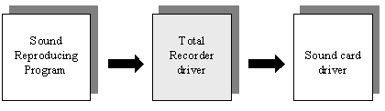
Total Recorder has a built-in scheduler. This allows you to automatically record a show at a given time for later playback or you can use the scheduler as an alarm. Note that this latter function does not require registration.

How Total Recorder Works with Different Sources
The following diagrams illustrate, in more detail, how Total Recorder works with different sources of input.

Software Recording
You can capture and record sound played back or requested by other computer programs.
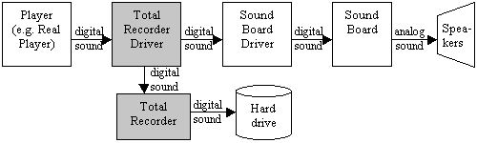

Software Accelerated Recording/Converting
You can speed up (or down) capturing and recording sound played back other computer programs. In this mode you could not hear a sound when a recording is in process.
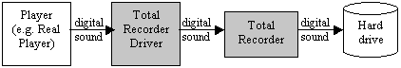

Board Recording
You can record sound digitized by a sound card. This includes a microphone, CD or other input lines.
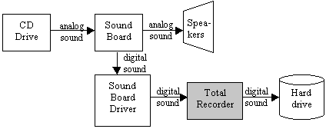

System Requirements
To use Total Recorder, you need the following:
- an IBM compatible computer
- a sound card
- Microsoft Windows 95, 98, ME (Millennium Edition), or 2000, or Windows NT 4.0.

Program Restrictions
Total Recorder records wave-type sound streams only. It cannot record any of the following:
- Sound reproduced by means of MIDI-output, unless your sound card has a special MIDI synthesis line (most sound cards have this feature).
- Sound reproduced by programs developed for systems other than Windows 95/98/Me or NT/2000 (e.g. DOS programs executing in DOS sessions).
Total Recorder can record only one output and one input sound stream at a time. If a sound card allows simultaneous output of several wave-streams and can mix these streams itself, then Total Recorder can only record one of these streams.

Installation and Configuration
Total Recorder is shipped via the Internet, as a self-extracting or regular archive, and consists of the files listed below. The following table indicates each file name, a description, and the environments in which each file is required.
File | Description | Required on Windows 95/98/ME | Required on Windows 2000/NT 4
TotalRecorder.exe | Total Recorder program | Yes | Yes
DrvTR95M.drv | device driver | Yes | No
DrvTRNTM.dll | device driver | No | Yes
DrvTR95L.dll | device driver library | Yes | No
DrvTRNTL.dll | device driver library | No | Yes
DrvTR95.vxd | virtual device driver | Yes | No
DrvTR95.inf | driver installation file | Yes | No
OEMSETUP.inf | driver installation file | No | Yes
TotalRecorder.hlp | help file | Yes | Yes
TotalRecorder.cnt | help content file | Yes | Yes
TRInst.exe | install/uninstall program | Yes | Yes
DrInst.exe | driver install/uninstall program | Yes | No
License.txt | license agreement file | Yes | Yes
Readme.txt | read-me first file | Yes | Yes
TotalRecorder.doc | documentation | Yes | Yes
Registration.txt | registration form | Yes | Yes

Installing Total Recorder
Beginning with version 3.0, Total Recorder uses a new format of the registration key. If you install version 3.2 over a version of Total Recorder that is older than 3.0, it will be unregistered until you enter a new registration key. The “Registering Total Recorder” section describes how to obtain a key, once you have installed and configured the software.
If you install version 3.2 over a registered version of Total Recorder 3.0, a new registration key is not required.

Specific Information for Windows NT
To install Total Recorder on Windows NT, you need the “Load and Unload Device Drivers” user right. Normally, only administrative users have this right.
To use the Total Recorder program, you do not need any special rights. However, the Total Recorder setup program changes settings only for the user who installed the program. Any other user must manual set the Total Recorder driver as a preferred device (see "Installing/Uninstalling the Total Recorder Driver Manually").

Specific Information for Windows 2000
Windows 2000 is a member of the Windows NT product family. All of the information in the previous section (“Installing Total Recorder in a Windows NT Environment”) applies to Windows 2000.
If you are planning to upgrade your Windows 95/98 system to Windows 2000, you must take the following steps:
- Before upgrading your Windows environment, uninstall Total Recorder.
- After the upgrade is complete, reinstall Total Recorder.
- Re-register Total Recorder. Have you registration information available.
Note: Total Recorder will not work if you simply upgrade your Windows environment to Windows 2000 without taking the steps described above.

Installation Steps
Version 3.2 cannot coexist on the same machine with any previous version (1.0, 2.0, 2.1, 2.2 or 3.0).
Take the following steps to install Total Recorder on your PC:
- Download the self-extracting archive totrec32.exe (http://www.highcriteria.com/download/totrec32.exe) and run it.
OR
Download the archive totrec32.zip (http://www.highcriteria.com/download/totrec32.zip). Unzip it and run TRInst.exe. Note that you must unzip the entire archive not just TRInst.exe.
If you have a previous version installed, you are prompted to uninstall it. Press “OK” to continue with the installation. Press “Cancel” if you want to exit the installation program without installing the software.
The installation program creates a directory for Total Recorder, copies all of the files to that directory, creates a Program Group called Total Recorder, installs a driver, and sets it as the default device for both playback and recording.
- After installing Version 3.2 over a previous version you must restart Windows. Under Windows NT or Windows 2000 you must reboot your PC, even after the initial installation. In all cases you will receive a prompt.
Tip:
Create a shortcut to Total Recorder and place it on your desktop. This gives you single-click access to Total Recorder.

Installing/Uninstalling the Total Recorder Driver Manually
If you experience problems with the automatic installation or uninstallation of the Total Recorder driver, you can install/uninstall this driver manually as described below. Otherwise, skip to the section “Configuring Total Recorder”.

Installing the Driver Manually
You need to install a virtual driver so that Total Recorder is able to record as well as play. This process is similar to that used for installing a sound card driver. The procedure you use depends on the version of Windows you are running.
Use the following procedure for Windows 95, Windows 98, or Windows ME:
- Select “Start”-“Settings”-“Control Panel”.
- Click on “Add New Hardware”.
- For Windows 95: Answer “No” to the question “Do you want Windows to search for your new hardware?”
For Windows 98/ME: Select “No - I want to select the hardware from a list” to the prompt “Windows can search for hardware that is not Plug and Play compatible or select from a list”.
- Select “Sound, video and game controllers” from the list of Hardware types.
- Click on “Have disk” instead of choosing from the list of manufacturers and models.
- Point to the directory you selected during the installation of Total Recorder (where DrvTR95.inf resides).
- There will only be one driver entry in this .inf file - Wave sound driver for the Total Recorder, and it will be selected by default. Click "OK" or press Enter.
- After clicking the “Finish” button, wait patiently for a wizard dialog window to disappear. It may take about one minute.
Use the following procedure for Windows NT 4.0:
- Select “Start”-“Settings”-“Control Panel”.
- Click on “Multimedia”.
- Select the “Devices” tab.
- Click “Add”.
- Click on “Unlisted or Updated driver” from the list of manufacturers and models.
- Point to the directory you selected during the installation of Total Recorder (where oemsetup.inf resides).
- There will only be one driver entry in this directory - Wave sound driver for the Total Recorder, and it will be selected by default. Click “OK” or press Enter.
- After the installation is complete, reboot your computer.
Use the following procedure for Windows 2000:
- Select "Start"-"Settings"-"Control Panel".
- Click on "Add/Remove Hardware".
- Click "Next" to continue.
- Select "Add/Troubleshoot a device" and click "Next".
- Select "Add a new device" and click "Next".
- Select "No, I want to select the hardware from a list" and click "Next".
- Select "Sound, video and game controllers" and click "Next".
- Click on "Have disk" instead of choosing from the list of manufacturers and models.
- Point to the directory you selected during the installation of Total Recorder (where oemsetup.inf resides).
- There will only be one driver entry in this directory - Wave sound driver for the Total Recorder, and it will be selected by default. Click "Next".
- Click "Next" again. A "Digital Signature Not Found" dialog appears.
- Click "Yes". A "Files Needed" dialog appears.
- Enter the same name as in step 9.
- Click "Finish".
- Close all applications and reboot your computer.

Setting preferred devices
After installing the virtual device driver manually, you must set this device as your default.
- Select “Start”-“Settings”-“Control Panel”.
- Select “Multimedia” (for Windows ME and Windows 2000 - "Sounds and Multimedia") and click on the “Audio” tab.
- Review the “Preferred device” list in the “Playback” section. Write down the name of the default device and then proceed to the next step. Important: This information is required if you uninstall Total Recorder.
- Select the “Playback through Total Recorder” entry.
- Review the “Preferred device” list in the “Recording” section. Write down the name of the default device and then proceed to the next step. Important: This information is required if you uninstall Total Recorder.
- Select the “Record through Total Recorder” entry.
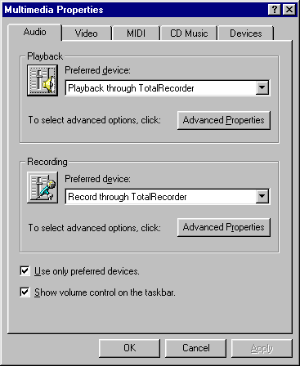
7. You should also check the “Use preferred devices only” box.

Uninstalling the Driver Manually
If you need to uninstall the Total Recorder driver manually, take the following steps for Windows 95/98/ME:
- Select “Start”-“Settings”-“Control Panel”.
- Select “System” and click on the “Device Manager” tab.
- Select “Sound, video and game controllers”.
- Highlight “Wave sound driver for the Total Recorder”.
- Click on “Remove”.
- Close all applications and reboot your computer.
- Verify that your preferred playback and recording devices are set correctly. You can use the Windows system dialog (“Start”, “Settings”, “Control Panel”, “Multimedia” or “Sounds and Multimedia”, “Audio tab”), or use the Total Recorder menu items (“Options”, “System settings”), and select the devices that were set before the installation of Total Recorder.

Take the following steps for Windows NT:
- Select "Start"-"Settings"-"Control Panel".
- Click on "Multimedia".
- Select the "Devices" tab.
- Select "Audio Devices".
- Highlight "Audio for Wave sound driver for the Total Recorder".
- Click on "Remove".
- Close all applications and reboot your computer.
- Verify that your preferred playback and recording devices are set correctly. You can use the Windows system dialog ("Start", "Settings", "Control Panel", "Multimedia", "Audio" tab), or use the Total Recorder menu items ("Options", "System settings"), and select the devices that were set before the installation of Total Recorder.

Take the following steps for Windows 2000:
- Select "Start"-"Settings"-"Control Panel".
- Click on "Add/Remove Hardware".
- Click "Next" to continue.
- Select "Uninstall/Unplug a device" and click "Next".
- Select "Uninstall a device" and click "Next".
- Select "Wave sound driver for the Total Recorder" and click "Next".
- Select "Yes, I want to uninstall this device" and click "Next".
- Click "Finish".
- Close all applications and reboot your computer.
- Verify that your preferred playback and recording devices are set correctly. You can use the Windows system dialog ("Start", "Settings", "Control Panel", "Sounds and Multimedia", "Audio" tab), or use the Total Recorder menu items ("Options", "System settings"), and select the devices that were set before the installation of Total Recorder.

Configuring Total Recorder
The configuration program allows you to set the following:
- suppression of system sounds
- preferred playback and recording devices
- priority of Total Recorder program
- directory for temporary files
- default directory
- actions when a recording is about to be overwritten
- resampling algorithm
- external programs for MP3 encoding
- default format (RIFF-WAVE or MP3) and ID3 tags (ID3v1 and ID3v2) for MP3 files
- pre-recording parameters
- debug mode for driver.
To configure Total Recorder, start the program and select “Options” – “Settings”. You are presented with a property sheet with the tabs: "System", "Open/save", "Algorithm", "MP3 encoding", "Pre-recording" and "Debug".

Using the System Tab
The dialog looks like this:
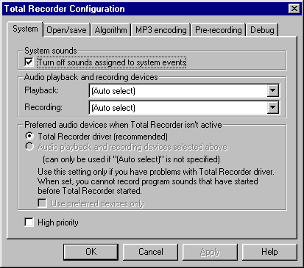

Each of the configuration options is described below.

System sounds
To prevent system sounds from interrupting your recording, check “Turn off sounds assigned to system events”. This is the default and the recommended setting. Your system sounds will return when you close Total Recorder.

Audio playback and recording devices
These devices are the names of the real drivers used for playback and recording. This is where Total Recorder redirects its input and output sound streams. The installation program automatically sets these values according to your current system settings and usually you do not need to change them.

Preferred audio devices when Total Recorder isn't active
This identifies the use of the Total Recorder driver. You can choose from the following:
Total Recorder driver (recommended) - does not change the preferred devices for playback and recording. The Total Recorder installation program sets the Total Recorder driver as the preferred device (i.e. "Playback through TotalRecorder" and "Record through TotalRecorder"). This driver works all the time and passes sound through it regardless of Total Recorder being active. This is normally transparent to the user.
Audio playback and recording devices selected above – this is recommended if the Total Recorder driver conflicts with some other programs and the conflict cannot be resolved by reconfiguring those programs. For more information, refer to the "Troubleshooting" section of this document. In this mode, Total Recorder sets its driver as a preferred device when it starts and your specified real drivers (not Auto Select) when you exit.
In this mode, Total Recorder cannot record sound that starts before it was started. You must start Total Recorder before your playback program.
Use preferred devices only - this flag should only be used if you have selected “Audio playback and recording devices selected above”. Select the value that will be set when Total Recorder exits. It is always on when Total Recorder is active.

High priority
Selecting this option raises the priority of the Total Recorder program. Because sound recording is a real-time process, any interruption can lead to skips, clicks, gaps, etc. This setting helps eliminate these problems and provides cleaner recordings.

Using the Open/Save Tab
The dialog looks like this:
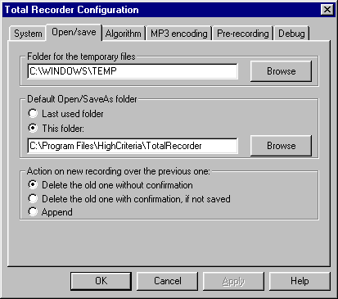

Each of the configuration options is described below.

Folder for the temporary files
The size of recording files can be quite large. Because of this, Total Recorder saves recorded information, not in memory, but in a temporary file. You can specify the directory for this file, if you wish.
When you first start the Total Recorder program, it sets the directory for temporary files based on the following:
- If the system environment variable TMP exists, it uses its value.
- Else, if the TEMP system environment variable exists, it uses its value.
- Otherwise, it uses the directory where the program is installed.
It is recommended that you store temporary files on the same hard drive where you will save your recordings. Otherwise, a full copy operation will be required and this will be time consuming for large files.
It is not recommended that you store temporary files on a compressed drive. If the folder for temporary files is on a compressed NTFS drive, then you should remove compression from the folder.

Default Open/SaveAs folder
When you first start Total Recorder, the default directory for opening and saving files is the directory from which the Total Recorder program was started. Subsequently, Total Recorder can use the previously used directory as the default (select “Last used folder”) or you can specify the default directory yourself (select “This folder” and specify the location).

Action on new recording over the previous one
You can select one of the following options during the attempt to record over an existing recording:
Delete the old one without confirmation – Clicking the “Record” button overwrites (and irreversibly destroys) the previous recording unless it has not yet been saved (in full) to a file
Delete the old one with confirmation, if not saved – similar to the above but if the recording has not been saved (in full) at least once, you must confirm the action. Recording does not start until you respond.
Append – a new recording is appended to an existing one regardless of it being saved. If you want to create a new file in this mode, you must explicitly select “New” from the “File” menu. Sound parameters (i.e. sample rate, mono/stereo, 8bit/16bit) are always inherited from the recording. Even if different parameters are set in “Recording source and parameters” dialog they will not be in effect unless you start a new recording.
A recording is not considered saved unless it was saved in full; partial recordings are not considered saved files.

Using the Algorithm Tab
This dialog lets you set the frequency conversion algorithm and looks like this:
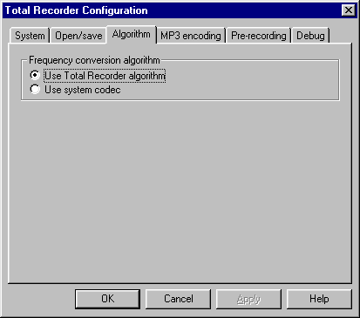

Frequency conversion algorithm
Select one of the following:
Use Total Recorder algorithm – use Total Recorder’s internal algorithm. This is the default and recommended value. It provides a reasonable compromise between speed and quality.
Use system codec – in most cases, this is Microsoft PCM Converter. It is very fast but the quality may be unacceptable.

Using the MP3 encoding Tab
Use this tab if you plan to use Total Recorder with MP3 format. Before working with this dialog, you should review the “Working with MP3 Format” section later in this document.
The dialog looks like this:
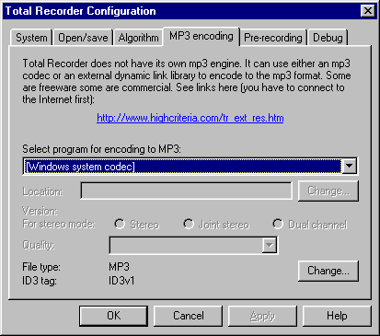
Each of the configuration options is described below.

Select program for encoding to MP3
You can select from the following:
Unable to encode Mpeg Layer 3 – this item is the first in the list if there is no MP3 codec installed on your system. If you select this item, Total Recorder will not be able to create MP3 files and “MPEG Layer 3: press F1 to get help” appears in the list of sound formats. You can use F1 to display some links to find MP3 encoders.
[Windows system codec] – this item is the first in the list if there is at least one MP3 codec on your system. If you select this item, Total Recorder will rely on the system to select an appropriate codec.
(Name of a particular codec) – one of these entries appears for each MP3 codec in the system. You can select any codec from the list. Normally there is only one MP3 codec installed, in which case you can either select it here or select [Windows system codec] as above.
Blade encoder (dll) – use BladeEnc.dll to encode to MP3. Total Recorder will show this item regardless of whether this dll exists on your system. However, you can only save this setting if you provide a full path to BladeEnc.dll in the Location field.
Lame encoder (dll) –use Lame_Enc.dll to encode to MP3. Total Recorder will show this item regardless of whether this dll exists on your system. However, you can only save this setting if you provide a full path to Lame_Enc.dll in the Location field.

Location
This identifies the full path for the external encoding program. Total Recorder will locate the program itself if it is in one of the PATH directories. Otherwise, click Change and enter the location. For example:

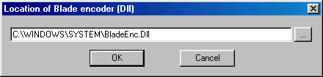

Version
Total Recorder checks the version of the external program. Some older versions are not supported, in which case an error message appears and you will need to download a newer version.
For stereo mode
MP3 format supports different versions of encoding stereo audio signals. When Total Recorder displays a dialog for selecting a format, it only includes mono or stereo. If stereo is specified, it will be encoded according to the mode selected in this tab.
You can select from the following, although some modes may not be available for some encoding programs:
Stereo – each channel is encoded separately but not necessarily the equal amount of space is allocated for each channel. For example, the encoding program may allocate a larger part to one channel based on the actual content of the sound stream.
Joint stereo – both channels are encoded together. The average of the two channels is calculated and encoded. The difference between channels is also encoded but with a lower bit rate. This method saves some space but the quality may suffer. This mode is not recommended for high-quality recordings with high bit rates (i.e. more than 192 Kbit/sec.).
Dual channel – each channel is encoded separately and independently. This is recommended where the content is not actually a stereo recording but two independent sound streams.
Quality
You can select the desired quality if the encoding program allows it. The better the quality you select, the slower the encoding will be.

File type
You can select the desired header format for MP3 files – either RIFF-WAV (WAV-MP3) or “pure” MP3. Click the Change button to change this setting. You can override this default value when you save a recording but it requires a full copy of the file.

ID3 tag
You can add ID3 tags (ID3v1, ID3v2 or both) to pure MP3 files but not to RIFF-WAV files. These tags can contain such information as the artist name, the album, etc. You can click on the Change button to set a default. For more information, refer to the "Using the MP3 properties dialog" section later in this document.
You can override this default value when you save a recording. For the ID3v1 tag, it is fast and does not require a full copy. Changing the ID3v2 tag may require a full copy of the file.
Note: The ID3v1 tag is completely supported. For the ID3v2 tag, only Version 2.3 and below is supported.

Using the Pre-recording Tab
The dialog looks like this:
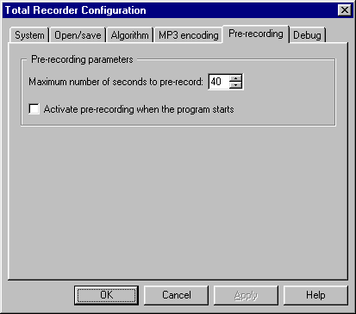
Each of the configuration options is described below.

Maximum number of seconds to pre-record
Specify the maximum number of seconds to be pre-recorded in the box to the right.

Activate pre-recording when the program starts
When this box is checked, the pre-recording mode activates automatically when Total Recorder starts.
For more information on pre-recording mode, refer to the "Pre-recording mode" section later in this document.

Using the Debug Tab
The dialog looks like this:
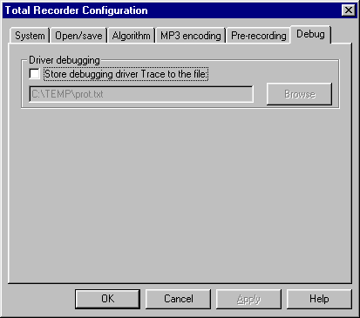

Driver debugging
Use this option only when advised by Technical Support. Selecting this option will result in additional overhead on your system.

Registering Total Recorder
After installing and verifying the program works properly, you should obtain a registration key from High Criteria. If the program is unregistered then your recordings are limited to 40 seconds each and you can use the scheduler only as an alarm.
Note: You cannot use your Version 1.x or 2.x registration key with Version 3.2. The registration key for version 3.0 is valid for version 3.2.
To register Total Recorder:
- Receive the registration key.
For registered users of versions 1.0 or 2.x. All registered users are entitled to a free registration key. It is sent by E-mail automatically unless you specified that you do not want to receive E-mails from High Criteria or you have not provided your E-mail address. If you are a registered user, want to upgrade, and didn’t get your registration key for some reason, contact support@HighCriteria.com
OR
For new users. Follow the instructions given on High Criteria Inc.'s web site at the following address: http://www.highcriteria.com/products.htm.
- Select “Help” - “Registration”. Type in the same name you used to obtain the registration key and your registration key. Note that after registration this menu item is not accessible.
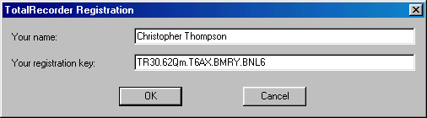
To order by check refer to the Registration.txt file in the installation folder of Total Recorder.

Uninstalling Total Recorder
To uninstall Total Recorder, use “Start”, “Settings”, “Control Panel”, “Add/Remove Programs”. The Total Recorder driver remains in memory until you reboot.

Using Total Recorder
Total Recorder works as a standard Windows multimedia program. You can use standard buttons, menu options, and keyboard shortcuts for recording and playback.

Setting Recording Parameters
Before you begin recording, use the “Recording source and parameters” dialog to set your recording parameters. These parameters are saved for subsequent use. Changing parameters after a recording is finished affects only subsequent recordings; Total Recorder can convert already recorded sound during saving only.
When you schedule recordings using Total Recorder's built in scheduler, you can use different parameters for each job using the “Schedule Item” dialog.
Click on the “Recording source and parameters” button or select “Recording source and parameters” from the “Options” menu. You are presented with the following dialog:
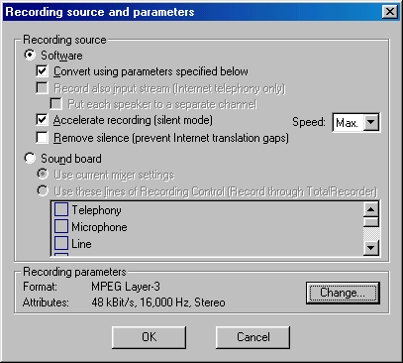

Recording source
Select one of the following (mutually exclusive) sound sources:
- Software – capture and record sound played back or requested by other computer programs. This feature is unique to Total Recorder and is not available from the vast majority of other sound recording programs.
- Sound board – record sound digitized by a sound card. This includes a microphone, CD or other input lines.

Additional parameters for source “Software”
If you select “Software”, you can specify the following:
- Convert using parameters specified below – convert the recorded sound to a format specified in the "Recording parameters" area.
If this is not selected, the recorded sound will be in the original format (i.e. the format of sound being sent to the soundboard). If different parts of the sound have different formats then only the longest part will be recorded.
- Record also input stream (Internet telephony only) – capture and record input sound streams, requested by programs from the soundboard. This applies only to the recording of Internet telephony conversations.
- Put each speaker to a separate channel – special mode for Internet-telephony only. You can set this option only if you have set the “Record also input stream” flag above. This creates a stereo file where one voice is in one channel and the other voice is in another channel.
If “Put each speaker to a separate channel” is not set, the voices of both speakers will be mixed in one channel.
Note: In version 3.0 and below, this mode was referred to as “Make Stereo”.
- Accelerate recording (silent mode) - the Total Recorder driver makes the playback program generate sound with a faster speed and suppresses the actual sound. Not all playback programs are compatible with this mode. For more information, refer to the "Accelerated Recording" section, described later in this document. If you select this option you must use the “Speed” pull-down menu to select the desired speed.
- Speed: Max. – Total Recorder tries to make the playback program play at maximum speed. This is recommended for converting a sound file from a non-standard format to a standard format.
- Speed: a value – set at a particular speed. Total Recorder tries to make the playback program play a specified number of times faster than normal. For example, you can set this speed to "4" to cause the playback program to play 4 times as fast as normal. This setting is recommended if the maximum speed is not possible (e.g. when recording from the Internet).
- Remove silence (prevent Internet translation gaps) - Total Recorder tries to fix Internet translation gaps. During the playback of an Internet translation, failures of a short duration can occur. These are often due to an insufficient speed of data transfer and appear as pauses and replications during playback. When using some audio programs, such as Windows Media Player and Real Player, these pauses and replications can also appear in the recording. With the “Remove silence” mode turned on, Total Recorder removes pauses and replications from recording.
Notes:
- This mode does not guarantee sound repair. The benefit you will see strongly depends on the characteristics of the gaps.
- It is very unlikely a recording will worsen when recording with this mode on.
- If you forget to turn this mode on before you start a recording, you can later play back the recording with one instance of Total Recorder and record the sound with another instance of Total Recorder that has the “Remove silence” mode turned on. You can use accelerated recording mode in this case.
- The “Property” part of Total Recorder’s main window displays the size of data without taking into account this mode. It displays the size of data passed to the soundboard. After a recording stops, the data size changes to reflect the size of actual data written to the file. If you see the data size become less after a recording has stopped, then some fixing of sound has taken place.

Additional parameters for source “Sound board”
If you select “Sound board”, you can specify the following:
- Use current mixer settings – use current system settings. Normally, they can be viewed or changed from the standard mixer by double clicking on the “Volume Control” icon in the system tray.
- Use these lines of … (the full name of this flag depends on the sound driver of the sound board) – points explicitly to lines that are switched on during recording. At least one line has to be specified. After a recording is finished, the original mixer settings are restored.

Using Different Settings
The following explains some different settings:
- If you select "Software" as the Recording source and PCM is specified, the conversion algorithm depends on the value selected under the Algorithm Tab. See the "Using the Algorithm Tab" section earlier in this document.
- If you select "Software" as the Recording source and a compressed format is specified (non-PCM), the compression will be performed either with a selected codec or (for MP3 only) with an external program. See the "Using the MP3 encoding Tab" section earlier in this document.
- If you select "Sound board" as the Recording source and PCM is specified, no conversion is needed. Sound board will produce the required format.
- If you select "Sound board" as the Recording source and a compressed format is specified (non-PCM), the closest PCM format will be requested from a sound board and compressed.
Any necessary conversions are normally done on the fly (i.e. as the recording is being made). If a conversion requires too much time and cannot complete during the recording, it will continue after the recording is finished. Refer to the "Long Operations" section later in this document.

Recording parameters
This sets recording parameters. To change a format click on the "Change" button. The “Sound format selection” dialog appears.

Using the Sound format selection Dialog
The dialog looks like this:
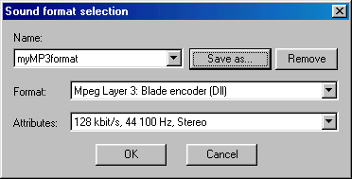
Each of the fields is described below.
Name – list of named formats. You can select any format from the list. There are some system-named formats and you can name any format and save it for future use.
Save As – assign a name to the format and its attributes so it will appear in the “Name” list above.
Remove – remove a named format. Note that you cannot delete a system-named format.
Format – list of format types. Note: To record in MP3 format you must have a fully functional codec (i.e. one that can encode and decode) or a special program. For more information, refer to the "Working with MP3 format" and "Using the MP3 encoding Tab" sections.
Attributes – list of format parameters.

The Total Recorder Dialog
The Total Recorder dialog is made up of different parts, as shown below:
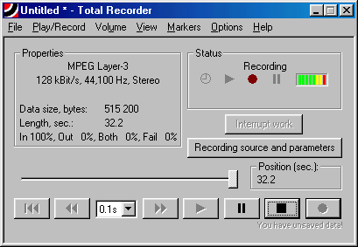

Properties
This part of the dialog displays information about the current file being played or recorded. For example:
MPEG Layer-3 – format name.
128kBit/s, 44,100Hz, Stereo – format parameters.
The line below these format parameters is normally empty but may contain a message such as "xx.x sec. of other formats lost". This message appears only in Software mode and only when the output format is not specified. If this is the case, and the recorded sound contains several fragments with different characteristics, only the longest fragment is kept and all others are lost.
Data size (bytes) – size of recorded data in the recording/playing file. This does not include the length of the non-data part. You can display the full length by selecting “File", "Properties".
Length (sec.) - playback time in seconds.
In xx%, Out xx%, Both xx%, Fail xx% - this information appears only when you record. The display varies depending on the recording activity.

Recording Activity | Display
Sound being played back | Out 100%
Internet telephone conversation in full-duplex mode | Both 100%, since sound is transmitted back and forth simultaneously
Internet telephone conversation in half-duplex mode | In - % of time the user of the given computer talked  Out - % of time the remote partner talked
From microphone, CD or other input line | In 100%
Internet telephone conversation in full-duplex mode, different format for input and output sounds | Fail 100%

Note: When you are appending to an existing file, this data relates only to the appended fragment and not to the entire file.

Status
This part of the dialog displays the current status of Total Recorder. The possible values are: “Playing”, “Paused Playing”, “Recording”, “Paused Recording”, “Auto playing until hh:mm:ss”, and “Auto recording until hh:mm:ss”. Values can include information related to pre-recording. Some further explanations follow.
“Auto” - recording or playback was started by the scheduler or from the command line, or auto stop is on. The time (hh:mm:ss) is the time that the job will complete. You cannot control the job other than cancel it by clicking on the “Interrupt work” button on the main program window or selecting “Interrupt work” from the “Play/Record” menu. Other controls, such as “Pause” are disabled. You can cancel Auto stop by selecting "Play/Record", "Auto stop recording".
xx.x sec. pre-recorded - indicates the number of pre-recorded seconds. This number is limited by the value you specify in the “Pre-recording parameters” dialog. This information is displayed only if pre-recording mode is on.
Clock icon - indicates that a scheduled job is currently in progress, or Auto Stop is on. It does not relate to the fact that some jobs are scheduled.
Level indicator - reflects the amplitude of a signal during recording and playback. When recording from “Software” the “reactivity” depends on the size of the playback program's internal buffer. For some programs this can be changed once per second or even more often.

“Interrupt work” button
This button allows you to cancel a scheduled job that is in progress, or auto stop. Already recorded information is put to a file and an error message “Job interrupted by user” is written to the Total Recorder Log.

“Recording source and parameters” button
This button displays a dialog for the recording source and parameters. For more information on this dialog, refer to the section “Setting Recording Parameters” earlier in this document.
During recording or pre-recording, you can use this dialog only to view recording parameters. Recording parameters must be set in advance.

Slider
In playing mode, the slider reflects which part of the sound file has been played back. You can move the slider backwards or forwards.
In recording mode, the slider is initially at the leftmost position. It moves immediately to the rightmost position once real recording starts.

Position (sec.)
This part of the dialog displays the real recording time (in seconds) when Total Recorder is in recording mode, or the reproducing time (in seconds) when Total Recorder is in playing mode.

Markers
Markers - , - let you select and save a fragment of a recording, or other sound file, to a file. The current position of each marker is controlled by a separate group of buttons. You can position markers with 0.1-second accuracy.
Markers below the slider are not visible by default. Select "View", "Show selection" from the menu to see them.
Here is the main dialog with markers displayed:
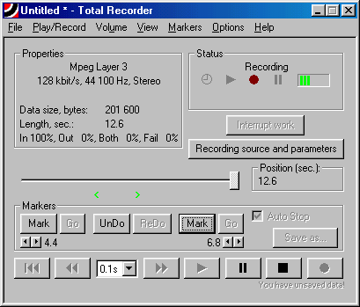
The following are some characteristics of markers:
- The buttons that control each marker show the position in seconds.
- If the left marker () moves to the right of the right marker (), they automatically switch positions.
- Initially the right marker () points to the end of the recording (file).

Marker Control Buttons
The control buttons for each marker are:

Button | Description
Mark | Mark the current position of the main slider. The marker moves; the main slider’s position does not change.
Go | Go to the marker. The main slider moves; the marker’s position does not change.
 | Precise marker positioning. The marker moves 0.1 second left and right. The main slider’s position does not change.

General Marker Control Buttons
The general control buttons for markers are:

Button | Description
UnDo | Undo the previous marker move. It does not affect the main slider. Up to 1000 operations can be undone.
ReDo | Redo move.
Save As... | Save the part of the recording between the markers.

Auto Stop flag
If set, the “Auto Stop” flag causes the playback to stop at the right marker. This ensures the selection ends at the correct place.

Buttons
You can use the following buttons:
Button | Description
 | Rewind to the beginning
 | Left (one step)
 | Right (one step)
 | Play
 | Pause/continue
 | Stop
 | Record

Between the "" and "" buttons is a list for selecting the step these buttons use to position your recording. The step is specified in units of time, ranging from 1/10 of a second (0.1s) to 15 minutes (15m).

Recording
In order to record all of the sound generated from a software program, you should start the recording before starting the playback's program. Every playback program sends information to a driver with some delay, usually several seconds. If you start recording when sound has already played back, it will look as if nothing happens for several seconds and then the indicators will show the real beginning of the recording.
For information on using the built-in scheduler or command line to schedule a recording, refer to the section “Using a Scheduler” later in this document.
For information on recording using "Software accelerated recording/converting", refer to the section "Accelerated Recording" later in this document.
For information on using pre-recording mode, refer to the section "Pre-recording mode" later in this document.

Starting Recording
Before you begin recording, set your recording source and other parameters if these have not been set as you require. Click on the “Recording source and parameters” button or select “Recording source and parameters” from the “Options” menu. Refer to “Setting Recording Parameters” earlier in this document for more information.
To start recording, either click on the “Record” button (), select Record from the “Play/Record” menu, or press Ctrl-R.
As soon as your recording starts, the message “You have unsaved data!” appears under the “Record” button. This is to remind you that data is being written to a temporary file. If you want to store the output permanently, you must save the data once your recording is complete.
If you try to make a new recording before saving the previous one, the result depends on the setting "Action on new recording over the previous one". For more information, refer to the "Using the Open/Save Tab" described earlier in this document.
If "Software" is selected as a source, a sound is recorded only when some program reproduces or requests it. After starting the “Record” feature, the corresponding indicator on the “Status” panel becomes highlighted. This indicates Total Recorder is ready to record but the real recording process does not start until Total Recorder receives some sound from another program. If the level indicator does not become green, there is no data to record.
If "Sound board" is selected as a source, the recording size remains at zero until sound data, that is not absolute silence, is received from the soundboard. This is reflected by the level indicator. When such sound data is received, the silence is included in the recording and reflected in the recording size displayed. If no source sends real sound to the soundboard, Total Recorder may receive non-silent sound from a particular soundboard line based on the following:
- soundboard characteristics
- level of recording
- type of input line. For example, non-silent sound will more likely be received from a microphone line than from "line-in",
- sound format parameters. For example, it is very likely that non-silent sound will be received in the case of 16-bit sound format but not in the case of 8-bit sound format.

Interrupting a Recording
To temporarily interrupt recording, either use the “Pause/Continue” button (), select “Pause” from the “Play/Record” menu, or use Ctrl-U. To continue a paused recording, either use the “Pause/Continue” button again, select “Continue” from the “Play/Record” menu, or use Ctrl-U.
If "Software" is selected as a source, all information during a pause will be written to a temporary file. This allows a recording to continue immediately after the pause is finished. Remaining in “pause” for a long time may take a lot of your hard disk space and is therefore not recommended.

Stopping a Recording
To stop recording, either use the “Stop” button (), select “Stop” from the “Play/Record” menu, or use Ctrl-P.

Saving a Recording
To save a recorded sound stream to a file, use “Save” or “Save As” on the “File” menu, or press Ctrl-S. The file is saved as a .wav or a .mp3 file.
If you save over an existing file, the resultant file format is:
- the same format of the source file, if you use “Save”
- the specified format, if you use “Save as”.
A recording is not considered saved unless it was saved in full. This affects the actions taken when you are about to overwrite a recording.

Saving Part of a Recording
You can also select and save only part of a recording by taking the following steps:
- Make the markers visible, if they are not visible already, by selecting "View", "Show selection" from the menu.
- Select the left and right boundaries by moving the slider and placing markers. For more information, refer to the "Markers" section described earlier in this document. You can set markers during recording and then slightly reposition them.
- Save your selection. Use the "Save as..." button in the Markers group or select "File", "Save selection as" from the menu.

Saving Multiple Recording Fragments

You can save multiple recording fragments as different files. The size of a .wav file cannot exceed 4GB. This is an internal limitation of the WAVE format. If the size of your recording is greater than 4GB, you can either divide it into smaller parts or convert it to a lower quality.

Saving a Recording in a Different Format
You can save your recording in a format different from the original, however it may take a significant amount of time.
To change the format, take the following steps:
- Choose the “Save As” dialog.
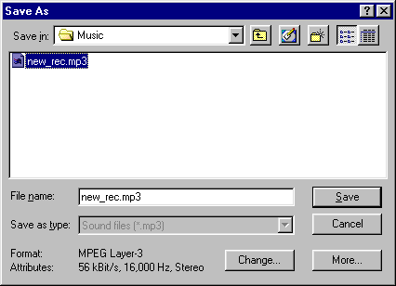

- Click on “Change” and select a format. For more information, refer to the “Using the Sound format selection Dialog” section earlier in this document.
- If you select MP3 format, you can click "More" and change the default file type and ID3 tags. For more information, see the "Using the MP3 properties Dialog" section later in this document. Changing a file type requires a full file copy but deleting, adding, or editing the ID3v1 tag does not. Adding or removing the ID3v2 tag requires a full file copy; editing the ID3v2 tag may require a full file copy.
- Enter the name of the new file, if you haven't already done so. The default extension is .wav or .mp3 depending on the selected format. You cannot manually specify an extension.
- Click “Save” to save your recording.

Using Fast Save
Beginning with Version 3.0, Total Recorder writes a ready-to-use wav or mp3 file without saving an intermediate working file. A save operation usually just renames (moves) the working file and is almost instantaneous regardless of the file size. However, the following situations will prevent this and require copying of the entire file.
- The file is being saved to a different drive, either physical or logical, than the drive that stores the working file. Use "Options", "Settings", "Open/save" tab to change the location of the working file.
- The file format changes.
- The header type changes from RIFF-WAV to MP3 or vice versa.
- The file is being normalized.
- The existing file was appended with new data.
- Adding or removing the ID3v2 tag. Editing the ID3v2 tag may require a full file copy.
Note that changing the ID3v1 tag does not prevent a fast save operation.

Using Auto Stop Mode

When Total Recorder is recording, you can specify a date and time when the recording will stop. You can set or reset the auto stop mode by selecting "Auto stop recording" from the "Play/Record" menu. The following dialog appears:

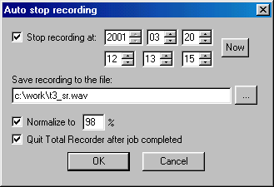
Stop recording at – when this box is checked, auto stop is on. You can then use the fields to the right to specify a date and a time:
Date (year, month, day), time (hours, minutes, seconds) – set the date and time to stop the recording.
Now – display the current date and time. This is useful when you want to use a relative time such as 5 minutes from now.
Save recording to the file – the file name where the recording will be saved. This field is mandatory.
Normalize to – check this box to normalize before saving then use the box to the right to specify a percentage. This is enabled only for PCM format. For more information, see “Normalizing a Sound File” later in this document.
Quit Total Recorder after job completed – Total Recorder will close after the recording stops.
When auto stop is active, all other controls are disabled. The behavior is similar to that of a scheduled job (see "Actions you can take during a Scheduled Job"). The only difference is that you can cancel the auto stop by selecting "Play/Record", "Auto stop recording" again and the recording will continue in regular mode. Any error messages are not displayed but are written to the Total Recorder Log (see "Handling Errors and Other Problems").

Accelerated Recording
Software accelerated recording (silent mode) lets you convert sound files of different formats to standard wave format. This is normally done at a fraction of the time required to play the file. Total Recorder suppresses playback, makes the sound stream go through the driver with an above normal speed, and records it.
The playback program switches to a different mode only when the new sound stream starts. When using accelerated mode you must switch on record first and then start playing the sound back.
You cannot use accelerated recording mode and pre-recording mode at the same time.
When using accelerated mode you cannot hear any sound but the slider of the playback program moves faster than normal. Total Recorder also shows the recording moves by the following:
- the indicator of the current position moves faster than normal
- the level indicator changes from being empty to green.

Compatibility
Since the playback program has to work faster than was intended, some programs are not compatible with this mode. They will either work with normal speed or some error may occur (e.g. some fragments may be lost or repeated more than once, or some extra pauses or noises may be inserted). Different versions of the same program may behave differently.
This document does not provide a list of compatible and incompatible programs. The simpler the playback program the more likely it will work correctly in accelerated mode. Programs that synchronize sound with some other events such as games or video players will not likely work in accelerated mode.
The maximum possible speed may also vary. This usually depends on some internal parameters of a playback program, which are not documented and are not configurable, because normally they do not matter.
Through experimentation, you can determine both the compatibility of a particular program with accelerated mode and the optimal speed. Make your recording then listen to it. If there is no problem, or a problem that can be easily corrected with a selective save, you may use the accelerated mode. Otherwise, you can lower the speed. If this doesn't help you can either use regular recording or change your playback program.
If a program plays a sound from a hard disk or a local area network and it allows accelerated mode, it will probably allow maximum speed. However, there are some exceptions. If the program plays a sound from the Internet, it is usually impossible because the sound driver will request the information faster than the connection supplies. In this case, you can manually adjust the speed based on the available bandwidth. If the connection is either very slow or bad, try to set the speed below normal.

Pre-recording Mode
Sometimes when listening to an audio program (e.g. Internet translation), you do not know exactly when to start recording. With previous versions of Total Recorder, you could either record sound continuously or start your recording when you hear the part in which you are interested. Each case has its own problems. Either you would likely end up with a large file, where you would need to remove large amounts of unwanted sound, or you would miss essential data.
Using Total Recorder’s pre-recording mode, a pre-specified amount of sound is stored internally. When you start your actual recording, the pre-recorded sound is added to the beginning of your recording and the storing of information in an internal buffer stops. If you were to start and stop a recording multiple times, where the number of seconds stopped each time is less than your specified pre-recording time, then your resultant recording will be the same as that obtained by an ordinary uninterrupted recording (see concerns when appending to a recording).
Note:
You cannot use pre-recording when “Accelerated recording” mode is on. For more information on “Accelerated recording” mode, refer to the "Accelerated Recording" section.

Using Pre-recording Mode
To set pre-recording parameters, use “Options” – “Settings” - "Pre-recording" tab. For more information, see "Using the Pre-recording Tab" earlier in this document.
To turn pre-recording mode on or off, use the "Pre-recording xxx last seconds" menu item from the "Play/Record" menu. You can also use the Ctrl+G shortcut. The actual number of seconds specified on the "Pre-recording" tab is displayed in the menu item name.
To clear the pre-recording buffer, use the "Clear pre-recording buffer" menu item from the "Play/Record" menu. You can also use the Ctrl+B shortcut. You may want to clear the pre-recording buffer if you do not wish to include pre-recorded sound in your recording. The pre-recording buffer can be cleared if it is not empty.
If Total Recorder starts to perform a scheduled job or starts with command line parameters, pre-recording mode will not be turned on at program start regardless of the "Activate pre-recording when the program starts" setting.
When pre-recording mode is on, the following takes place:
- a message appears in the “Status” part of Total Recorder’s main window that indicates the number of actual pre-recorded seconds (e.g. “xx.x sec. pre-recorded”).
- the record notification picture, , changes to , if currently there is no actual recording.
- the “ Pre-recording xxx last seconds” menu item changes.
- the level indicator displays the level of pre-recorded sound.
Caution:
Pre-recording uses computer hardware resources. This mode should only be used when necessary.
Note:
When you record and pre-record using compressed (non-PCM) format, a gap may appear in your recording at the point when you switch from recording mode to pre-recording mode.

Playing a Sound File
To play a sound file, either click on the “Play” button (), select “Play” from the “Play/Record” menu, or press Ctrl-Y. Total Recorder starts to play the recording from the current position or from the beginning if the current position is set to the end of the file.
For information on using the built-in scheduler or command line to schedule a playback, refer to the section “Using a Scheduler” later in this document.

Pausing the Playback
To interrupt the playing of a sound file, either click on the “Pause/Continue” button (), select “Pause” from the “Play/Record” menu, or press Ctrl-U. To resume a paused playing, either click on the “Pause/Continue” button, select “Continue” from the “Play/Record” menu, or press Ctrl-U.

Moving Within a File
You can use the slider to move forward or backward in a sound file or you can use the rewind button ( ) to go to the beginning. Additionally, you can move right or left with a fixed step using the and buttons or their keyboard equivalents (Ctrl-L - left, Ctrl-T - right). There is a drop-down list for selecting the step between the andbuttons.

Stopping
To stop playing, either use the “Stop” button (), select “Stop” from the “Play/Record” menu, or use Ctrl-P.

Playing a Selection
If markers are visible in the main window, you can play a selection by selecting “Play selection” from the “Play/Record” menu or by using Ctrl-E.

Normalizing a Sound File
Normalizing is a process of increasing the sound level (loudness) so that the amplitude of the loudest parts is close to the maximum allowed for a given sound format. Because it also increases the level of noise, normalizing should only be used if there is no other way to adjust the volume. For example, you should not use normalizing with Sound Board mode recording because you can always adjust the level using a mixer.
Only a non-compressed file (PCM format) can be normalized.
To normalize a sound file, take the following steps:
- Select “Volume”, “Normalize” from the main menu. The “Normalization” dialog appears, as shown below.
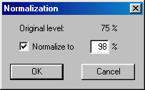
- Select the level of normalization in percentage. The default is 100%. If you plan to later transform your sound file (to compress it, for example), it is recommended you set this value to 80-90% to avoid overflowing.
- Click on “OK”.
The normalization process is fully reversible. You can set any value and go back to the original.
In rare cases, you may need to set the normalization percentage greater than 100. For example, you can improve a recording if the average level is low but there are a couple of peaks (may even be noise).

Long Operations
The following operations may take a significant amount of time:
- Saving a file, if fast saving is not possible.
- Finishing "on the fly" conversion, if it was not possible in real time.
- Calculating the maximum amplitude for normalization.
A dialog, similar to the following, appears during long operations:
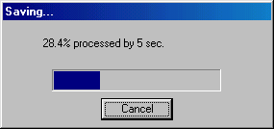

Stopping a Long Operation
To stop an operation, click “Cancel” and reply to the confirmation. The result depends on the operation:
- Saving a file – stops and erases the part of the file that has already been written.
- Converting format – stops and the converted part of the file is saved.
- Normalization – the Normalization dialog will not be displayed.

Working with MP3 Format
Total Recorder does not have a built-in compression/decompression engine for any sound format, including MP3. Total Recorder can only play and record a compressed file if the appropriate audio codecs are installed.

Using Codecs
An audio codec is a special program (driver) that converts sound formats. When a codec is registered (installed) it can be used by any audio processing application. Each version of Windows includes a basic set of codecs. Users can also download, or buy and install, additional codecs. Starting with version 3.0, Total Recorder can use codecs installed in your system.
There are different types of codecs that support MP3. A simple codec can only decode MP3 and is sufficient for playing MP3 files. However, to create an MP3 file you need a codec that supports encoding. A codec that only supports encoding for low bit rates is included in some versions of Windows (e.g. Windows 98 and Windows ME). This is sufficient for recording radio broadcasts but not for CD-quality music. You can buy codecs that support higher bit rates.

Using DLLs
Total Recorder can also use a dll (dynamic link library) dedicated to MP3, either BladeEnc.dll or Lame_Enc.dll. Unlike codecs, neither one of these dlls can decode an MP3 file, which means that Total Recorder may be able to record but not play MP3 files. If you use one of these dlls, it is recommended that you also install a decoding-only codec to enable both playing and recording of MP3 files.

Selecting an MP3 Encoder
MP3 encoders, including codecs, BladeEnc.dll, and Lame_Enc.dll, differ in price, speed and quality. Select the one you find most suitable.

Types of MP3 Format
Total Recorder can play and record MP3 files in either WAV or MP3 format. The difference is in the file header.
WAV-format files have a standard RIFF-WAVE header. These files usually have a .wav extension. As long as an appropriate codec is installed and recognized, any playback program can play them.
Pure MP3-format files do not contain any special headers but may contain an ID3 tag. These files usually have a .mp3 extension. To play this type of file, you need a program that can decode MP3 format.

Setting MP3 Parameters
You set parameters relating to MP3 on the "MP3 encoding" tab of the configuration dialog. For more information, see "Using the MP3 encoding Tab" earlier in this document.

Using the MP3 properties Dialog
Total Recorder lets you record MP3 files as WAV-MP3 files, with a standard RIFF-WAVE header, or "pure" MP3 files. For pure MP3 files, you can also create ID3 tags (ID3v1, ID3v2, or both) that contain information about the audio file.
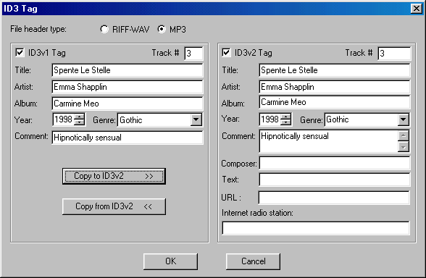

You can invoke this dialog from different places. If you invoke it from the configuration dialog or saving dialog, you can change the File header type. If you invoke it from the "ID3 tag" field of the “File” menu, only part of this dialog appears.

The "ID3 tag" menu item is enabled for "pure" MP3 files only.

Note: The ID3v1 tag is completely supported. Only Version 2.3 and below of the ID3v2 tag is supported. An error message is issued if the file being opened has an unsupported version of the ID3v2 tag, the tag is not correct, or the tag cannot be read by Total Recorder for some other reason. In such cases, the only operation allowed is deletion.

Displaying File and Recording Properties
You can display properties of a file and of a recording by selecting “File”, “Properties”. The following dialog appears:
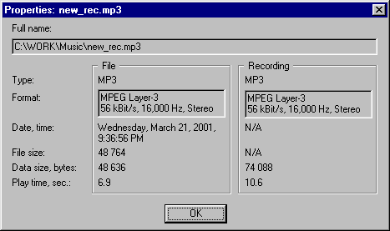

Columns
There are the following two columns, or groups, in the display:
File – this left column relates to a disk file (i.e. the last saved version). If the recording was not saved and was not appended to an existing file, this column will be empty.
Recording – this right column relates to the current recording, which has not yet been saved. This column becomes empty once the recording is saved.

Rows
The rows of each column are described below.
Type – header type.
RIFF-WAVE – standard header. This type of file normally has a WAV extension.
MP3 – no header. This applies only for MPEG Layer 3 (MP3) files. This type of file normally has an MP3 extension.
Format – format description. The first line indicates the format type: PCM – main, non-compressed format; all other formats are compressed. The second line indicates the frequency, number of channels (mono or stereo), and some format–dependent parameters (e.g. bit rate for MP3).
Warning:
If some of the row data is displayed in both the "File" and "Recording" columns and the format descriptions of "File" and "Recording" are different, then the resultant file format after using the "Save" command will be the same as the "File" format (see "Saving a Recording").
Date, time – date and time of the last modification.
File size – full size of file.
Data size – size of data in the file. This excludes headers and tags.
Play time – play time. This is an approximate time only and the accuracy depends on the compression and the particular codec.

Using a Scheduler
Total Recorder lets you program jobs (recording or playback) to start at a given time, similar to programming your VCR. You can either use Total Recorder's built-in scheduler or use command line options with an external scheduler, such as Microsoft Task Scheduler. The preferred method is to use the built-in scheduler because it lets you set all the parameters using a GUI and you can set different parameters for each job.
To start the built-in scheduler:
Select “Schedule…” from the “Options” menu. You are presented with the “Record/Play Schedule” dialog box.
To use an external scheduler:
Put Total Recorder as one of the scheduled tasks using the appropriate command line parameters. These command line parameters are described later in the section “Using the Command Line”.
The Total Recorder Log contains a list of all messages relating to jobs scheduled by the built-in scheduler or initiated through the command line. For information on this log, refer to the section “Using the Total Recorder Log” later in this document.

Launching Scheduled Jobs
Launching of a scheduled job starts one second before the scheduled time. The actual starting time depends on the speed of your computer but one second is usually more than enough to start a program. A scheduled job stops at exactly the scheduled time regardless of the time it was started.
For each scheduled job, a new copy of Total Recorder is launched regardless of another copy being present. This copy closes after the job is finished except in the following two cases:

- you started the job with command line parameters (either explicitly or implicitly) that indicate the copy should stay active

- you interrupted the job.

Actions You Can Take During a Scheduled Job
During performing a scheduled job or a job initiated from the command line, all buttons and menu items are disabled except:
- the “Interrupt work” button
- the “Interrupt work” item of the “Play/Record” menu
- the item “Exit” of the “File” menu.
Clicking the “Interrupt work” button or selecting the corresponding menu item stops the job. Already recorded information is put to a file, an error message “Job interrupted by user” is written to the Total Recorder Log, and Total Recorder stays active. When you use “Exit” from the “File” menu or close Total Recorder in any other way (e.g. Alt-F4), all of these actions are done after the program terminates.

Handling Errors and Other Problems
The Total Recorder sound driver is a component that checks the time and launches the Total Recorder program. If for some reason the driver is not installed, scheduled jobs will not be launched.
Error messages, such as “file does not exist”, do not go directly to a user since a user is not always present. These messages go to the Total Recorder Log.
If recording was active but nothing was actually recorded, the empty file is not saved and a message “Nothing was recorded” is written to the Total Recorder Log. This may happen if “Software” was set as a source but none of the programs played sound during the recording time. The job is considered to perform normally if it was not interrupted.

Displaying and Controlling Scheduled Jobs
The “Record/Play Schedule” dialog shows a list of scheduled jobs. From this dialog you can control scheduled jobs and create new ones.
Select “Schedule” from the “Options” menu and you are presented with the following dialog:
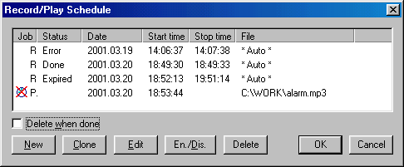

Job – scheduled job types, “Play” or “Record”. There is an icon to the left that reflects the job status:

Icon | Status
 | job should be performed
 | job is disabled
No icon | job should not be performed because the time has passed, regardless of whether the job was actually performed

Status – the result of the job. For a repeated job (e.g. daily), the last result is displayed. You can view detailed results in the “Schedule item” window, accessed with the “Edit” button. This window is described later.
The Status field may be one of the following:

Status | Explanation
Empty | never run
Done | job ran normally
Expired | job did not run and never will because the time has already passed. Your computer being switched off at the scheduled time for the job may have caused this. For repeated jobs, this will never be displayed.
Interrupted | job was interrupted by a user
Error | error during the job. The error message can be viewed in the “Schedule item” window.
Running | Currently the job has been performed by another running instance of Total Recorder. It is also possible that the job was started but there is no information of a normal or abnormal termination. Your computer being switched off during the job may have caused this.

The Status field contains information from the Total Recorder Log. If records were deleted from the Total Recorder Log, either automatically or manually, they will not appear here. If all records for a particular job were deleted, the job will appear as if it had never run.
Date – identifies when the job should run:

Date | Explanation
Daily | each day
Day of the week | each week on the given day
YYYY.MM.DD | the date when the job should run

Start time – the time the job should start (in 24-hour format, hh:mm:ss).
Stop time – the time the job should finish (in 24-hour format, hh:mm:ss). If the “Stop time” is less than the “Start time”, it is assumed that the “Stop time” belongs to the next day. For playing a file, you can omit the “Stop time” and the file will be played back once.
File – the name of the file being played or recorded. This is always a full path. When using automatic file name generation for recording it will show “* Auto *”.

Controls
You can use the following controls from this dialog:
“Delete when done” flag. If set, a job that finishes normally will automatically be deleted from the list.
“New” button. Open the “Schedule item” dialog for entering a new job.
“Clone” button. Build a new job by copying the current one and then open the “Schedule item” dialog for editing. This is useful, for example, if you need to schedule a job to run on certain days of the week but not daily.
“Edit” button. Open the “Schedule item” dialog for detailed viewing and editing of job parameters.
“En./Dis.” button. Current job switches between Enable and Disable status. An icon reflects the current status. A crossed icon means Disable and such jobs are kept in the list but are not started.
“Delete” button. Deletes current job, after confirmation.
“OK” button. Accept all changes.
“Cancel” button. Discard all changes. If any changes were made, confirmation is required.

Scheduling a Job
Use the “Schedule Item” dialog to schedule a job, either a recording or a playback.
- Open the “Record/Play Schedule” dialog.
- Use the “New” button to create a new job.
OR
Select a job and use the “Clone” button to copy the current job for editing. This is useful, for example, if you need to schedule a job to run on certain days of the week but not daily.
- Use the following dialog to specify your requirements:
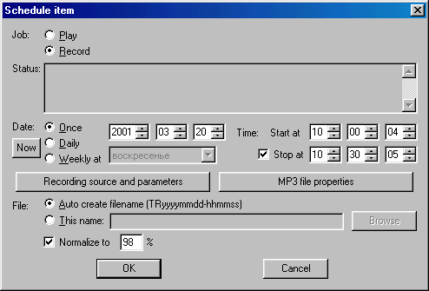

Job
You must specify the action, either “Play” or “Record”.

Status
Lists all of the Total Recorder Log messages, in chronological order, for the current job. If a job has not started, this field is empty.
The purpose of this field is to help you with scheduling. For example, if you edit an old job it can be useful to see if it has ever run and what the results were.

Date
You can schedule jobs with the following frequency:

Frequency | Explanation
Once | one time. Specify year, month and day (in that order) when the job should start.
Daily | each day
Weekly | each week. Specify (or select from the list) on which day of the week the job should be scheduled.

The “Now” button sets the current date and time as the moment when the job should start. The time when the job should stop is set as the current time plus one second. After that, you can modify these parameters manually.

Time
You can specify a starting time and a stopping time:
- Start at –time (hours, minutes, and seconds) when the job should start. The job will be launched one second before the scheduled time.
- Stop at – time (hours, minutes, and seconds) when the job should stop. This is required for recording and optional for playback. Zeros in this field means midnight and not the absence of a stop time. If the “Stop at” time is less than the “Start at” time, the activity (either play or record) will stop the next day.
If you want to specify a stopping time for playback, click on the “Stop at” flag to the left and enter your stop time. Without a stop time, the file will be played once. If the flag is on, a file will be played continuously from the “Start at” time until the “Stop at” time, regardless of the length of the file.

Recording source and parameters
When you use this button the Recording source and parameters dialog appears. Refer to the "Setting Recording Parameters" section.

MP3 file properties
This button is enabled only when you schedule a recording and conversion to MP3 (MPEG Layer 3). When you click this button, the MP3-file properties dialog appears. Refer to the "Using the MP3 properties Dialog” section earlier in this document.

File
This specifies the name of the file you want to create or play:
Auto create filename (TRyyyymmdd_hhmmss) – this may be used for recording only. A new file is created based on the current date and time when the job completes. The file will be placed in the Total Recorder current directory.
This name – a file name for recording or playback. You can enter it manually or use the “Browse” button.
Normalize to – normalize the recording, using the percentage indicated, before saving. This only applies when recording. The Scheduler lets you specify normalization for all formats including compressed. It the latter case, the actual recording is in PCM format and will be normalized and converted when saving.
When saving an automatically recorded file, Total Recorder overwrites an existing file with the same name and no message is written to the Total Recorder Log. If a file with a given name cannot be created (e.g. the directory does not exist) a message is put to the Total Recorder Log and all recorded information is lost. It is recommended you use automatic file name generation to decrease the risk of these errors.

Using the Command Line
Performing a job specified in the command line is similar to performing a job started by the built-in scheduler. From the command line, you can play or record a file.

General Command Line Syntax
The syntax of Total Recorder's command line is:
TotalRecorder [Filename] [/Play|/Record] [/Time:[[hh:]mm:]ss] [/Normalize[:percent]] [/Noclose]
A file name, if specified, must be the first parameter. Other parameters can be in any order.

Filename Parameter
The name of the file you want to load, play or record. If the name contains spaces, enclose it within double quotes (e.g. “My Recordings”).

/Play Parameter
Play a file. The filename is mandatory.
You can use the abbreviation - /P.

/Record Parameter
Perform recording. The current source and recording parameters will be used. If a file name is specified the result will be saved with this name. Otherwise, a name in the form of TRyyyymmdd_hhmmss.WAV will be generated based on the current date and time. The file will be placed in the Total Recorder current directory.
For recording, duration must be specified using the /Time parameter.
You can use the abbreviation - /R.

/Time Parameter
Specifies the duration of recording or playing. This is required for recording.
If you omit this parameter for playing, the entire file will be played once. If you specify this parameter for playing, a part of a file may be played or the playing may be repeated as necessary. For example, if you schedule a 4-minute file to play for 10 minutes, it will play 2 1/2 times. Or if you schedule a 10-minute file to play for 4 minutes, only the first 4 minutes of the file will play.
You can use the abbreviation - /T.
There are three different ways to specify duration. The following examples each specify the same duration (1 hour, 1 minute, and 1 second):
- /T:hh:mm:ss, for example: /T:1:01:01 or /T:1:1:1
- /T:mm:ss, for example: /T:61:01 or /T:61:1
- /T:ss, for example: /T:3661
The following are not correct:
- Incorrect: /T:1:61:01 - since mm cannot exceed 59
- Incorrect: /T:2:60 - since ss cannot exceed 59

/Normalize Parameter
This parameter causes Total Recorder to normalize the file to a given percentage after it is recorded. You can specify a value from 1 to 999. The default is 100%. For example: /Normalize:95.
You can use the abbreviation - /Norm.

/Noclose Parameter
This parameter causes Total Recorder to stay active after the job is done. If not specified, Total Recorder will close except in the case where neither /Play nor /Record were specified.
You can use one of the abbreviations - /NC or /N.

Examples
Perform recording for five minutes, save the result in a file with an automatically generated name and do not close the program:
TotalRecorder /R /T:5:00 /NC
Play a sound file and close the program:
TotalRecorder C:\MyFolder\MySoundFile.WAV /P
Play a bell (Ring.WAV) continuously for one minute:
TotalRecorder C:\MySoundDir\Ring.WAV /P /T:60
Start Total Recorder and load a sound file. You can then use the “Play” button to play the file:
TotalRecorder “C:\My folder\My sound file.WAV”

Using the Total Recorder Log
The Total Recorder Log contains a list of all messages relating to jobs scheduled by the built-in scheduler or initiated through the command line or auto stop. This log sits in the registry and unlimited expansion is not desirable. By default, all records older than one week will be automatically deleted.
Some errors cannot be written to the Total Recorder Log, for example, errors when writing to the registry and syntax errors in command line parameters. These errors will not occur when working with the built-in scheduler.
To review or control information in the Total Recorder Log, select “View Log” from the “File” menu. You are presented with the following dialog:
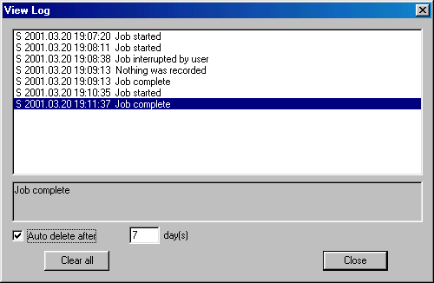

Message list
The list contains all messages, in chronological order, relating to jobs scheduled by the built-in scheduler or initiated through the command line. For each job it includes the starting time, ending time, and all error messages. Scheduler messages are marked with the letter “S”; command line messages and auto stop related messages are marked with the letter “P”. The current message is displayed below the list.

Controls
You can use the following controls from this dialog:
- Auto delete after – controls the automatic deletion of obsolete records. This is the default mode. Switching it off is not recommended because it will cause the registry to grow and decrease system performance.
- Day(s) – records will be deleted after this number of full days. Records are deleted at midnight on the expiry date or the next time your computer is on after this date. For example, “0” means that only records from the current day are accessible, “1” means that records will be kept for one full day and deleted at midnight the following day, and so on.
- Clear all – delete all records. Confirmation is required.
- Close – close the dialog. All changes are immediately made.

Keyboard Shortcuts
Most control elements have keyboard shortcuts:
Button | Shortcut | Menu Item
Interrupt work |  | Play/Record - Interrupt work
Recording source and parameters |  | Options - Recording source and parameters...
Mark (left) | Shift-L | Markers - Set left mark
Go (left) | L | Markers - Go to Left mark
(left) | Shift-M | Markers - Shift left mark left by 0.1s
(left) | Shift-N | Markers - Shift left mark right by 0.1s
UnDo | Shift-U | Markers - UnDo markers settings
ReDo | Shift-D | Markers - ReDo markers settings
Mark (right) | Shift-R | Markers - Set right mark
Go (right) | R | Markers - Go to Right mark
(right) | Shift-S | Markers - Shift right mark left by 0.1s
(right) | Shift-T | Markers - Shift right mark right by 0.1s
Auto Stop | P | Markers - Stop playing at the right marker
Save as... |  | File - Save selection as...
 | Ctrl-A | Play/Record - To Start
 | Ctrl-L | Play/Record - Left by step
 | Ctrl-T | Play/Record - Right by step
 | Ctrl-Y | Play/Record – Play
 | Ctrl-U | Play/Record – Pause
 | Ctrl-U | Play/Record – Continue
 | Ctrl-P | Play/Record – Stop
 | Ctrl-R | Play/Record – Record
no button – only in menu | Ctrl-E | Play/Record – Play selection
no button – only in menu | Ctrl-G | Activate/deactivate pre-recording mode
no button – only in menu | Ctrl-B | Clear pre-recording buffer

Troubleshooting
This section describes problems that may occur and some techniques for diagnosing problems.

Symptom - Unable to Play Simultaneous Sound Streams
After the installation of Total Recorder your computer lost the ability to play several sound streams simultaneously. This applies only to some very advanced sound cards that are capable of playing multiple streams or if your computer has more than one sound card.
Possible Cause #1
During the Total Recorder installation, its driver is set as a preferred device and the flag “Use preferred devices only” is set. This flag disables playing multiple sound streams. Some programs (e.g. Windows Media Player) need this flag to be set in order to work correctly with Total Recorder (see next symptom, Possible Cause # 3).
Action #1
Select "Start"-"Settings"-"Control Panel"-"Multimedia" (or from the Total Recorder menu, select "Options"-"System settings"), tab "Audio", and uncheck the box "Use preferred devices only". If this causes a problem after recording a program, you will need to turn it on during recording and then turn it off when you are done. Or you can set mode to turn on the Total Recorder driver only when Total Recorder is running. For more information, refer to the "Configuring Total Recorder" - "Using the System Tab" section of this document. In this case you should uncheck the "Use preferred devices only" flag, in order to turn it off automatically when Total Recorder finishes.

Symptom - No sound recorded
Sound is reproduced but Total Recorder does not record it. The slider remains at the left edge and the “Length (sec.)” counter does not change.
Possible Cause #1
Some playback programs do not perform a system inquiry for the default sound driver; they explicitly indicate the driver they need. These programs may be older, obsolete programs or may use special functions of specific devices. It is not possible to set the system to ignore these direct requests and sounds reproduced by such programs will not be recorded.
Action #1
Change the playback program where possible.

Possible Cause #2
Some programs (e.g. Internet telephony) have the ability to select the necessary audio driver manually and ignore system settings.
Action #2
Read the program manual and set the Total Recorder driver as both the driver for playing and recording.

Possible Cause #3
Total Recorder's driver perceives a sound stream in main wave-format (PCM, pulse-coded modulation) only. If the reproducing program sends a sound stream in any other format (e.g. compressed), Windows usually calls the decoding drivers itself to perform all of the required translation. However, if your sound card can make some translation at the hardware level, then Windows can direct the sound stream to the driver of such a sound card immediately, and bypass Total Recorder's driver. As a result, sound cannot be recorded.
Action #3
Select “Start”-”Settings”-”Control Panel”-”Multimedia” (or from the Total Recorder menu, select "Options"-"System settings"), tab “Audio”, and check the box “Use preferred devices only”. This eliminates the use of any device other than the default one.
Possible Cause #4
The mode "Preferred audio devices when Total Recorder isn't active" - "Audio playback and recording devices selected above" is turned on. In this case, if the playing back of the sound you are attempting to record was started before Total Recorder was started, the playback program does not use the Total Recorder driver. You have changed playback or recording preferred device either manually or it has been done after the play back was started.
Action #4
Without closing Total Recorder, close the playback program and restart it. Try to make your recording again. Remember if the mode of automatic driver switching is turned on, you should start Total Recorder first and only after that should you start the playback program from which you are going to record sound.

Symptom - Sound recorded with gaps
Sound is recorded with gaps. The “sec. lost” counter on the “Status” panel has a value other than 0.
Possible Cause #1
Total Recorder does not have enough time to record sound. This can happen on slow computers or when a slow device (e.g. a diskette) is used as a destination device for the temporary recording file.
Action #1
Use a faster device for storing temporary files.

Possible Cause #2
The Playback program's buffer is bigger than Total Recorder’s driver buffer. In this case all sound will be omitted. The “sec. lost” counter will grow while the “Position (sec.)” counter will remain at 0. This situation is extremely unlikely since Total Recorder’s buffer should be big enough.
Action #2
Go to the URL: http://www.highcriteria.com/support.htm.
Possible Cause #3
Your computer is overloaded with other jobs.
Action #3
Select “Options”, “Settings”, “System” tab and enable the “High priority” setting.

Symptom - Sound system or playback programs not working properly
After installing Total Recorder, the sound system or some playback programs are not working properly, even when Total Recorder is not active.
Possible Cause #1
There is an incompatibility with Direct Sound. When a playback program uses Direct Sound, the sound can sometimes be garbled.
Action #1
Many modern programs can be set up to optionally use Direct Sound. Read the program’s help to determine the required settings.

Possible Cause #2
The Total Recorder driver is not compatible with other installed programs.
Action #2
Describe your system configuration and the nature of your problem via E-mail to High Criteria Inc. This will help eliminate the problem in future releases.
You cannot record from a conflicting playback program. However, you can eliminate the conflict when Total Recorder is not active by using the Total Recorder driver as a preferred device only when necessary. This can either be done automatically; each Total Recorder starts up and shuts down, or manually. Automatic switching is simpler.
To automatically switch preferred devices:
Use the "Options"-"Settings", "System" tab, and set "Preferred audio devices when Total Recorder isn't active" as "Audio playback and recording devices selected above". For more information, refer to the “Using the System Tab” section of this manual.
To manually switch preferred devices:
- Leave the default setting for “Preferred audio devices when Total Recorder isn’t active” as "Total Recorder driver (recommended)". Total Recorder will not switch devices and will not check the settings until it needs some service from its driver (i.e. during a recording from source "Software").
- Use the Windows system dialog (“Start”, “Settings”, “Control Panel”, “Multimedia” or “Sounds and Multimedia”, “Audio tab”), or use the Total Recorder menu items (“Options”, “System settings”), and select the devices that were set before the installation of Total Recorder. If you are unsure what to select, review the Total Recorder settings: “Options”, “Settings”, “System” tab, “Audio playback and recording devices”.
- For recording sources other than “Sound board”, you must make either one or two of the Total Recorder virtual devices (i.e. playback and recording) your preferred devices before you start the playback program you would like to record.
- If you record from “Software” and “Record also input stream” is not checked, the device "Playback through Total Recorder" must be your preferred playback device.
- If you record from “Software” and “Record also input stream” is checked, the device "Playback through Total Recorder" must be your preferred playback device, and the device "Record through Total Recorder" must be your preferred recording device.
- If Total Recorder needs a device that is not set as a preferred device when you start a recording, the recording does not begin and the system dialog pops up.
- After your recording is finished, you can return the original preferred devices so that Total Recorder will not interfere with any other software.

Diagnosing Problems
If you experience problems with Total Recorder that you cannot resolve yourself, visit the support area at http://www.highcriteria.com/support.htm. You should read Frequently Asked Questions at http://www.highcriteria.com/faq_tr.htm before sending a letter to support.
Technical Support may ask you to set the Total Recorder program in debug mode and send them a debug file. When advised by Technical Support, take the following steps:
- Use the configuration menu to select “Driver debugging” and specify the name of the debug file you want to use. Total Recorder will write diagnostic information, in ASCII format, to this file.
- Try to reproduce the problem.
- As soon as you have reproduced the problem, turn off the debugging option. Running in debug mode slows down the operation of the software and takes up additional hard drive space.
- Send the debug file and a description of the problem to High Criteria.
Note. Beginning with Version 3.2, Total Recorder’s message boxes have the ability to copy messages to the clipboard. This will aid in a precise description of your problem.

