PopRoute 1.05
=============
9 May 1999

ORNIC Technologies, Inc.
http://www.ornic.com
info@ornic.com

1. description
==============
PopRoute picks up emails from POP3 accounts and routes them to MS Exchange Server mailboxes.

2. installation
===============
Run poproute105.exe and expand files to selected folder (e.g. c:\program files\poproute).

3. uninstallation
=================
Remove all files and folders in poproute folder (e.g. c:\program files\poproute).

4. configuration
================
Edit text file poproute.dat in bin subdirectory (do not type red text to the configuration file):

[General]
MS Exchange Server=ORNICNT01 NT server where you run MS Exchange Server

Queue Directory=c:\program files\poproute\queue Folder where PopRoute will store downloaded emails

Archive Directory=c:\program files\poproute\archive Folder where PopRoute will archive downloaded emails

Log Directory=c:\program files\poproute\logs Folder where PopRoute will save log files

[Mailbox1]
account=john POP3 account's name
password=johns_password POP3 account's password
server=pop.yourserver.com POP3 server
routeto=johns_mailbox@exchange_domain.com email address where PopRoute will route downloaded emails from this account

[Mailbox2] Definition of another POP3 accounts for routing to MS Exchange Server
...

[Mailbox3]
...

...
...
...

[Mailbox12]
...

5. setting ms exchange server
=============================
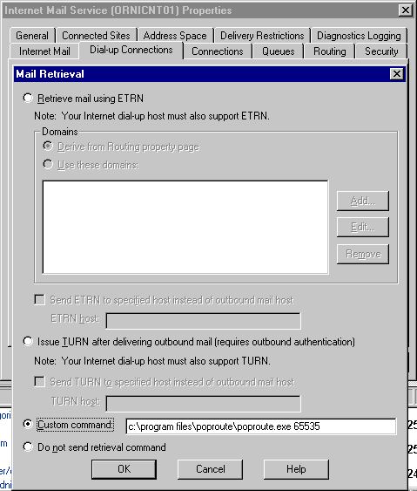
Run MS Exchange Server Administrator, go to "internet mail service properties" (under connections), select "dial-up connection" tab and press "mail retrieval" button.
Select "Custom command" radio button and to the edit box type poproute.exe command including the whole path. As a parameter you can set maximum size of one email that PopRoute will download from POP3 account.

Now PopRoute will retrieve your emails automatically whenever you will dial-up your ISP for sending emails or generally whenever you will be online.

You can also run PopRoute manually from command line. This is useful e.g. if you set the limit size for downloaded emails in Internet Mail Service Properties.

6. license
==========
PopRoute. Copyright (c) 1998-99 ORNIC Technologies, Inc. All Rights Reserved.

PopRoute License Policy:

ORNIC TECHNOLOGIES, INC. DISCLAIMS ALL WARRANTIES RELATING TO THIS SOFTWARE, WHETHER EXPRESS OR IMPLIED, INCLUDING BUT NOT LIMITED TO ANY IMPLIED WARRANTIES OF MERCHANTABILITY AND FITNESS FOR A PARTICULAR PURPOSE, AND ALL SUCH WARRANTIES
ARE EXPRESSLY and SPECIFICALLY DISCLAIMED.

PopRoute is a freeware product and its use in a personal, business, commercial, government, or institutional environment doesn't require registration.

We ask that users share PopRoute with a friend and recommend it to others if they like it.

WHILE POPROUTE IS FREELY AVAILABLE, WE HAPPILY ACCEPT ANY DONATION.

ORNIC Technologies, Inc.
http://www.ornic.com
info@ornic.com

