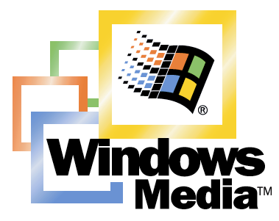

Windows Media™
Player 7
Technology Preview Reviewer’s Guide

March 2000

For more information, press only:

Crystal Patriarche
Shandwick International
(425) 452-5400
cpatriarche@shandwick.com

Sean Alexander
Microsoft Corp.
(425) 703-9797
seanalex@microsoft.com

Table of Contents

Welcome to Windows Media Player 7 3
Executive Summary 5
What’s New In Windows Media Player 7 7
Windows Media Consumer Scenarios 8
Personalizing your Digital Media Experience 8
Unchaining your Music Collection 8
Discovering New Content and Old Favorites 8
Purchasing a Movie 8
Watching a Pay-Per-View Live Event 9
Listening to your Hometown Sports Radio station 9
Viewing your Home Video Collection 9
Windows Media Player 7 Features 10
Easy to Use 10
Competitive Perspectives on Ease of Use 12
All-In-One 14
Competitive Perspectives on All-in-One Functionality 16
Best Audio and Video Experience 18
Competitive Perspectives on Audio and Video Quality 20
More Personality 22
Competitive Perspectives on Personalization Features 28
Summary 29
Easy to Use 30
All-In-One 30
Best Audio & Video Experience 31
More Personality 32
Appendix 1: Availability and System Requirements 33
Appendix 1: Evolution of Windows Media 34
Appendix 2: Windows Media Architectural Overview 35
Streaming Live Content 35
Streaming On-Demand Content 35
Appendix 3: Windows Media Family of Technologies 36
Appendix 4: Glossary 39

This document is provided for informational purposes only. Microsoft makes no warranties, either express or implied, in this document. Information in this document is subject to change without notice. The entire risk of the use or the results of the use of this document remains with the user. The example companies, organizations, products, people and events depicted herein are fictitious. No association with any real company, organization, product, person or event is intended or should be inferred. Complying with all applicable copyright laws is the responsibility of the user. Without limiting the rights under copyright, no part of this document may be reproduced, stored in or introduced into a retrieval system, or transmitted in any form or by any means (electronic, mechanical, photocopying, recording or otherwise), or for any purpose, without the express written permission of Microsoft Corp.
Microsoft may have patents, patent applications, trademarks, copyrights or other intellectual property rights covering subject matter in this document. Except as expressly provided in any written license agreement from Microsoft, the furnishing of this document does not give you any license to these patents, trademarks, copyrights or other intellectual property.
© 2000 Microsoft Corp. All rights reserved.
The information contained in this document represents the current view of Microsoft Corp. on the issues discussed as of the date of publication. Because Microsoft must respond to changing market conditions, it should not be interpreted to be a commitment on the part of Microsoft, and Microsoft cannot guarantee the accuracy of any information presented after the date of publication.
Microsoft, Windows Media, NetShow, PowerPoint, Windows, MSN, Visual Basic, ActiveX, Windows NT, DirectDraw and JScript are either registered trademarks or trademarks of Microsoft Corp. in the United States and/or other countries.
Other product or company names herein may be trademarks of their respective owners.
Microsoft Corp. • One Microsoft Way • Redmond, WA 98052-6399 • USA
Rev 1 - 0300

Welcome to Windows Media Player 7
Welcome to the Microsoft® Windows Media™ 7 reviewers guide. Windows Media Player 7 is designed to offer the best consumer experience for the discovery, download, personalization, and playback of high quality Windows Media audio and video.

The reviewers guide is divided into the following sections to assist you in your evaluation:

- Executive Summary
- Evolution of Windows Media
- What’s New In Windows Media Player 7
- Windows Media Consumer Scenarios
- Windows Media Player 7 Features
- Supplemental Information

Windows Media Player 7 represents a significant enhancement to the Windows Media consumer experience. We encourage you to take time to enjoy Windows Media Player 7 first-hand with your favorite music and media content.

Supplemental information about Windows Media can be found online at http://www.microsoft.com/windowsmedia/

Please contact Crystal Patriarche, Shandwick International, at (425) 452-5400 or cpatriarche@shandwick.com, for any additional information you might need.

Executive Summary
As the PC continues to become a more integral part of our entertainment experiences from Web “surfing” to discovering and purchasing digital media, there is an increasing need to provide the same easy “it just works” experience that consumers have today with appliances such as televisions and stereos. Wouldn’t you like to listen to your favorite music while typing a document, or surfing the Web? How about listening to your alma-mater’s sports radio station over the Web, despite you’re over 1500 miles away and have no hope of catching the game locally? These activities are becoming more common every day.

Initial attempts to make the PC a more inviting digital media experience through PC jukeboxes and streaming media players have left most “non-techie” consumers confused about which applications to use when, frustrated about file types, deluged with advertising, and confronting issues of individual privacy.

The goal in designing Windows Media Player 7 was to learn from other media players’ and jukeboxes’ mistakes and provide an easy to use experience designed for mainstream PC users. The result is a single application that provides one-click access to your most common activities, incorporates an audio and video jukebox, personalization, and makes it easy to play music on portable devices.

PC users representing a wide range of user types played an important role in helping Microsoft shape this new application, providing input on elements such as the feature set, usability, personalization, and overall experience. Based upon the feedback of these consumers, Windows Media Player 7 introduces four key design elements that put the new player in a class by itself:

Easy to Use
In order to make the use of digital media accessible to mainstream consumers, it is critical that a media player be easy to use, without sacrificing features. As the Web grows exponentially in entertainment programming and information on artists and events, consumers need an easy way to find their favorite sites and sounds and build a media player that suits their needs.

All-In-One
Windows Media Player 7 includes one-click access to all of your most common digital media experiences including discovering great new movies and music, organizing your media into personalized playlists, tuning into distant radio stations, and transferring your music to your portable music player. A single easy to use interface stitches together all of your activities into one seamless experience.

Best Audio and Video Experience
Providing a positive experience to customers is crucial to digital media enjoyment, and audio and video quality should be as close to the original as possible. Whether you’re connected via a 28.8 connection, DSL, Cablemodem, or a 10 Mbit LAN, the video should provide scalability and the best customer experience possible. Common features such as audio and video tuning should come standard, further enhancing the overall experience.

More Personality
Consumers today expect personalization and a customized experience in many aspects of their lives, from cars, to Web sites and more recently PC’s. The same should be applied to PC entertainment experience, through customized colors, designs, and features that extend the functionality of the application.

By incorporating these design themes and involving consumer’s input heavily into the design and usability of the product, Windows Media Player 7 gives you the best audio and video experience in an easy, integrated and personalized way.

What’s New In Windows Media Player 7
Based upon customer research, usability testing and the innovations of the Windows Media team, Windows Media Player 7 represents the next-generation in PC-based, digital media jukeboxes and players. The following is a summary of the most significant enhancements to the Windows Media Player:

- Integrated Media Jukebox – Now includes integrated playback, jukebox recording, media library and playlist features, and transfer to portable devices.
- New Look and Design – Clearly defined buttons and simple one-click access to your most common activities are all designed to make it easier to find, organize, and play your digital audio and digital video.
- CD to PC Recorder – Copy entire CD’s to your PC in just a few minutes- even listen to the CD as it’s being recorded. Stored in Windows Media audio, you get CD quality at 1/2 the size of MP3's.
- Portable Device & Media Support – Transfer music to the latest portable devices and media including the Creative Nomad II, RCA Lyra, CompactFlash, SmartMedia, and Windows CE-based devices.
- Media Guide & Radio Tuner – The WindowsMedia.com Guide and Radio Tuner are an integral part of the player, offering one-click access to the best music, radio, movies, broadband and more.
- Enhanced Media Library w/ Playlists – Customize, manage, and store all of your favorite Windows Media content in one place, conveniently housed in one easy to use media library.
- Improved Audio and Video Controls – Integrated 10-band audio equalizer with over 20 presets lets you customize the sound just the way you want it. Easily adjust brightness, contrast, saturation, and hue of any video clip to the exact settings you prefer.
- Interactive Skins – Skins let you personalize the look, feel, and operation of the media player by changing the user interface. Windows Media skins go beyond other players, offering enhanced functionality, animation, and feature extensibility.
- Visualizations Support – Ships with over 20 professionally created, customizable two and three-dimensional animations that change and move to your music.
- Enhanced AMG Music information – Get in-depth information on your favorite artists right inside the player, including artist biographies, discographies, liner notes, reviews and more all from the premier resource: AMG- the All Music Guide.
- Digital Rights Management (DRM) v2.0 - Integrated client support for SDMI-capable Windows Media rights management technology delivers a simplified consumer experience from purchase to playback of digital media without the need to download additional plugins.
- Localized in over 20 Languages – With client and media guide content localized in over 20 languages, Windows Media Player 7 offers personalization and customization on a global scale.

Windows Media Consumer Scenarios
What you do with Windows Media Player 7 is as personal a choice as what kind of music or movies you like. The following are just a few brief samples of the many ways Windows Media Player 7 can be used to enrich the PC experience.

Personalizing your Digital Media Experience
It’s just after dinner, and Sarah has settled down in her study to work on the big business proposal due at 9am the next morning. She’s a little stressed about the project and decides to put on some mood music to help her relax and get creative. Sarah begins by clicking on Windows Media Player 7 and selecting her Media Library. She creates a new playlist, “Sarah’s Stress Busters” and drops a selection of Jazz favorites from her local media library into the new playlist. Next, she adds a few streamed Jazz favorites from the Web to her playlist and she’s ready to play. The soothing sound of Miles Davis can be heard. Sarah clicks the display toggle to bring up her preset skin, a Jazz Bass, and she enjoys the soothing visualizations moving to the sound of the music. After a few minutes, she’s ready to start working and loads up Word 2000 to start her work with Miles playing in the background.

Unchaining your Music Collection
Jon has a 50-disc CD changer in his dorm room. He loves the changer because he can listen to almost all of his music at any given time. The problem is, Jon also likes to play his CD’s in his car and listen to his own custom compilations. Shuttling the CD’s back and forth and programming custom playlists into the CD player is frustrating, so he uses Windows Media Player 7 to copy all of his CD’s on his computer in high-fidelity Windows Media Audio. Now when Jon wants to listen to his music in his car, he takes his portable music device that can play skip-free in his car or the gym. And since Windows Media offers him CD quality at half the size of MP3, Jon will have plenty of room to play a larger selection of music.

Discovering New Content and Old Favorites
One of Rob’s favorite hobbies is discovering new music and movies. He often visits his local music store and can spend hours at the listening stations and kiosks sampling new content. Recently, Rob downloaded Windows Media Player 7 and discovered the WindowsMedia.com Media Guide. The Media Guide gives him access to the best Windows Media content on the net, from movie previews and artist reviews, to the hottest music and more. From his personal media library, Rob has access to the latest album information such as artist bios, reviews, discographies, even recommendations on other artists he might like, all straight from the premier AMG Music Service hosted on WindowsMedia.com.

Purchasing a Movie
Kevin’s flight to New York is always a long trip, and he travels so often that he’s on reruns of most in-flight airline movies. Before packing, Kevin logs on to Intertainer.com and purchases, “The Matrix” for his trip. After verifying his credit card, the movie starts downloading over his cable modem. By the time Kevin is packed, the movie is in his media library, stored on his laptop, ready for him to view during the flight in near-broadcast quality video.

Watching a Pay-Per-View Live Event
Dave’s 13-year-old son, Tim, is a big professional wrestling fan. After school, Tim logs onto the Internet and starts up the media player to do some media surfing. He loads Windows Media Player 7, clicks on the media guide and is alerted that tonight’s Pay-Per-View event will feature his favorite wrestler, “The Stone”. Later that evening Dave and Tim log into Wrestlingmania.com and purchase the special pay-per-view event. At 8pm, they share an hour together watching, The Stone check his opponents into the, “Slapdown Hotel”.

Listening to your Hometown Sports Radio station
Pat has always groused about how he could never pick up the television or radio broadcasts of his alma mater’s football or basketball games since he moved out of state. Using the Windows Media Player 7 Radio Guide however, Pat not only found a site that simulcasts the games, but also has links to the official Web site where he can download the official school skin, a dancing visualization of the school’s mascot, “The Golden Muskrat”, or chat with other alumni during a live webcast with the coach about how last week’s loss to their arch rival was a fluke.

Viewing your Home Video Collection
Sue is an avid home video director. She loves to put together funny videos of family and friends to send via email or record to CD as presents. Most of all, she enjoys showing off the videos she’s made with Windows Movie Maker when family come over to visit. Using Windows Media Player 7, she’s able to quickly find all of her home movies and “Best of…” collections in the media guide. Just a few clicks and her friends and family are laughing at a video of when her husband accidentally knocked a beehive off the roof last summer.

Windows Media Player 7 Features
Building upon each of the themes described earlier, Windows Media Player 7 is designed to provide the best consumer digital media experience possible today. The following sections are designed to familiarize you with the common design themes of Windows Media Player 7, and the new features that correspond to each design theme:

Easy to Use
Every feature in Windows Media Player 7 is designed to make the digital media experience as easy as possible. Most consumers don’t care about bit-rates, codecs, or digital vs. analog recording. They also don’t want to be confused by banner ads and offers throughout the application, distorting the lines between functionality and fund raising. What they want is access to their personalized media and devices as quickly as possible.

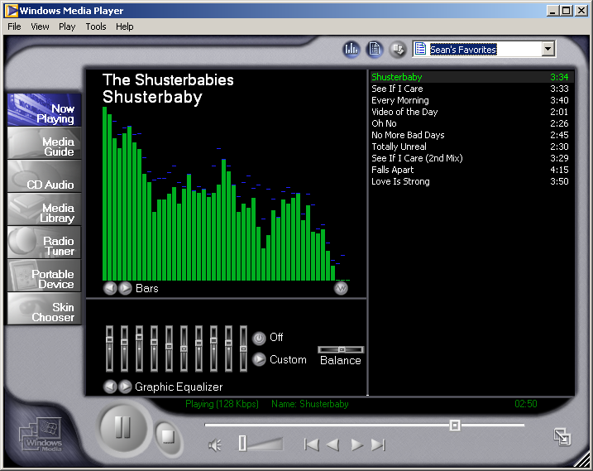
Figure 1: Windows Media Player 7's intuitive new UI makes it fast and easy to do everything from discovering content to transferring music to your portable music device. Note the easy to use, quick access buttons with one-click to common features such as playlists and the enlarged Play/Pause/Stop Buttons.

New Look and Design
One of the first things you’ll notice about the new Windows Media Player 7 is the brand new look and feel of the application with a clear focus on simplicity (or ease of use) without sacrificing visual appeal. The new full activity mode is designed to provide you with one-click access to all of your most common activities -- from viewing your current selections in “Now Playing,” to transferring CD audio to your computer or portable device.

In particular, the “Quick Access” panel and the main Play/Pause and Stop buttons highlighted in Figure 1 were two features scored that very high in usability tests. Consumers found that the “Quick Access panel were very useful for accessing your media library playlists, or setting shuffle and visualization features. The general size and availability of the Play/Pause and Stop buttons made it easy for consumers to take control.

Improved Radio Guide
The new WindowsMedia.com Radio Guide gives you unparalleled search and customization features. Search capabilities are now fully integrated into the player, giving you the power to search over 1500 radio stations online by location, genre, radio personality, language, even frequency or call sign. You can even sort stations by connection speed to get the best audio quality possible. Once you’ve found the radio stations that suit your interests, one click will add your selection to your own favorite preset buttons- just like your stereo today.

Intelligent Updates
New and improved intelligent update feature automatically ensures that you have the latest Windows Media technologies installed in your player. Different from other applications’ auto-update features, consumers don’t have to understand codecs, file formats, or proprietary add-ons. The latest components are installed automatically when they are needed, and in a secure fashion.

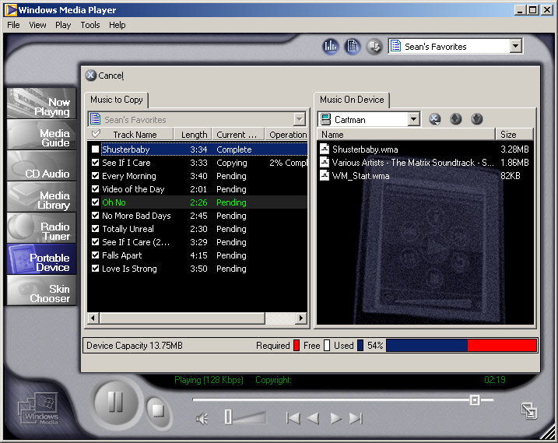
Figure 2: Plug and Play support for your portable music or CE device is built-into Windows Media Player 7. Easily transfer your custom music and playlist selections to your device with a single click.

Plug and Play the latest Portable Devices
Unchain those melodies from your PC! Windows Media Player 7 has full plug-and-play support for the latest generation of digital music and Windows CE-based devices so your music is always with you. It’s as easy as the click of a button to transfer your own custom compilations and playlists to your device. An intelligent space meter actively tracks available and allocated storage space so you never have to worry about running out mid-way through the transfer. Windows Media Player 7 even includes support for the secure transfer of DRM or SDMI-compatible (copy protected) content.
Portable Devices Supporting Windows Media
Music Devices
Cassiopeia E-100 and E-105 | Casio Corp.
Diamond Rio | Diamond Multimedia
Creative Nomad II | Creative Labs
Sony Vaio Music Clip  (MC-P10) | Sony Corp.
RCA Lyra | Thomson/RCA
I-Jam | I-Jam Multimedia LLC
Storage Devices
CompactFlash | Various Manufacturers
SmartMedia | Various Manufacturers
MultiMedia Card (MMC) | Various Manufacturers
Jaz, Zip, Clik Drives | Iomega
SuperDisk | Imation
CD-R and CD-RW Drives | Various Manufacturers

One of the key differentiating features of Windows Media Player’s portable and removable device support is that it provides a single mechanism for communicating with all of the latest devices. Using a technology called, Windows Media Device Manager (WMDM), device manufacturers can write a standard driver that allows their own applications as well as Windows Media Player to support their device. Similar in function to a printer driver, WMDM will ensure that Windows Media Player will support new devices as they become available.

Largest Native Support for Removable Storage Devices
Take more of your music further with removable storage devices such as CompactFlash, SmartMedia, Iomega Jaz, Clik, Zip disks and many more. Windows Media Player 7 also supports secure writing of copy-protected content. Take a handful of storage cards on the road and your media library is at your disposal!

PC Friendly
Windows Media Player 7 is resource conscious- using only the memory and processor time it needs for your current activity. Additionally, Windows Media Player doesn’t take over shared file types without your explicit direction.

DRM License Backup and Restore
You can now you can easily back up and restore the licenses to copy-protected content you’ve purchased over the Net, a highly-requested feature that saves significant time in playing your favorite digital content.

Competitive Perspectives on Ease of Use
When evaluating other media players and jukebox products, we suggest that you take a look at the overall design of the UI and how it would appear to a wide-range of consumers. Are the buttons clearly laid out by activity? Is the application PC Friendly?

Another important factor is support for removable storage devices. Does the player or jukebox make it easy to incorporate new devices? What about support for multiple devices on the same PC? Do plug-ins have to be downloaded every time you add a new device? Windows Media Player 7 takes advantage of the Windows Media Device Manager (WMDM), similar to a print driver or universal CD-ROM driver; portable device manufacturers can use WMDM to provide a standard way for PC’s to talk to their devices, which many different applications can use.

How aggressive is the application in taking over file types and “advertising” itself on the desktop, the browser, and the system tray (a.k.a. StartCenter)? A common trick used by many applications is to load in the system tray at boot to increase the perception of a fast startup. What you aren’t told is that this can reduce your system resources by up to 1/3 on the average home PC with 32MB of RAM, regardless of whether you are actively using the player or not. The end result is that your PC is slower to boot and general PC performance is degraded.

Another key factor is support for Digital Rights Management. Many players try to mimic support for DRM by providing simple “backup and restore” keys. While this solution works for copy protecting your own CD collection that you copy to your PC, Windows Media Player 7 provides fully integrated support for backup and restore of digital media downloaded off the Web. This is essential for scenarios where content is purchased online.

Ease of Use Competitive Analysis
Feature | Microsoft  Windows Media Player 7 | RealNetworks RealPlayer 7 | RealNetworks RealJukebox
One Click Access to all your activities | Yes | No | No
Fully integrated Radio Guide with searching by location, personality, call letters, and more | Yes | No | No
Intelligent Updates | Yes | Yes | Yes
Pre-populated Radio Guide | Yes | Yes | No
Built-in backup and restore support for DRM-enabled content | Yes | N/A | N/A
Portable Music Device support | Yes | No | Partial; One device supports G2, some MP3 players
Palm-Sized PC Support, Pocket PC Support | Yes | No | No
PC Friendly | Yes, only loads what it needs | No, Default loads app into memory at boot | No, Default loads app into memory at boot
Removable Storage Support | CompactFlash, SmartMedia, MMS, SD, Iomega Jaz, Zip, Clik, plus many more. | No | Iomega Jaz, Zip, Clik, CD-R, some cards through download of proprietary add-ons

All-In-One
Windows Media Player 7 is pioneering an all-in-one destination application for consumers of digital media. A tightly integrated and easy-to-use design let you create, organize, and experience your media faster than ever. Streamed or downloaded, audio or video, Windows Media Player 7 makes it simple to discover, organize, or play digital media.

Integrated Media Jukebox
Brand new to Windows Media Player 7 are a rich set of new features that are tightly woven together, using the same look, feel, and ease of use consumers are accustomed to. Just as Microsoft Office redefined productivity in the workplace through shared user interface features, Windows Media Player 7 will redefine how you play digital media.

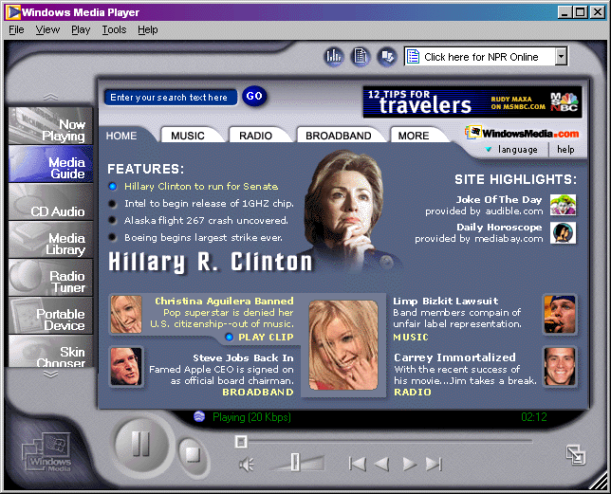
Figure 3: A new, integrated media guide gives you the best of the best of the Web in Windows Media. Music, Radio, Movies, and Broadband- all just a single click away.

Built-In Media Guide
Now a part of Windows Media Player 7, the WindowsMedia.com interactive media guide is a great place to discover and play back great Windows Media content from the Web. Content is aggregated from partner sites such as MSNBC, Bloomberg, Fox Sports, Atom Films and more, and offers you the best of the best in Music, Radio, Movies, and premium broadband content.

Record your CD Collection to your PC
Copy and play your entire CD collection on-demand from your PC hard drive using the Windows Media Player 7 CD copy feature. Windows Media Player 7 includes a full-featured high-speed engine for recording and compressing CD’s to your PC using the Windows Media Audio format, all without any perceptible loss in quality. With a single click, you can copy entire CD’s to your computer in just minutes. For example, if you have a CD that is 60 minutes in length, you can record the entire CD to your hard drive in less than 12 minutes. You can even copy CD’s while listening to music from the same CD or your media library. Are your older CD’s scratched from use? Advanced error-correction features will attempt to recover the music.

Support for both Download and Stream-based Playback
Windows Media Player 7 gives you more control over your playback options. From video to audio, Windows Media to MP3, Windows Media supports streaming and downloaded content seamlessly while other jukeboxes require multiple programs to support streaming and can only play downloaded video content in a fixed window size.

Easier, More Powerful Search
The new media guide search now supports searching of premium content from a combined library of thousands of hours of content right from within the media library. Search by artist, media type, or keyword. You can download or stream from thousands of hours worth of audio and video from top artists in high quality Windows Media audio and video.

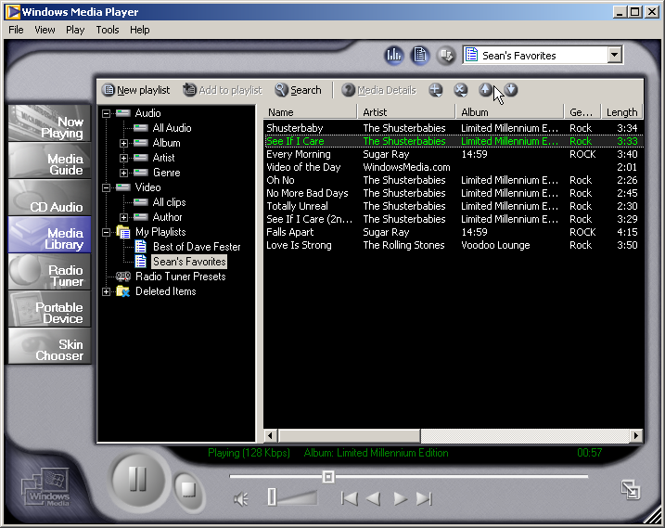
Figure 4: The Enhanced Media Library is designed for you to easily manage your favorite media, create playlists, and quickly jump to your favorite radio tuner presets.

Enhanced Media Library
Once you’ve created your collection of media and favorites, how do you explore and manage it all? The new media library incorporates all of your local and Internet favorites into one easy to use place. Using an intuitive tree-view interface familiar from many Windows-based applications, you can browse and sort your content by types such as Album, Artist, or Genre. Customize and sort your content on a large set of categories from the standard Artist Name and Track Length to the encoded rate and number of times played. In addition, playlists are clearly displayed, as are your favorite radio stations and streamed content. There’s no need for a separate Favorites list in the player -- the Media Library is your one-click destination for all of your media in any format.

Digital Rights Management (DRM) 2.0
One of the primary barriers to the widespread distribution of digital music by major record labels is the lack of integrated copy protection for formats such as MP3. Media companies have a responsibility to protect the intellectual property created by the artists and deter piracy. It is also the responsibility of the media player to include a proven solution that guards against piracy while still being easy for the consumer to use. This opens up new content possibilities to consumers and new e-commerce opportunities to content providers and distributors.

Windows Media Digital Rights Management (DRM) secures content and manages access rights, protecting the copyright holders and/or pay-per-view providers. DRM 2.0 simply put, lets you effortlessly listen to the latest copy-protected content released from major labels and artists without the need for add-ons or invasive copy-protection schemes.

As a mature technology in use by major distributors, Windows Media digital rights management platform benefits from early user feedback to provide a better consumer experience. As you purchase DRM-enabled content, you will notice that it is automatically listed in your media library upon downloading. In addition, if you decide to purchase a new computer, the new license backup and restore feature will make it easy for you to unlock your content for playback on your new machine.

Purchase Music and Movies Online
Visit one of our many partner sites online and preview or purchase CD quality music or high-quality video delivered immediately- no trips to the mall required. Many of our partner sites such as Intertainer.com and Launch.com give you access to the latest music, videos, and movies at the click of a mouse.

Competitive Perspectives on All-in-One Functionality
Media players are much more than just utilitarian accessories or plug-ins that play back digital media. Consumers today want an integrated, all-in-one destination application that handles everything from streamed to downloaded media. Other media players may require that you install an additional application, or even multiple applications and plug-ins to get the same level of functionality in Windows Media Player. By incorporating a single, unified media guide, you are less likely to be confused about where to go when and find the content you are looking for.

Once you have your content, how do you organize and play it? Other media players have limited support for media libraries or custom playlists and no support for favorites. Others depend on add-on applications with jukebox functionality to manage your personal music collection, but store favorites in a different place. Windows Media Player 7 provides a fully integrated, all-in-one media library where all of your content, local or streamed is available to you.

Other media players say they have built-in Digital Rights Management, but there is a key difference between DRM and basic copy protection. Basic copy protection, sometimes called “Secure Music Files” only protects your personal library from being copied between devices. Digital Rights Management on the other hand, provides a secure way to get new brand-name music for evaluation or electronic purchase and delivery from all of the major record labels for downloaded content. Artists such as Mariah Carey, David Bowie, and The Artist (formerly known as Prince) have all provided content in Microsoft’s DRM-enabled Windows Media format. Since Windows Media Player includes DRM support, don’t have to download a multitude of plug-ins to play the content you just purchased or downloaded for free.

All-in-One Competitive Analysis
Feature | Microsoft  Windows Media Player 7 | RealNetworks RealPlayer 7 | RealNetworks RealJukebox
Integrated Media Jukebox | Yes | No | Yes
Built-In Media Guide | Yes | Yes | Yes, limited
Record your CD Collection to your PC | Yes | No, requires RealJukebox | Yes
Support for both Download and Stream-based Playback | Yes | Basic, doesn't support media library | Download only
Enhanced Media Library | Yes | No | Basic
Built-In Digital Rights Management Technology | Yes | No | No

Best Audio and Video Experience
What makes the best audio and video experience? It’s a combination of a number of factors- the ability to reproduce audio and video as true to the original as possible, the ability to display content at a varying number of sizes, or easy to use and performs quickly. Another feature often overlooked is the ability to customize the experience to each person’s individual taste and environment. Windows Media Player 7 builds upon the industry-leading audio and video quality first made available in Windows Media Technologies 4 to enhance the overall experience from end to end.
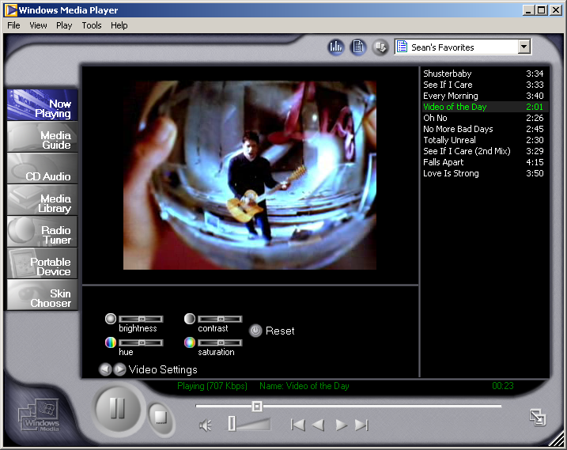
Figure 5: Now improved and more discoverable, Windows Media Player 7 video controls make it easy for you to adjust the video to adjust for environmental settings such as ambient lighting and monitor color.

Improved Video Controls
Each computer monitor’s video display is different- varying color and brightness settings; even ambient light in the room can have a profound effect on the display of video. Just as the latest computer games have gamma settings to optimize the video for your particular environment, Windows Media Player 7 is designed to make it fast and easy for you to optimize your video settings. Updated and easy-to-use video controls adjust settings such as brightness, hue, contrast and saturation to your own preferences fast and easily.

Best Video Quality at All Speeds
With multiple Internet connection speeds available to consumers—from slower modems to high-speed DSL or cable access-- providing a positive experience to consumers at varying levels of connectivity is crucial. Video quality should be as close to the original as possible and the quality should degrade gracefully under adverse conditions such as network congestion. Windows Media Player 7 consistently presents higher frame rates than RealSystem G2 (which uses proprietary audio and video codecs) at all bandwidth points; this is especially evident at bandwidths above 300 Kbps or at 30 frames per second. Windows Media Player 7 is ready for the future, supporting bit rates beyond 3.5 Mbps, while RealSystem G2 does not.

The growth of broadband connections, such as cable modems and ADSL, has increased the availability of broadband content-- more video encoded and delivered from bit rates of 100 Kbps to over 700 Kbps. Using Microsoft’s advanced, standards-compliant MPEG-4 video codec, Windows Media Player 7 is optimized to present exceptionally high-quality video at these higher bandwidths. The Microsoft MPEG-4 codec provides the latest in narrow and broadband video compression technology, and is based on the latest generation of the same technology used in DVD (DVDs and satellite television use MPEG-2).The MPEG-4 codec is in its third generation has been optimized for the latest Intel and AMD processor-based multimedia extensions, and delivers superior picture quality at all bandwidths.

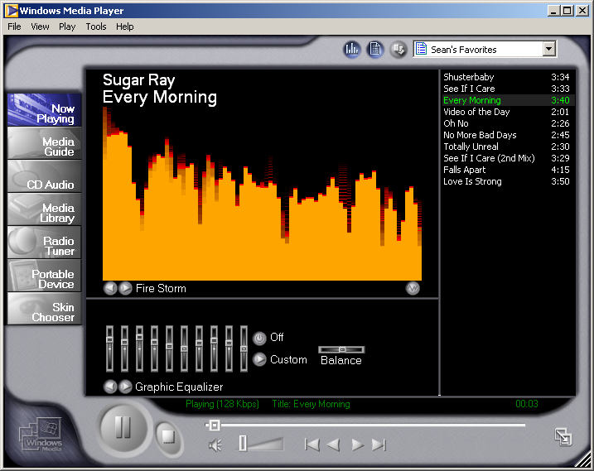
Figure 6: The new 10-band graphic equalizer with over 20 presets gives you superb audio
tuned to your preferences.

Interactive 10-Band Audio Equalizer
From rock to reggae, classical to club, listen to your music the way you want it. Use the custom 10-band audio equalizer to tune music to your personal preferences, your speakers, or the acoustics of your room. With over 20 presets settings for the equalizer you get the best audio experience possible. You can even create and save your own custom presets so your favorite music always sounds its best.

CD Quality at Half the Size of MP3
Windows Media Audio gives you CD quality audio at half the size of MP3, which means you can double the amount of music on your PC or portable device. When you copy CD’s to your hard drive, they are automatically compressed and stored as Windows Media Audio to give you most storage space for content while preserving the CD-quality sound.

Figure 7: ZDLabs tests show nearly 90 percent of consumers tested preferred or could not tell the difference in quality between music in the Windows Media Format and songs in the MP3 format created with RealNetworks’ RealJukebox that were twice the size.

Independent double-blind tests conducted by ZD Labs found that when compared to the CD-quality originals, nearly 90 percent of consumers tested preferred or could not tell the difference in quality between music in the Windows Media Format and songs in the MP3 format created with RealNetworks’ RealJukebox that were twice the size.

Power users can choose to set recording at a custom bit-rate all the way up to 220 kilobits per second. Other jukeboxes have to go as high as 320 kbps to offer the same quality as Windows Media Audio at much lower rates. Overall, Windows Media provides the best audio quality for copying to your PC or digital media device.

Optimized for the latest processors
Windows Media Player 7 is one of the few player applications to be optimized for the Intel Pentium II, Pentium III, AMD K6, and Athlon processors, Windows Media Player 7 takes advantage of the latest chip-based multimedia enhancements, delivering crisper sound, and clearer, more vibrant video.

Competitive Perspectives on Audio and Video Quality
A common misconception among consumers is that MP3 is a recent audio standard. MP3 was developed a decade ago, and only recent gained in popularity and notoriety largely from the illegal sharing of copyrighted music. On the other hand, the advanced compression of Windows Media, developed with Microsoft Research, gives the same CD quality audio at half the size of MP3. This is crucial when you consider that most portable MP3 players today can hold less than a full CD’s worth of music. By using Windows Media, you can get twice the amount of music on the same portable or removable storage device and hard drive. Today, all of the major record labels are delivering content in the Windows Media format. All of the top portable music players have announced support for Windows Media on their devices, making Windows Media the preferred format for secured music.

Video quality is more subjective, but waiting for it is not. Other media players artificially boost the quality of their video by increasing the buffer time (or lag time) between the time you requested the video, and the time it starts playing. Usability tests run by the Windows Media team have shown that most consumers will not wait more than 5-10 seconds for a video to start playing before becoming frustrated. Windows Media Player on the other hand, uses an advanced, standards-based video codec to compress video and deliver it as quickly as possible without sacrificing quality.

Why should consumers have to pay extra for basic features such as color or tone control that come on any basic radio or television set? Windows Media Player 7 integrates these features right into the application. Another feature you may note lacking is resizable video windows. Some players support resizable windows, some jukeboxes do not. Often times they also require a lengthy configuration process. Windows Media Player can resize all video, without re-configuration.

Audio and Video Competitive Analysis
Feature | Microsoft  Windows Media Player 7 | RealNetworks RealPlayer 7 | RealNetworks RealJukebox
Video Quality Controls (Brightness, Saturation, Hue, Tint) | Yes | $29.99  Plus version only | $29.99  Plus version only
Interactive 10-Band Graphic Equalizer | Yes | $29.99  Plus version only | $29.99  Plus version only
Resizable Video Window | Yes | Yes | No
CD Quality recording at 1/2 size of MP3 | Yes | No | No
Optimized for Intel and AMD processors | Yes | No | No
Advanced motion detection algorithm | Yes | No | No
Audio bit rate range (Windows Media vs. Real G2) | 2.4 Kbps to 220 Kbps | 6 Kbps to 96 Kbps | 6 Kbps to 96 Kbps
FM stereo quality at 28.8 Kbps | Yes | No | No
30 fps video down to 28.8 Kbps transmission | Yes | No | No

More Personality
Consumers aren’t satisfied with one-size-fits-all media players or jukeboxes designed for the masses. You have your own tastes and preferences and a need to express yourself. While other media players give you limited personalization options, Windows Media Player 7 was designed to extend the functionality and features of the player to encompass not just your preferences, but also your personality. From industry-first interactive skins, to visualizations that move with the music, Windows Media Player 7 is the media player with more personality- and a host of extensibility options to suit your style, tastes, and individuality.

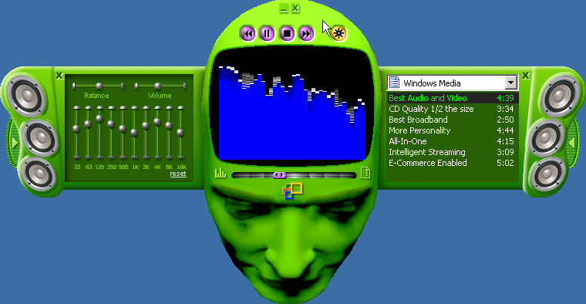
Figure 8: Interactive Skins such as the one shown above let you express your individuality more than any other media player. Note the interactive panels and controls

Interactive Skins
For the first time ever, you can create their own look and personality for their Windows Media Player. Windows Media Player 7 includes interactive “skins” that let you personalize the look and feel of the player to your tastes and interests. What makes Windows Media Player 7 skins unique is the interactivity and animation that goes far beyond any other media player. A skin can be functional with sliding control panels, windows, playlists and controls, or hidden surprises that must be discovered. Navigation is never an issue however; just click the Windows Media icon to return to full mode view.

Another industry first is the ability to download custom skins that are tied to particular content. For example, you could download a custom guitar skin for the Eric Clapton album that you just purchased online, or a custom Now Playing dashboard skin for the latest Pink Floyd compendium.

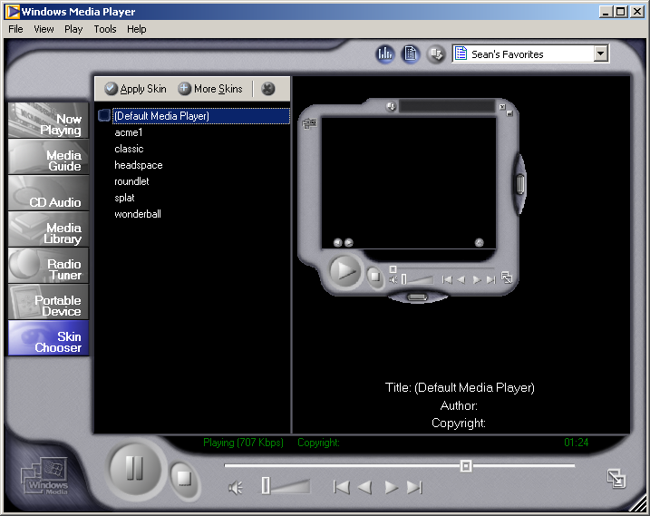
Figure 9: Managing and discovering skins is easy with one-click access to the skin chooser in the media center.

Although Windows Media provides a variety of colorful and creative skins, many consumers and content providers will want to create their own with the Windows Media Software Development Kit (SDK) available at http://msdn.microsoft.com/windowsmedia. Using industry-standard graphics, XML, and JScript, anyone familiar with Web development can create their own custom skin. The more experienced developer can create custom controls that add new features to the player.

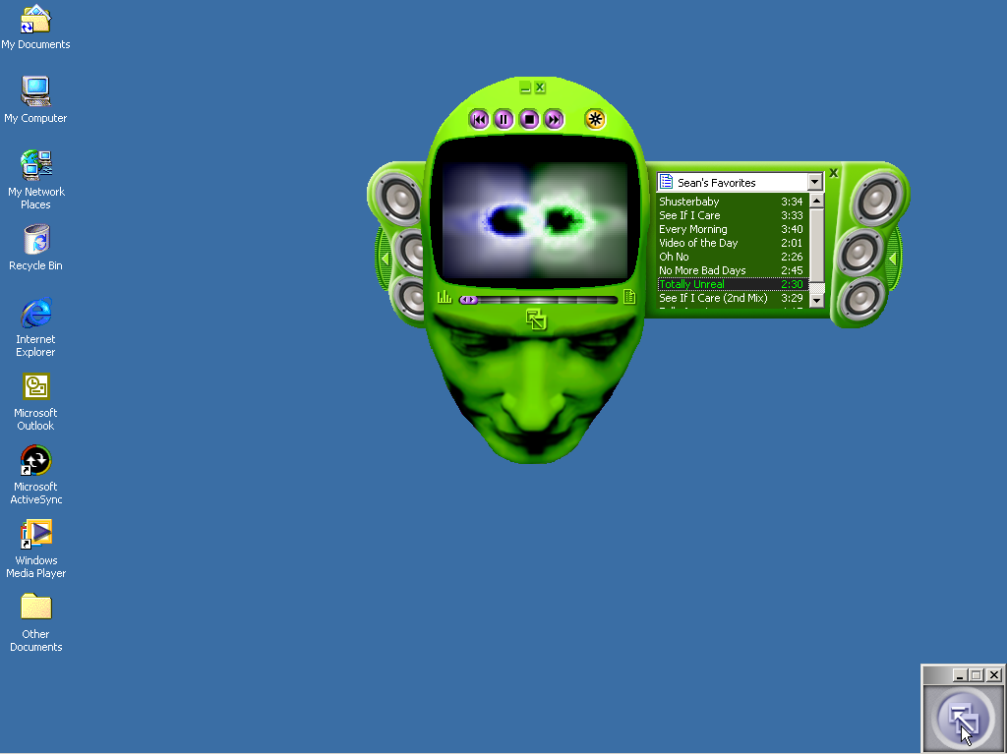
Figure 10: Unlike other media players, with Windows Media Player 7, you’ll never get lost in a custom skin. The Windows Media anchor (highlighted) will always be there to bring you back into full mode.

Another feature of the player is the Windows Media Player “anchor”, which sits in the lower right-hand corner of your screen when you are in skin mode. Consumers told us that one of their chief complaints about other media players is how easy it is to get lost when you are in a skin. Windows Media Player 7 solves this by making the anchor always available in the same place. One click will always bring you back into full mode.

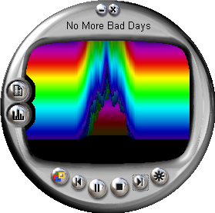
Figure 11: Windows Media Player 7 ships with over 20 professionally created, three and two-dimensional visualizations that move to your music. Visualizations can be displayed full screen, windowed in Now Playing, or through many custom skins.

Eye-Catching Visualizations
Experiencing your music means more that just listening. Visualizations of the music can be soothing, hypnotic, and just plain cool. Windows Media Player 7 ships with over 20 visualizations that move to your music- from standard spectrum analyzers to 3-D effects. Visualizations can be displayed full-screen, or inside the media center or embedded in many skins. Many visualizations also include special personalization display controls that adjust the colors and types of visualizations displayed.

Windows Media Player 7 visualizations can be optimized with Microsoft’s award-winning Direct X graphics technology. All of the same rich multimedia elements such as full-color graphics, video, 3-D animation and more are available for use in visualizations. Developers interested in creating their own visualizations can download the custom Windows Media Player 7 SDK for free from http://msdn.microsoft.com/windowsmedia.

Skins and Visualizations Gallery
The new Windows Media Player 7 Gallery is the premier location for discovering the best Windows Media Player skins, visualizations, and add-on services to make the most of your Windows Media Player experience. You’ll have easy access to dozens of custom skins and visualizations from around the world. Weekly updates and special events such as contests and “Ask the Expert” sessions will make sure the content is always fresh and exciting.

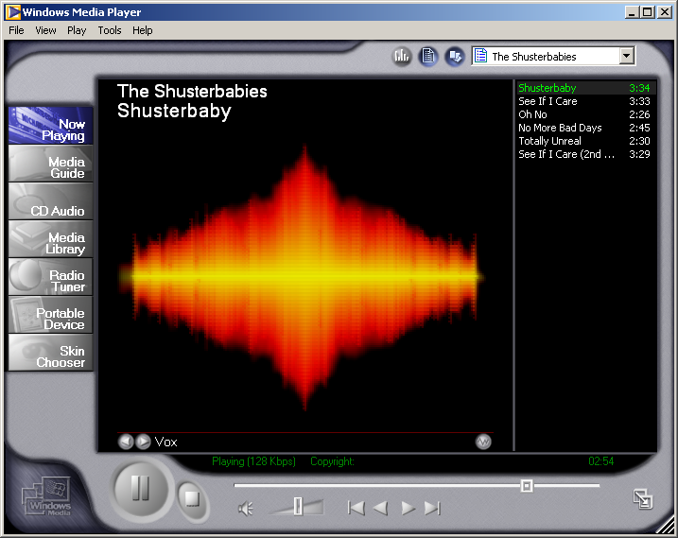
Figure 12: Use Now Playing to create your own personal multimedia experience. You can change visualizations and display video or audio settings, media information, or the playlist area.

Now Playing View
Use the new “Now Playing” View to create your own personal multimedia experience. You can change visualizations and customize the display to suit your preferences, including such features as audio and video settings, media information, or the playlist area. Each of the windows can be turned on or off and resized to better accommodate your content.

Most Extensible Player Platform
By developing Windows Media Player 7 to be the most extensible player platform, consumers can take advantage of new applications and services that extend the functionality of core player.

- Consumer Extensibility– An industry-standard scripting interface allows 3rd parties to develop new features for you to experience. Skins, visualizations, and even new Web-based application services help you get more from your media.
- Interactive Multimedia Applications – Create rich and interactive synchronized multimedia applications for Windows and the Web. Windows Media Player 7 supports industry-standard HTML+TIME and SMIL Boston multimedia extensions.
- New Embeddable Player Component – At the heart of Windows Media Player 7 is a robust media engine that can be incorporated into new or existing applications using the Windows Media SDK. Using the SDK, customers such as Launch.com have developed interactive media services that take advantage of Windows Media Player 7 by embedding the Windows Media Player control directly into their applications.

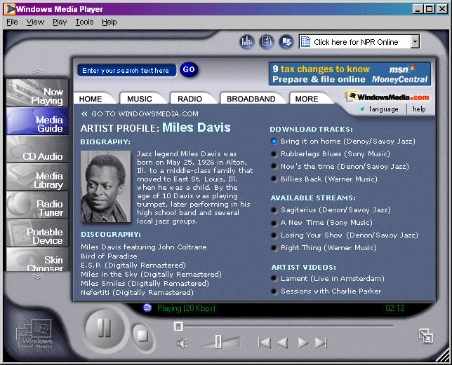
Figure 13: Now a part of Windows Media Player and WindowsMedia.com, the All Music Guide’s (AMG) enhanced album information gives you in-depth details on your favorite artists and albums from leading sources for magazines like Rolling Stone, Spin, Billboard and many more.

AMG Enhanced Album Information
Windows Media Player 7 goes far beyond other players and jukeboxes to bring you comprehensive, in-depth information on the artists and albums in your media library, straight from AMG- the All Music Guide.

AMG is the world's largest and most comprehensive entertainment information database for music. A massive archive available through WindowsMedia.com, All Media Guide's extensive data includes expert reviews, biographies, ratings, images, titles, credits, essays and much more.

When you place a CD into your drive or import content into your media guide on a PC connected to the Internet, Windows Media Player 7 automatically retrieves AMG’s artist and album information via the Web anonymously and without violating consumer privacy.

Integrated entertainment information helps to make Windows Media Player 7 the most feature-rich media player available today. Information details include:

- Album Information – includes Album art, Artist, Album, Genre, Release Date and more
- Artist Biography – in-depth biographies and statistics on your favorite artists
- AMG Reviews – comprehensive reviews by well-known music writers give you the inside-scoop
- Artist Discography – never miss the release of an artists album with AMG’s detailed collection of past work
- Related Artists – cross-referenced lists of related artists by musical type and genre help you to discover new favorite artists and albums.

Additionally, you can search AMG’s database for artist information via WindowsMedia.com.

Localized in over 20 Languages
Often overlooked, Windows Media Player provides a great consumer experience on a global scale. With player and media guide localization in over 20 languages, Windows Media Player 7 offers personalization and customization at a global scale. This is especially beneficial for Internet applications that need to reach a broad audience.

Competitive Perspectives on Personalization Features
Each of us has our own tastes, our own personalities. Why shouldn’t your media player be able to reflect your individuality? Other media players will claim rich skins support, but if you scratch the surface, you’ll find they just tack a new picture or pictures on the front of the player. While this is useful for changing the look, it doesn’t change the feel of the application. What about animation or the ability to interact with the skin?

Microsoft has taken an open approach to the development of skins by providing a free SDK, and an open programming model based upon industry-standard XML and JavaScript. Conceivably, other media players could adopt this open format to incorporate rich skins support into their applications as well.

Windows Media Player’s extensibility goes much further than competitors at the application level as well. Unfortunately, you have to read the fine print of the licensing agreements of other players to learn that their “open” player components require direct negotiation with the vendor before you can create your own custom application. Microsoft on the other hand, makes the Windows Media Player openly available as a control that can be incorporated into Windows-based applications or Web sites. Many 3rd party sites such as Launch.com’s LaunchCast and MSNBC use this functionality to build their own Web-based media players.

Another personalization feature lacking in other players and jukeboxes is the ability to get more information about your music. Many jukeboxes and players tout support for ID3 tags, and the ability to connect to the Internet to get artist and track information. What they don’t tell you is that most of this information is entered by random users on the Web and isn’t authenticated; meaning it often contains typos, missing information or wrong data. Windows Media Player on the other hand gets the latest information from AMG, the premier source of authenticated music information.

It is also very important to look at localization of the product. While some player and jukebox manufacturers claim localized versions of their applications, they are difficult to find, even more difficult to download, and are not fully localized. Visit one of the major player manufacturers, type in your locale information and note that you still are sent the English version of the product. Windows Media Player 7 will be available in over 20 localized languages.

Personalization Competitive Analysis
Feature | Microsoft  Windows Media Player 7 | RealNetworks RealPlayer 7 | RealNetworks RealJukebox
Basic Skins Support | Yes | No | Yes
Standards-based, open skins programming model with support for animation, additional features | Yes | No | No
Custom Visualizations | Yes | No | No
Enhanced Album Information | Yes | No | No
Extend through 3rd Party Web Applications and Services | Yes | Requires negotiation with RealNetworks | No
Localized in over 20 languages | Yes | No | No

Summary
The goal in designing Windows Media Player 7 was to learn from other media players’ and jukeboxes’ mistakes and provide an easy to use digital media experience for mainstream PC users. Windows Media Player 7 pioneers the evolution of digital media players as an integrated destination application. The result is a single application that provides one-click access to your most common digital media activities, incorporates an audio and video jukebox, personalization, and makes it easy to play music on portable devices.

PC users representing a wide range of user types played an important role in helping Microsoft shape this new application, providing input on elements such as the feature set, usability, personalization, and overall experience. Based upon the feedback of these consumers and the innovations of the Digital Media Division, Windows Media Player 7 gives you the best audio and video experience in an easy, integrated and personalized way.
Comprehensive Feature Summary
- The following section describes the key features of Windows Media Player 7. The features are divided along each of the design themes:

Easy to Use
- New Look and Design – Visually appealing and easier to use, the new Windows Media Player 7 has a brand new look and feel designed to make it easier to find, manage, and play your audio and video.
- One Click Activity Buttons – From the media guide to skins, everything you need is only one-click away.

Improved Radio Guide – New radio guide puts over 1500 radio stations at your fingertips. Easily find the station you’re looking for by call letters, frequency, genre, location, and even radio personality. Custom presets make surfing your favorite stations a snap.
- Intelligent Updates – Automatically notifies you when new updates and features are available. One click installation takes the hassle out of application management.

Portable Device Support – Download music to the latest generation of portable devices such as the Diamond Rio, Creative Nomad II, RCA Lyra, and Windows CE-based Palm PC devices.
- Removable Storage Support – Built-in support for the secure transfer of your music to the widest range of removable storage devices including CompactFlash, SmartMedia, MMC, and SD-based devices.
- PC Friendly – Unlike other media players that may take up to 11MB of memory even when you’re not running them, WMP7 only uses the resources it needs.
- Intelligent, Unobtrusive Setup – Setup intelligently checks for the presence of previously installed media players and only re-assigns default playback from other Microsoft players. It enables users to add Windows Media Player to their computers without disrupting the default playback settings for previously installed third-party players.
- Automatic Firewall and Protocol Configuration – Windows Media Player 7 intelligently connects to the server through firewalls without user intervention. After the best protocol is selected, the Windows Media Player “remembers” that protocol, to save time the next time a connection to that server is established.
- License Backup and Restore – Easily back up and restore licenses for playback of copy-protected music purchased online.

Closed-Captioning – Content authors can provide closed-captioning for people with disabilities or subtitles for foreign-language videos.

All-In-One
- Integrated Media Jukebox – Now includes integrated Windows Media jukebox, support for portable music devices, rich album and artist in formation and more.
- Built-in Media Guide – Now integrated, the WindowsMedia.com guide offers you the best of the best of the Web in Music, Radio, Movies, Broadband and more- delivered to you automatically.
- Record Your CD Collection to Your PC – Building your own jukebox is easier and faster than ever. Copy entire CD’s to your PC in just a few minutes, even listen to the CD as it’s being recorded.
- Support for both Download and Stream-based Playback – From video to audio, Windows Media to MP3, Windows Media Player 7 supports streaming and downloaded content seamlessly.
- Easier, More Powerful Search – WindowsMedia.com search now supports searching of thousands of hours of fresh content from Windows Media partners such as MSNBC, Bloomberg, Fox Sports, Atom Films and many more.
- Integrated, Resizable Video Playback – No need to launch another player, Windows Media Player 7 can play both streaming and downloaded video in variable window sizes.
- Enhanced Media Library – Media Library keeps all of your streamed and downloaded audio and video, even favorites together in a single place
- Digital Rights Management (DRM) 2.0 – Integrated client support for Digital Rights Management offers seamless consumer experience from purchase to playback without the need to download additional plugins.

Best Audio & Video Experience
- Improved Video Controls – Easily adjust brightness, contrast, saturation, and hue of any video clip to the exact settings you prefer.
- Best Video Quality at All Speeds – Whether you’re watching a video on a Web page at 56k or full screen, webcasted video at 600k over a cable modem, you’ll get the best experience with Windows Media Player 7.
- Interactive 10-Band Audio Equalizer – Integrated 10-band audio equalizer lets users customize the sound just the way they want it. From rock to reggae, classical to club, over 20 presets get you started.
- CD Quality at half the size of MP3 – Windows Media Audio gives you industry-leading CD quality at half the size of MP3, making it ideal for storing twice the amount of music on your PC or portable device.
- Video De-blocking Filter – The video de-blocking filter improves the video quality of ASF content by removing the blockiness caused by video compression. It improves the end-user experience of viewing streaming video content, especially at low data rates such as 28.8 Kbps.
- Enhanced content information – Windows Media Player 7 goes beyond other players to automatically bring you in-depth information on your favorite artists including CD artwork, liner notes, artist biographies and much more.
- Full-Screen, Full Motion Video – Get full-screen, full motion playback of video using the advanced DirectDraw® API. No configuration necessary.
- Scalable Video – Users can size the video window without being locked into predefined sizes.
- Seamless Stream Switching – Streams are played consecutively as one clip. Users can switch between content quickly and smoothly without long buffering delays. This enables a seamless viewing experience, even through commercials.
- Optimized for the latest processors – Get smoother, sharper audio and video with the only media player to take advantage of special optimizations for the Intel Pentium series and AMD CPUs.
- ID3 Extension Support – Includes full support for playback of MP3 files with ID3 extensions. This allows full compatibility for the playback of files in the MP3 file format
- Streaming MP3 Support – Play streaming MP3 previews, radio stations and other content, complete with playlist support.
- Network Error Correction – If UDP packets are missing, the server determines whether or not it needs to resend the lost packets. Intelligent UDP resend provides a better quality of media when using the UDP protocol.
- Volume Control and Mute – Adjustable volume and mute functions makes it easy to adjust or mute the volume without requiring the user to find and use the Windows volume control.
- Backward/Forward Button – Users can view or hear previous ASF streams without having to return to the URL. This provides easier navigation for users when listening to or watching ASF content.
- Index (Chapter) List – Viewable chapter markers enable users to jump to important spots in lengthy videos.
- CD Error Correction – During playback and recording of CD’s, if Windows Media Player 7 encounters a scratch or error on the CD that might result in a pop, skip, or hiss, it will try to correct the problem.

More Personality
- Interactive, Scriptable Skins – Ships with over 20 professionally created “skins” that personalize the look and feel of the player to your tastes. Windows Media Player 7 skins go further than other players to bring you enhanced functionality and the ability to extend features with industry-standard Jscript.
- Eye-Catching Visualizations – Ships with over 20 professionally created, customizable two and three-dimensional visualizations that move to your music. Windows Media Player 7 visualizations go beyond those of other media players by allowing authors access to advanced media effects normally found in high-end games and graphics applications.
- Skins and Visualizations Gallery – New download center gives you easy access to dozens of custom skins and visualizations from around the world. Find the skin and visualization that suits your tastes.
- “Now Playing” view – Customize the new “Now Playing” view to create your own personal multimedia experience.
- Embeddable Player Component—Corporations, service providers, and consumers can integrate the player engine into custom Win32 and Web-based applications while retaining full control of all of the built-in features.

Localized in over 20 Languages – With player and media guide localization in over 20 languages, Windows Media Player 7 offers personalization and customization at a global scale. This is especially beneficial for Internet applications that need to reach a broad audience.
- Windows Media Player for Macintosh and UNIX – Versions of the Windows Media Player are available for the Macintosh and UNIX platforms (including Linux, Solaris, HP-UX, and AIX). This enables users of Macintosh and UNIX operating systems to play local and streaming media content in the ASF format.

Appendix 1: Availability and System Requirements
The following application and contact information applies to the latest information available on Windows Media Player 7.
Windows Media Player 7
List price | Included with Windows operating system and available for download on the Web (connect-time charges may apply)
Company | Microsoft Corp.
Address | One Microsoft Way, Redmond, WA 98052-6399
Toll-free number | (800) 426-9400
Phone number | (425) 882-8080
Fax number | (425) 706-7329
Web site | http://www.microsoft.com/windowsmedia

Operating Systems | System Requirements
Windows 98,  Windows 98SE, Windows Me, and  Windows 2000 | To Be Announced

Appendix 1: Evolution of Windows Media

1991- 1992
Windows 3.0 with Multimedia Extensions 1.0, software-based AVI playback, and Device Support
Since the early days of Windows, Microsoft has taken pride in offering the richest media support available to PC users as a part of the Microsoft Windows operating system. From the first industry-standard media player and software-based video playback technology, to a universal way of communicating with media devices, Microsoft has been a pioneer in the audio and video media industry since its onset.

1992 – 1996
Windows 95 and NetShow 1.0 streaming media usher in a new era
In the early to mid-nineties, the industry was just beginning to understand the impact that multimedia would have on computing. As the compact disc was becoming ubiquitous in the music business, CD-ROM technologies were entering the workplace and the home. In conjunction with industry leaders, Microsoft co-developed the Multimedia-PC (MPC) standard, incorporating sound, video and CD-ROM support into even the most basic personal computers. At the same time, Microsoft Research was developing advanced new audio and video compression technologies first tested for streaming video-on-demand use as a part of the Microsoft “Tiger” Project.

1997 – 1999
Windows 98 and Windows Media Technologies 4.0
In the late nineties, the majority of computers in the home and workplace became “connected”; the advent of the Internet and intranet for information sharing and communication having taken place on a global scale. In recent years, the pace has quickened exponentially. Witness the advent of portal sites such as Yahoo!, Excite, MSN™ and Lycos; the advertising industry has turned on its ear as Web-based ads and pay-per-view have become revenue-generating opportunities. In the home, DVD players, CD-recorders, high-speed Internet connections via ADSL, cable modems, Net radio and portable music devices are all evidence of the changes to come. The only certainty in this new digital economy is that consumers’ and corporations’ desire for new forms of multimedia for communication, education and entertainment is accelerating.

2000 - Present
Windows Media Player 7 and Windows 2000 deliver best overall experience
Windows Media Player 7 was designed to satisfy the desires of everyday consumers by providing an easy to use, comprehensive central resource for discovering, personalizing, and playing digital media. This includes experiencing both local and streamed multimedia files ranging from less than 14.4Kbps audio to near broadcast-quality, full-screen video. Content streamed from Windows 2000-based servers provides the best consumer experience possible, through increased server scalability and reliability.

The Windows Media Player 7 supports a multitude of new and existing formats for audio and video including (but not limited to) Windows Media, Advanced Streaming Format (ASF), WAV and MP3. Relying on advanced new compression technologies and personalization features, the Windows Media Player delivers stunning audio and video in a single, personalized environment.

Appendix 2: Windows Media Architectural Overview
The architecture of the Windows Media platform follows a very simple formula: Create It. Host It. Play It. The goal is to provide a zero-maintenance platform that ensures maximum up time to the most clients possible, using the least amount of bandwidth. Fig. 1 below provides a high-level architectural overview of how customers can stream both live and on-demand content over the Internet and intranets using Windows Media. 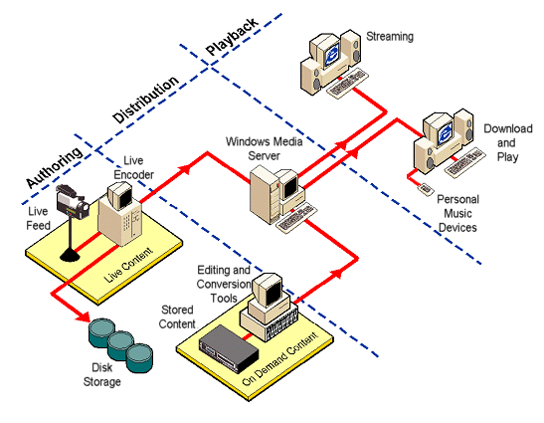
Figure 8. The Windows Media Technologies Architecture is designed to provide a seamless solution for the creation, hosting and playback of digitally compressed audio and video.

Streaming Live Content
For streaming a live event over the Internet or intranet, a live video source such as a Mini-DV or Hi-8 video camera captures the content and delivers it over the Internet or intranet using Windows Media Services. This content also can be saved for on-demand playback at a later time.

Streaming On-Demand Content
To deliver a training video over the Internet or an intranet, you can easily convert use any standard video source such as a Beta SP or VHS tape to Windows Media, allowing you to stream stored content from a Windows Media Server to an individual PC on request.

Appendix 3: Windows Media Family of Technologies
From security to e-commerce, Windows Media's innovative digital media platform enables you to develop powerful applications, create high-quality multimedia content, and reliably distribute your content. The following list describes the applications that make up the Windows Media Platform, not including the countless 3rd party tools and solutions also available.

Windows Media Product | Description
Windows Media Playback
Windows Media Player 7 | Windows Media Player 7 gives you the best audio and video experience in an easy, integrated and personalized way on your PC or portable device.
Windows Media Player 6.4 | Designed to meet the needs of corporate customers, Windows Media Player enables playback of high-quality, local and streamed multimedia content over multiple bandwidths ranging from less than 14.4Kbps audio to broadcast-quality, full-screen video.
Windows Media Player for Palm-Sized and Pocket PCs | The Windows Media Player enhances existing Palm-size PCs by adding capability for playback of CD-quality music in Windows Media format from the consumer's digital music library, created with personal jukebox software or downloaded from the Internet.
Media Distribution and Services
Windows Media Services 4.1 for Windows NT 4.0 and Windows 2000 | Windows Media Services is used to send audio and video content, by unicast and multicast, to clients. The Windows Media Services that enable your Microsoft Windows NT Server to stream audio and video over a network include:
Windows Media Rights Manager | Windows Media Rights Manager enables content authors to protect their intellectual property and generate revenue from the use of their content.
Windows Media Event Guide | The Windows Media Event Guide provides an easy way to create and maintain a Web-based content programming guide. The complete solution makes it easy to set up a SQL Server-based content management environment for submitting events, publishing and searching content more easily.
Windows Media Digital Broadcast Manager | Digital Broadcast Manager makes it possible for companies to sell pay-per-view and pay-per-download content via the Internet. Digital Broadcast Manager rapidly transforms any Web site with digital media content into a secure e-commerce solution with copy-protected content.
Online Resources
Microsoft Windows Media Web site  http://www.microsoft.com/windowsmedia | The central resource for all of your Windows Media downloads and information whether you’re a consumer or a corporate user, partner or provider.
WindowsMedia.com  http://www.windowsmedia.com | The premier guide to the best Windows Media audio and video content on the Web, WindowsMedia.com provides you with the broadest selection of Windows Media audio and video content from thousands of content partners.
Windows Media Developer Center  http://msdn.microsoft.com/windowsmedia | Windows Media technologies enable developers to be more creative and productive. Whether you are a content or application developer, you should check out the MSDN Online Windows Media Developer Center for technical information and other resources.
Content Creation and Editing Tools
Windows Media Encoder | The Windows Media Encoder converts existing AVI, WAV and MP3 files as well as live audio or video to Windows Media. The encoder can stream live audio or video directly via unicast or multicast, or save it as Windows Media files for future broadcasts with Windows Media Services.
Windows Media On-Demand Producer | The Windows Media On-Demand Producer translates AVI and WAV files to Windows Media, enabling high-quality, streamable file production with very little effort. Video editors can adjust elements such as brightness, contrast, markers, script commands and fade in/fade out.
Windows Media Plug-In for Adobe Premiere | Windows Media Tools plug-in for Adobe Premiere enables content developers to output Adobe Premiere movies directly to Windows Media.
PowerPoint 2000 Presentation Broadcaster | A feature of the PowerPoint 2000 presentation graphics program, Presentation Broadcaster enables PowerPoint slides to be integrated into any streaming media presentation, from an audio overview to a filmed lecture.
Windows Media Presenter and Windows Media Publish to ASF | Add-on tools to Powerpoint 97, Windows Media Presenter and Publish to ASF offer an easy-to-use way to create streaming media presentations using Microsoft PowerPoint. This add-on tool can save PowerPoint 97 slides and accompanying audio clips together as a single ASF file.
Windows Media Author | Windows Media Author is an excellent tool for combining audio with still images, such as photographs and original artwork. Based on Digital Renaissance’s award-winning T.A.G. Editor, Windows Media Author provides easy tools that insert graphics, markers and URL transitions into the actual Windows Media stream.
Windows Media ASF Indexer | Windows Media Tools ASF Indexer provides an easy way to make changes to existing ASF-based content. The graphical time line interface and display window make it easy to locate portions of a presentation for edits. The Indexer can be used to edit properties such as markers, script commands, file properties, or start and end times.
Development Resources
Windows Media Software Development Kit (SDK) | The Windows Media SDK consists of a family of SDK components to meet the needs of a wide range of developers. The Windows Media SDK components are designed to enable application developers to make their applications Windows Media compatible, and for content developers and systems administrators who wish to incorporate support for Windows Media in their Web sites.
Windows Media Load Simulator | The Windows Media Load Simulator simulates large numbers of clients in order to stress test Windows Media services, determine the scalability of a server configuration and confirm the reliability under high load.

Appendix 4: Glossary

ActiveX
A Microsoft technology that enables different programs to share information. ActiveX extends Microsoft Windows-based architecture to include Internet and corporate intranet features and capabilities. Developers use it to build user interactivity into programs and World Wide Web pages.

ActiveX Controls
Controls that use ActiveX technology. These controls can be downloaded automatically from a Web page and executed by a Web browser.

Asymmetric Digital Subscriber Line (ADSL)
A new high-speed broadband technology that is the phone company's answer to cable modems. It supports data speeds over 7 Mbps downstream (to the user) and slower speeds upstream (to the Internet). Most consumers will experience 100-700 Kbps speeds for $30-$70/month depending upon location.

Advanced Streaming Format (ASF)
A data format for streaming audio and video content, images and script commands in packets over a network. ASF content can be an ASF file or a live stream generated by Windows Media Encoder. ASF content that is in the process of being delivered over a network is called an ASF stream. See also Windows Media Audio File Format.

ASD Stream Descriptor File
A configuration file created and read by Windows Media Encoder. The file contains Encoder settings that describe the characteristics of a multimedia stream. The file is also read by the Windows Media Station service to define the stream format supported by a given station.

ASF Stream Redirector (ASX) File
An XML-based metafile that provides information which Microsoft Windows Media Player uses to receive unicast streams, multicast streams and other supported media from an intranet or the Internet. These files are quickly loaded by Windows Media Player and contain information for the following purposes:
- To transfer control from the HTTP browser to the Windows Media Player control, so streams can be directed to Windows Media Player
- To provide an announcement that Windows Media Player can use to access a program on a Windows Media station
- To provide references to streams and the rules for protocol rollover that Windows Media Player uses to process them
- To provide an XML-based playlist that defines the order in which streams are streamed to Windows Media Player
- See also Windows Media Audio Stream Redirector (WMX) file

Attribute
In an ASX file, a qualifier that describes a property of an ASX element. For example, an ASX file can include the element Repeat that contains the attribute Count. This element and attribute define the number of times the client repeats the playback of the piece of content or the playlist. See Element.

Bandwidth
The amount of data that can be transmitted in a fixed amount of time. On computer networks, higher bandwidth indicates faster data transfer. Network bandwidth is expressed in bits per second (bps) or kilobits per second (Kbps).

Broadcast
Describes how a client experiences receiving a stream. A broadcast stream can be multicast or unicast. In a broadcast connection, the client is passive and is not in control of when the stream starts or stops. In contrast, in an on-demand connection, the client is active and is in control of when the stream is started or stopped.

Broadcast Multicast
Delivery of one stream by a Windows Media server to many clients that listen to it by monitoring the IP address over which the stream is multicast. From the client perspective, a broadcast multicast is a connectionless experience because the client never connects to a Windows Media server. Similar to a television broadcast where clients “tune in”.

Broadcast Unicast
A point-to-point connection that a Windows Media Player client initiates to a Windows Media server. Similar to a telephone call, where a persistent connection is established between each client and the server.

Buffer
An area in computer memory where data is temporarily held while waiting to be transferred between two locations. Windows Media Player and server automatically buffer content to compensate for network congestion and delay across the Internet or intranet.

Cable Modem
A special kind of modem that connects your computer to the Internet via the cable television network. Services such as Roadrunner and @Home provide Internet connection speeds up to 20x standard 56k modems.

Channel
See Station.

Client
Typically, the software (Windows Media Player) that requests data from a server (Windows Media server). Client software requests connections and communicates with servers.

Codec
Short for compressor/decompressor. An algorithm or scheme used when recording digital video or audio. A codec is used, for example, when video is transmitted over the Internet; the video must be compressed on the sending end and decompressed on the receiving end. Windows Media Tools provides a choice of codecs for ASF content. Users can select a codec based on the audio or image quality and image size preferred.

Content Provider
Artist or distributor that provides programming or content such as music, movies, and video. Windows Media content providers include Warner Brothers, BMG, and Sony Entertainment.

Digital Rights Management (DRM)
An end-to-end solution for encrypting and distributing digital content in a secure manner on the Internet. Users need a license key to play back the encrypted content, which is provided by the Rights Manager under the terms specified by the content provider.

DirectX
Microsoft® DirectX® is a group of technologies designed by Microsoft to make Windows-based computers an ideal platform for running and displaying applications rich in multimedia elements such as full-color graphics, video, 3-D animation, and surround sound. Built directly into the Microsoft® Windows® family of operating systems, DirectX is an integral part of Windows 98 and Windows 2000, as well as Microsoft® Internet Explorer.

Digital Broadcast Manager
A Windows Media platform solution that makes it possible for companies to sell secure pay-per-view and pay-per-download content via the Internet using DRM technology. Digital Broadcast Manager rapidly transforms any Web site with digital media content into an e-commerce solution.

Digital Media
Audio and video, still images, and other types of media generally stored in binary form (as zeros and ones), and capable of being manipulated by electronics. Examples of digital media include CD’s, DVD’s, Windows Media Audio and Video, and MP3’s.

Digital Rights Management (DRM)
An end-to-end solution for the secure distribution of copy-protected digital media. Using encryption, content providers and distributors can thwart piracy by unlocking content for playback only by the individual who purchased it.

Edge Network
Proprietary network operated by streaming media distributors that meshes satellite delivery of content to multiple physical points across the Internet. Designed to increase audio and video quality by reducing time-lag and network congestion common across the public Internet.

Element
In an ASX file, an entity that defines a particular setting or action to the client. Elements can be modified by attributes. For example, a ref element has attributes that define the URL that points to particular content. See Attribute.

Encoder or Encoding
See Windows Media Encoder

Extensible Markup Language (XML)
A standard way for describing data on the Web. Microsoft Windows Media Player 7 uses XML for the structure of ASX files and Windows Media Player 7 skins.

Firewall
A system or combination of systems that enforces a boundary between two or more networks and keeps unauthorized users out of private networks. A firewall system checks all incoming and outgoing messages to make sure they meet predetermined security criteria.

Frame
One static image of many sequential images that make up a video title.

Frame Rate
The speed at which individual frames change. High frame rates generally produce better-quality images. Broadcast quality video is 30 frames per second.

Hypertext Markup Language (HTML)
The language used to format information displayed on corporate intranets and the World Wide Web. HTML is a subset of SGML and, like SGML; HTML uses tags to identify the format for a particular piece of information.

Hypertext Transfer Protocol (HTTP)
A protocol used to exchange HTML documents among clients and servers. See also Uniform Resource Locator (URL).

Illustrated Audio
A stream that combines audio content with synchronized images to make up an online slide show that runs at low bandwidths.

Integrated Services Digital Network (ISDN)
A completely digital telephone/telecommunications network for carrying voice, text, images and video traffic at high speed by sending digitally encoded signals. Windows Media Player 7 can play back content designed for ISDN bandwidth.

Internet Protocol (IP) Address
Each computer or device on the Internet has a unique IP address, a 32-bit number that specifies a physical location, or node, on the network.

Intranet
A network belonging to an organization and accessible only by members of that organization. A firewall or other device usually protects an intranet that is connected to the Internet.

Local Area Network (LAN)
A group of computers and other devices dispersed over a relatively limited area and connected by a communications link that enables any device to interact with any other on the network.

Media Stream Broadcast Distribution (MSBD) Protocol
A protocol used to reference a Windows Media Encoder, which is the source of a stream, such as msbd://server_name. It is also used when streaming from the Windows Media Station service to a content-storage server. In addition, it is used for server-to-server distribution.

Microsoft Internet Explorer
A Windows-based Web browser produced by Microsoft Corp. Microsoft Internet Explorer 5 is used by Windows Media Services in several ways. For example, Windows Media Administrator uses Internet Explorer to display its Web pages. Content creators can embed the Microsoft Windows Media Player ActiveX Control in an HTML page that is viewable with Internet Explorer.

Microsoft Media Server (MMS) Protocol
A protocol used to reference and stream ASF files from a Windows Media server.

Microsoft Windows Media Player
The Microsoft Windows Media Player is the first player that will play back multiple file types for a consistent user experience, whether the content is played locally from a hard drive or streamed over a network. This player can either run as a standalone client-executable program or be embedded in a Web page, C++, or a Microsoft Visual Basic program that uses the client ActiveX Control.

Multi-Bit-Rate (MBR) Encoding
Using multi-bit-rate encoding, content can be encoded for delivery at multiple bandwidths. The client will continuously monitor the network traffic and will direct the Windows Media Server to “shift up” or “shift down” to a different video bandwidth to fully utilize the available connection speed. MBR is a part of the Windows Media Technologies Intelligent Streaming feature.

Multicast
A one-to-many connection in which multiple clients can receive the same stream from a server. To receive a multicast, a client must have access to a multicast-enabled network. In contrast, a unicast is a one-to-one connection in which one client receives a distinct stream from a server.

OCX
Frequently used as a synonym for an ActiveX Control, OCX is the file-name extension for a control.

On-Demand
Describes stored media content that is available for streaming at the user’s command or request from a Windows Media server. Windows Media Services can stream either stored content from a publishing point on the server, or live content using Windows Media Encoder.

Packet
A unit of data transmitted over a network. A packet is of fixed size and is routed between a source and a destination. It contains binary information that represents both data and a header that contains an ID number, source address and destination address.

Player
A client program or control that receives content streamed from a digital media server such as a Windows 2000 server running Windows Media Services. Throughout the online Help, this refers to Microsoft Windows Media Player.

Playlist
A custom list of local files or streams that a digital media player plays sequentially. Windows Media supports both server-side and client-side playlists.
- A server-side playlist is played as part of a program over a Windows Media server’s station. A server-side playlist can include URLs that point to streams, including ASF files.
- A client-side playlist is an ASX file that contains multiple Entry elements. Windows Media Player plays the Entry elements in the order in which they appear in the ASX file.

Protocol
A set of formats and procedures that enable computers to exchange information. Protocols that Windows Media Services use include HTTP, MMS and MSBD.

Proxy Server
A server computer that controls Web-based traffic between local area networks and the Internet or other intranets.

Real Time Control Protocol (RTCP)
A standard networking protocol for monitoring the delivery of real-time streams.

Remote (as in “Remote Computer”)
Not in the immediate vicinity or not directly accessible. A computer or other device located in another place (room, building or city) and accessible through some type of communications link. For example, Windows Media Administrator can be run on a computer (a remote computer) other than the Windows Media server, so a remote administrator can administer the server. Windows Media Encoder also can be run from a remote computer.

Rollover
The ability of a player to try different protocols automatically to access a stream from the service. The rules for rolling over from one protocol to another are defined by a combination of the station definition, the announcement, and various preferences set by the user on the client computer.

Router
A device that connects two or more networks and carries data forward. A router determines where the destination computer is located and then finds the best way to transmit the data there.

Scalable Video
A feature supported by some streaming media platforms that supports the creation and streaming of multiple encoded video streams within a single file. Scalable video in Windows Media Encoder creates ASF content that has a variety of video streams at variable bandwidths that range from 28.8 Kbps to 300 Kbps, as well as a separate audio stream. After receiving this multiple encoded stream, the server determines which bandwidth to stream based on the network bandwidth available. Scalable video is not supported on generic HTTP (Web) servers that are not running Windows Media Services.

Scope
In multicasting, the reach of a stream. Windows Media Administrator enables the user to define the scope of a multicast. The scope of a multicast stream can be set to reach only an immediate subnetwork, or it can be set to reach the entire Internet. Scope is also equal to time-to-live (TTL).

SDMI (Secure Digital Music Initiative)

A secure digital format for distributing music over the Internet. Announced in February 1999, it is backed by the Recording Industry Association of America (RIAA) and Sony, Warner, BMG, EMI and Universal, the top five music production companies.

Security
The process of controlling access to resources based on user credentials and permissions. In a Windows Media Services environment, security means restricting and controlling access to Windows Media server components, Windows Media Administrator, and Windows Media content, both stored and streamed. Windows Media Services has built-in security mechanisms that integrate with Microsoft NTLM. Windows Media Services supports both server-side and client-side authentication.

Skins
Modular visual elements, or “faceplates” that make up the look and feel of an application.

Station
A defined location from which a player can receive streams. In effect, it is an IP address and a port. Windows Media server components use stations with ASF streams only and save station information as a file with an NSC extension.

Stream
Data transmitted across a network and any properties associated with the data. Streaming data allows the player to begin rendering the data immediately instead of waiting for the entire file to be downloaded.

Template Stream Format (TSF)
In Windows Media Technologies, a predefined group of settings that match content type and bit rate with appropriate audio and video codecs. Windows Media Encoder uses this feature to assist the user in quickly configuring the encoder to create ASF content.

Time-to-Live (TTL)
In multicasting, a value that defines the number of routers through which a multicast can pass before a router stops forwarding the multicast. TTL is equivalent to scope.

Transmission Control Protocol/Internet Protocol (TCP/IP)
The collection of networking protocols that allow computers to communicate across networks and the Internet. Every computer on the Internet supports TCP/IP.

Unicast
A client/server connection in which a client receives an on-demand stream of stored content from a server or receives a broadcast of live content. No other client has access to this stream. In contrast, a single multicast stream is available to multiple clients.

Uniform Resource Locator (URL)
A pointer to information on the Internet. A URL provides the address of a Web page, and consists of the following:
- A protocol identifier, such as http://, mms://, or msbd://
- A host name, such as msn.com
- A directory and/or file name, such as contentdir/filename

User Datagram Protocol (UDP)
A connectionless transport protocol in the TCP/IP protocol stack that, like TCP, runs on top of IP networks.

Video Capture Card
An add-on board for providing digitized images on a computer. With a video capture card, you can provide live camera or VCR input to the Windows Media Encoder.

Visualizations
Special visual effects of an entertainment value that animate and move to the sound of music played in the Windows Media Player 7.

Windows Media Administrator
A Web-based administrative application for monitoring real-time usage of Windows Media component services, managing content and configuring the system.

Windows Media Audio Codec
A high-quality audio codec developed by Microsoft Research and the Windows Media team that reproduces high-fidelity stereo sound, while minimizing the amount of CPU required when compared to other comparable codecs.

Windows Media Audio (.WMA) File Format
A data format for download-and-play audio content. Primarily the same format as an ASF file, WMA allows third-party applications to be the default player for audio files, leaving the Windows Media Player as the default application for video and ASF files.

Windows Media Audio Stream Redirector (WMX) File
A WMX metafile provides information that Microsoft Windows Media Player uses to create playlists and enter data about the media for viewing by the user. A WMX file is equivalent to an ASX file, but for audio (WMA) files instead of ASF.

Windows Media Author
A graphical interface tool for creating and testing illustrated audio. The tool is designed to combine and synchronize audio and image files. Using it, the author can manage objects such as sounds, images and URLs so that they appear at the correct time during playback. This tool uses technology from Digital Renaissance Inc.

Windows Media Device Manager (WMDM)
With the Windows Media Device Manager (WMDM), application developers, device makers, and memory manufacturers can transfer secure content from a Windows application to a portable device. WMDM is available for download and development as a part of the Windows Media Format SDK.

Windows Media Client
The ActiveX Control called Microsoft Windows Media Player that receives and renders ASF content from Windows Media server components. The client can be on the same computer as the server or on another computer.

Windows Media Component Services
A set of services running on Windows Media server. These services multicast and unicast live audio and video presentations and stored files to client computers.

Windows Media Encoder
A feature of Windows Media Technologies used to create live ASF streams. Windows Media Encoder turns live audio and video content into an ASF stream and distributes that stream through a port. Windows Media Encoder also can save an ASF stream as an ASF file. Windows Media Encoder can distribute an ASF stream via MSBD protocol or HTTP.

Windows Media Presenter for Microsoft PowerPoint 97
A Windows Media Technologies feature, available from within Microsoft PowerPoint 97. It enables PowerPoint to connect to Windows Media Encoder and to send a PowerPoint presentation to a Windows Media server for distribution to client computers.

Windows Media Program (NSP) File
A file that contains information about a Windows Media program, used primarily in backing up and restoring Windows Media Services program definitions.

Windows Media Rights Manager
See Digital Broadcast Manager.

Windows Media Station Service
One of the Windows Media component services that provides multicasting, distribution and storage functions for ASF streams. It can manage multiple stations, with each station having an ASF stream as input, and can direct the stream to a multicast address, one or more distribution servers, a disk, or a combination of all three. A similar feature, Windows Media Unicast service, is available for unicasting ASF streams.

Windows Media Tools
A set of tools that can be used to create ASF content for Windows Media Services. These tools include Windows Media Encoder, Windows Media Author and Windows Media ASF Indexer; the conversion utilities VidToASF and WavToASF; and the file utilities ASFCheck, ASFChop and ASX3Test.

XML
See Extensible Markup Language.

Perceived CD-quality output can be achieved at 64 kbps or higher as proven by independent tests performed by ZD Labs.
Dependent upon system and CD drive speeds.
Microsoft Audio Format Comparison. ZDLabs. 11/1999 http://www.zdnet.com/zdlabs/stories/main/0,8829,2352352,00.html
Requires Internet Explorer 5.5 or greater. Please note that SMIL Boston is a working-draft standard and is subject to change. Microsoft will make every possible effort to provide full SMIL support as rapidly as possible after formal standards are in-place.
Requires Internet Explorer 4.0 or greater or a browser that supports ActiveX controls

