CHAPTER 2

INSTALLATION

Contents:
- System Requirements
- Installation Instructions
- Starting SDS HelpDesk
- License Agreement and Code
- Updating your SDS HelpDesk License Code
- User Login

System Requirements
- Windows 95, Windows 98, or Windows NT 4.0.
- IBM-compatible PC with 486DX2/66 or higher microprocessor.
- 16 megabytes of RAM. 32 megabytes of RAM is recommended.
- Hard drive with 25 megabytes of free disk space.
NOTE: This is the amount of free disk space needed to install the program and system files. The amount of disk space needed to run SDS HelpDesk depends on the amount of data you enter into the program.
- SVGA (800 x 600) resolution video display.
- Mouse.
- Printer.

Installation Instructions

Default Installation - All Program Files Are Installed on a Single Computer
- Double-click the downloaded self-extracting executable file. Follow the instructions to decompress the file.
- Before running the setup program, close all applications currently running.
- Double-click on the file called setup.exe.
- Follow the instructions on the setup screen.
Installation Instructions (cont’d)

Network Installation – All Program Files Are Installed on a Single Computer, but the Database File is Moved to a Network Server
- Double-click the downloaded self-extracting executable file. Follow the instructions to decompress the file.
- Before running the setup program, close all applications currently running.
- Double-click on the file called setup.exe.
- Follow the instructions on the setup screen.
- Create an SDS HelpDesk folder in the route directory of the server. Select the HelpDesk folder, and then create a subfolder of it called Database.
- Move the database file (called HelpDesk.mdb) from your local computer into the Database folder on the server. This step only needs to be done once by the system administrator.
- Each licensed user needs to set the path to the database file on the server. This is done through the File, Login screen, Browse button.

Starting SDS HelpDesk
SDS HelpDesk starts the same way as other Windows programs.
- Click the Start button.
- Select the Programs option.
- Select SDS HelpDesk.
The first time you start SDS HelpDesk you are greeted by a welcome screen that is shown only once.

License Agreement and Code
Users of SDS HelpDesk must have a valid SDS Software License and license code. There are two types of license codes. One is a temporary code, which expires after a reasonable evaluation period. Your temporary demo code is entered for you automatically when you install SDS HelpDesk. The other is a permanent code. This code is given to users who register and purchase the software. Once you register the program, Scott Data Systems will email your permanent license code to you.
- Start SDS HelpDesk. The following dialog box opens.
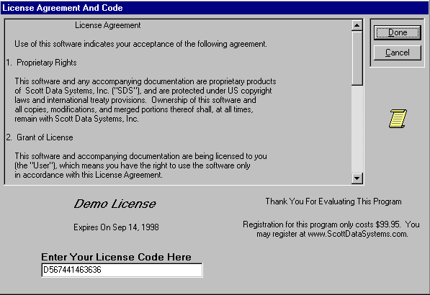
- Your current License Code is displayed. Demo licenses also display the expiration date. An unregistered version of the program will not function after the evaluation period until it becomes registered.
- If you have not already done so, be sure to read the License Agreement. Click the Done button.

License Agreement and Code (cont’d)
- You need to logon and enter a password whenever you start SDS HelpDesk. The Start Wizard can be used to make it easier to get started and to switch between databases. The top two buttons in the Start Wizard will pre-configure the login screen for you during the evaluation phase. The bottom two buttons can be used once you begin to enter information into the HelpDesk database. Initially the password for ADMIN is admin. This password can be changed at a later time when you have entered more users. After you have been added as a user and have been given an initial password, enter your password whenever you start the program.

You are now ready to begin using SDS HelpDesk.

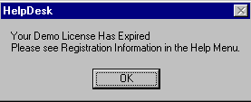
The following dialog box opens when the evaluation period expires on a demo license code. Close the dialog box. Click the Help menu and select the How to Register option. This will provide instructions on how to register the program and obtain a permanent license code.
License Has Expired Dialog Box

Updating your SDS HelpDesk License Code
You need to update your SDS License Code when you register the program or if you need additional evaluation time on a demo license. Click the Help menu and select the How to Register option. This will provide instructions on how to register the program and obtain a permanent license code.
- Click the File menu. Select the License option to open the following dialog box.
Enter your new License Code here.

- Enter the new license code in the edit box.
- Click the Done button.

User Login
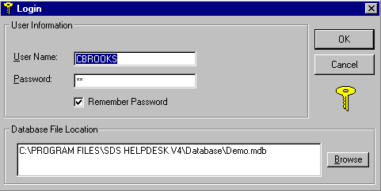
Whenever you start SDS HelpDesk you will be asked to enter your password. The system administrator must set up users and their initial passwords from the Admin, Users menu option.
Login Dialog Box

- Once your system administrator has entered you as a user, enter your user name in the edit box.
- Enter your password. Click the OK button.
- You will be notified if you enter an invalid user name or password. User names and passwords are case sensitive, so be sure to enter yours correctly.
You can change your password at any time by using the Modules menu, Change Password option. You can also check the Remember Password box. This will save you from typing in your password whenever you start SDS HelpDesk.
NOTE: It is recommended that you leave the Remember Password box unchecked if multiple people have access to your computer.

User Login (cont’d)
- The path to the database is displayed in the Database File Location box. Click the Browse button to select a different database or to select the database if you have moved it to a file server.

