CHAPTER 14

REPORT MANAGER

Contents:
- Overview
- Add a New ExecReport
- Modify an ExecReport Name
- Delete an ExecReport
- Preview and Print an ExecReport

Overview
Two kinds of reports are available in SDS HelpDesk depending on your needs. Use SnapShot Reports when you want to see information for a currently selected record, or when you want a printout of items in a Lookup Table. SnapShot Reports can be previewed and printed directly from the module you are working in.
Use ExecReports when you need to print out details for groups of records. You can change the name of any report to make it more meaningful to your organization. If you have Seagate Crystal Reports, Version 7.0, you can even add your own reports.
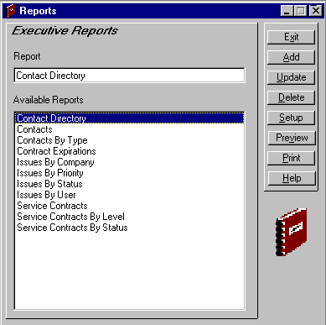
Click the Reports icon 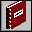 in the toolbar to open the module.
Change the name of a report by selecting it, then typing the new name here.

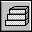 Steps to . . .

Add a New ExecReport

SDS HelpDesk SnapShot and ExecReports are located in the Reports folder. SnapShot reports are used when you are in a module and you want to see information for a currently selected record or when you are in Lookup Tables and you want a printout of the items. Executive reports are used when you want to see details for groups of records. If you have Seagate Crystal Reports, Version 7.0, you can design and add your own executive reports.
NOTE: If you design your own reports, be sure to put them in the Reports folder under HelpDesk. The file name extension should be *.rpt.
Once your new report file has been put in the Reports folder, you can add it to the list of available executive reports.
- Click the Add button. This launches the Open dialog box.
- Use the Look In drop down list to locate the Reports folder. The default path is C:\Program Files\SDS HelpDesk V4\Reports. Double-click on the Reports folder to open it.
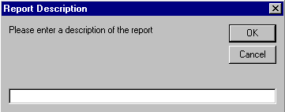
- Select the new report you want to add to the Available Reports list. Click the OK button. The following dialog box opens.
Type a descriptive name for your report here.

- Type a descriptive name for your report in the edit box. Click the OK button.
NOTE: SnapShot reports should not be added to the Available Reports list. If you do so, you may get an error message when you preview the report.

Modify an ExecReport Name
- Select the report from the Available Reports list.
- Make your changes to the report name that is displayed in the Report edit box.
- Click the Update button to save your changes.

Delete an ExecReport
- Select the report from the Available Reports list.
- Click the Delete button. This just deletes the report from the Available Reports list. It does not delete it from the Reports folder.

Preview and Print an ExecReport
- Select the report from the Available Reports list.
- Click the Preview button to see view the report on your screen. Click the Printer icon at the top of the Preview screen to get a hard copy of the report.
- To print a report without previewing it first, click the Print button.
NOTE: Use the Setup button to select the print range and the number of copies you want.

