CHAPTER 12

KNOWLEDGE BASE

Contents:
- Overview
- Add Knowledge Base Article
- Search the Knowledge Base
- Preview and Print a Knowledge Base Article

Overview
The SDS HelpDesk Knowledge Base is used to store and retrieve answers to repeat questions. It can be used to maintain step-by-step instructions, scripts, system configuration information, part numbers, lists of tools and materials to do a job, conversion factors, the International System of Measures, or just about anything else desired.
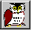
You can pre-load the Knowledge Base with information or built it up over time as issues are entered and resolved. Then use the search engine to quickly scan the Knowledge Base for the solution or information you need.

Click the Knowledge Base icon in the toolbar to open the module.
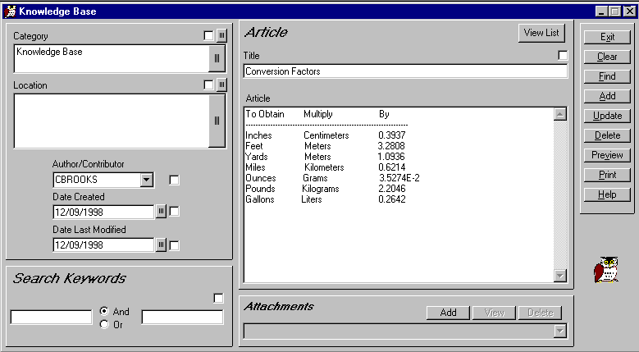
Click the small box to set the item as part of your search criteria.

Click the Find button to see a pop-up list of Knowledge Base titles. Double-click one of the titles to view its contents.

 Steps to . . .

Add Knowledge Base Article
You can add as much or as little information as needed to a Knowledge Base article. However, it is recommended that at a minimum, you enter some kind of title so that you will know what the article is about, as well as a category. This makes searching for the article much easier.
- Enter a short descriptive title into the Title edit box.
- Click the large button next to the Category box to open the drop-down tree. A plus (+) next to a category means that there is one or more subcategory. Click the plus (+) to see the subcategories. Double-click a subcategory and it and the category it is associated with are entered for you automatically.
- If appropriate, click the large button next to the Location box to open the drop-down tree. A plus (+) next to a location means that there is another level below it. Click the plus (+) to see the next level. Double-click a level and it and all higher levels that it is associated with are entered for you automatically.
- Select the author/contributor’s user name from the drop-down box.
- Enter the current date or the date created into the Date Created box, or click the small button to open the calendar.
- Type the information you want into the Article box and then click the Add button. If you prefer, you can attach an existing article. Once you enter the Title, click the Add button. Then click the Attachments Add button to launch the Open screen. Select the article you want to add and then click the Open button. Click the Update button to save the attachment.
You can also add resolved issues to the Knowledge Base from the Issue Manager module (see Chapter 9; Add to the Knowledge Base).

Search the Knowledge Base
You can search the Knowledge Base by category, location, author, dates, keywords, or title.
- If you want to use category as one of your search criteria, click the large button next to the Category box to open the drop-down tree. A plus (+) next to a category means that there is one or more subcategory. Click the plus (+) to see the subcategories. Double-click a subcategory and it and the category it is associated with are entered for you automatically. Click the check box in the upper right-hand corner. This sets Category as a search criterion.
- If you want to use location as one of your search criteria, click the large button next to the Location box to open the drop-down tree. A plus (+) next to a location means that there is another level below it. Click the plus (+) to see the next level. Double-click a level and it and it and all higher levels that it is associated with are entered for you automatically. Click the check box in the upper right-hand corner. This sets Location as a search criterion.
- Click any of the other check boxes that you want to use as part of your search criteria.
- If you want to use keywords, enter a word in the first keyword box. You can enter another word in the second box. If you select the “And” radio button the search engine will look for Knowledge Base articles that contain both words. If you select the “Or” radio button, the search engine will look for articles that contain one or the other word.
NOTE: Your search can be as broad or as narrow as you wish. The more check boxes you click, the narrower your search.
- Click the Find button to see a pop-up list of Knowledge Base titles. Double-click one of the titles to view its contents.

Preview and Print a Knowledge Base Article
- Click the Find button to see a pop-up list of Knowledge Base titles. Double-click one of the titles to view its contents.
- Click the Preview button to see a SnapShot report of the article. Click the Printer icon at the top of the Preview screen for a hard copy of the article.

