CHAPTER 11

TIME TRACKER

Contents:
- Overview

Overview
You can get to Time Tracker in two ways. One is by clicking on the Time Tracker icon. The other is by clicking the View Time Records button in the My Issue module. Time Tracker is used to track the amount of time you spend resolving an issue. It not only displays the total time, but it also displays the time you spend on each task associated with the issue. You can search using just about any field and you can also track billable hours.
NOTE: If you open Time Tracker by clicking on the My Issues, View Time Records button the issue and its associated times are preloaded for you. Click the individual task records to see the actual hours spent. The total time spent on the issue is displayed in the Total Actual Hours box.
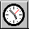
Click the Time Tracker icon in the toolbar to open the module.

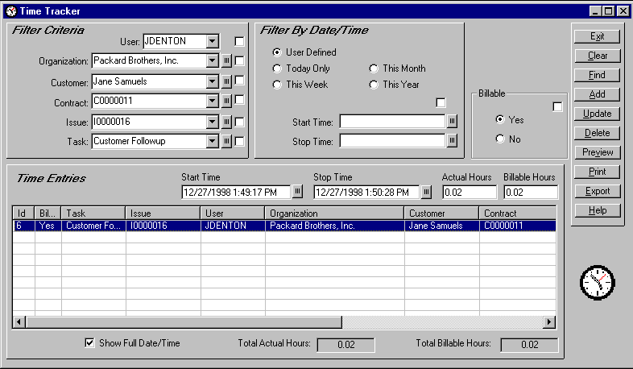
- Set you search criteria. For example, if you want to see a list of all issues and tasks that have been assigned to you, select your User Name from the User drop-down list. Then click the small box next to User to set this as your search criterion.
- Click the Find button. You will see a list of issues and your tasks displayed in the Time Entries grid. Another example is to also select an organization from the Organization drop-down list, or click the small button next to Organization to select from Lookup Tables. Click the small box next to Organization to set it as another search criterion. Click the Find button. You will see a list of issues and your tasks (if there are any) for the organization you selected.
NOTE: You can use any field(s) that has a small box next to it as a search criterion. Just be sure to click the small box to indicate that you want to include it as part of your search criteria. Also remember that the more items you select, the narrower your search results.
You can also conduct a broad search and then filter the results. For example, select your User Name from the User drop-down list. Click the small box and then click the Find button. Select an issue from the Time Entries grid and then click the small box next to Issue. Click the Find button again. The Time Entries grid now only displays the tasks for that issue.
- Select one of the issue tasks in the Time Entries grid. The Start and Stop times are displayed as well as the actual hours and any billable hours. If needed, you can modify the Actual and Billable Hours. Some companies may round actual hours to the nearest quarter hour. Other companies may only bill for full hour increments. After you have made any necessary changes, click the Update button.
- You can add additional tasks from the Time Tracker screen. Select the issue you want to add a task to. Select a new task from the Task drop-down list. Click the Add button. You can enter your Actual Hours and/or Billable Hours directly into the boxes.
- Click the Preview button to see a SnapShot report of issues and tasks. To filter the report, click one or more of the small check boxes. When previewed the report shows the filters you selected.

