  You've got connections. ™ | X-NetStat Professional Users Manual  Last Revised: May 2005  Copyright © 2005 Fresh Software

Please check the X-NetStat Professional website at www.freshsw.com/xns/pro for updates to the manual and program.

Contents

- What is X-NetStat? ……………………………………….……………….……2
- Main Window………………………………………………….…………………3
- Interpreting Connections…………………………………….…………………4
- Getting more information…………………………………….…………………5
  - Connection Information……………………………..……....…………6
  - Process Information……………………………….…….…….....……7
  - Port Information…………………………………….…………….……8
  - The InfoPanel…………………………………………….……….....…9
  - Lookup Tools…………………………………………………………12
- Options: Configuring and Customizing XNS………………..………………14
- Other ways to access X-NetStat
  - ViewBar Access………………………………………....……………22
  - Tray Access………………………………………..…..........…………23
  - Remote Access…………………………………….....………………24
- Logging……………………………………………………….....………………26
- Rules: Responding to Network Events…………………………………....…27
- Recognizing your connections with Friendly Names………………………30
- Net Stats: Your Network Statistics………………………………………...…32
- Add more power: The X-NetStat Packet Sniffer………………....…………33
- Other X-NetStat Tools………………………………………………....………34
- Appendices
  - Appendix A: Netstat Status codes……………….……….……...…35
  - Appendix B: WHOIS Servers………………….……….….…….......36
  - Appendix C: IP Addresses & Hostnames…………….....….…........37
  - Appendix D: About Fresh Software and its commitment……........38

See also: readme.txt / whatsnew.txt

What is X-NetStat?

X-NetStat is a program that displays information on your current Internet and network connections, much like the console netstat.exe program, but in a graphical interface. These connections are established each time you visit a web page, send an instant message, check your email, or anytime you do network activity that requires you to connect to another computer. They also appear when outside computers attempt to connect to your machine, authorized or not.

Each connection is displayed in the Connection Table, where you can see the address you are connected to, what
ports (local and remote) are being used, the connection status, the program EXE * used to open the connection, and how long the connection has been active.

The Professional edition of X-NetStat offers a smorgasbord of additional features that are geared towards Network Administrators for their tasks of monitoring and managing networks. X-NetStat Professional contains powerful features like a Rules system that lets you set up actions based on network conditions, a comprehensive Network Statistics window displaying information on network interfaces and protocols, a Web Server that lets you access XNS information remotely, a collection of Lookup Tools (TraceRoute, WHOIS, Finger, DNS, Web Search, etc), and many more features.

Feature List

- Display TCP connections & UDP listens  - Connection info: Process, Port, Status, Addresses  - Location Info (Automatic WHOIS)  - System Info  - FilterBar – search for connections  - Ability to kill/disconnect connections  - Nuke Connections (mass kill)  - DNS Cache for fast hostname resolution  - Logging XNS activity to file  - Feature centric toolbar  - ViewBar & System tray access  - Remote Access thru X-NetStat Server  - Comprehensive Port Information Database  - Banish Hostname | - Condition/Action Rules system  - Print / Save Connection Table  - Process Information  - Customize Columns & Toolbar buttons  - Customize Status Bar  - Customize external Programs  - Customize Font & Appearance  - Lookup Tools (WHOIS, TraceRoute, etc)  - Net Stats (Interface, TCP, IP, ICMP, UDP)  - Check for Updates  - Assign addresses “friendly” names  - DOS Commands menu  - Get External IP Address  - Log Manager

System Requirements

- Windows 98, 2000, or XP
- 64MB Ram
- Pentium 233 MHz

On average X-NetStat will consume less than 1% CPU resources at any given time.

To begin discovering how X-NetStat can empower your network management, keep reading, or simply start the program and play around with it – you should find the program intuitive to use.

*Windows XP Only

Main Window

Toolbar: Quick access to the most important features of X-NetStat.  To add or remove buttons to the toolbar, right-click on any button and check/uncheck the buttons you wish to be visible. You may also add or remove buttons by using the View menu.  Connection Table: The core of X-NetStat. This is where connections are displayed.  InfoPanel: Shows detailed information on the currently selected connection.  Status Bar: Shows progress of a connection refresh, time of last refresh, address information for computer, pings sent/received, etc. You can customize what you want to appear in the status bar.  Double-click the status bar to add or remove panels. | 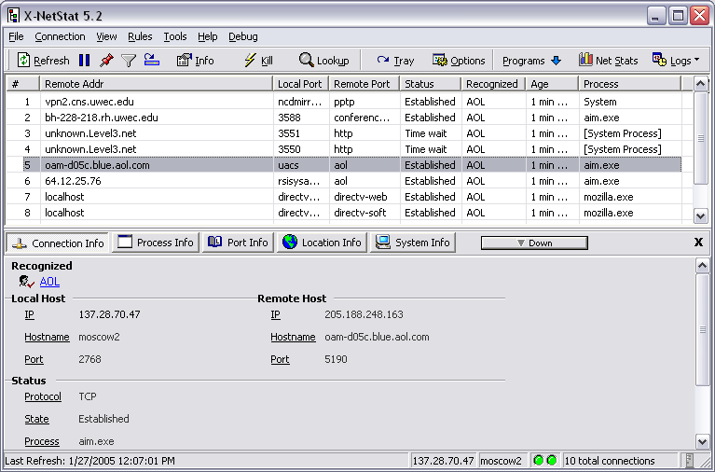

Interpreting Connections

Connections are listed in the Connection Table. Here’s what a connection might look like:

A set of headings is at the top of the Connection Table. Use the table below for an explanation of these headings:

# | The connection number.
Remote Addr | The computer / server the connection is involved with. This can be displayed as either an IP address or hostname, depending on your DNS Settings and whether a hostname for the IP address exists.  See: Appendix C, IP Addresses and Hostnames.
Local Port | The port your computer is using for the connection.
Remote Port | The port the remote computer is using for the connection.
Status | One-word status code describing the state of the connection. Status codes are explained in Appendix A.
Age | How long XNS has known about the connection (hh:mm:ss)
Time | The time XNS first noticed this connection.
Recognized | The "friendly name" (if any) for the connection. A friendly name is specified by you to help you remember who or what a certain IP / hostname address is.
Protocol | The protocol being used for the connection (Either TCP or UDP).
Local Addr | The local address used for this connection (Your IP or hostname)
Process * | The program/application that is facilitating the connection.
 | * Only available on Windows XP systems.

Getting more information

The Connection Table shows all available information about the connection, but you may find yourself in a situation where you need to know more. X-NetStat has several built-in features to help you further research a connection.

The Context Menu
If you right-click on a connection, the context menu appears.  This popup menu lets you perform several actions on a connection.  View Alert: View Message Alert if connection has tripped a rule.  Refresh: Refresh Connection List  Copy Connection Info: Copy information to clipboard.  Connection Info: Opens Connection Info window  Process Info: Opens Process Info window  Local/Remote Port: Opens Port Information window  Kill Connection: Attempts to forcibly disconnect the connection  Extended Kill Kills and sets rule to auto-kill address if seen again  Recognize as: Associates a friendly name with the connection  TraceRoute: Traces the path from your computer to remote comp  WHOIS: Various WHOIS functions  NBLookup: Attempts to retrieve computer’s NetBIOS name. | 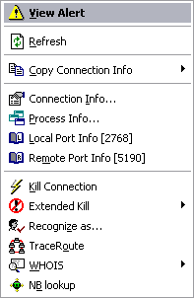

These commands are also available under the “Connection” main menu.

New in version 5.2 is the InfoPanel, which provides easy access to
Connection Info, Process Info, Port Info, Location Info and System Info in one place.

Connection Information Window

Double-clicking a connection in the Connection Table brings up the Connection Info window. Here, all available information about the connection is shown.  If the IP or hostname matches an IP address or hostname you have recognized, it will display the name at the top.  Then comes local information: Your local IP and hostname, and the port being used on your end.  - Click the ? button to display Port Information on the local port.  Next is remote information: The IP and hostname (if available) of the remote computer, and the port it is using.  - Click the ? button to display Port Information on the remote port.  Next, status information is shown: The Protocol being used (either TCP or UDP), the “state” or status code of the connection, an explanation, and what process/running program is being used to facilitate the connection. *  Finally, X-NetStat displays how long it has been aware of the connection.  To close the window, hit ESC.  * Advanced API must be turned on (Windows XP only) | 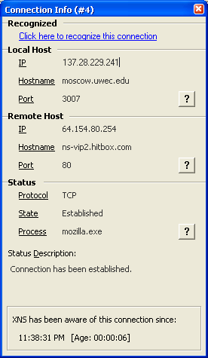  Local Port Info  Remote Port Info  Process Info

Connection Information is also available in the InfoPanel under the Connection Info tab.

Process Information Window

This dialog box shows you information about the Process (AKA application, or running program) that is behind the connection. The program has either initiated the connection to the remote address, or has facilitated a connection the remote address has made to your computer.  The Process Information dialog displays the EXE file and location, the program icon, and version information.  Click the Actions button for a list of actions to:  - Terminate Process: Stops the program and removes it from memory.*  - Restart Process: Terminates and then re-runs a program.*  - Open containing folder: Display the folder/directory where the EXE file is located.  - Google Search: Performs a Google search on the EXE filename. | 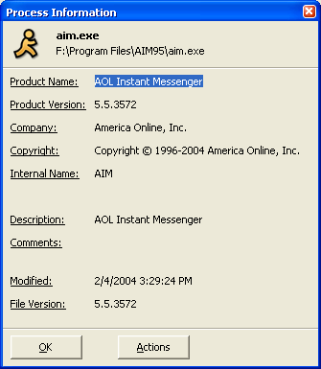

* Warnings will be displayed unless you check Don’t Warn when Terminating/Restarting in Extra Options .

Process Information is also available in the InfoPanel under the Process Info tab.

Port Information Window

X-NetStat displays a local port and a remote port for each connection, each a number between 1 and 65,435. Knowing what these ports do can help you understand the purpose and relevance of each connection.

X-NetStat has a built in port database that provides quick reference to common Internet ports and what their functions are. You can access the Port Info database three different ways:

- Click the ? button in the Connection Information window
- Click Port Info from the Tools menu
- Right-click a connection and select Port Info
- Click Port Info tab on the InfoPanel

Port Information window  The majority of the window is taken up by a field that describes the port's code word, the name of the port, and a description if it's available.  To look up a port, just type it in.  If the port you have looked up is associated with any trojan horse programs, the Trojan horse information >> button will light up.  Upon clicking it, the window will expand and display a list of associated trojans, with a link to detailed information on each. (See below) | 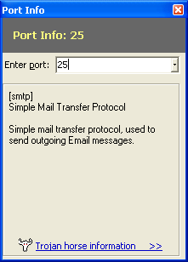

If a trojan horse has been known to use the port you just looked up, clicking the Trojan horse information >> button will expand the Port Information window with the list of trojans.  Clicking on any trojan horse name in the list will take you to a website with detailed information (and removal instructions) on each trojan.  For more Information:  What is a trojan? (whatis.com)  Trojan Horse Attacks (irchelp.org) | 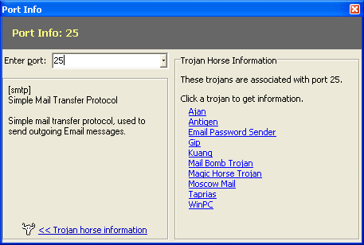
The InfoPanel

New in version 5.2 is the InfoPanel, a dashboard that sits below the connection table that integrates Connection
Information, Process Information, Port Information, Location Information and System Information into one easy-to-access place.

InfoPanel: Click a button to display information.
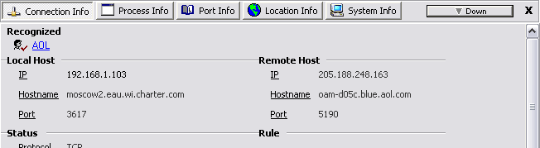

To make use of the InfoPanel, just select a connection and information will appear. Click another tab to display other information.

To get the InfoPanel out of the way, click the Down button. This will shrink the InfoPanel down to a minimal size and change the Down button to an Up button.  Click Up to restore the InfoPanel to its previous height.  To close the InfoPanel completely, click the X in the upper-right hand corner. To turn it back on, click the View menu and choose “Show InfoPan” | 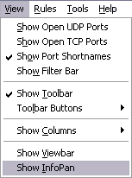

Everything in the InfoPanel can be activated through the Context Menu, except for Location Info and System Info which are explained below.

InfoPanel: Location Info

The Location Info section of the InfoPan allows you to do a one-click WHOIS lookup of a connection’s IP address, domain name, or both. To use, simply select a connection, click the Location Info tab, and click IP Lookup or Domain Lookup.

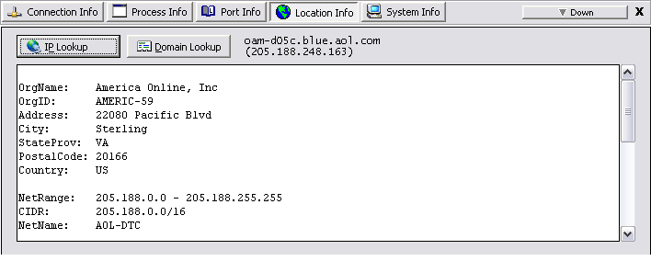

IP Lookup

When clicked, X-NetStat will query the IP address of the connection in the databases of :

 | ARIN | American Registry for Internet Numbers
 | RIPE | Réseaux IP Européens
 | APNIC | Asia Pacific Network Information Centre
 | LACNIC | Latin American and Caribbean Internet Addresses Registry

The organization that owns the IP address will then be displayed (see above). In rare instances, several duplicate records will be found and you will need to focus your query by clicking the button

Domain Lookup

When clicked, X-NetStat will determine the domain name of the selected connection and query Verisign’s central database to find which registrar handles its registration, and then will pull up the WHOIS record.

This button will only be enabled if the connection’s IP address was resolved into a hostname.

See Also: Appendix B: WHOIS Servers

InfoPanel: System Info

The System Info section of the InfoPanel does not display connection-specific information. Rather, it shows useful stats such as X-NetStat version, System Uptime, Windows Username, Workgroup, MAC Address, and more.

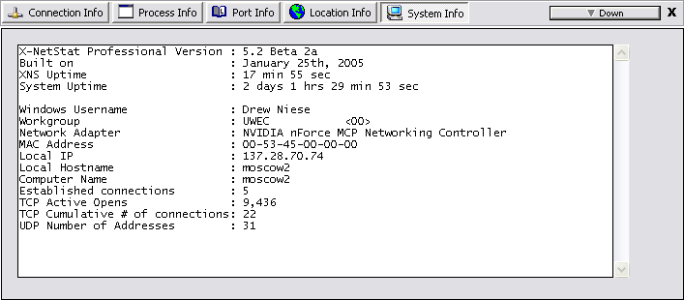

Lookup Tools

X-NetStat has an integrated interface for several network tools, the Lookup Tools window.

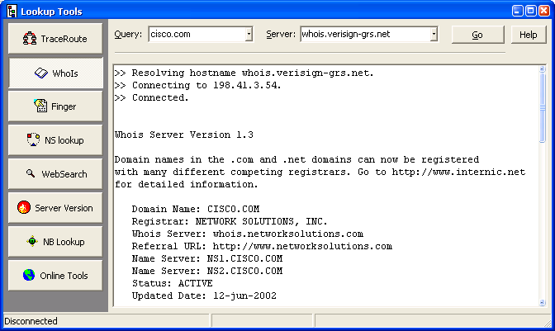

TraceRoute: A graphical interface for the TraceRoute or tracert program. This applet uses the ICMP protocol to map what servers ("hops") are being used to route a packet of data from your computer to a remote, destination system. To trace a server, just enter the IP address or hostname and click Trace. During this process, information regarding the status of the TraceRoute will be shown in the status bar. As each hop is reached, information about the hop will be shown in the table.

Note: Your firewall may restrict ICMP packets, which may result in TraceRoute not working properly
.

WHOIS: WHOIS connects to one of several online databases of domain names (domain.com, domain.net, etc). You can obtain information on a domain name, such as who registered it, where that person resides, and contact information for businesses and people associated with the domain.

There are two things you must know when doing a WHOIS query: The query string, and the server you are going to query.

The query string is usually a domain name, such as “freshsw.com”. However, it can include other types of queries as well, and will give different results based on what's on the WHOIS server. You can try entering a person's last name, the name of a corporation, or the direct handle of a contact. To see what syntax a server accepts, click the Help button after choosing a server.

The WHOIS server you must use usually depends on the type of domain name you are querying. If it ends in a .com, .net, or .org, you will want to use whois.verisign-grs.net as the server. If you need to query an IP address, use arin.net for the United States and ripe.net for Europe. (See Appendix B, WHOIS servers). Click the Go button to start the query. You can also use a specific port in this format: server:port , eg arin.net:44

Finger: According to RFC742, a finger query “returns a friendly, human-oriented status report on either the system at the moment or a particular person in depth.”

Note that Finger is an old protocol that is not in common usage today. However, some servers still run finger daemons and you may find the information they return to be useful. To make a query, use the form of an email address, such as user@server.com.

Check Verbose to instruct the server to return as much information as possible.

See Also: RFC 742
NS Lookup: NS Lookup is a program to query Internet domain name servers for their records on an IP or hostname. There are several types of queries that can be made:

Simple | Changes IP to Hostname or Hostname to IP based on records in the DNS Cache.
MX | Short for mail exchange record, an entry in a domain name database that identifies the mail server that is responsible for handling e-mails for that domain name.
A | Address records. This is where the hostname to IP (name-to-number) mappings are kept.
PTR | PTR records are the reverse of A records. They map an IP address to a hostname, rather than vice-versa.
SOA | SOA (Start Of Authority) records indicate the extent of the zone for which the name server is authoritative. They also contain information about how frequently they should be checked for updated information.
Any | Returns any available information.

For more information: The In’s and Out’s of DNS and Appendix C, IP Addresses and Hostnames.

Web Search: Provides a gateway to query several popular web search-engines. Simply type in your search query, select which search engine to use, and click search.

Server Version: Sends a HTTP HEAD request to a server on port 80, which returns data on the type of web server and operating system the server is running on.

Ex: Apache/1.3.29 (Unix) mod_webapp/1.2.0-dev PHP/4.3.4 FrontPage/5.0.2.2634 Rewrit/1.1a

NB Lookup: Given an IP address, NB Lookup will try to establish a NetBIOS connection, and if successful, will return the name table of the remote computer.

Online Tools: Contains a list of links to popular web-based network tools. This list is customizable, so you can add your own favorite links. Just click the Edit Online Tools button and enter a link in the form of NAME=URL (e.g., Fresh Software=http://www.freshsw.com)

Options: Configuring and Customizing X-NetStat

Click the Options button to change X-NetStat program settings.
General Connection Table Friendly Names Rules Programs Viewbar Remote Access Logging Packet Sniffer Advanced Extra Options

General Options  Auto refresh connections – When checked, X-NetStat will refresh the Connection Table for you automatically so you don’t have to push the Refresh button each time.  Count down seconds in status bar – When checked, X-NetStat will count down the last 5 seconds until a refresh.  Auto lookup hostnames – When checked, X-NetStat will attempt to resolve all IP addresses to a hostname.  Use Advanced API – When checked, X-NetStat will display the process / EXE behind each connection in the Connection Table.  Cache DNS – Stores the results of an IP to hostname lookup for future reference. Speeds up the application.  Edit DNS Cache  Opens the DNS Cache in Notepad for manual editing.  Clear DNS Cache  Clears the cache and looks up every IP address from scratch.  Show X-NetStat Tips – Displays helpful tips and hints on how to use X-NetStat when the program starts.  Start in system tray – When checked, X-NetStat will start minimized to the system tray.  Check for X-NetStat Updates – Checks Fresh Software’s website on startup to make sure you are running the latest version of X-NetStat.  Run X-NetStat at Windows startup – Loads X-NetStat every time Windows starts. | 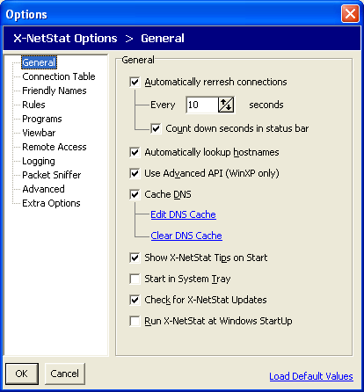  Click Load Default Values link to revert to X-NetStat’s default settings (the settings used on the first install)

Connection Table Options  Font – Picks the font face, the size, color and style of the font used for the Connection Table.  Columns – Shows and hides columns in  X-NetStat’s main window.  HotTrack on Connection Table – When checked, you can select a connection by hovering your mouse over it.  Show grid lines – Separates information in the Connection Table with lines for easier reading.  Show FilterBar – Turns the Filter Bar on or off. When the Filter Bar is on, type into a text field at the top of the connection table to show ONLY connections that match that criteria.  You can use multiple filters by using a comma. For example, to show .com addresses but hide all .net addresses use:  .com, %.net  This option can also be toggled from the View menu, or by clicking the funnel icon on the toolbar.  Show open UDP ports – Displays UDP listening ports in the Connection Table.  Show open TCP ports – Displays TCP connections with “Listening” status (AKA Open Ports) in the Connection Table.  Show a port’s shortname when available – Displays a “code” word (from the Port Database) for local and remote ports instead of numbers.  If the port is not in the Port Database, only the port number will be shown.  To display BOTH shortname and numbers, also check Show Port Numbers with Shortnames in the Extra Options section. | 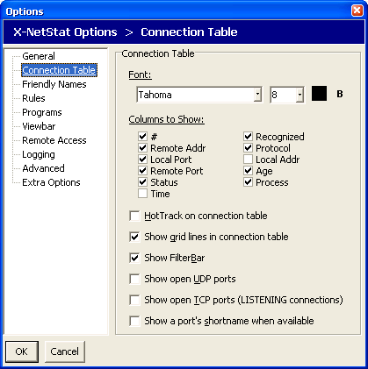
Friendly Names Editor  Here is where you can edit all of your recognized friendly names.  See Also: Friendly Names | 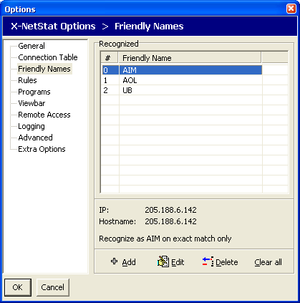

Rules Editor  This page displays all your rules and allows you add, edit, and delete them. You can enable or disable a rule by checking the box in the “On” column.  See also: Rules | 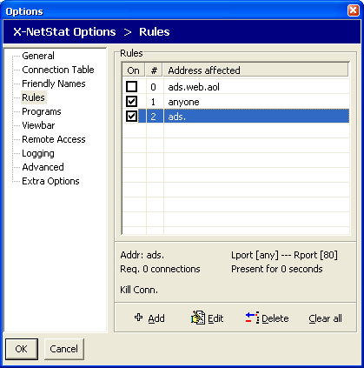

Programs Editor  This page lists all the external programs to be shown under the Programs button on the toolbar.  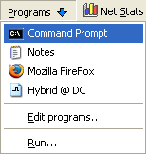  Click Add to add a new program/file to the list. A window will appear asking for the location of the file, folder, or URL and a name to give it.  When you click this item in the Programs dropdown menu (shown above), the program, file, or URL will launch. | 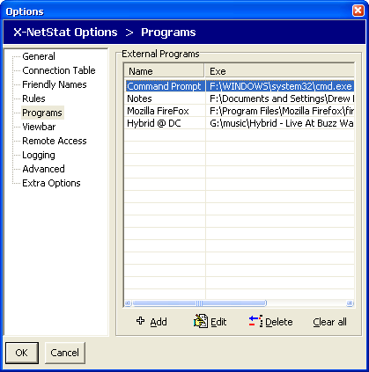

ViewBar Options  Enable ViewBar – When checked, X-NetStat shows the ViewBar by default.  Start Docked to – The initial dock location of the ViewBar.  Autohide – Hides the ViewBar at the very top or bottom unless the mouse is hovered over it.  Slide Effect – Animate the ViewBar when it is changing position.  Blend Connections – An alternate style to show the ViewBar in.  Show transmission lights – Shows transmission LEDs, the same ones on the status bar.  Show Clock – Displays the time on the ViewBar.  Autoscroll connections – When checked, each connection is shown for a specified time and then the next connection is shown. | 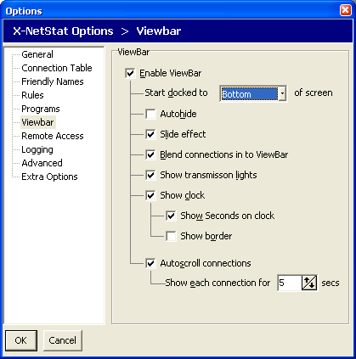
Remote Access Options  Enable X-NetStat Server – Turns the server on or off.  Port to Use – The port on your computer that the server will use. Port 11131 is default.  Include Net Stats – Include information from the Net Stats window in the HTML report.  AutoRefresh – Includes a META Refresh tag so the page is reloaded every few seconds.  Authentication required – Password protects access to the X-NetStat server. You must know the password in order to view the report.  URLs – Shows the URLs to access the X-NetStat server.  See Also: Remote Access | 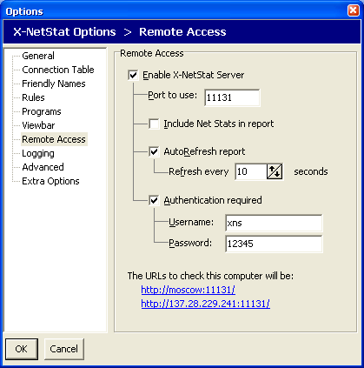

Logging Options  Log X-NetStat Activity – When checked, certain activity in X-NetStat will be logged to a file.  Record address and… -- What to include when recording each activity.  See also: Logging | 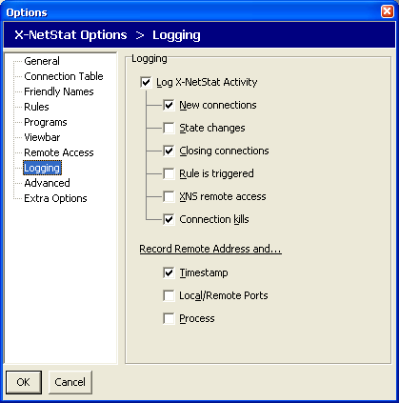

Packet Sniffer Options  Enable X-NetStat Packet Sniffer – Turns on packet sniffing when checked so XNS can calculate bandwidth usage for each connection. Corresponds to the button  Show total traffic in KiloBytes – When checked, displays total traffic in KB instead of bytes.  Display Bandwidth Meters – For each connection, shows meteres that measure the portion of total bandwidth used.  Enter in the maximum KB/s (KiloBytes per second) for your upstream and downstream connection.  You can choose from a preset of common connection types, but this may not accurately represent the bandwidth capabilities of your connection.  To accurately figure out your connection speeds, contact your network administrator or Internet Service Provider, or click one of the links to go to an online bandwidth speed test. | 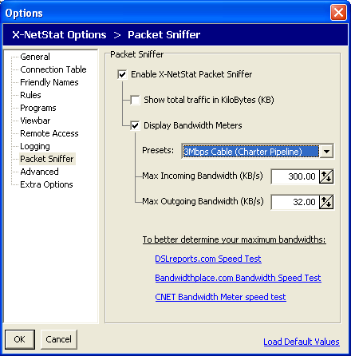

See Also: The X-NetStat Packet Sniffer

Advanced Options  SMTP email server – The outgoing email server to use when sending an email triggered by a rule.  SMTP username – If a username is needed to send email on this server, specify it here.  SMTP password – If a password must accompany a username, specify it here.  Show splash screen – Shows the X-NetStat splash screen on startup.  Flash cells – When checked, a border flashes around each value in Net Stats that has changed.  Update NetStats – How often to refresh Network Statistics in the Net Stats window.  Update LED lights – How often to check bytes in / bytes out to see if a LED should be flashed on or off. Also how often to check the transmission rate. Setting this too low will decrease performance. Recommended setting is 100ms to 500ms. | 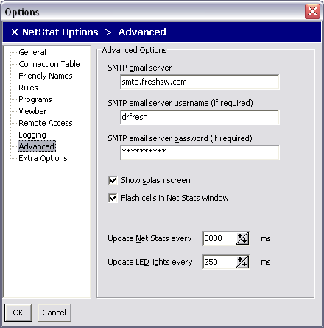

Extra Options  Old style toolbar highlight – Turns a toolbar button’s text blue when the mouse is hovered over it, much like the HotTracking feature in XNS version 4.0.  Flat Column headers – Flattens the column headers in the Connection Table.  Confirm on Exit – Asks you if you are sure you want to exit X-NetStat when closing.  Check for changes in Local IP/Hostname  When enabled, XNS will update the Local IP and Local Hostname on every refresh to reflect potential changes.  Memory Leak protection – For beta versions only, checking this will make X-NetStat restart itself every 24 hours.  Continuously repaint Connection Table  When checked, the Connection Table will be repainted every second instead of every refresh. Uncheck to increase performance.  Show Connection Events - Specifies where you want “Events” (New Connection, Closed Connection, etc) to show up when the program is minimized.  Show Port Numbers with Shortnames  When enabled, turning on Shortnames will display both the Port’s “code name” and its number.  Don’t Warn when Terminating/Restarting  Checking this will disable the confirmation message box when you decide to terminate or restart a process. | 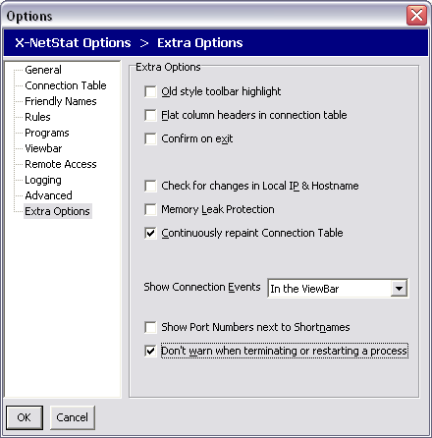

ViewBar Access

The ViewBar is a small window that is dockable to the top or bottom of your screen, and displays your connections over time. This handy feature allows you to keep an eye on your connections, but without having the main X-NetStat window visible and taking up space. It has the same appearance and nature as the Windows taskbar, and the Microsoft Office "Shortcut Bar". Other windows will adjust around it, so it will always be visible.

Turning on the ViewBar

The ViewBar is disabled by default. To turn it on, click the View menu and check Show ViewBar.

After this, a small bar will appear on the bottom of your screen and the surrounding windows should adjust around it.

The ViewBar

1 | 2 | 3 | 4 | 5
- XNS Button – If you click this button, it will bring up a menu to toggle the options related to the ViewBar. You can also close the ViewBar and exit XNS from here.
- Connection display – Here is where the connections are displayed one at a time. If "Scroll connections" is enabled, new connections will automatically be displayed after a certain interval. If the Scroll connections feature is not enabled, you must manually advance to the next connection (see #3). By right-clicking on a displayed connection, you can copy it's information to the clipboard.
Connection “Events”, like New and Closed connection messages will also flash here.
- Next, Previous, Pause, Refresh buttons – By clicking the up and down arrows, you can manually browse through your current connection list. Clicking the Pause button will stop Auto-Scrolling connections. Clicking the Refresh button forces a refresh of active connections, and should be done every so often if you do not have AutoRefresh enabled.
- Transmission LEDs – Transmission LEDs will light up in response to network activity.
- System clock – Shows your current time. Double-click to copy it to the clipboard.

Tray Access

X-NetStat minimizes to the system tray for easy access.

Click the Tray button to send X-NetStat to the system tray. You can also simple minimize X-NetStat.

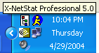  X-NetStat’s Tray icon. | 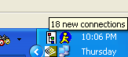  Hover your mouse over the icon to display X-NetStat’s status. | 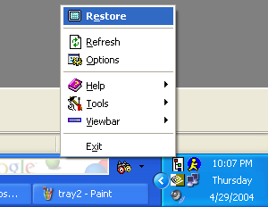  Right-Click the tray icon to display the system menu.  Double-Click the icon to restore X-NetStat.

Remote Access

X-NetStat features a built-in web server that lets you view your connections from any web browser.

Remote Access Options

Enable X-NetStat Server – Turns the server on or off.

Port to Use – The port on your computer that the server will use.

Include Net Stats – Include information from the Net Stats window in the HTML report.

AutoRefresh – Includes a META Refresh tag so the page is reloaded every few seconds.

Authentication required – Password protects access to the X-NetStat server. You must know the password in order to view the report.

URLs – Shows the URLs to access the X-NetStat server. Note that the top URL shows the NetBIOS name and will only be accessible from Microsoft-based networks.

When running, the X-NetStat server will stay in the background. You can see the server status on the status bar.

When someone makes a request to the XNS Server, it will appear in the leftmost panel of the status bar (The main status text). The status of the server can also be seen by looking at the server icon.

Server is OFF | Server is ON | Server is BUSY

When the server is OFF, double-click the server icon to start it.
When the server is ON, double-click the server to see the Server status window.

XNS Server Status Window  Server activity is logged in this window. A GET message means someone has tried to connect to the server. A subsequent >> Sent message means the user was authorized and the report was sent.  To close the window, hit ESC or close with the X button. If you want to stop the server, click Stop Server.  To show the current report, click Show Report. | 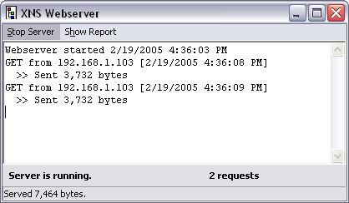

Someone who successfully accesses the server will see a report like this.

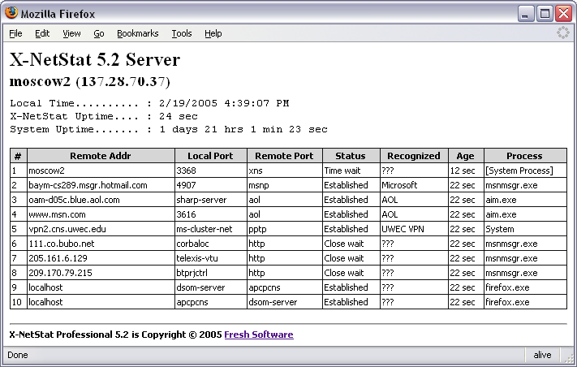

Logging

You don’t have to be sitting in front of your computer to catch every connection. If you turn on X-NetStat’s logging features, you can record X-NetStat activity to a text file and review it later.

X-NetStat can log these events:

- New Connections
- Changes in connection state/status
- Closing connections
- Rule activity
- Use of the X-NetStat server (Remote Access)
- Connection Kills

When logging, you can choose whether to include a timestamp for the event, the ports involved, and the process involved. Here is what a X-NetStat log file might look like with all these options on:

[ Time ] [ Log message ] [ Ports ] [ Status ] [ Process ]

-- X-NetStat log file -- created 4/30/2004 8:02:29 PM

[8:02:29 PM] Started Recording
[8:02:33 PM] New : 205.188.12.127 <3032/5190> (Established) [aim.exe]
[8:02:33 PM] New : 205.188.6.143 <3040/5190> (Established) [aim.exe]
[8:02:33 PM] New : 218.78.211.62 <3149/4661> (Established) [emule.exe]
[8:02:33 PM] New : host207105075031.borland.com <3262/80> (Close wait) [delphi32.exe]
[8:02:33 PM] New : 207.105.83.51 <3263/80> (Close wait) [delphi32.exe]
[8:02:33 PM] New : aba23.neoplus.adsl.tpnet.pl <3436/4662> (Time wait) [System Process]
[8:02:33 PM] New : 218.68.224.146 <3437/80> (Time wait) [System Process]
[8:02:33 PM] New : pool80183.interbusiness.it <3439/4662> (Closing) [emule.exe]
[8:02:34 PM] New : pD9E49117.dip.t-dialin.net <3441/4662> (Time wait) [System Process]
[8:02:59 PM] New : moscow.uwec.edu <3001/3633> (Established) [alg.exe]
[8:02:59 PM] Change: 80.13.40.17 <3548/4662> (Established->Fin wait1) [emule.exe]
[8:02:59 PM] Change: 80.15.148.16 <3559/4660> (Established->Fin wait1) [emule.exe]
[8:07:02 PM] New : localhost <3813/3814> (Established) [mozilla.exe]
[8:07:02 PM] New : localhost <3814/3813> (Established) [mozilla.exe]
[8:07:02 PM] New : 205.188.12.127 <3032/5190> (Established) [aim.exe]
[8:07:02 PM] New : 205.188.6.143 <3040/5190> (Established) [aim.exe]
[8:07:02 PM] New : host207105075031.borland.com <3262/80> (Close wait) [delphi32.exe]
[8:07:02 PM] New : 207.105.83.51 <3263/80> (Close wait) [delphi32.exe]
[8:07:08 PM] New : 216.200.111.181 <3848/443> (Established) [mozilla.exe]
[8:07:21 PM] Closed: i8.cnn.net <3833/80> [mozilla.exe]
[8:07:21 PM] Closed: i8.cnn.net <3832/80> [mozilla.exe]
[8:07:29 PM] Closed: 80.8.55.221 <3851/4662> [emule.exe]
[8:07:29 PM] Closed: 217.5.28.163 <3850/4661> [emule.exe]
[8:07:31 PM] X-NetStat shutdown

To view your Logs, click the Logs button on the toolbar or click the Logs main menu, and then click the date you want to view. The log file will be opened in Notepad.  Click Show all Logs to open the Logs folder in Windows Explorer.  Alternatively, you can click Log Viewer to use X-NetStat’s internal Log manager.  TIP: Turning on many logging options can slow down X-NetStat’s performance, especially if there is a significant amount of network activity. | 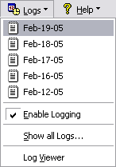
Rules: Responding to Network Events

One of X-NetStat’s most outstanding features is the ability to respond to certain network activity. With the Rules system, you can configure the program to act upon certain incoming & outgoing connections.

Once a rule is triggered, X-NetStat can do the following things:

- Kill the connection
- Notify users via email
- Play a WAV file
- Launch a script or program
- Start the Lookup Tools
- Display a message window

Criteria used to trigger a rule:

- The IP addresses or hostname
- The local & remote ports being used
- How many connections from the remote address
- How long the connection has been present
- The Process EXE facilitating the connection

All rules in X-NetStat are shown in the Options window, under the Rules section. You can jump to this by clicking on the Rules menu and choosing Edit Rules…

Rules Editor  The rules are displayed in a table like the one on the right. Click a rule to read a summary, which is displayed at the lower panel.  To turn a on or off, check or uncheck the box next to the rule in the On column.  To edit an existing rule, select a rule and click Edit.  To add a new rule, click the Add button.  Both Edit and Add buttons brings up the Add/Edit Rule dialog box. | 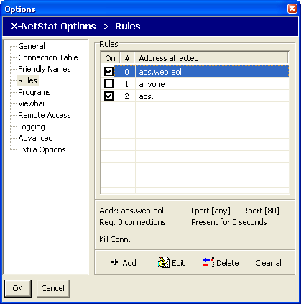

Edit Rule: Conditions  The Edit Rule dialog box has two parts: Conditions and actions.  These are the conditions which must be met by a connection for X-NetStat to trigger the rule. They include:  - Address  - Number of connections  - Local / Remote Port  - Process EXE  - How long the connection has been present  Once you have set the conditions for the rule, click the Actions tab at the top of the screen to tell X-NetStat what you want to have happen when those conditions are met. | 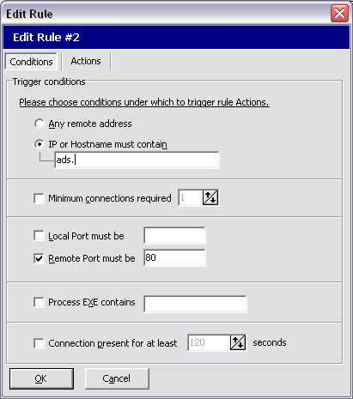

Edit Rule: Actions  When your conditions are met, X-NetStat can perform several actions:  - Execute a program or file  - Play a WAV file in the background  - Open a web page (URL)  - Kill the connection  - Start Lookup Tools  - Pop-up Message Alert  - Send email  To send email to multiple addresses, separate the addresses with a semicolon ;  Pop-up Message Alerts will not be displayed when X-NetStat is minimized. Instead, the system tray icon will blink. | 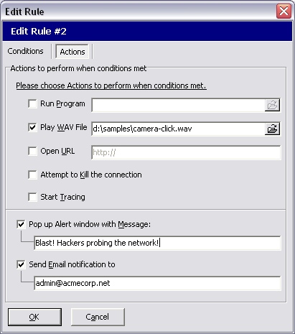

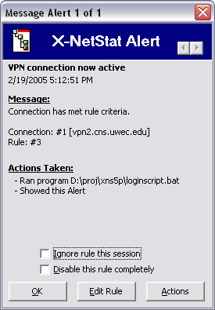 | Message Alert window  This window is displayed when either you specify an alert to pop up, or by right-clicking a connection and choosing View Alert.  The window shows the Alert message, what connection met what rule, and the actions automatically taken by X-NetStat.  If you want to stop seeing Alert windows pop up, check Ignore rule this session. The rule will no longer be active until you restart the program.  If you want to turn off the rule completely, check Disable this rule completely.  At the bottom of the window are three buttons:  OK – Close the window  Edit Rule – Opens the Edit Rule Dialog box  Actions – Provides a menu of additional actions to perform  Click the Left/Right arrows to scroll through your current Alerts.

Recognizing your Connections with Friendly Names

What’s a Friendly Name?

If you’re running a busy network, there may be a whole lot of connections displayed in X-NetStat, making it hard to ascertain what each one is for. It’s your job to make sure that “good” connections are getting through, and “bad” ones aren’t. You can simplify this job by using Friendly Names.

Say that ultrabank.com (216.138.240.196) is a business partner of your firm and connects to your network occasionally for transaction processing. This would be a great address to recognize so that it is marked as a friendly, human-readable name when it shows up in X-NetStat.

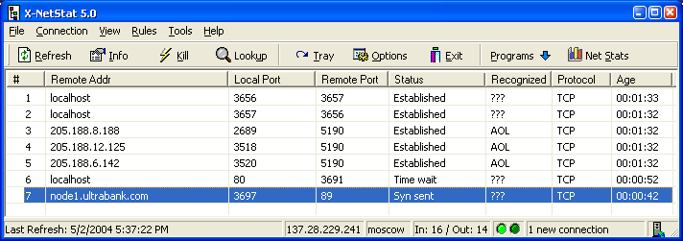
Ultrabank.com is a business partner that frequents our network. Let’s recognize them.

Right click the connection and choose Recognize as. | 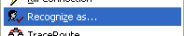

For each friendly name, you can have X-NetStat recognize on either an exact match or a partial match.  If you choose EXACT match, X-NetStat will ONLY recognize when either the IP or Hostname exactly matches the friendly name.  For PARTIAL matches (see right), X-NetStat will recognize a connection even when a portion of the addresses match up. For example, by using “.ultrabank.com” and “216.138.240.” , X-NetStat will recognize all these addresses as “UB”:  node1.ultrabank.com  node2.ultrabank.com  www.ultrabank.com  216.138.240.10  216.138.240.23  216.138.240.255 | 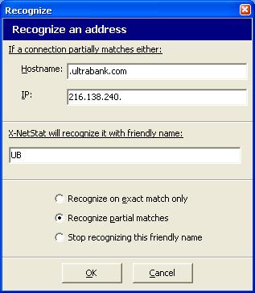

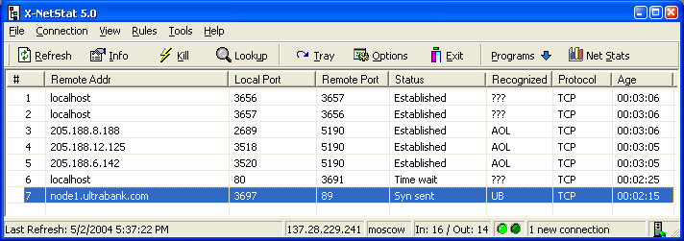

This connection is now recognized as UB (Ultrabank).

Other connections that X-NetStat doesn’t recognize are shown as ???

Net Stats: Your Network Statistics

The Network Statistics window displays information on your network interface and statistics for the IP, ICMP, TCP/IP and UDP protocols.  If more than one interface is detected, you can view the them by clicking the dropdown arrow next to the adapter name (see Red Box)  Accessing Network Statistics  You can view Network Statistics 4 ways:  - Click the Net Stats button on the toolbar  - Click Network Statistics on the Tools menu  - Double-click the LEDs in the status bar | 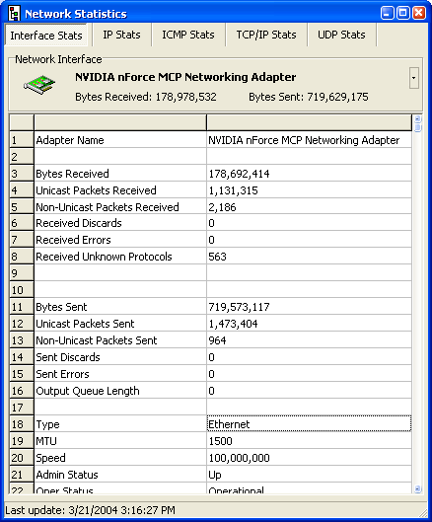

The X-NetStat Packet Sniffer

X-NetStat Professional comes with a built in packet sniffer that can double the program’s power in one click.
When the Sniffer is activated, X-NetStat will monitor the data coming in and out of your network adapter so it can calculate the bytes coming in and out per connection. It will even tell you how fast the data is flowing!

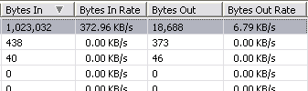
Click to activate the X-NetStat Sniffer.
X-NetStat will calculate the data flow for every connection.

This feature is perfect for telling which connections are actively pumping data, and which ones are just sitting idle.

The X-NetStat Packet Sniffer may increase your total CPU usage, so if you are running on a slower system it is recommended to only turn it on as needed.

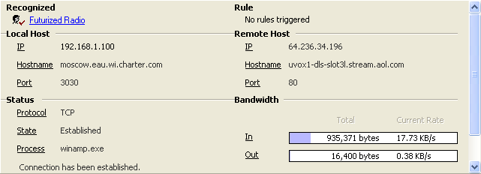
The X-NetStat Packet Sniffer can display bandwidth meters to show the portion of total available bandwidth used per connection.

See Also: Packet Sniffer Options

Other X-NetStat Tools

X-NetStat has other tools you can access from the Tools menu.

Google Search: You can do a Google Search any time by hitting Ctrl-G and typing in your query.

Get External IP Address: If you are behind a NAT or internal network setup, your External IP – the one the outside world sees – may not be obvious. Click this will contact Fresh Software’s server and report back to you your external IP.

Banish Hostname: This feature adds an entry to your HOSTS file that makes a hostname resolve to 0.0.0.0, preventing any outgoing connections to be made.

Nuke Connections: Attempts to kill EVERY established connection.

RWHOIS: RWHOIS extends and enhances the WHOIS concept in a hierarchical and scalable fashion. It focuses on the distribution of "network objects"--the data representing Internet resources or people--and uses the inherently hierarchical nature of these network objects (domain names, Internet Protocol (IP) networks, email addresses) to more accurately discover the requested information. See Also: About RWHOIS

Find Files: Opens the Windows Find Files dialog.
Find Computer: Opens the Windows Find Computer dialog.
Run: Opens the Windows Run dialog.
Shut Down: Opens the Windows Shut Down/Restart/Log Off/Standby dialog.

Appendix A: Netstat status codes

CLOSED | The connection is disconnected and not being used
LISTEN | Your computer is waiting for an incoming connection. This is an open port.
SYN_SENT | Actively trying to establish connection
SYN_RECEIVED | Initial synchronization of the connection under way, about to connect
ESTABLISHED | Connection has been established, connection is active
CLOSE_WAIT | Remote shut down: waiting for the socket to close
FIN_WAIT_1 | Socket closed, shutting down connection
CLOSING | Closed, then remote shutdown: awaiting acknowledgement. Attempting to shut down connection
LAST_ACK | Remote shut down, then closed: awaiting acknowledgement
FIN_WAIT_2 | Socket closed, waiting for shutdown from other computer
TIME_WAIT | Wait after close for remote shutdown retransmission
TCB_DISCARD | TCP connection control block discarded

Appendix B: WHOIS Servers

Note: Click on the globe icon to visit the web gateway for each WHOIS server.

For a really handy Web-based WHOIS gateway, check out allwhois.com

Type of query | Server to use |  | Example query
.com, .org, .net Domain name |  | whois.networksolutions.com | powder.com
Government .gov |  | nic.gov | fbi.gov
Military .mil |  | whois.nic.mil | usace.army.mil
IP address (USA) |  | arin.net | 172.206.65.182
IP address (Europe) |  | ripe.net | 80.170.35.191
IP address (Asia/Pacific) |  | apnic.net | 203.99.65.227
IP address (Latin America) |  | lacnic.net | 200.47.53.10
Other country (.uk, .de, etc) |  | nic.xxx (where xxx is the country code or domain suffix)* | amiga.de

* Note: See the file whoislist.dat in the X-NetStat directory for a list of international WHOIS servers

Appendix C: IP Addresses & Hostnames

An IP (Internet Protocol) address is a numerical sequence that uniquely identify a computer, or other networked device, on a network such as the Internet. To be able to use the Internet, your computer needs an IP address so that network traffic can be directed to and from it.

When you log on to the Internet, your Internet Service Provider (ISP) typically assigns you an IP address for your current session. If you use a dial-up, you usually receive a different address each time you connect. If you connect to the Internet from a local-area network, like you might at work, or through a cable modem or DSL line, you might have an IP address permanently assigned to your computer.

Anytime you send an e-mail, access a Web page, or try to send or gather other information to or from the Internet, your Internet application communicates with a server via its IP address. IP addresses are usually formatted by means of four numbers from 0 to 255, separated by dots. A typical IP address might be "209.94.162.45".

Since it is difficult to remember arbitrary strings of numbers, and an IP address for a given computer can frequently change, textual "hostnames" are used in place of numeric addresses. Hostnames are used to make addresses easier to remember, and to continue to identify a specific computer even when its IP address changes. DNS (Domain Name System) is the Internet function that provides "hostname resolution", which translates textual hostnames into numeric IP addresses.

The Domain Name System is what enables you to type in names (such as "www.freshsw.com") instead of numerical IP addresses. When DNS translates hostnames into their numerical counterpart, the process is usually transparent to the end user. When an Internet application encounters a textual hostname, it sends a request to a DNS server. The DNS server will then respond with the IP address associated with the textual hostname, or it will signal an error if it cannot find an associated address.

For more information: The In’s and Out’s of DNS

Appendix D: About Fresh Software and its commitment

Fresh Software is not a giant corporation. It was founded by Drew Niese (me) in 1998 when I was 15 years old, as an extension of my programming hobby. Since that time FS has released several freeware and shareware programs to the Internet community.

I don’t have the resources to run Fresh Software like a conventional full-time business because I am enrolled as a student at UW-Eau Claire, studying a blend of Business, Computers, and Management Information Systems.

That’s why I want my software done right the first time. X-NetStat Professional has gone through an extensive beta testing program to make sure that it is of the highest quality in terms of features, ease of use, performance and stability. That’s part of the four driving commitments Fresh Software has to its customers:

  - Ensuring FS programs are unique and useful
  - Ensuring FS programs are easy to use and of superior quality
  - Ensuring customers are completely satisfied
  - Ensuring customers are always listened to

I hope that I have met these commitments and that you find X-NetStat Professional to be well worth the registration price. If you have complaints, praise, questions, suggestions or comments about the program, I would really like to hear from you and I will do my best to respond.

You can email me at drew@freshsw.com.

Fresh Software is on the web at http://www.freshsw.com/

