
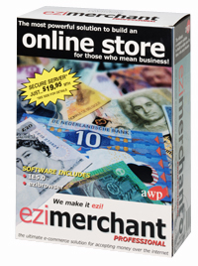 | ezimerchant Professional compared to ezimerchant is what a Mack Truck is to a one tonner.  The one tonner is still a good machine. It’s just that the Mack truck will carry a lot more a lot further.
To carry this extra weight the Mack truck carries a few more features in the cab. More gears, knobs and switches and a driver who means business. Likewise, ezimerchant Professional carries more features, more bells and whistles. While the modern trucks are not necessarily a lot more difficult to drive (in a straight line anyway), you do have to know what all the knobs and buttons are if you want to take advantage of this increased capability.

Features include:
- Wizard driven process - enter your company details
- ODBC database import and export
- Enter categories, products and images –also incorporates image resizer which prepares thumbnails and larger images for publication
- Include short or detailed descriptions
- Attach files (ie - pdf, demos, video, etc)
- Active and non-active states for products
- View categories from different perspectives
- Add custom fields (ie - colour or size)
- Drag and drop categories with the ability to have as many levels as required
- Ability to customise screen and toolbars
- Manage product promotions and sales. Automatically applies promotional discounts to products. Registers active/non-active promotional and discount states.

Freight
- Numerous freight options that incorporate shipping based on percentages, weights, initial base charge, per product or State/National/International

Online Marketing
- Ability to enter metatags
- Participate in banner add campaigns

Customer Services
- The Customer Services Module automatically lists customers in an easy to use database
- Organise customers into groups, easy to use drag and drop grouping function
- Build email templates to mail clients. Send in batches to selected groups with latest offers, etc

Sales Management
- Easily view and import customer orders
- Synchronise ezimerchant Professional with Quick Books or MYOB
- Workflow management to monitor activities by customer, communications and order status
- Sophisticated 3D graphing and reporting function

Tax: Ability to enter tax rates (GST compliant) on products as well as freight services if required

Site Generation
- Select how many products you would like to appear per page
- Select a theme/layout from a database of professionally produced templates
- Modify/Edit layout
- Add new pages to your site
- Includes HTML and WYSIWYG editor
- Preview site as you design and build
- Easy upload of completed site to host server
- Supports standard and real time credit card transactions (real time is an optional extra)
- Orders by account
- Download updates and add-ons
- Supports DHTML/XHTML and java
- Allows customers to select the order in which products are listed

The vast majority of e-commerce solutions for small to medium business today host the clients website on a secure server as well as keeping the database with the service provider. The majority of small to medium businesses don’t need this. They pay significantly more than required and are faced with expensive maintenance.
ezimerchant Professional is a client side solution that leaves the merchant/business in control. The ability to import/export databases and the fact the database stays in control of the client (you), means that should your business wish to change solutions or your business needs change, you are not locked in.

Screengrabs

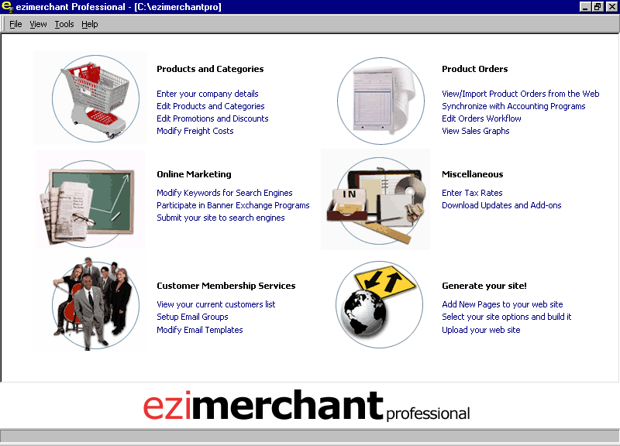 | 